Design Day Booklet Team Page

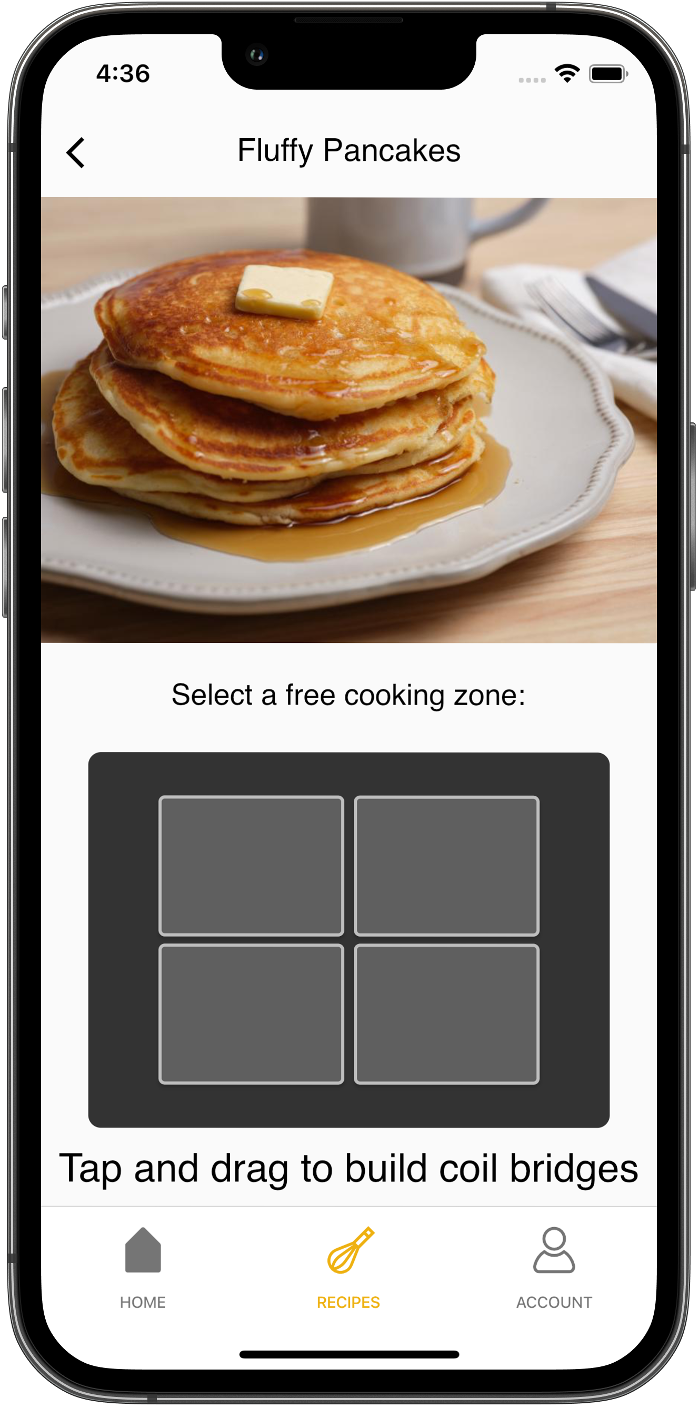

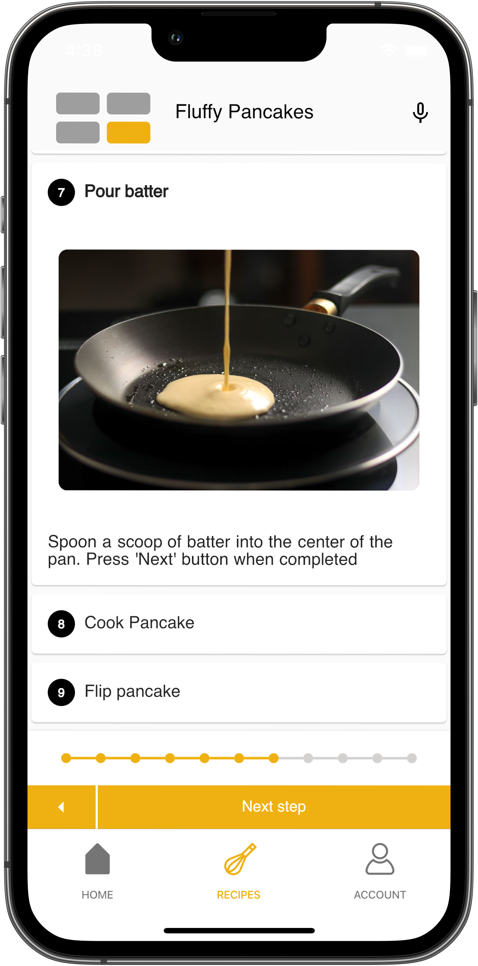

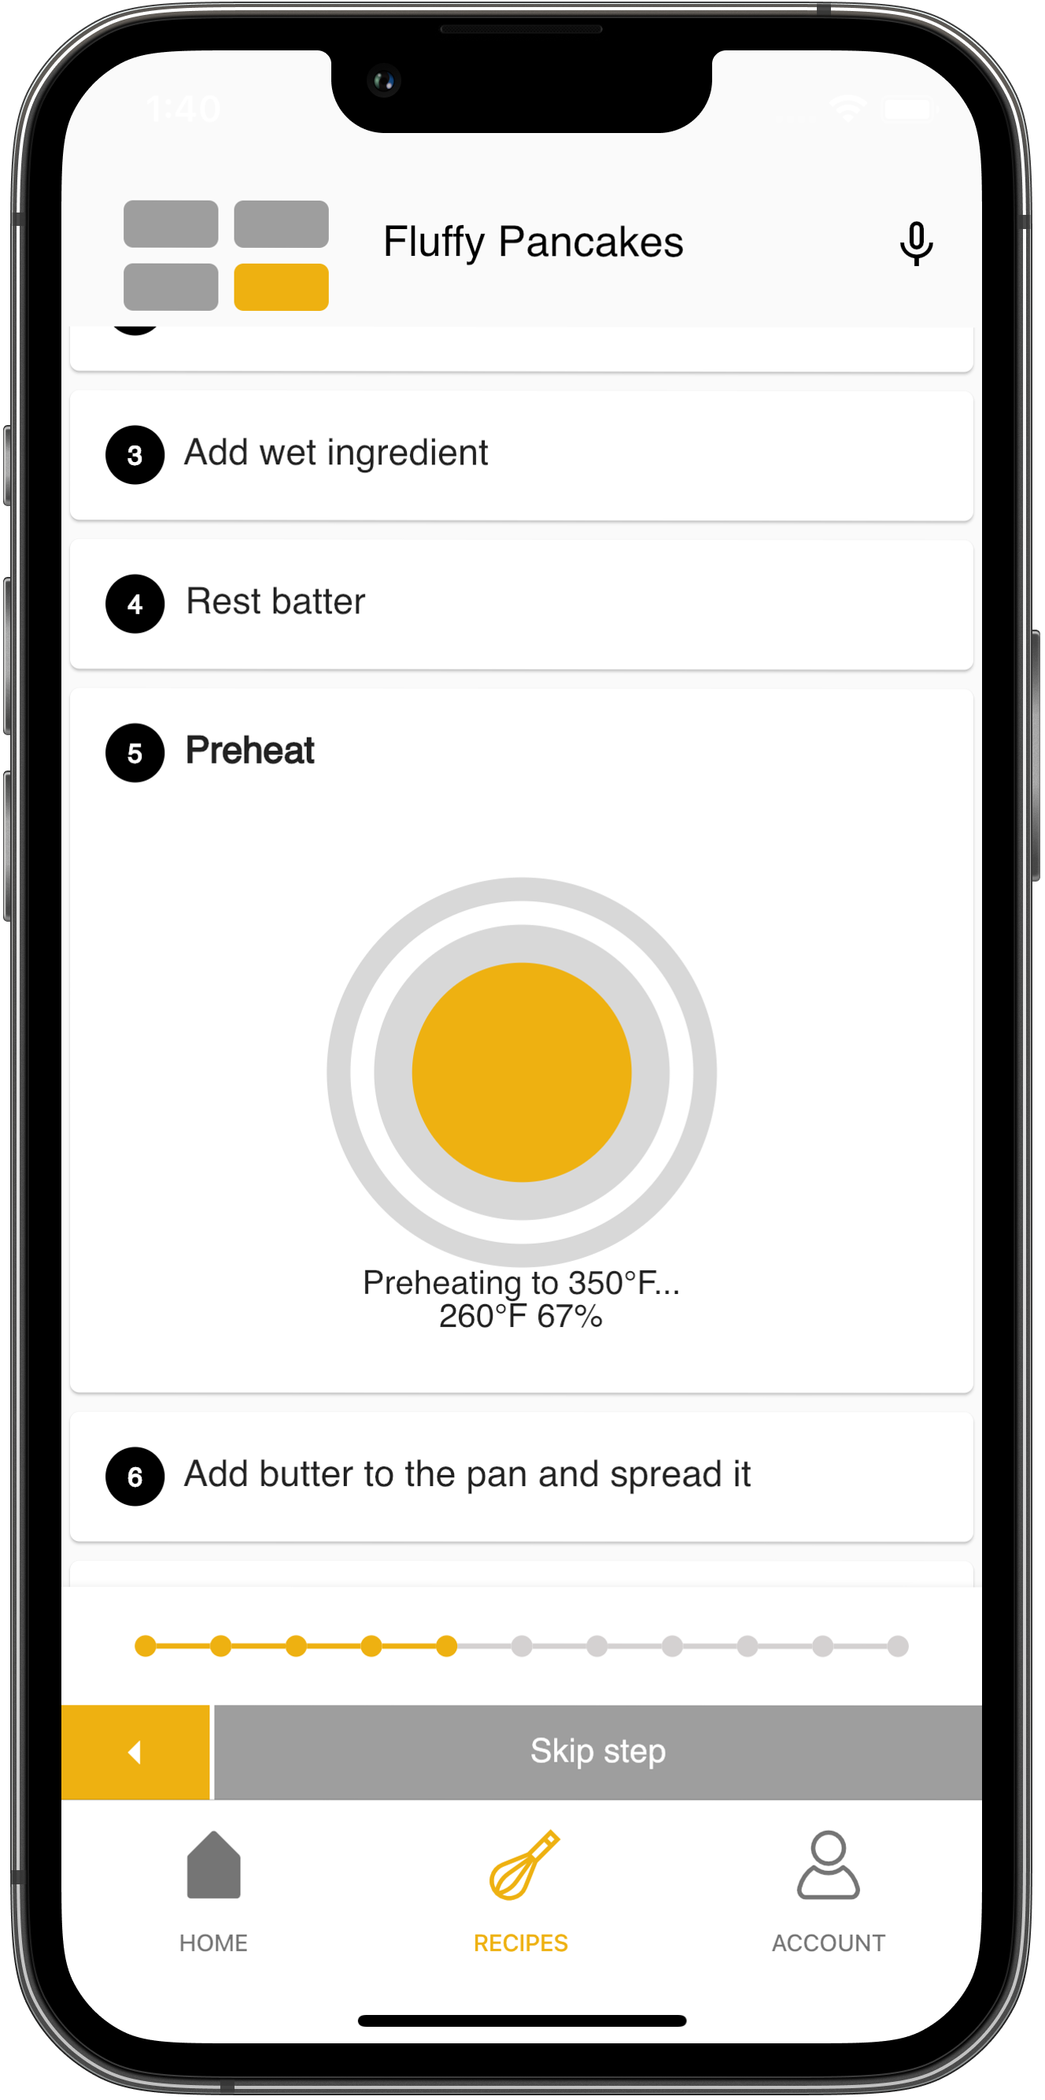

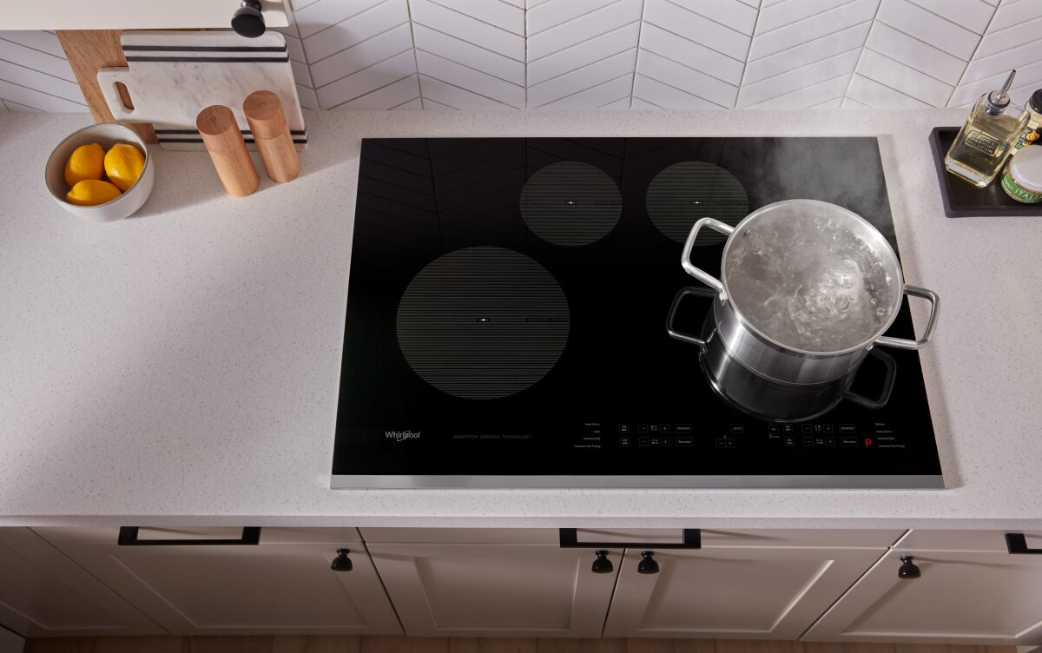

PAGE N + 31



Whirlpool

Project Sponsors

Colleen Doyle

Benton Harbor, Michigan

Jackie Li

Shenzhen, China

Gian Mauro Musso

Varese, Italy

Collin Stipe

Benton Harbor, Michigan

Michigan State University

Team Members (left to right)

Preston Harrell

Novi, Michigan

Daniel Nguyen

Kalamazoo, Michigan

Ziming Qiu

Haikou, Hainan, China

Alexis Tochiki

Honolulu, Hawaii

Ashu Acharya

Canton, Michigan

Clarence Nanamori

Novi, Michigan

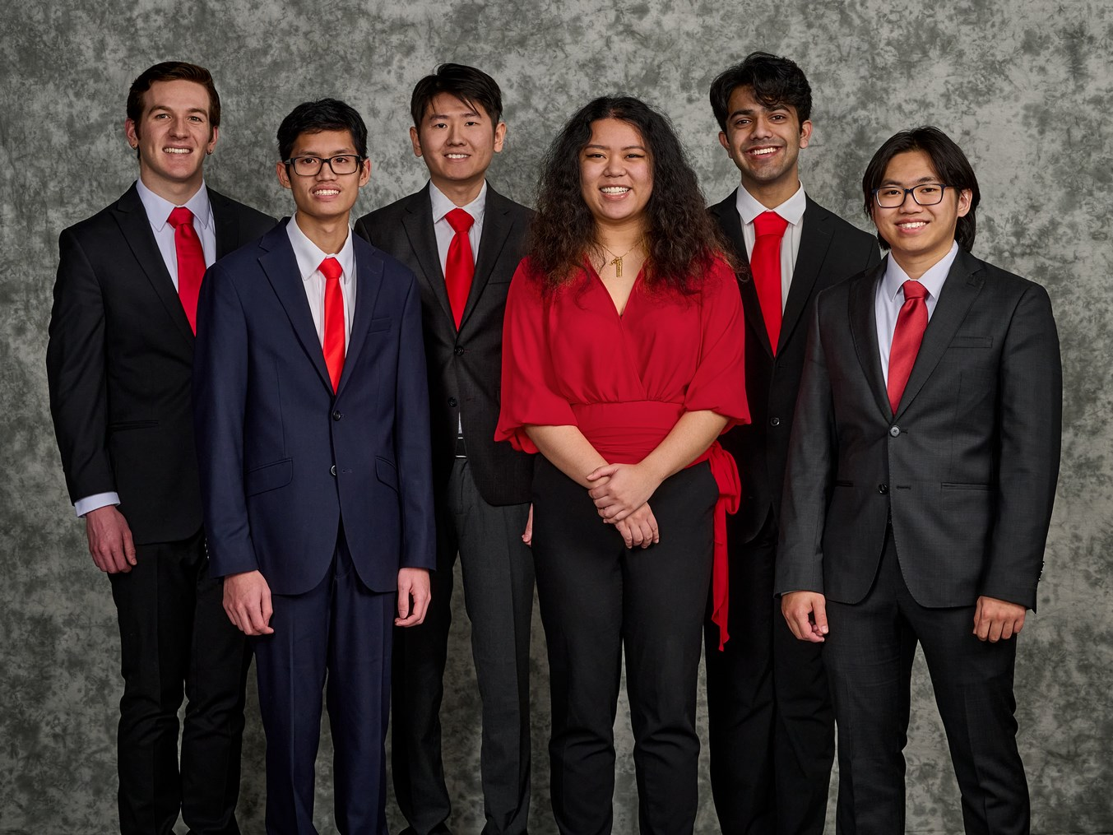

Whirlpool Corporation is based out of Benton Harbor, Michigan and is one of the world’s best known home appliance manufacturers. They are a Fortune 500 company with approximately $20 billion in annual sales and 54 manufacturing and technology research centers across the globe.

Recently, Whirlpool has been focusing on introducing more smart appliances for the kitchen to assist chefs of all backgrounds.

One of these appliances is the Assist Cooking with Temperature (ACT) Cooktop. This is a smart induction cooktop that assists in the automation of the cooking process with its precise temperature control and smart recipes alongside a mobile app called SmartCook.

Our SmartCook application improves the quality of the user’s cooking experience through automation features such as pan recognition and auto-recipe progression.

As the user cooks, the application controls the pan’s temperature and autonomously progresses through a chosen recipe based on predictions of recipe progress. This minimizes the time users spend on their phone leaving more time for cooking their meal.

While cooking, the user is guided through each instruction, which is displayed on their iPhone or Android device. During each step of a recipe, the ACT Cooktop gathers data from the sensors on its surface. Our machine learning algorithms analyze the cooking data to determine when a step has been completed, after which the app instructs the user what to do next.

Our application helps Whirlpool achieve their vision of making cooking easy and accessible to everyone. Our app simplifies the overall cooking process and makes it less stressful for everybody from amateur to professional chefs.

The back end of our SmartCook app uses a Firebase server to store recipe data and employs scikit-learn for machine learning. The front end is created using the cross-platform SDK called Flutter.

Computer Science and Engineering CSE 498

Whirlpool Corporation

SmartCook: Smart App for Induction Cooktop Cooking