Design Day Booklet Team Page

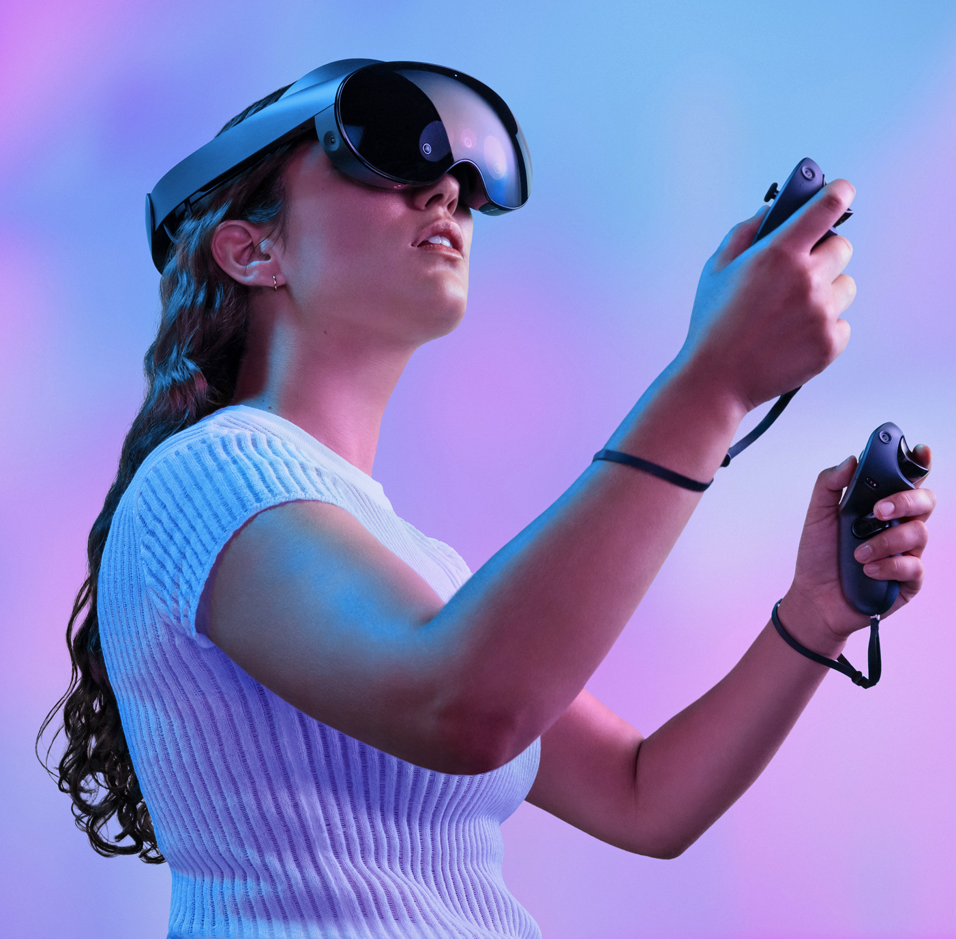

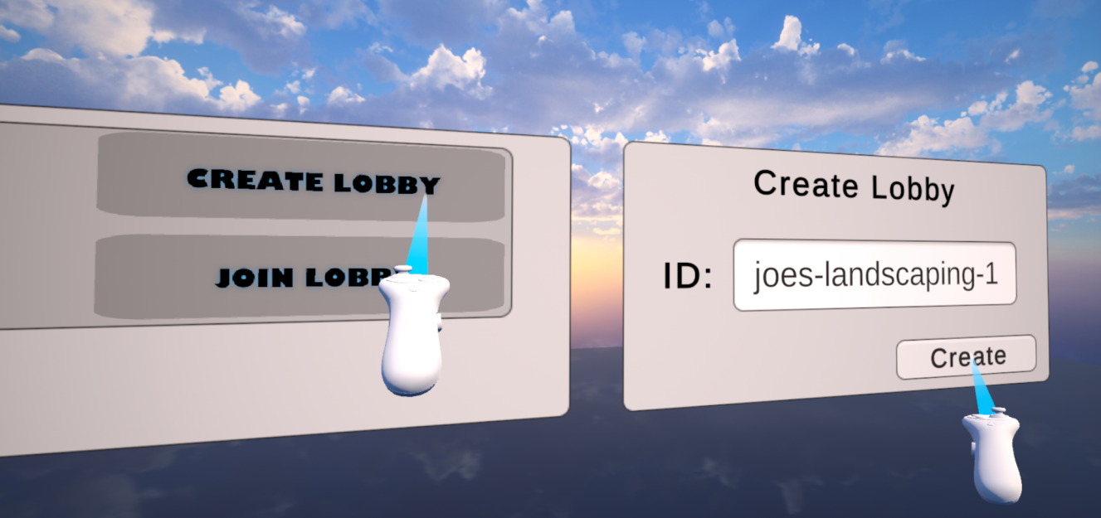

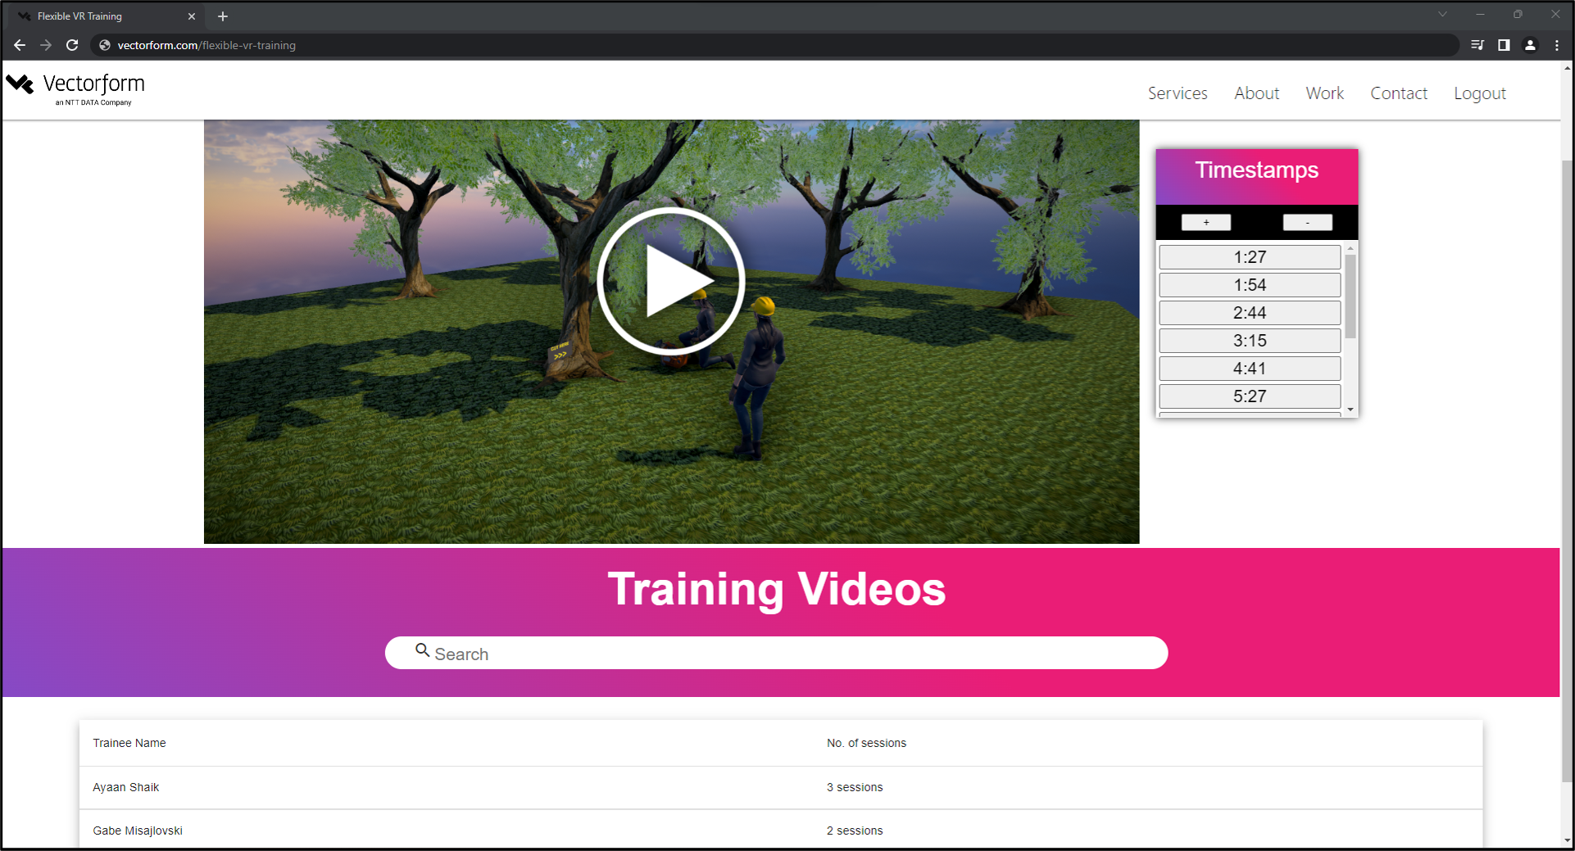

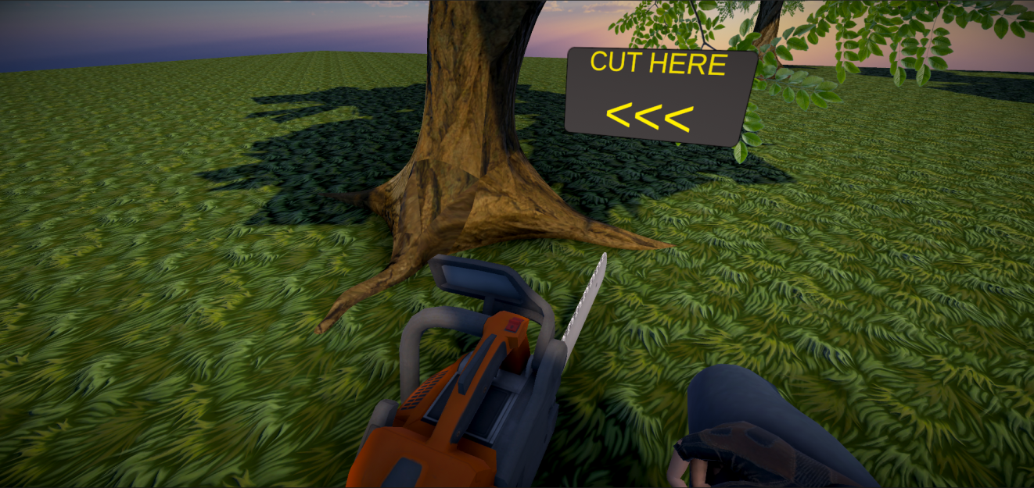

PAGE N + 29



Vectorform

Project Sponsors

Amity Calhoun

Troy, Michigan

Chris Cornish

Troy, Michigan

Woody Floyd

Seattle, Washington

Jeff Meador

Troy, Michigan

Josh Parmenter

Seattle, Washington

Michigan State University

Team Members (left to right)

Matthew Burkett

West Bloomfield, Michigan

Jiuhua Wu

Beijing, Beijing, China

Casey Stironek

Lake Orion, Michigan

Michael Burkett

West Bloomfield, Michigan

Gabe Misajlovski

West Bloomfield, Michigan

Ayaan Shaik

Vijayawada, Andhra Pradesh, India

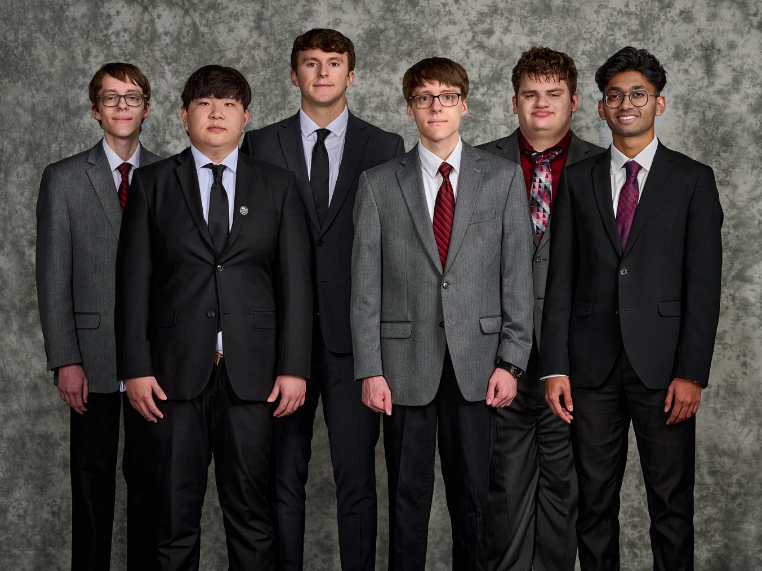

Vectorform LLC is a cutting-edge technology company committed to accelerating change and solving society's most complex problems. Headquartered in Troy, Michigan, with four global offices and over 100 employees in design, engineering, and product development services, Vectorform is dedicated to creating the newest, most innovative technologies.

Certain careers require dangerous, time-consuming, and costly workplace training, such as law enforcement, firefighting, and construction. Traditional training methods compromise the safety of the trainee while attempting to replicate real-life situations. We have a solution: immersive technologies.

Our Flexible VR Training system provides trainees with a fully digital workspace environment that replicates life-like scenarios they will face on the job. The instruction is customizable based on company preferences, and the application supports two different training methods: a real-time human trainer and a human-like AI trainer. The AI trainer learns and adapts from live training sessions. Company officials can view recorded training sessions through our web application.

Our web application provides access to recordings of previous training sessions and information about each. Employers can set timestamps during these recordings as reference points for training evaluation.

Overall, the Flexible VR Training system is a cost-effective and safe way to train employees while providing realistic training scenarios.

The VR application is incorporated through Unity and a Meta Quest Pro VR headset. The back end is implemented with Node.js and a Microsoft Azure SQL database/mobile server. The web application uses Angular and WebGL, while the AI trainer utilizes an OpenAI API.

Computer Science and Engineering CSE 498

Vectorform

Flexible VR Training