Design Day Booklet Team Page

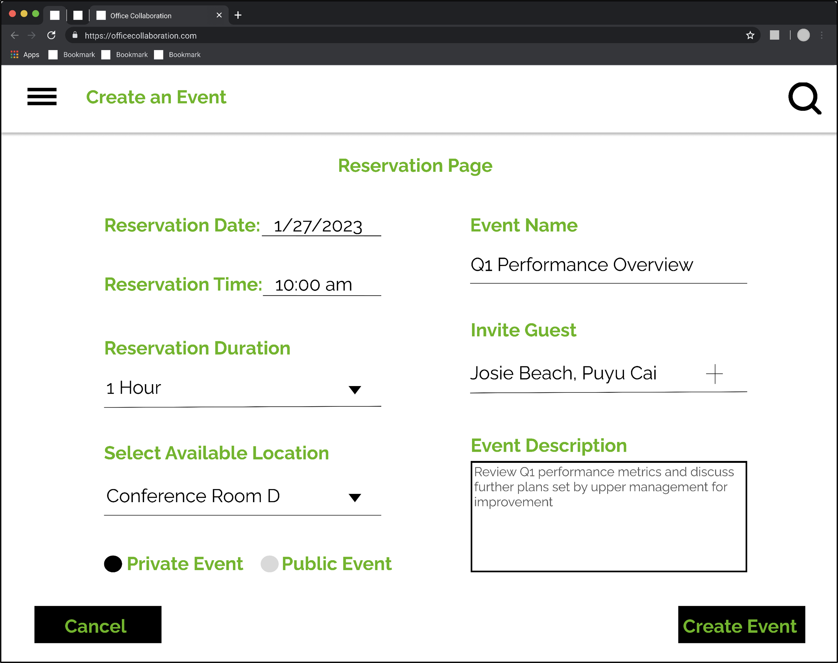

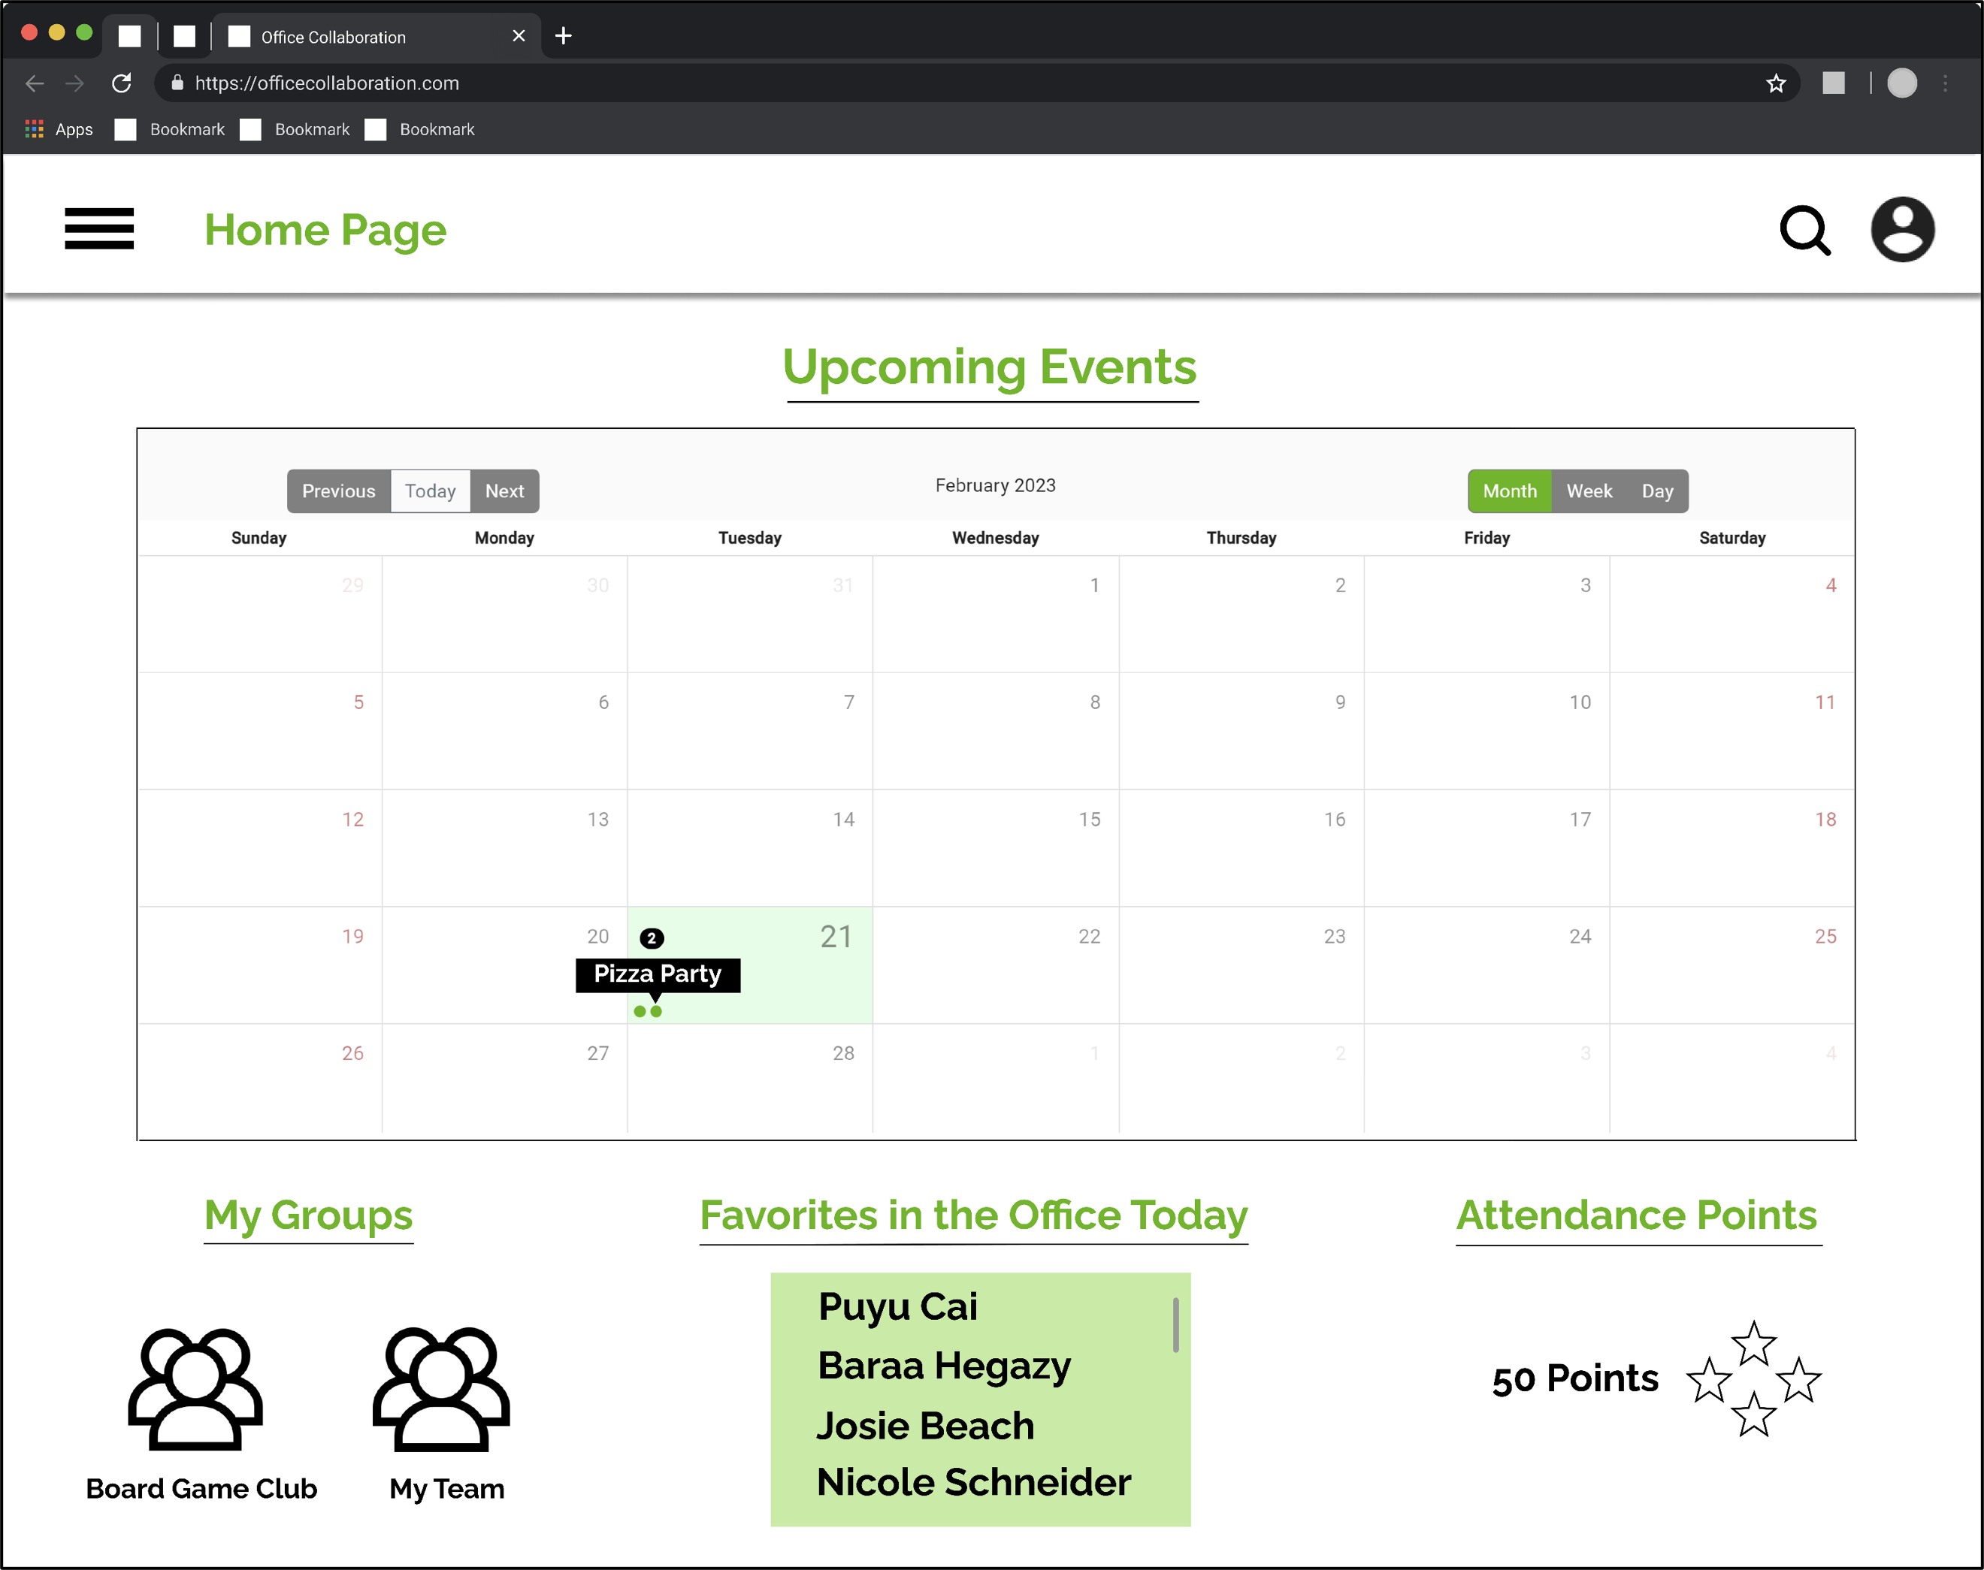

PAGE N + 28



Urban Science

Project Sponsors

Mike DeRiso

Detroit, Michigan

Elizabeth Klee

Detroit, Michigan

David Michael

Detroit, Michigan

Michigan State University

Team Members (left to right)

William Wyrick

Clarkston, Michigan

Nicole Schneider

Chesterfield, Michigan

Jacob Miller

Fowlerville, Michigan

Puyu Cai

Shanghai, Shanghai, China

Baraa Hegazy

Portage, Michigan

Josie Beach

Rochester, Michigan

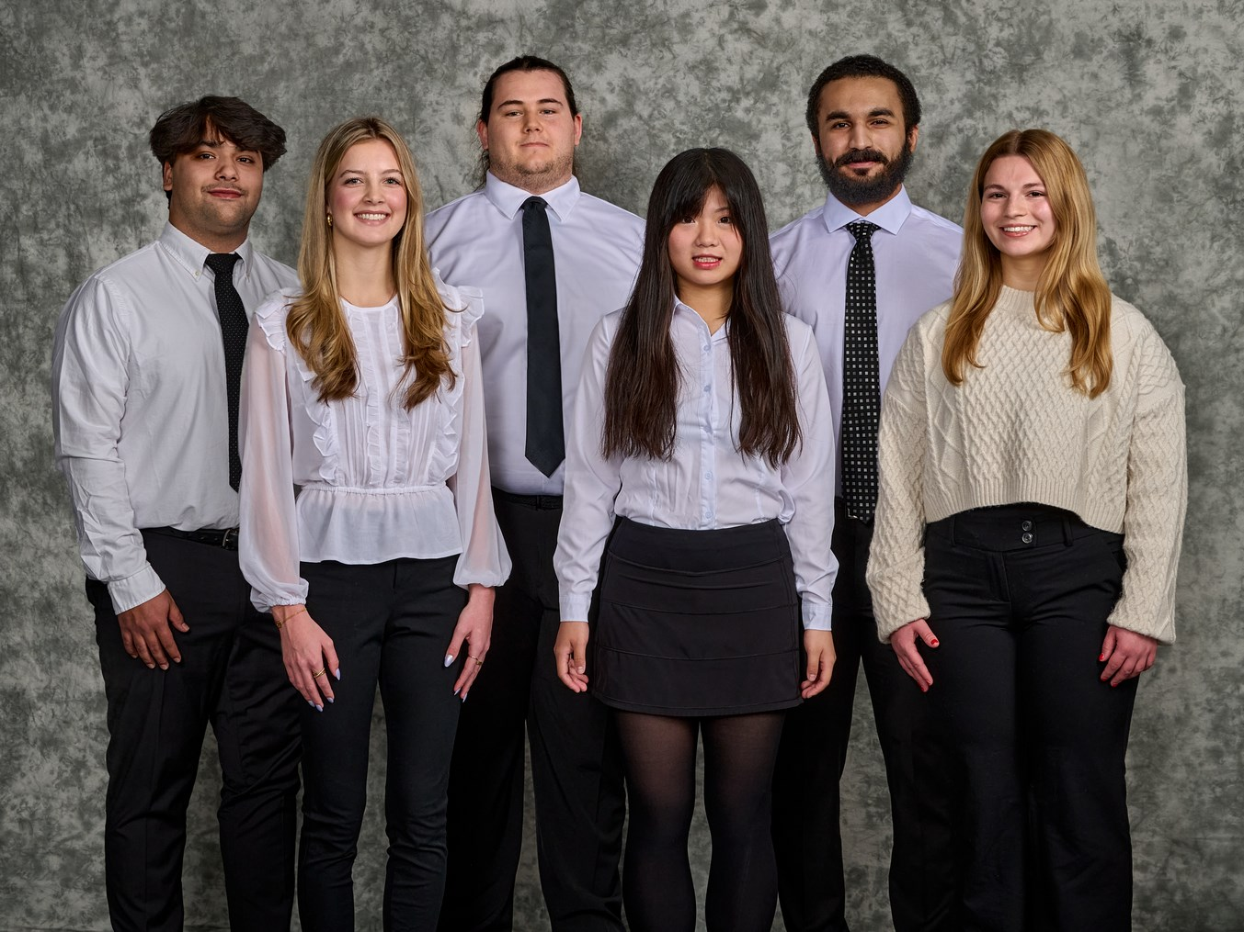

Urban Science, headquartered in Detroit, Michigan, is a consulting firm that supports every global OEM and numerous major automotive companies by providing them with service in the most efficient and effective way to increase the company's profitability and market share.

Since COVID-19 hit in early 2020, employees that work in the office have realized how convenient working remotely from home can be. However, this has caused a significant decline in socializing amongst coworkers. Urban Science conducted a study that discovered upwards of 80% of employees would be more encouraged to return to the office if they could socialize with their coworkers and rebuild bonds with their team members.

Our OfficeBuddy web application assists office workers in their transition back to in-person work by creating a convenient and robust social environment within the workplace.

OfficeBuddy enables users to select their seat before they come to the office, allowing them to sit by their friends. Users can add coworkers to their favorites list and track what days their favorite coworkers are going into the office.

Users can create public or private events that can be used for official meetings or fun events with coworkers. Users can also create groups with other users that can then be used to invite an entire group of people to attend a private or public event. Users are rewarded based on attendance, encouraging employees to utilize the office in a new and unique way.

OfficeBuddy gives employees the chance to regain the relationships within the office that might’ve been hurt by the COVID-19 pandemic.

The OfficeBuddy application is composed of an Angular front end that utilizes HTML, CSS, and TypeScript, a .Net Core Web API, and an Azure SQL database.

The Capstone Experience

Urban Science

OfficeBuddy