Design Day Booklet Team Page

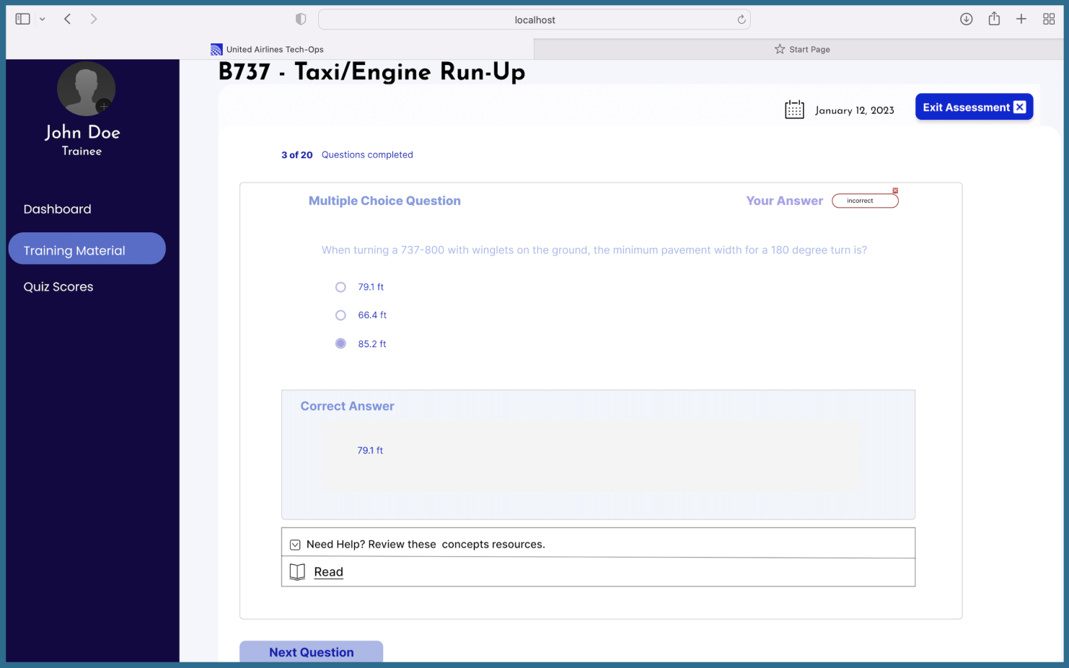

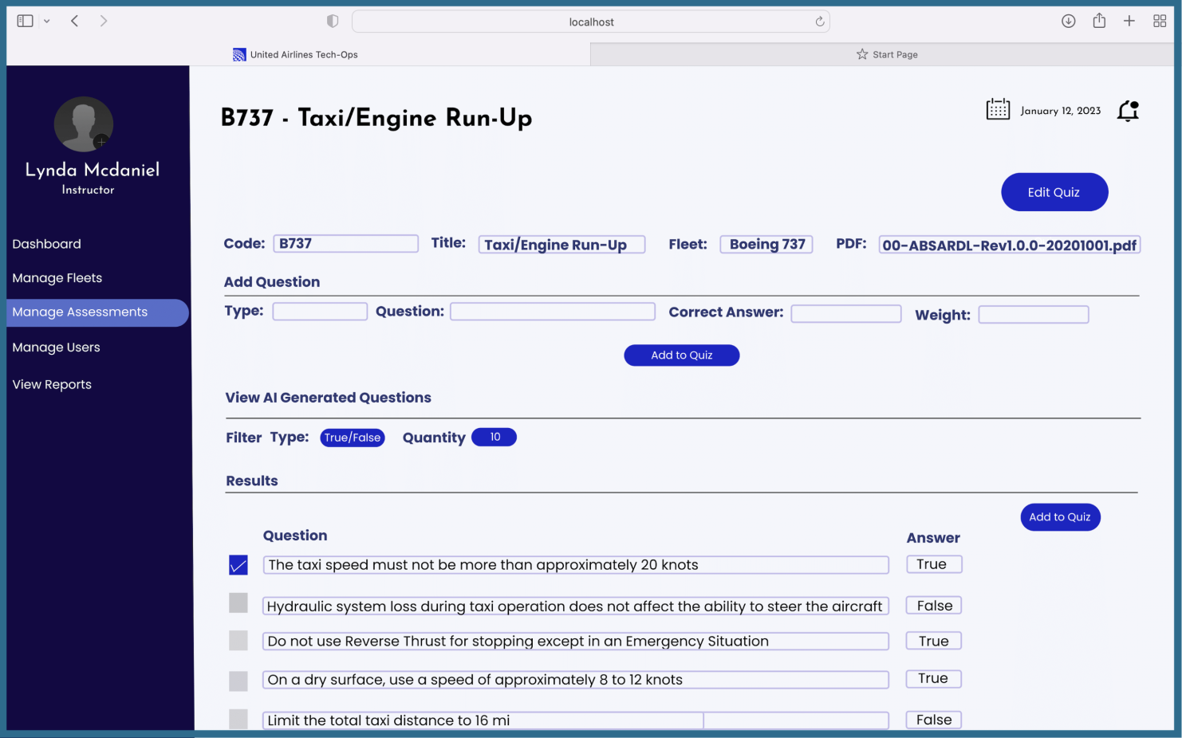

PAGE N + 27



United Airlines Training

Project Sponsors

Rick Brown

Chicago, Illinois

Mike Keating

Chicago, Illinois

Lynda McDaniel

Houston, Texas

Tom Wilson

Chicago, Illinois

Michigan State University

Team Members (left to right)

Akhil Tatineni

Troy, Michigan

Thad Greiner

Plymouth, Michigan

Aref Zeitoun

Bloomfield Hills, Michigan

Lama Alqrni

Jeddah, Saudi Arabia

Eric Raines

Clarkston, Michigan

Eshan Dixit

Novi, Michigan

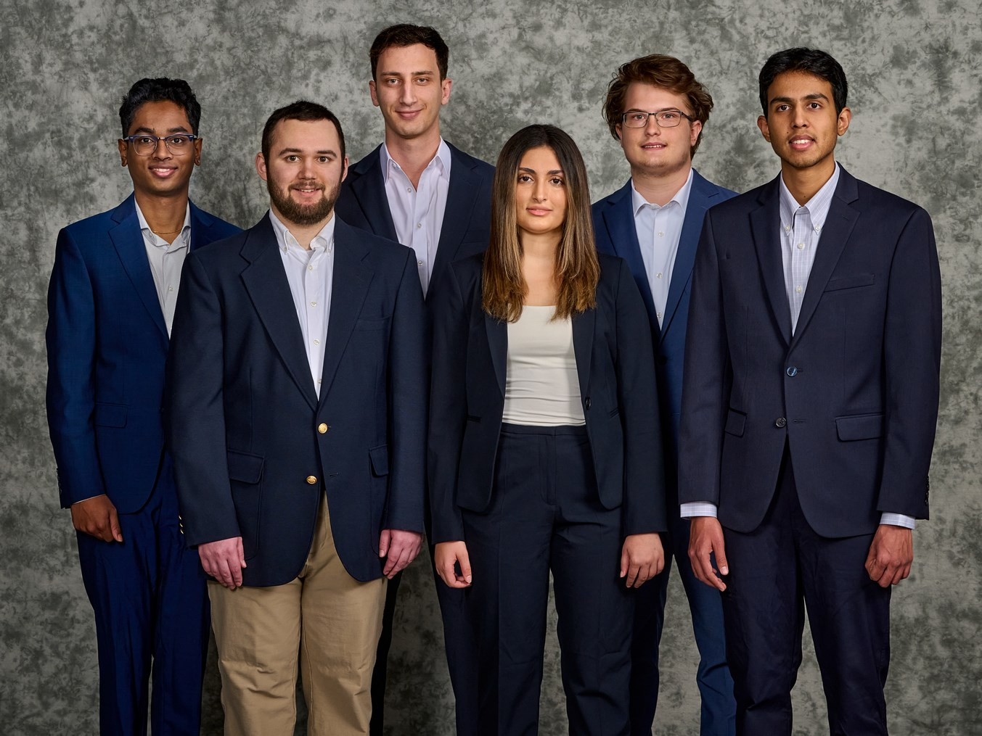

Based out of the Willis Tower in Chicago, Illinois, United Airlines is one of the world's largest airlines with a current fleet size of over 875 aircrafts with plans to acquire 500 more. They currently operate over 4,000 flights per day spanning five continents, 74 different countries and more than 300 airports across the globe.

Maintaining a high level of safety and reliability is critical to United Airlines, and their maintenance staff undergo a series of rigorous training courses taught by United Airlines. However, manually generating assessments is a time-consuming and challenging task for instructors. To ensure that their technicians receive the best training possible, United Airlines places a strong emphasis on providing the right training platform.

Our Adaptive Assessment Generator for Tech Ops Training offers a highly interactive and collaborative platform for delivering and teaching a wide range of training topics. Designed to cater to both students and instructors, the system offers two perspectives that provide a comprehensive learning experience.

Students can browse through corresponding course materials, gaining a comprehensive understanding of various maintenance topics. Once they feel confident in their knowledge, trainees take quizzes to test their comprehension.

Alternatively, instructors can generate questions using our machine learning model which creates questions that test students' understanding of the course materials. Instructors have full control over the training process, with the ability to manage students, material, and assessments through our web application. Instructors can also track individual student progress, as well as the overall milestones of the group.

Our application utilizes ReactJS for the front end, Python and Django for the back end, and Firebase for storage. The machine learning model is built using Python.

Computer Science and Engineering CSE 498

United Airlines

Adaptive Assessment Generator for Tech Ops Training