Design Day Booklet Team Page

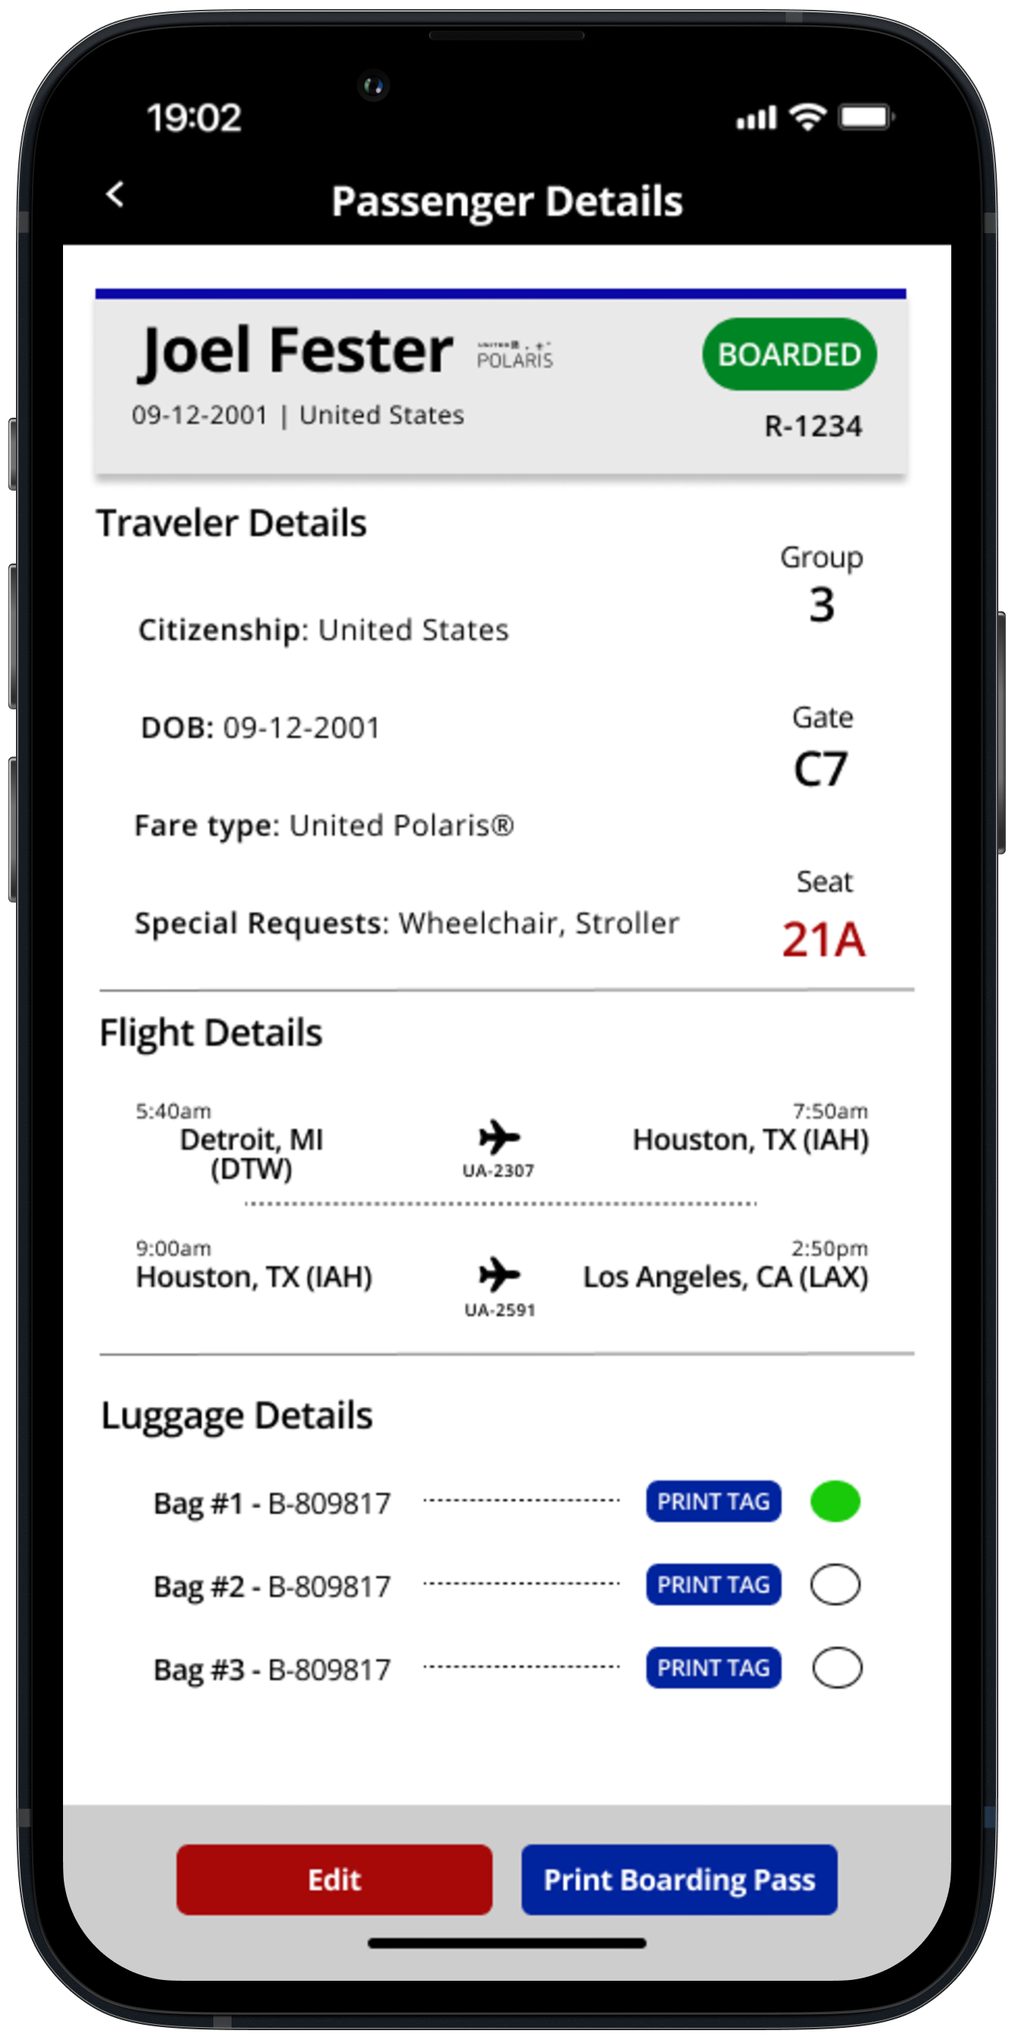

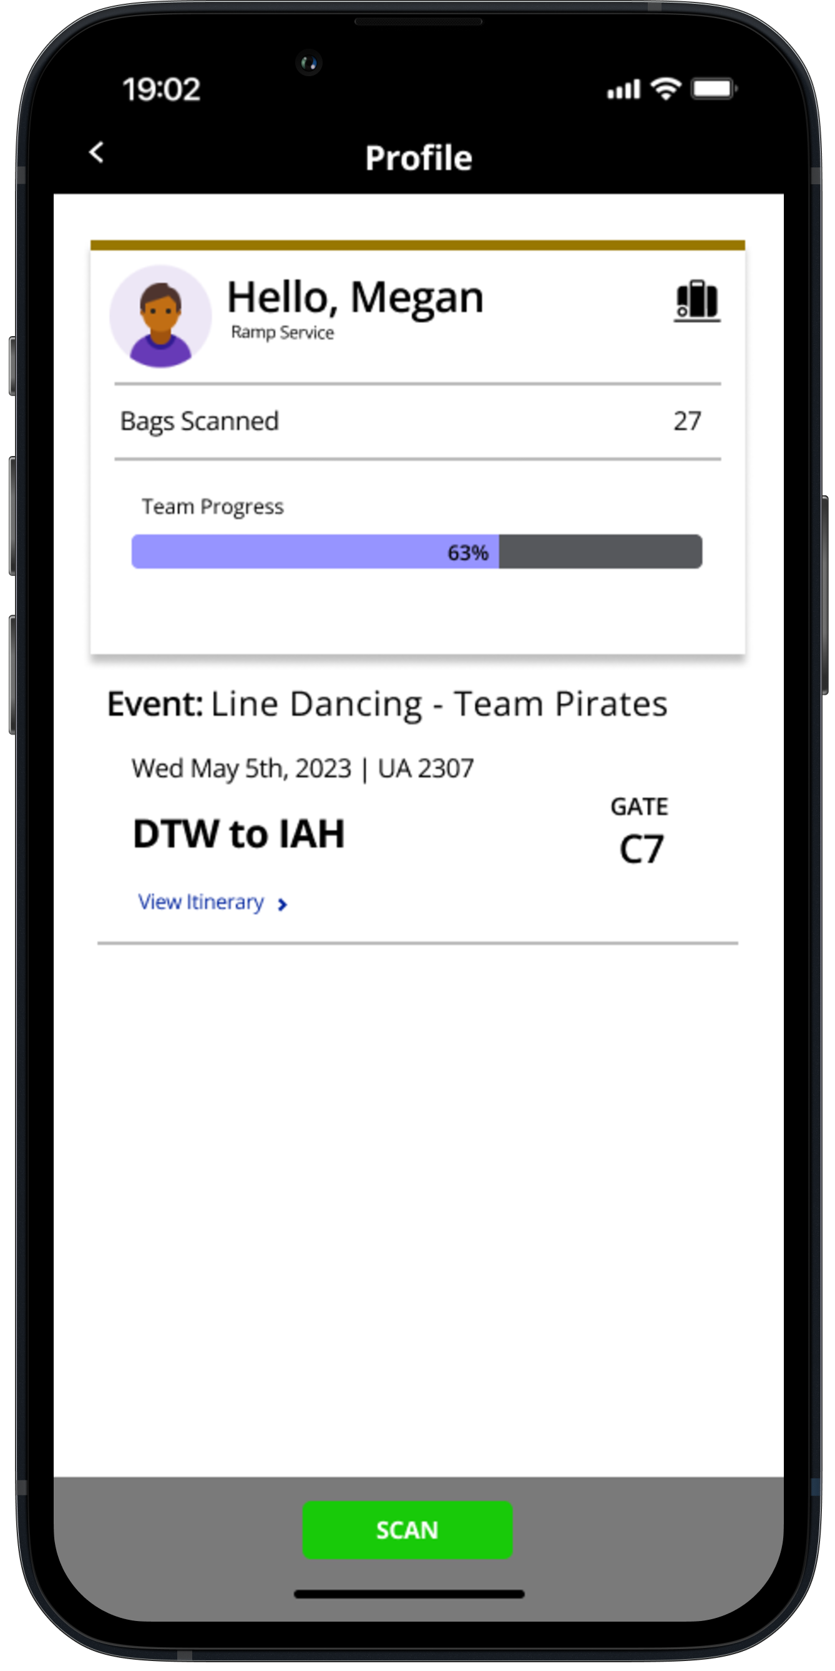

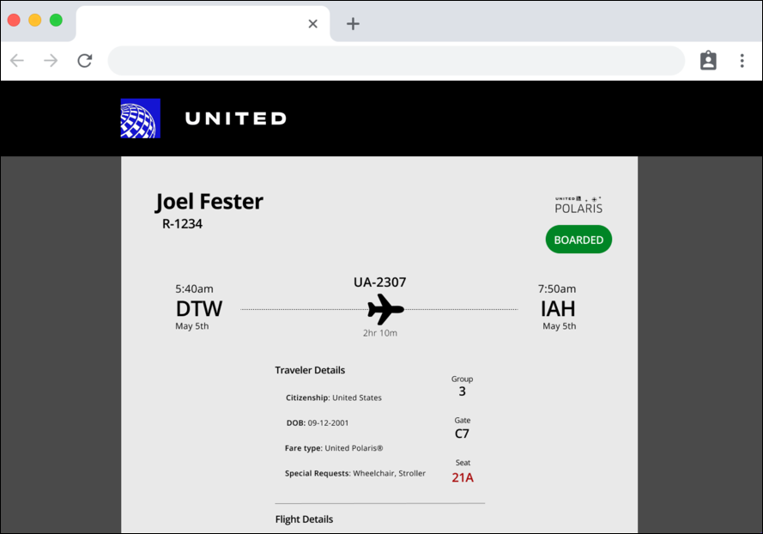

PAGE N + 25



United Airlines Airport Operations

Project Sponsors

John Kleberg

Chicago, Illinois

Juan Munoz

Chicago, Illinois

Sanjay Sabherwal

Chicago, Illinois

Moin Siddiqui

Chicago, Illinois

Michigan State University

Team Members (left to right)

Satvik Ravipati

Okemos, Michigan

Yi Wu

China, Shanghai, Shanghai

Austin Leblanc

Clinton Township, Michigan

Ethan Malzone

Howell, Michigan

John Rumler

Mason, Michigan

Stanley Duru

Detroit, Michigan



United Airlines is the third largest airline in the world, flying to and from over 340 destinations worldwide with a fleet of over 900 aircraft. They employ over 80,000 people, with well over 28,000 personnel working in passenger service. Due to this, nothing is more important to United Airlines than safety.

United Airlines holds Safety Rodeo events to train their staff in safety, efficiency, and accuracy in a friendly and realistic training environment. These rodeos require dozens of fake passengers and a significant amount of effort to accurately simulate standard airport operations, making it difficult for United Airlines employees to hold these vital rodeos.

Our Airline Passenger and Baggage Application tackles these issues by simulating the tools that are currently used by Customer Service Representatives and Ramp Service Employees within intuitive web and phone applications.

Our Airline Passenger and Baggage Application enables the creation of randomized passengers and bags to aid Customer Service Representatives and Ramp Service Employees in their training.

Our system employs support for phone camera and physical scanner readings of embedded QR codes on baggage tags and boarding passes to connect with our database of passengers and associated bags. Ramp and Customer Service employees have the option of checking in the associated passenger or bag. Realistic passenger and bag data errors are integrated seamlessly into the data to test the employee’s attention to detail.

The front end of our application was created with the Flutter framework and Dart language to facilitate ease of cross platform development. The back end of our application works with an Amazon Web Services Elastic Cloud Computing instance hosting our MongoDB database and our API endpoints.

Computer Science and Engineering CSE 498

United Airlines

Airline Passenger and Baggage Application