Design Day Booklet Team Page
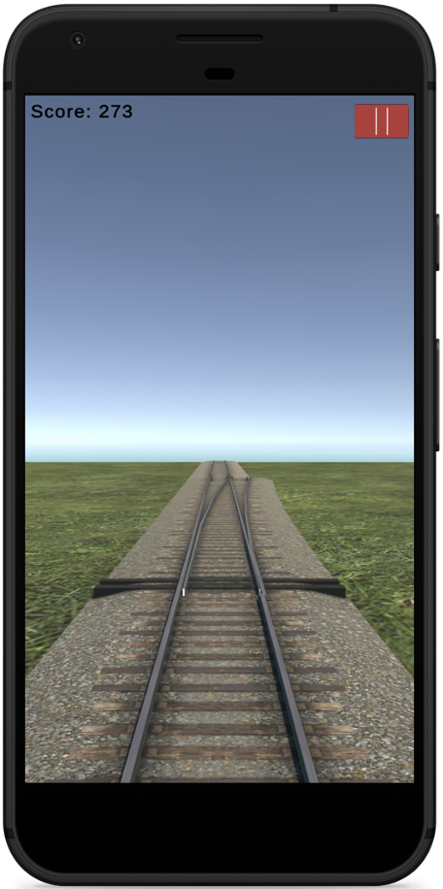
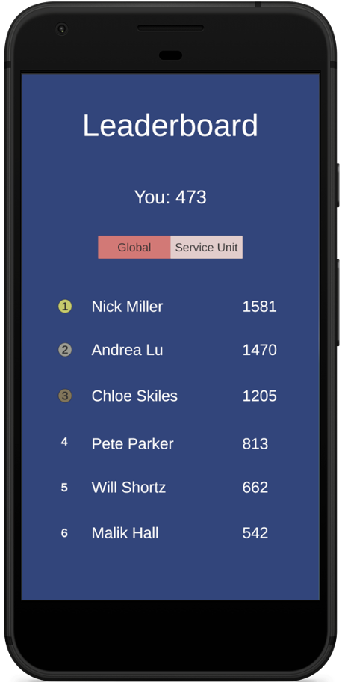
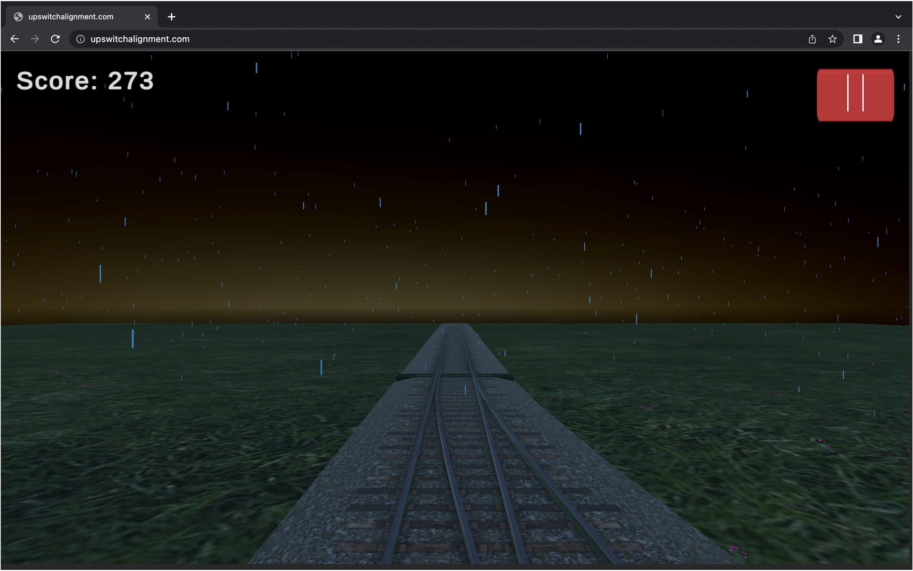
PAGE N + 24
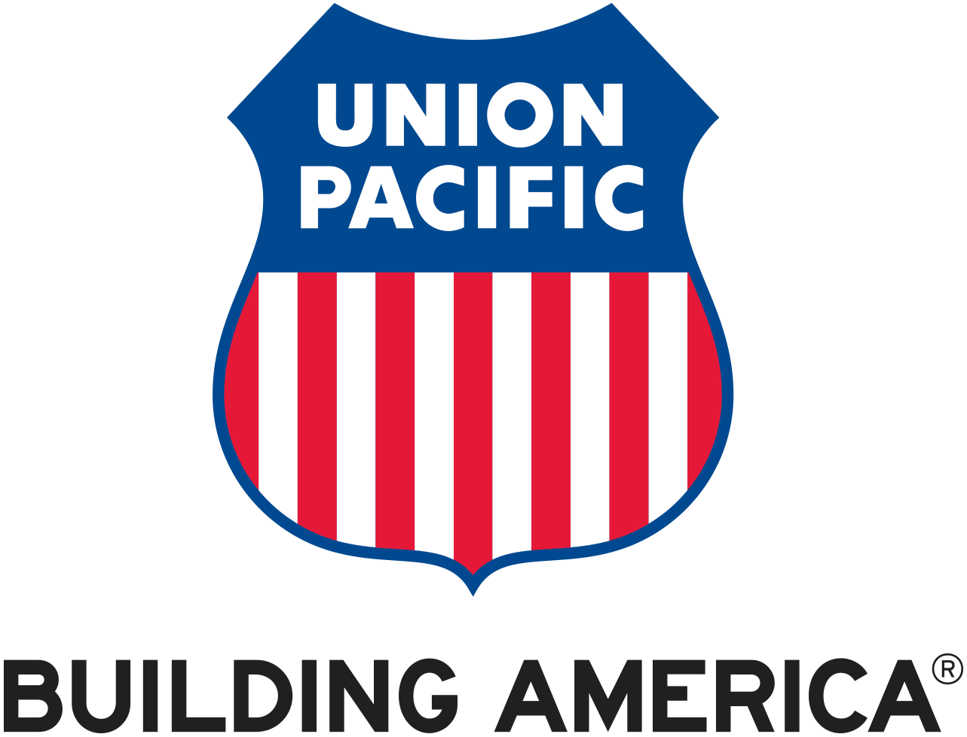
Union Pacific
Project Sponsors
Seenu Chundru
Louisville, Colorado
Ira Cooper
Okemos, Michigan
Jeff Girbach
Milford, Michigan
Laura Greet
Omaha, Nebraska
Adam Halley
Omaha, Nebraska
Jason Taullie
Omaha, Nebraska
Michigan State University
Team Members (left to right)
Kyle Martin
Alpena, Michigan
Mike Walton
Shrewsbury, Massachusetts
Jiayue Chai
Shenyang, Liaoning, China
Zack Joyce
Ridgefield, Connecticut
Alexa Kelley
Novi, Michigan
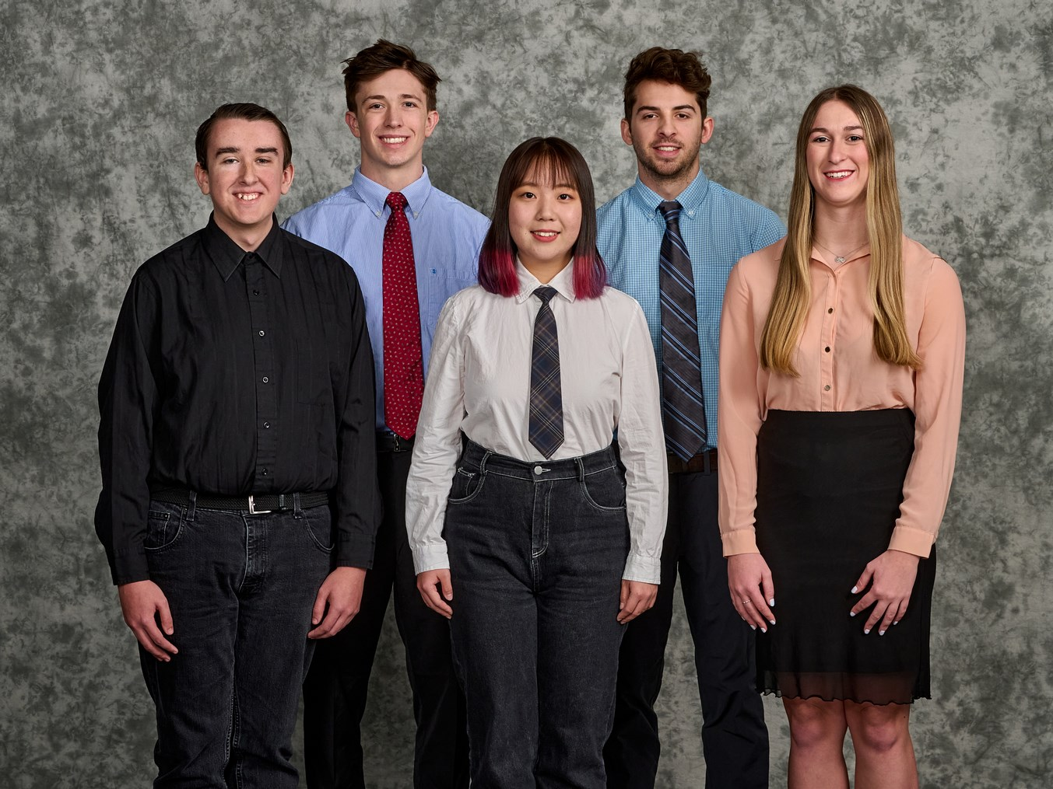
Union Pacific is one of the largest railroad companies in the United States, which has over 32,000 miles of track in 23 states in the west. The company primarily transports agricultural, industrial and customer products.
Misaligned switches can cause problems, such as damage to equipment, delays in train schedules and derailments. With the goal of being the safest, most reliable and most efficient railroad in North America, it is important to train newly hired field employees in a safe space with sufficient practice.
Our Switch Alignment Mobile Game teaches players to learn to identify differently aligned switches from the first-person view of a train on the railroad. The game is an infinite-runner game, with dynamically changing time and random weather conditions, such as sun, rain, and snow.
To access the gameplay, tutorial, leaderboard, and settings, the players must use their Union Pacific employee IDs. During gameplay, a train runs on an infinite random path populated by railroad tracks, and the player must identify switches correctly. Switches may be left-aligned, right-aligned, or misaligned. As gameplay progresses, new challenges are introduced, such as changing time of day and weather conditions reducing visibility.
The tutorial shows the rules of the game, as well as the leaderboard, which shows the rankings of the player’s scores based on their performance. Additionally, the players can adjust the volume and other preferences in the settings menu.
Our software offers a realistic simulation for players to learn and practice switch alignment. With our software, Union Pacific can train new employees safely and practically.
Our software is developed with Unity3D and scripted with C#. The back end for the software is Oracle database, which is connected to front end through REST API.
The Capstone Experience
Union Pacific
Switch Alignment Mobile Game

