Design Day Booklet Team Page

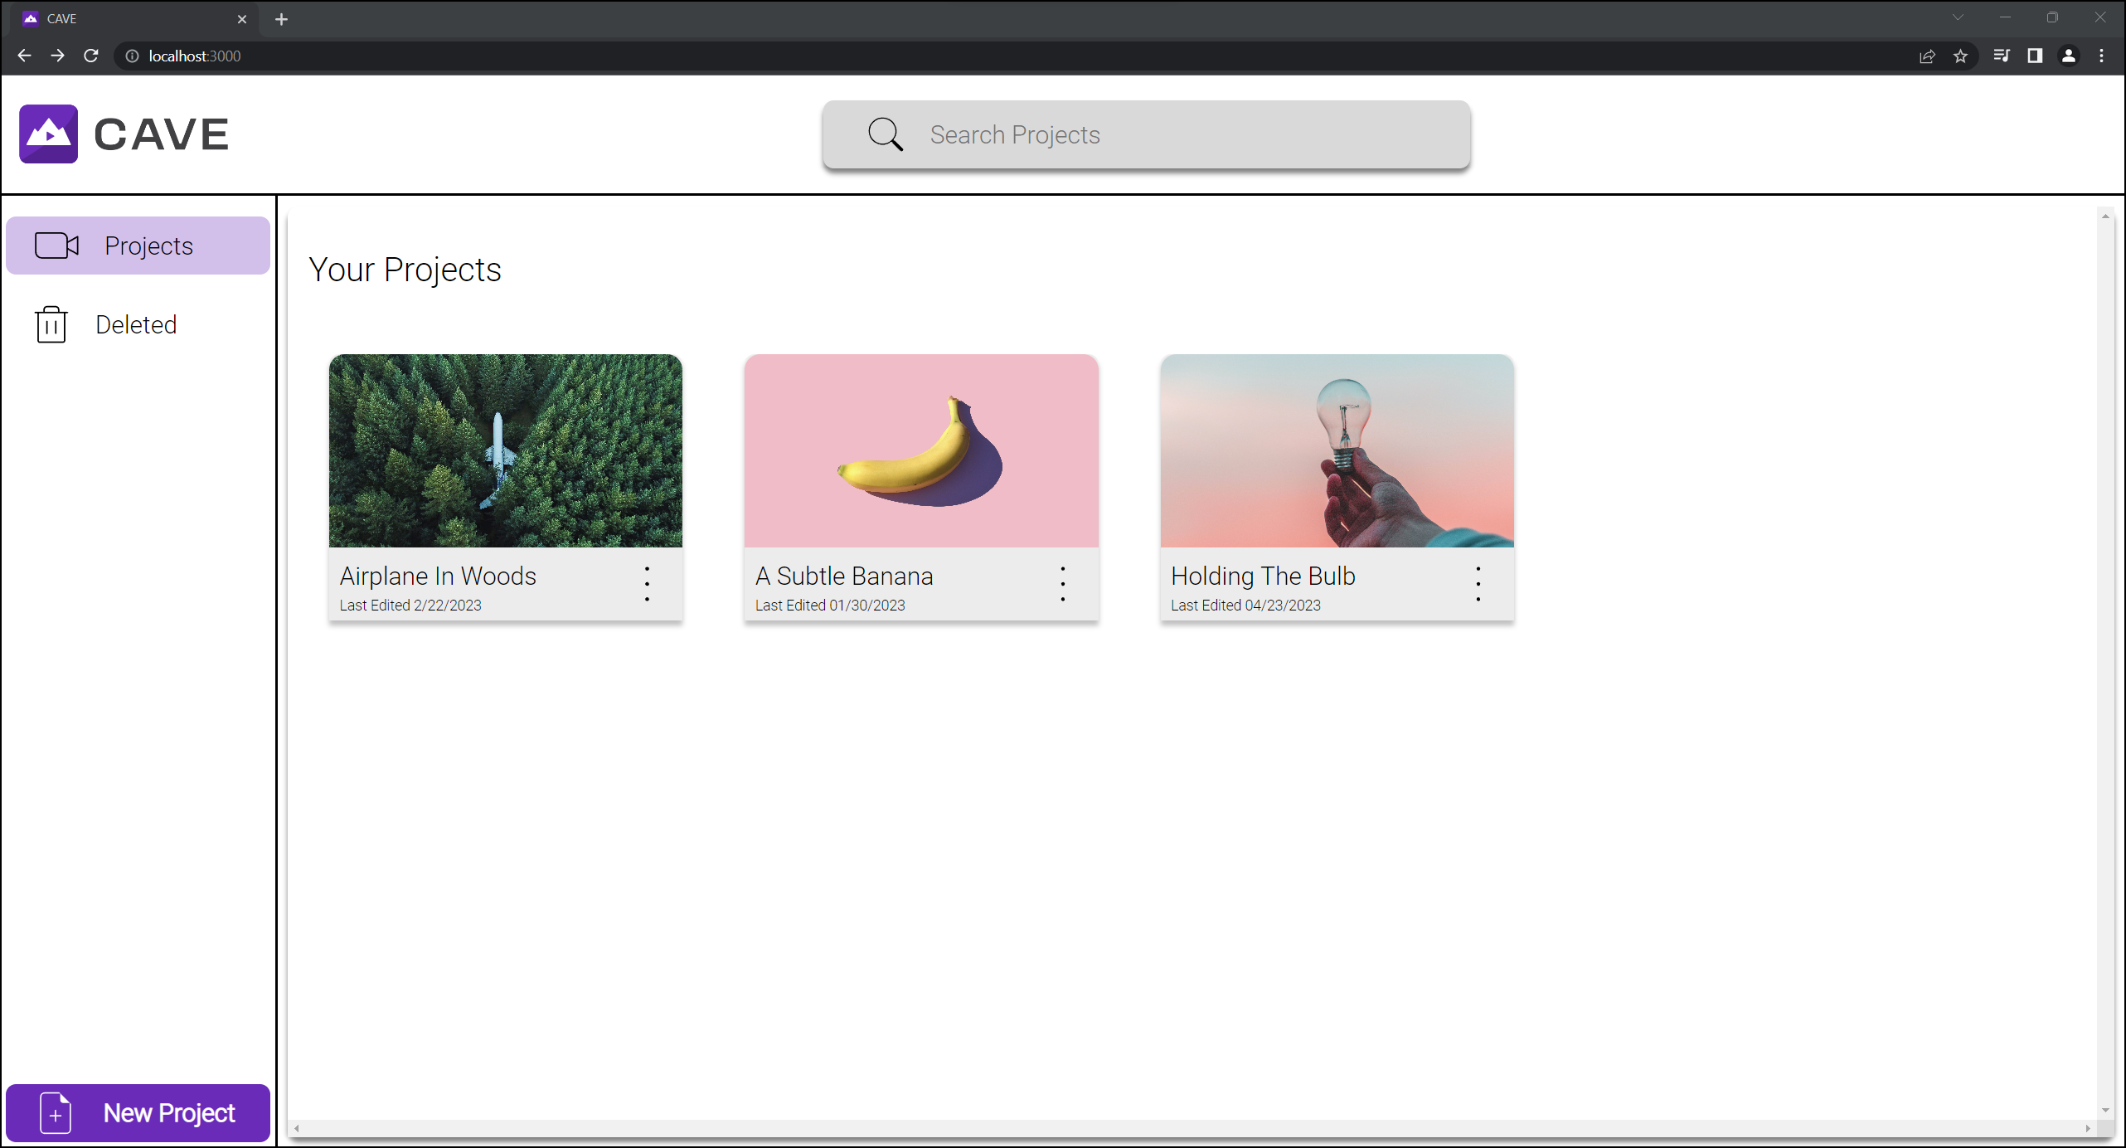

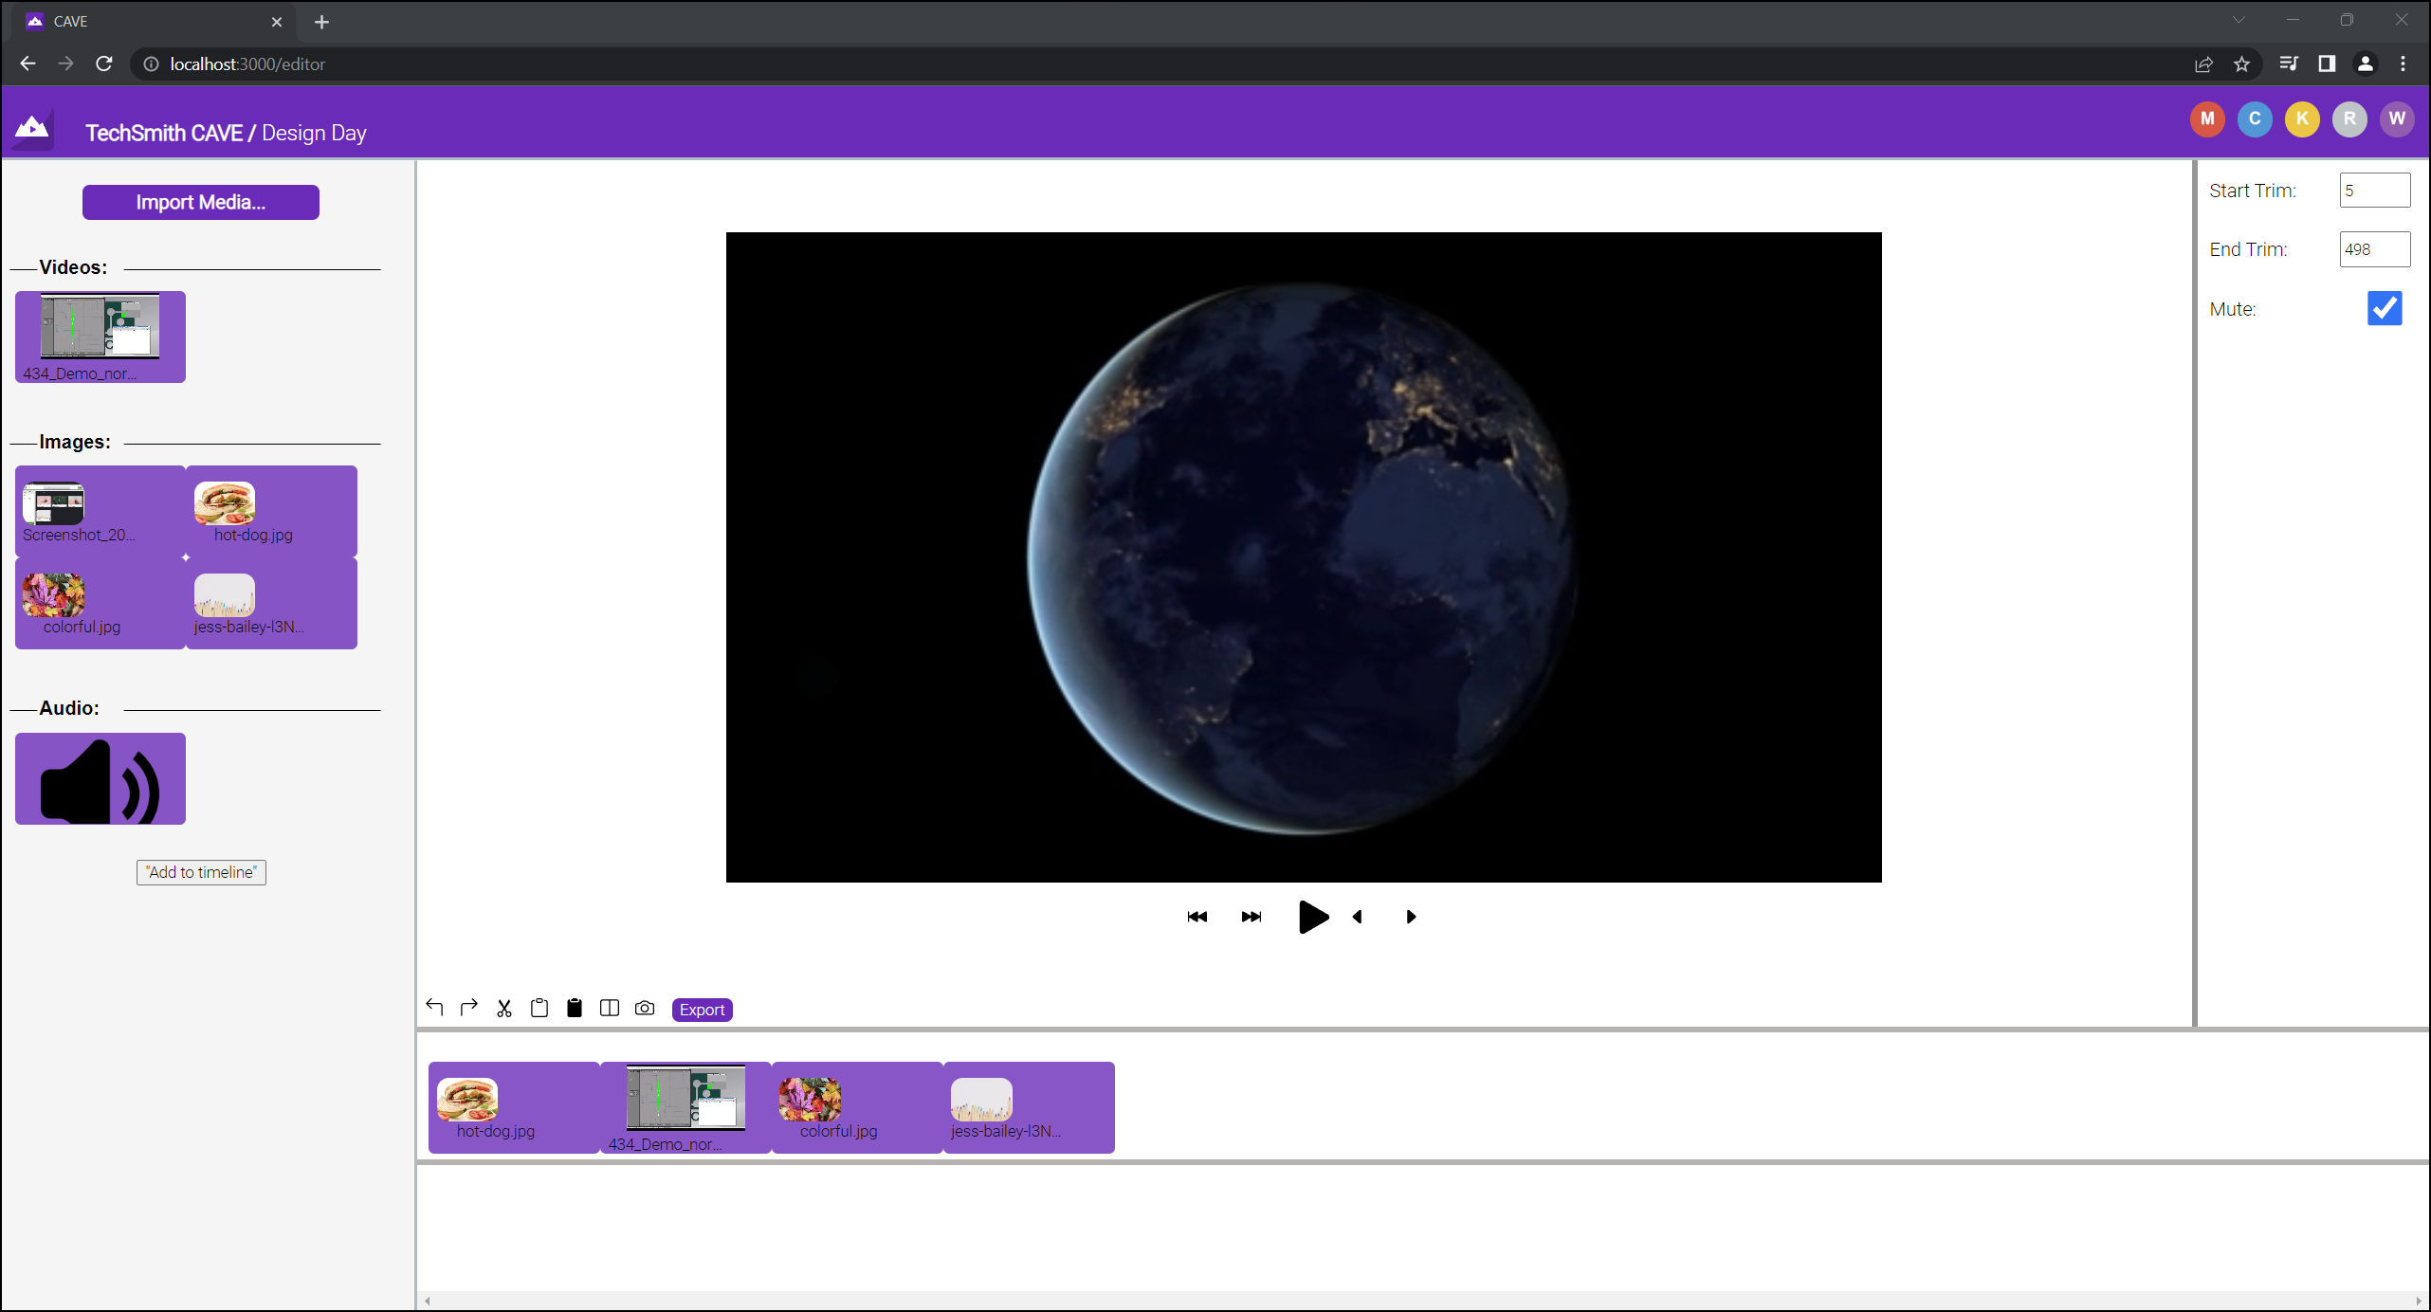

PAGE N + 23



TechSmith

Project Sponsors

Dorie Blaisdell

East Lansing, Michigan

Tony Cooke

East Lansing, Michigan

Wendy Hamilton

East Lansing, Michigan

Jake Hood

East Lansing, Michigan

Rory Hool

East Lansing, Michigan

Tony Lambert

East Lansing, Michigan

Michael Malinak

East Lansing, Michigan

Scott Schmerer

East Lansing, Michigan

Michigan State University

Team Members (left to right)

Craig Smith

Zeeland, Michigan

Faran Meshinchi

Ann Arbor, Michigan

Kyle Wagner

Saline, Michigan

Rachel Townson

White Lake, Michigan

Wenrui Li

Guangdong, Taishan, China

Marco Suriano

Tipton, Michigan

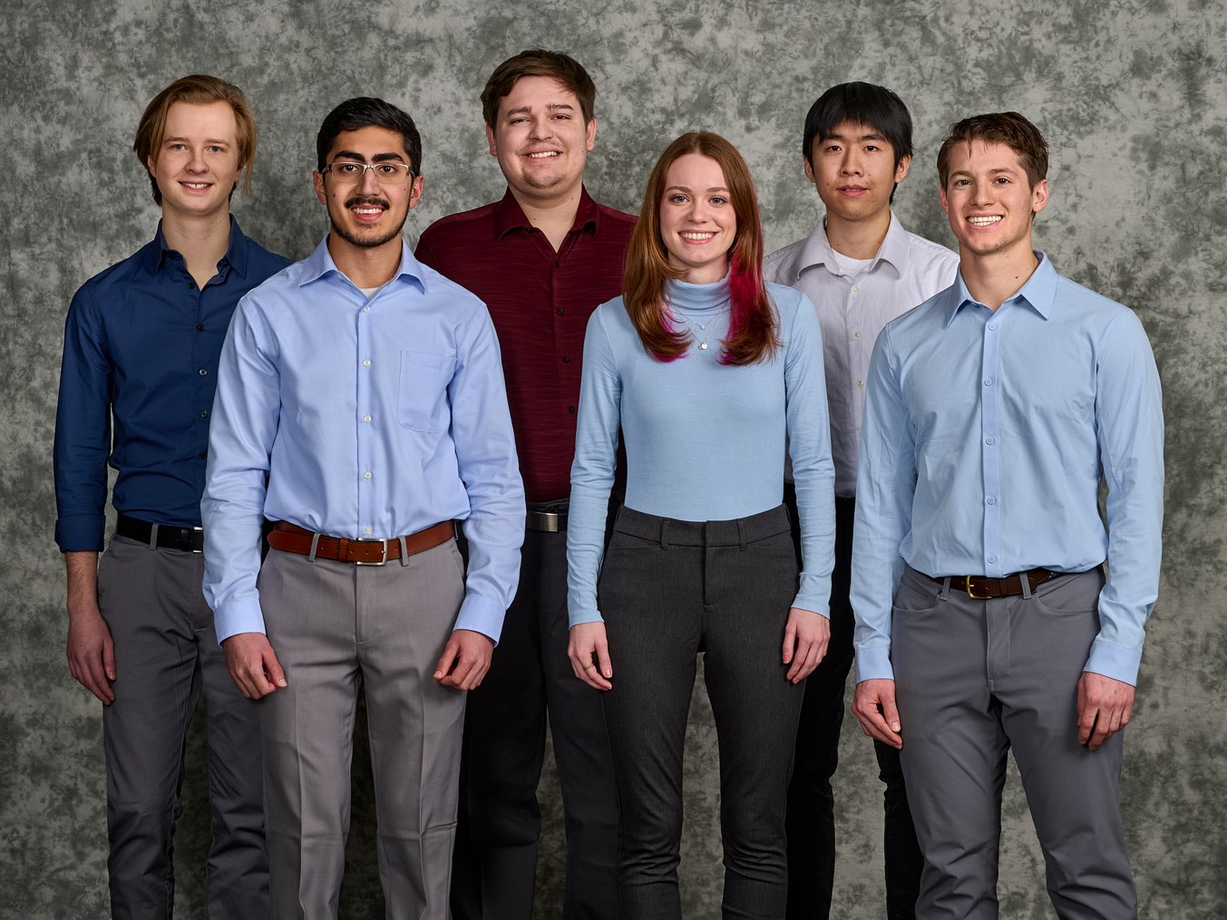

TechSmith’s mission is to empower people to communicate and share knowledge using media capture and editing software. Based in East Lansing, Michigan, TechSmith’s products are used by 73 million users worldwide and by every Fortune 500 company.

Collaborating with a team to create content can be challenging. Doing so often results in an individual coordinating the efforts of multiple team members or organizations, restricting the creative workflow that is essential to digital media creation. This disjointed process of indirect collaboration limits users to working sequentially and prevents all voices from being included.

Our CAVE: Collaborative Audio/Video Editor web application streamlines collaboration on media projects by enabling users to edit synchronously.

Users upload video, image, and audio files and arrange them with an intuitive timeline UI. Editors then preview the edited video at any time, and when completed, the final video can be downloaded for distribution across various platforms.

All media projects and their associated media are stored securely in the cloud where users can invite others to collaborate. Collaborators log in securely and can begin working on their project independently or together in real time.

Users need not worry about others overwriting their changes as the application ensures synchronization of contributions. By enabling team members to collaborate seamlessly, the final product better highlights the contributions of individuals and reflects a shared voice.

Our web application is built on JavaScript and ReactJS. FFmpeg runs on the client side to process media previews and the final exported project. Edits from simultaneous users are kept in sync with WebSockets. The back end is built using Node.js and is hosted on Microsoft Azure.

Computer Science and Engineering CSE 498

TechSmith

CAVE: Collaborative Audio/Video Editor