Design Day Booklet Team Page

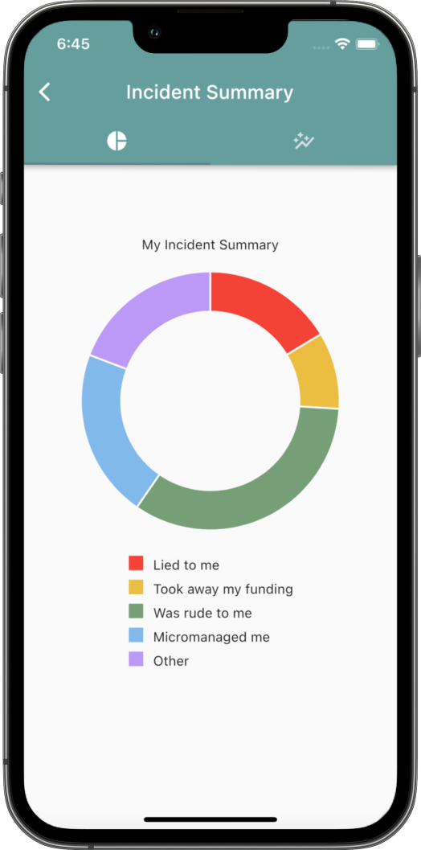

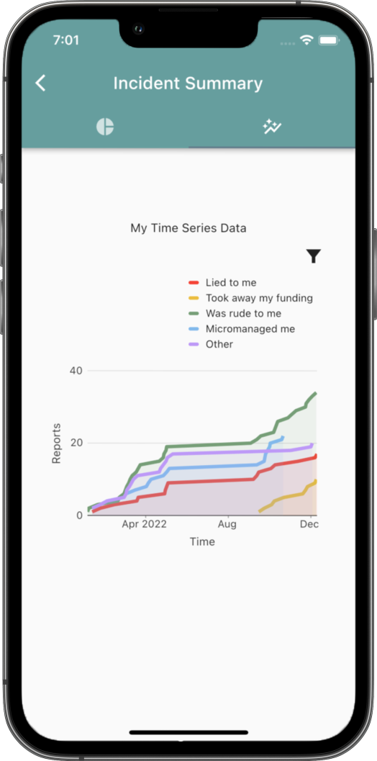

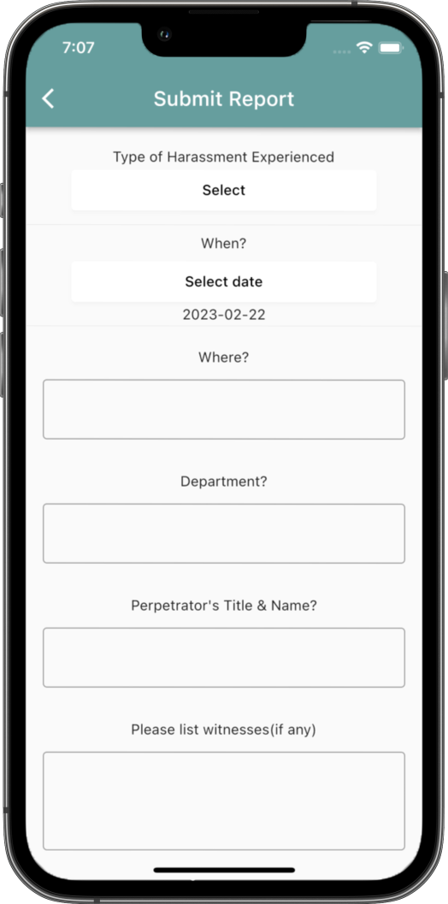

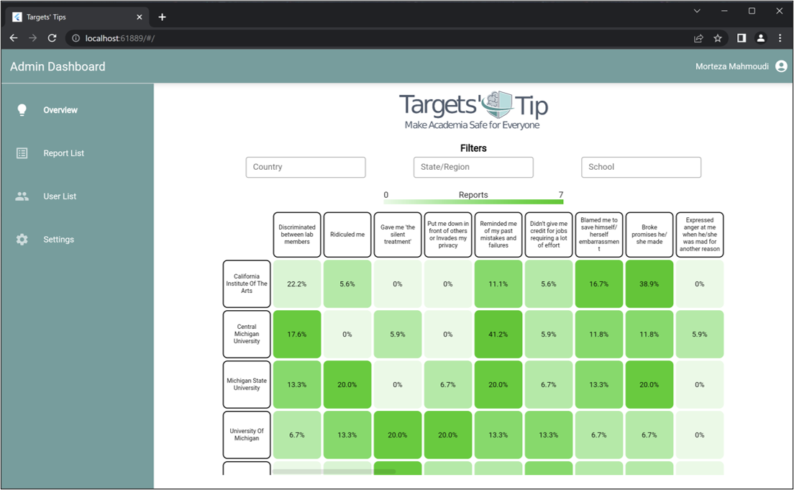

PAGE N + 22



Targets’ Tip

Project Sponsor

Morteza Mahmoudi

Okemos, Michigan

Michigan State University

Team Members (left to right)

Yanping Lyu

Beijing, Beijing, China

Michael Monticciolo

New York, New York

Lydia Wibbelman

Huntington Woods, Michigan

Treasure Ogundiran

Ibadan, Oyo, Nigeria

Brandon Lam

Lansing, Michigan



Targets’ Tip is a startup based in Okemos, Michigan, founded by an assistant professor at Michigan State University, Dr. Morteza Mahmoudi. The company’s primary objective is to foster a safe academic environment for targets experiencing academic harassment. Targets’ Tip offers support for targets of academic harassment by providing resources for them to report incidents and receive the help they need.

The fight against academic harassment has two major challenges: the absence of proper documentation surrounding incidents, and a tendency for cases to be forgotten or dismissed.

Our application, Documenting Academic Harassment, provides a user-friendly platform for secure documentation of academic harassment incidents to make sure that no case goes unnoticed.

Users of this application have a place to store their experiences and evidence where they do not go unrecorded and undocumented. Users can specify the date, location, and category of specific harassment incidents. The application generates a personal portfolio where the user can review and edit their reports. Both time series and pictorial visualizations of their history automatically update for the user to view a cohesive summary of their experiences.

Data collected from this application from its users is utilized to create an overview of cases from every university in the world. Incident occurrences are displayed in a heatmap visualization that filters by country, state, region, type of harassment, and department. Administrators can analyze and export the data in the heatmap to identify problems within institutions globally.

Through our application, users can have the peace of mind that their experiences are well documented and safe.

The front end of our Targets’ Tip application is built using Dart and Flutter, while the data, storage and authentication is handled with Firebase.

The Capstone Experience

Targets’ Tip

Documenting Academic Harassment