Design Day Booklet Team Page

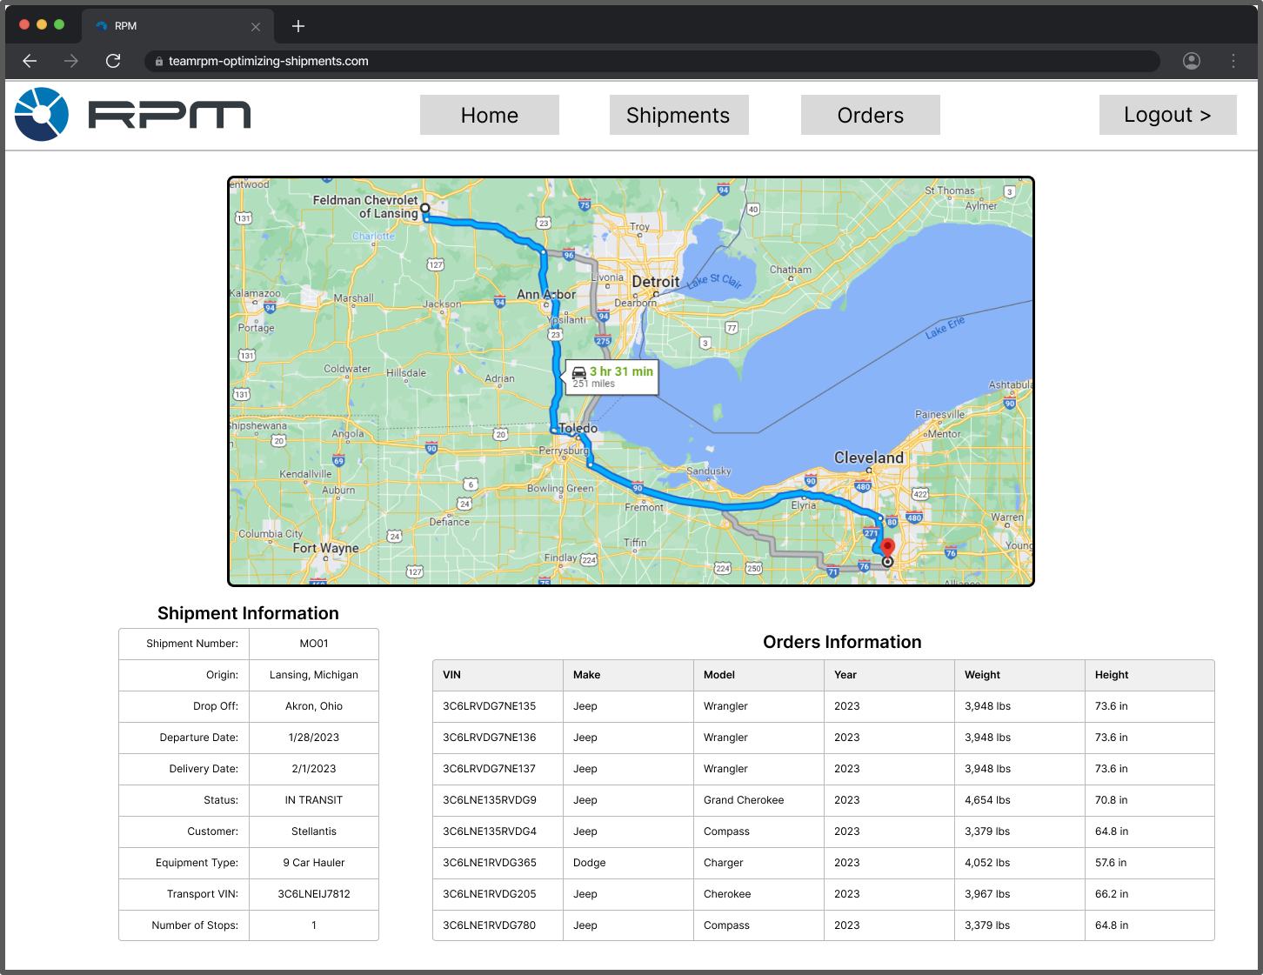

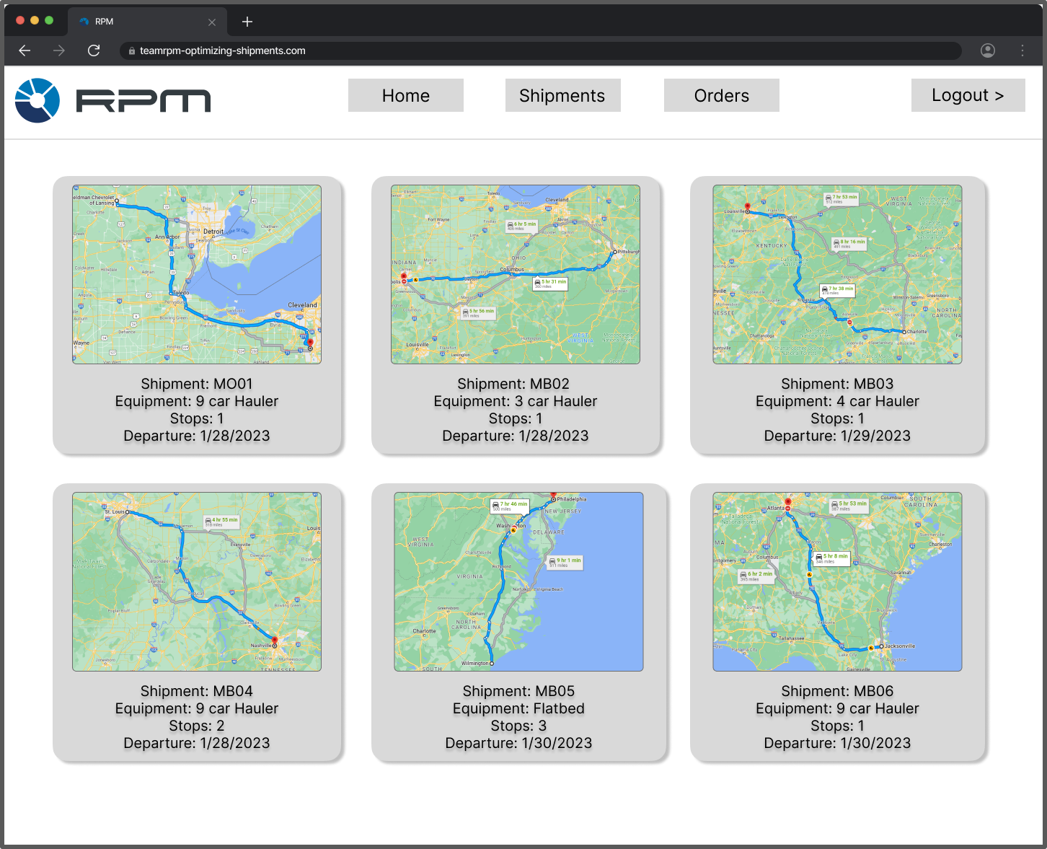

PAGE N + 21

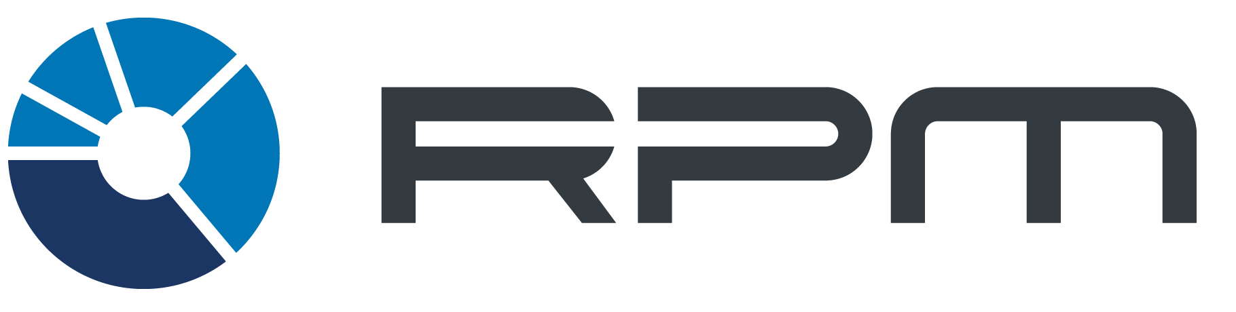

RPM

Project Sponsors

Rick Grubb

Royal Oak, Michigan

Synica Melton

Royal Oak, Michigan

John Perkovich

Royal Oak, Michigan

Navnik Shivadas

Royal Oak, Michigan

Frank Soehnge

Royal Oak, Michigan

Michigan State University

Team Members (left to right)

Yanjia Zhu

Nanchang, Jiangxi, China

Ian Berriel

Lake Orion, Michigan

Nicholas Klein

Lakewood Ranch, Florida

Shoimya Chowdhury

Chittagong, Chittagong, Bangladesh

Drew Markel

Cass City, Michigan

Jonathan Ayoub

Sterling Heights, Michigan

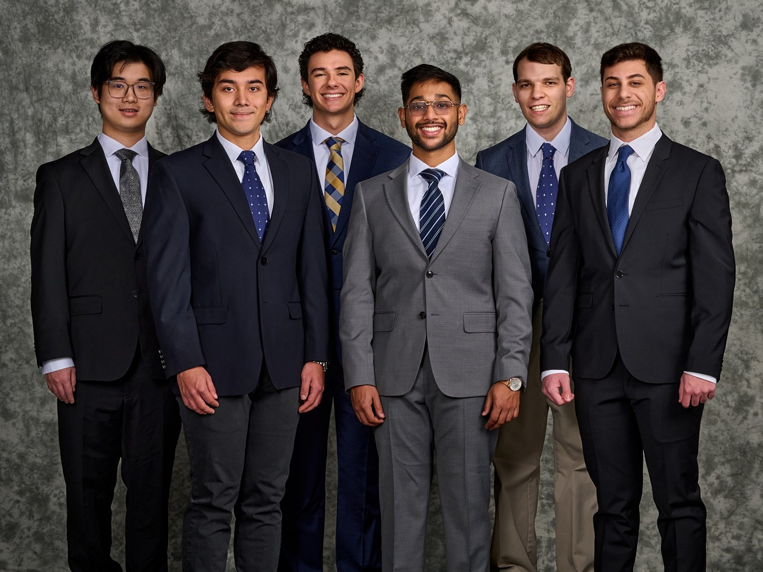

RPM is an international logistics corporation which specializes in end-to-end transportation of freight and automobiles. On a monthly basis, RPM’s carriers deliver 50,000 automobiles and 15,000 freight shipments. The company's headquarters are in Royal Oak, Michigan, and Amsterdam, Netherlands.

The logistics involved in the automotive industry are complex and shipments need to fit to customer specifications while adhering to carrier restrictions. Curating shipments using machine learning takes every specification into consideration.

Our Building Shipments using Machine Learning web application organizes shipping orders based on features and pick-up/drop-off locations to create shipment schedules with the fewest possible stops. It also suggests the best carrier for such shipments to optimize the shipping process.

New orders are input by RPM through CSV or manual data entry, finally being verified by the user to ensure the shipping information is correct.

The process considers the VIN for each individual vehicle, make, model, and all the different vehicle specifications to organize orders and create optimized shipments. An optimized shipment has the least amount of stops and shortest route while also keeping trucks full. This improves the utilization of shipments and improves delivery time.

Our software uses various methods for creating shipments and suggesting carrier vehicle types that users can compare to select what fits their needs the best. We also provide tools for users to analyze and make necessary changes to their shipments.

Our system is built on .NET for front end development and Microsoft Azure for back-end tools and databases. Python’s scikit-learn library is used to develop machine learning models to optimize shipments through clustering.

Computer Science and Engineering CSE 498

RPM

Building Shipments using Machine Learning