Design Day Booklet Team Page

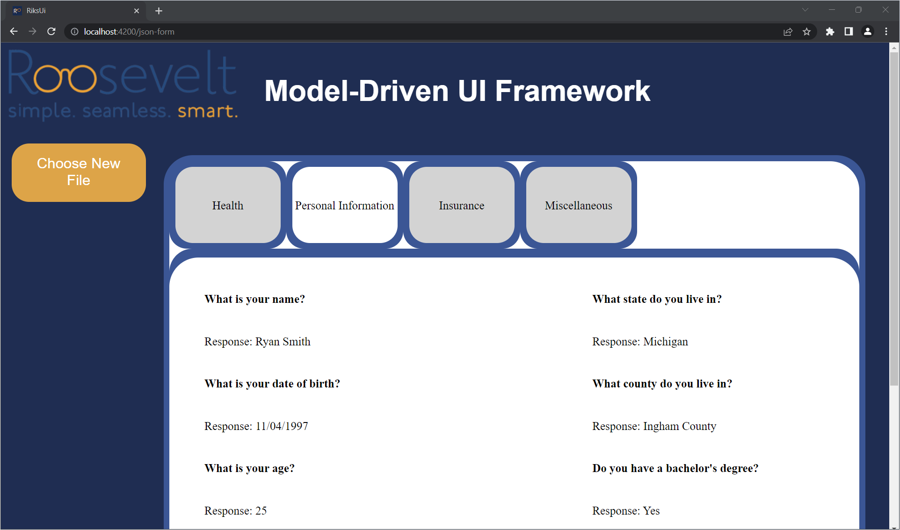

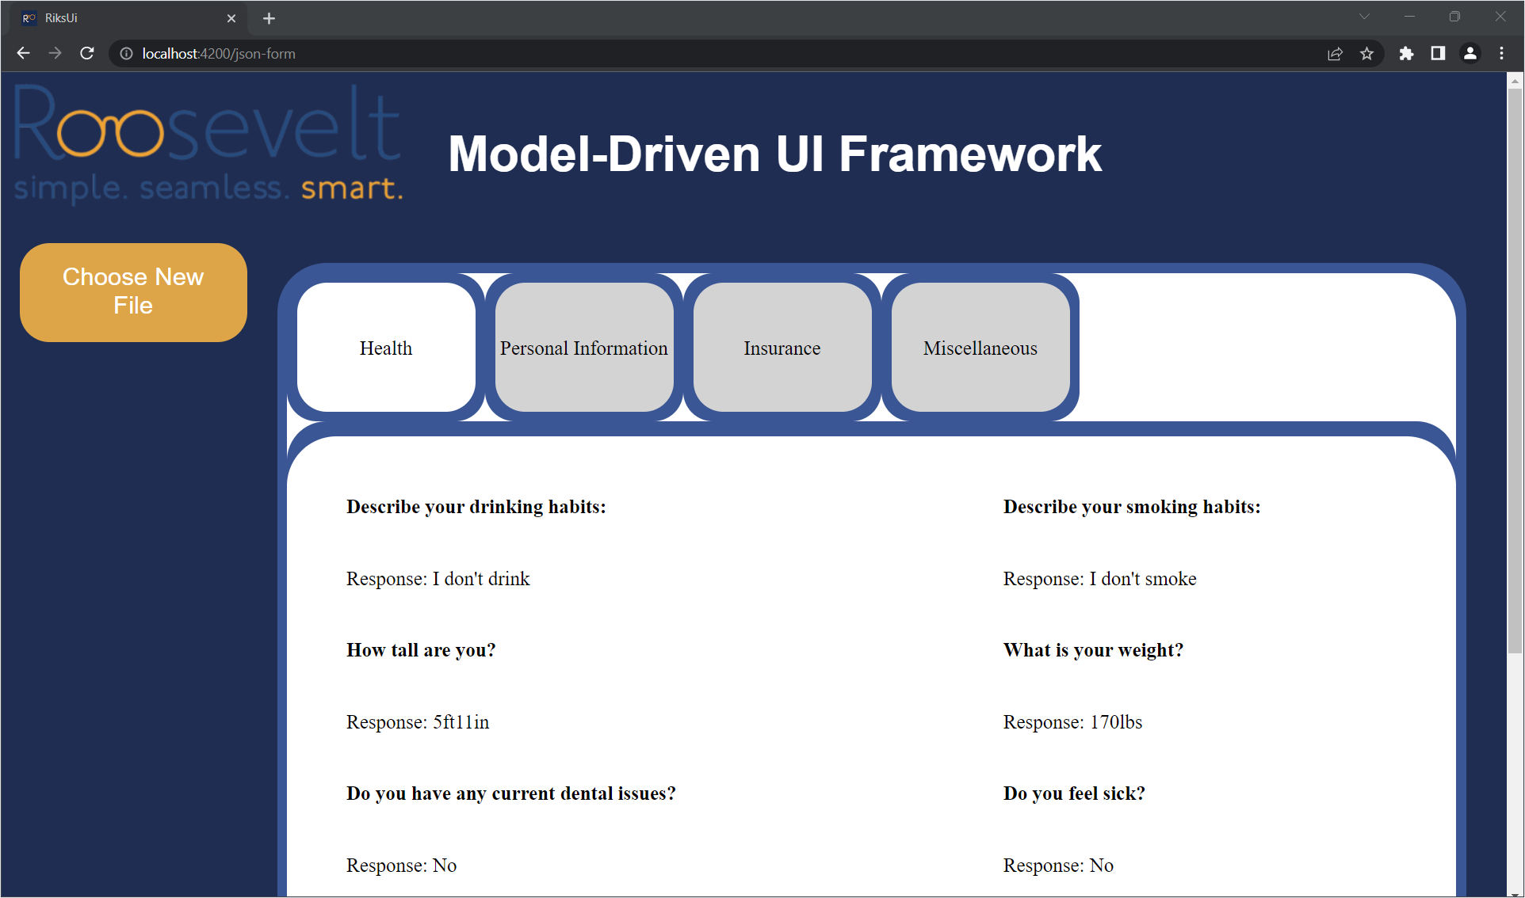

PAGE N + 20

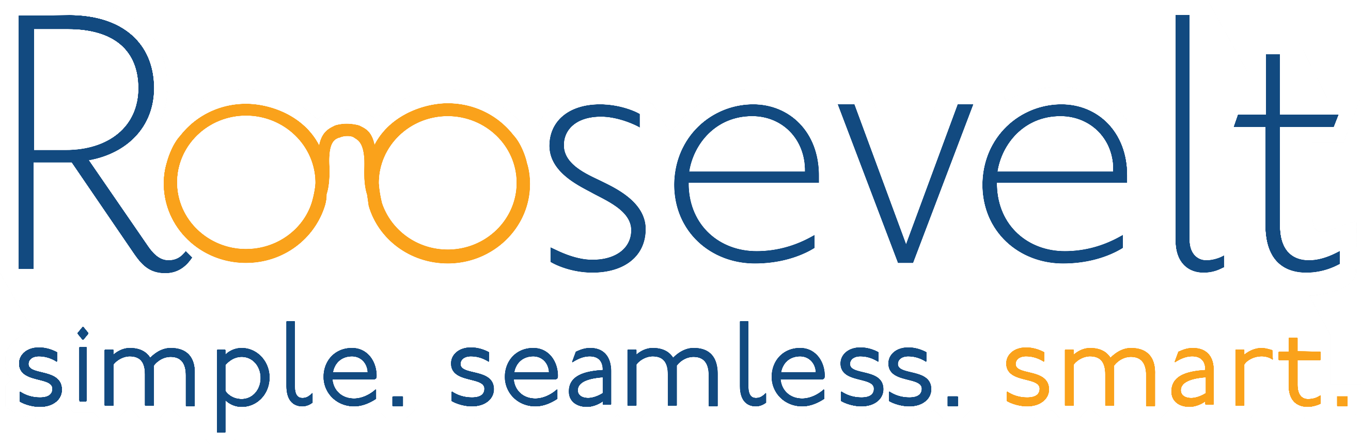

Roosevelt Innovations Knowledge Science

Project Sponsors

Mukundan Agaram

Okemos, Michigan

Will Cicola

Okemos, Michigan

Jacob Ernst

Okemos, Michigan

Chang Liu

Okemos, Michigan

Michigan State University

Team Members (left to right)

Ben Lynch

La Grange, Illinois

Naffy Nihal

Roseville, Michigan

Cole Coughlin

Grand Rapids, Michigan

Yuqi Pan

Harbin, Heilongjiang Province, China

Drew Hubble

Okemos, Michigan

Alex Hettle

Rochester, Michigan

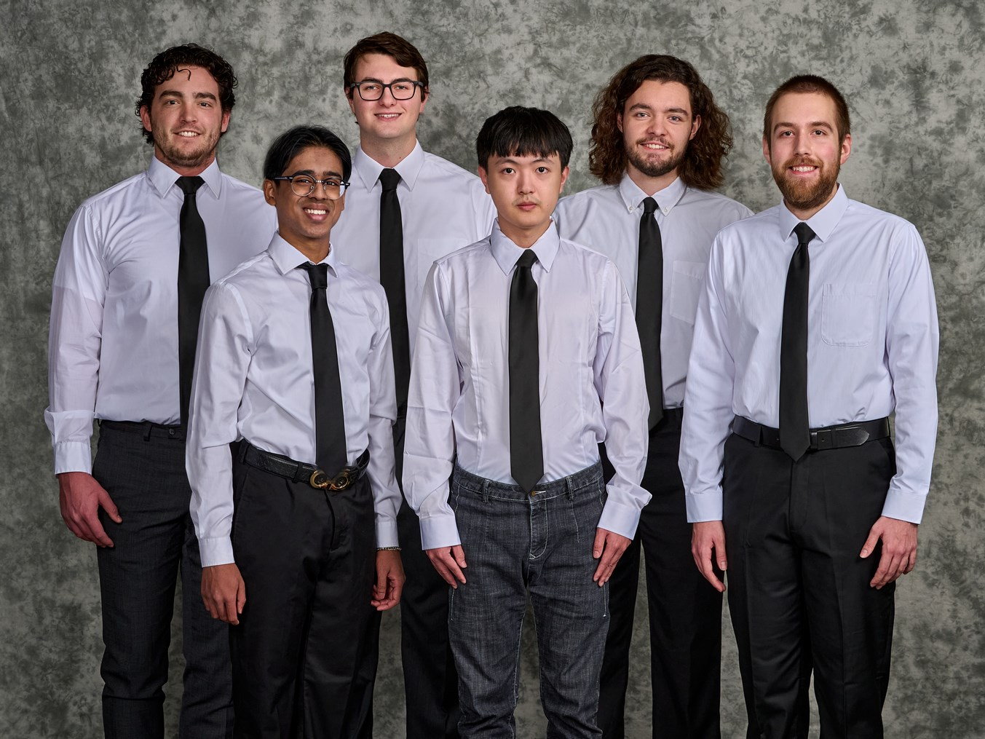

Roosevelt Innovations, headquartered in Okemos, Michigan, is a software solutions company owned by Delta Dental of Michigan. Its software solutions include customizable data services, customer portals, billing services, and industry-leading claims auto-adjudication. Roosevelt Innovations extends its services to several insurance companies across the country. Altogether, Roosevelt Innovations has over 22 million users on its platforms.

At Roosevelt Innovations, many different user interfaces are developed for insurance companies and their customers. Each new user interface is developed from scratch. This process can be very time-consuming, often requiring hours of effort from developers.

Our Model-Driven UI Framework streamlines the process of designing and building a website, creating dynamic and complex user interfaces with ease.

Our framework documents strategies and formats for creating the skeleton of a form. Once that skeleton is created, it is read by the web application and the form is displayed on the screen. Users can interact with this form and populate the data fields. Upon completing the form, users click on the submit button, at which point the entered data is validated and saved.

In addition to quicker build times, the developers can use the framework to easily create complex forms. The framework contains guidelines for validating user-entered data as well as a structure for creating fields that appear conditionally, making it very versatile. The same system can be used to create many highly customized forms specific to each customer’s needs.

The framework expands upon JSON with custom keywords allowing for additional validation and manipulation of elements. The front end is built using Angular reactive forms to dynamically draw ionic form elements on the webpage. The back end uses Quarkus to process objects and requests from the front end.

The Capstone Experience

Roosevelt Innovations

Model-Driven UI Framework