Design Day Booklet Team Page

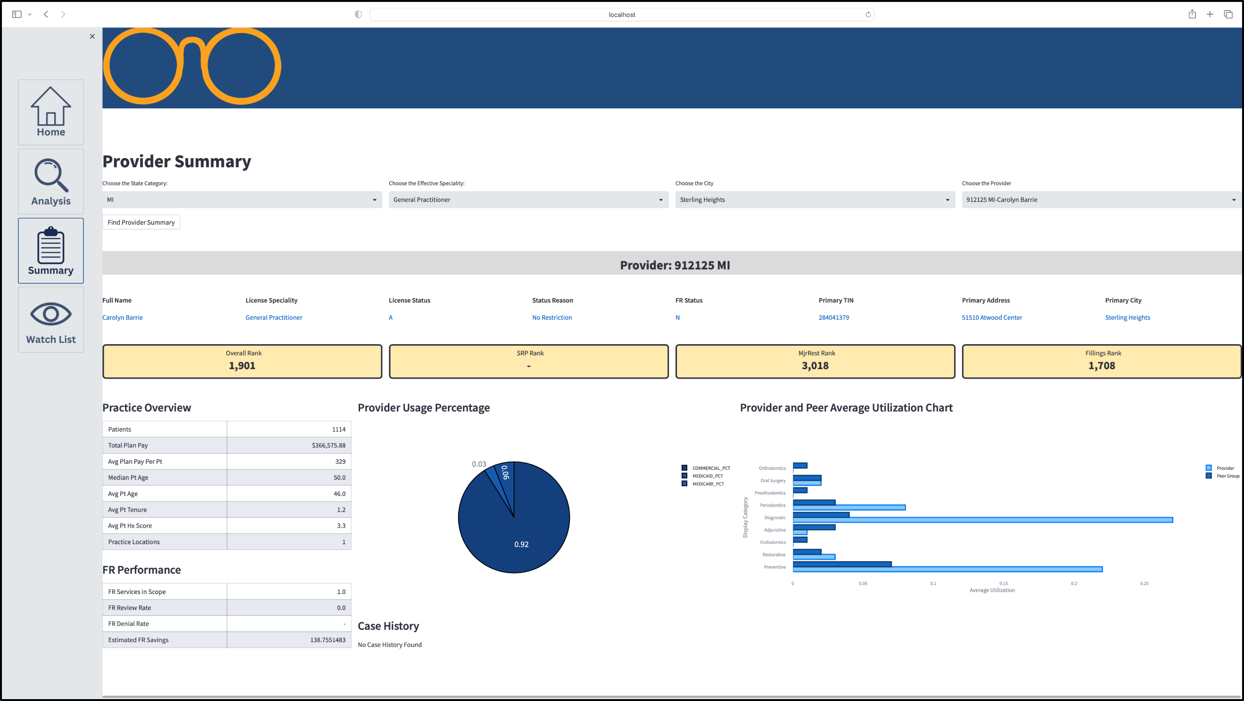

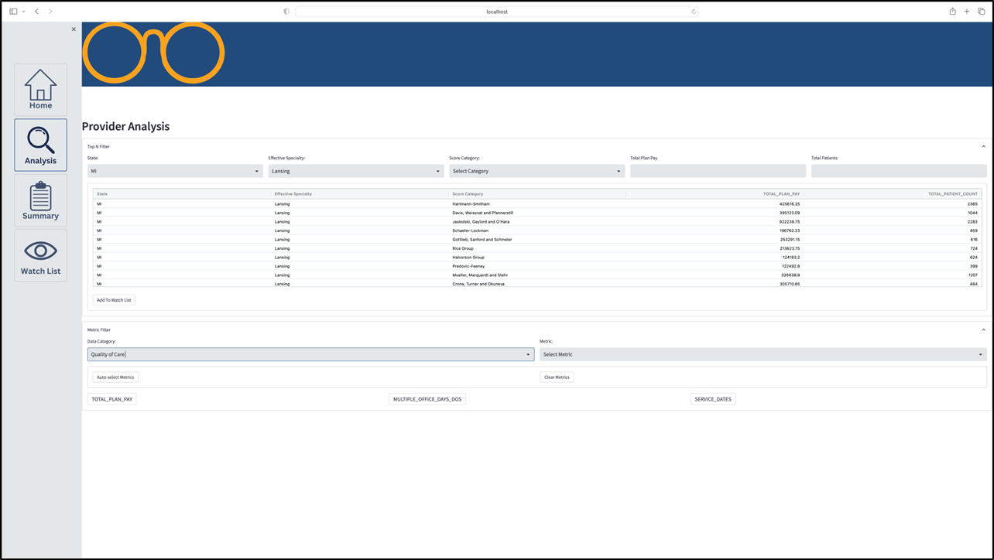

PAGE N + 19

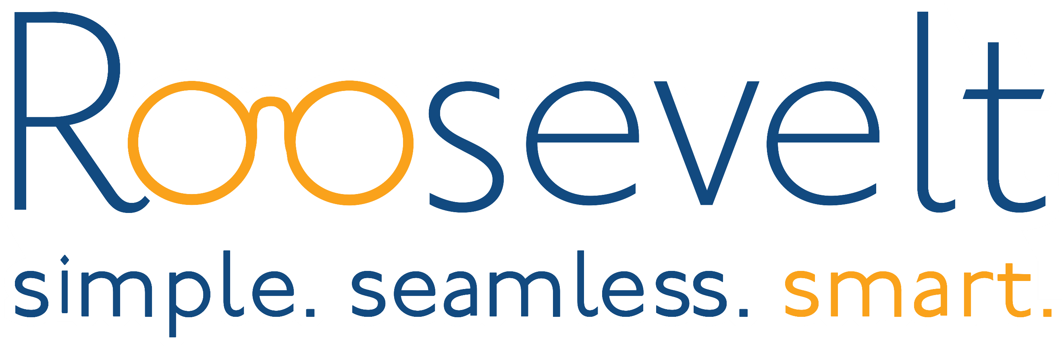

Roosevelt Innovations Data Science

Project Sponsors

Mukundan Agaram

Okemos, Michigan

Jessica Black

Okemos, Michigan

Jacob Ernst

Okemos, Michigan

Toby Hall

Okemos, Michigan

Shikha Mohindra

Okemos, Michigan

Ayush Singh

Okemos, Michigan

Abhinav Thirupathi

Okemos, Michigan

Michigan State University

Team Members (left to right)

Michael Stanley

Addison, Michigan

Kirsten Gross

Canton, Michigan

Marshall Kroske

Birmingham, Michigan

Rajaditya Bajaj

Yavatmal, Maharashtra, India

Zhenhao Zhao

Taixing, Jiangsu, China

Anna Parkinson

Clarklake, Michigan

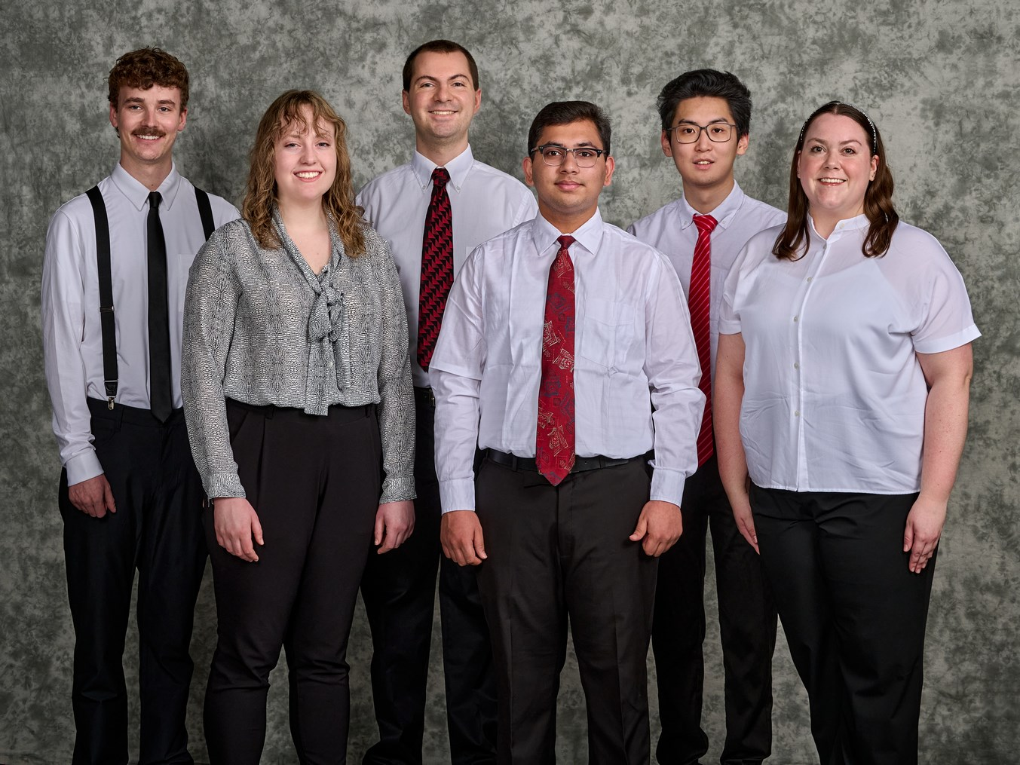

Roosevelt Innovations, LLC is the first technology solution to deliver a simple, seamless, and smart platform for health insurance companies. With industry-leading claims processing capabilities, Roosevelt has transformed operations, enabling a total treatment cost savings of $972 million. Additionally, Roosevelt has more than 22 million users on its platform and an industry-leading auto-adjudication rate of 95%.

When processing many insurance claims, there is a large amount of data generated. Data that is anomalous for any reason is cause for further investigation.

Our Provider Analysis Toolkit gives data analysts of Roosevelt Innovations a streamlined, efficient, and verbose view of the data that comes from processing claims. Users can view real-time data, exchange their thoughts with other analysts on specific data, and share reports with other analysts.

Our solution identifies statistical anomalies within the data that can help them further investigate the causes for these anomalies. Data is filtered for the analysts so that the most anomalous data is easily accessible to them in a simple, quick, and efficient manner, requiring no further mathematical calculations on the analysts’ end.

Data visualizations are also provided. Whether the data is represented in tables or charts, everything is laid out in a way that is streamlined and easily digestible.

Our solution automatically flags anomalous data and provides a suite of tools for further analysis, increasing productivity of analysts.

The web application is written in Python with utilization of the Streamlit library for the front-end framework, as well as FastAPI are used for construction of the web application’s APIs. The anomaly detection machine learning models were developed using the PyTorch framework and scikit-learn library, while the data is stored within a Snowflake database.

Computer Science and Engineering CSE 498

Roosevelt Innovations

Provider Analysis Toolkit