Design Day Booklet Team Page

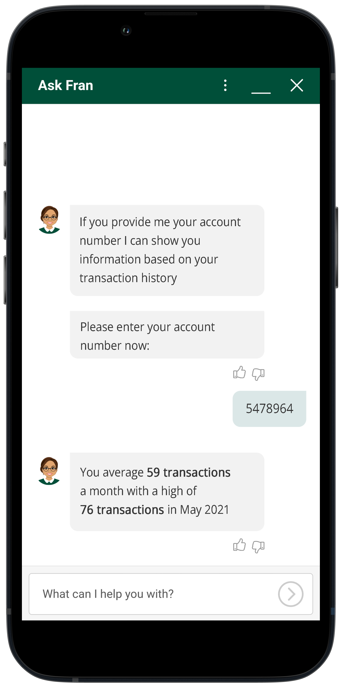

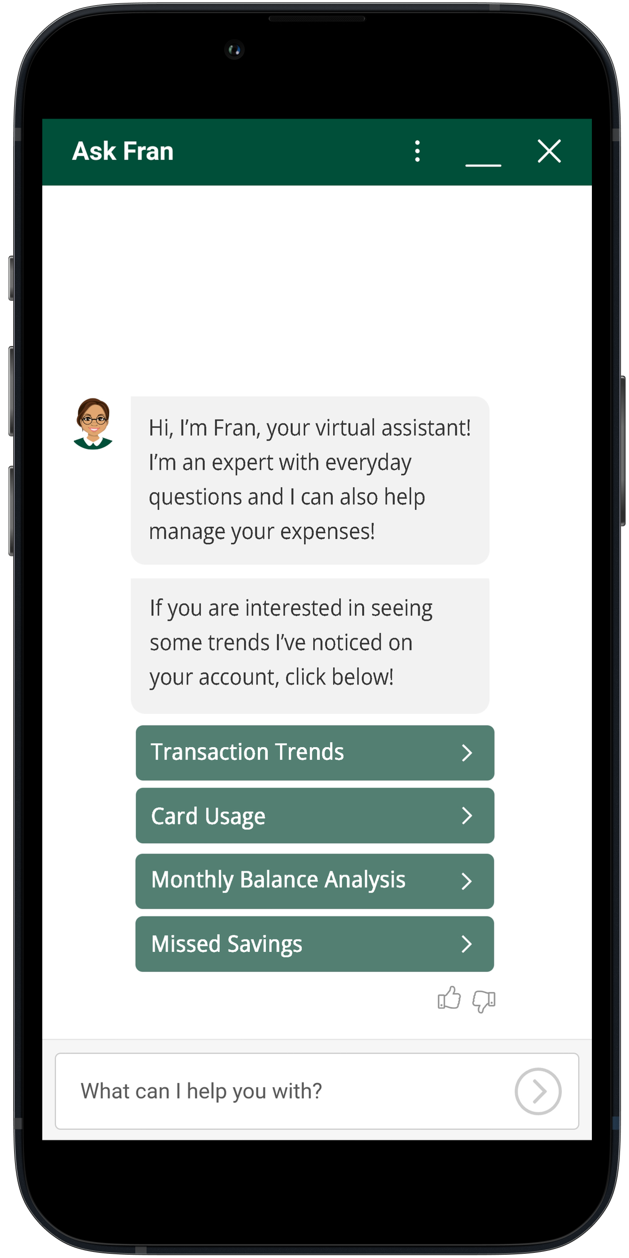

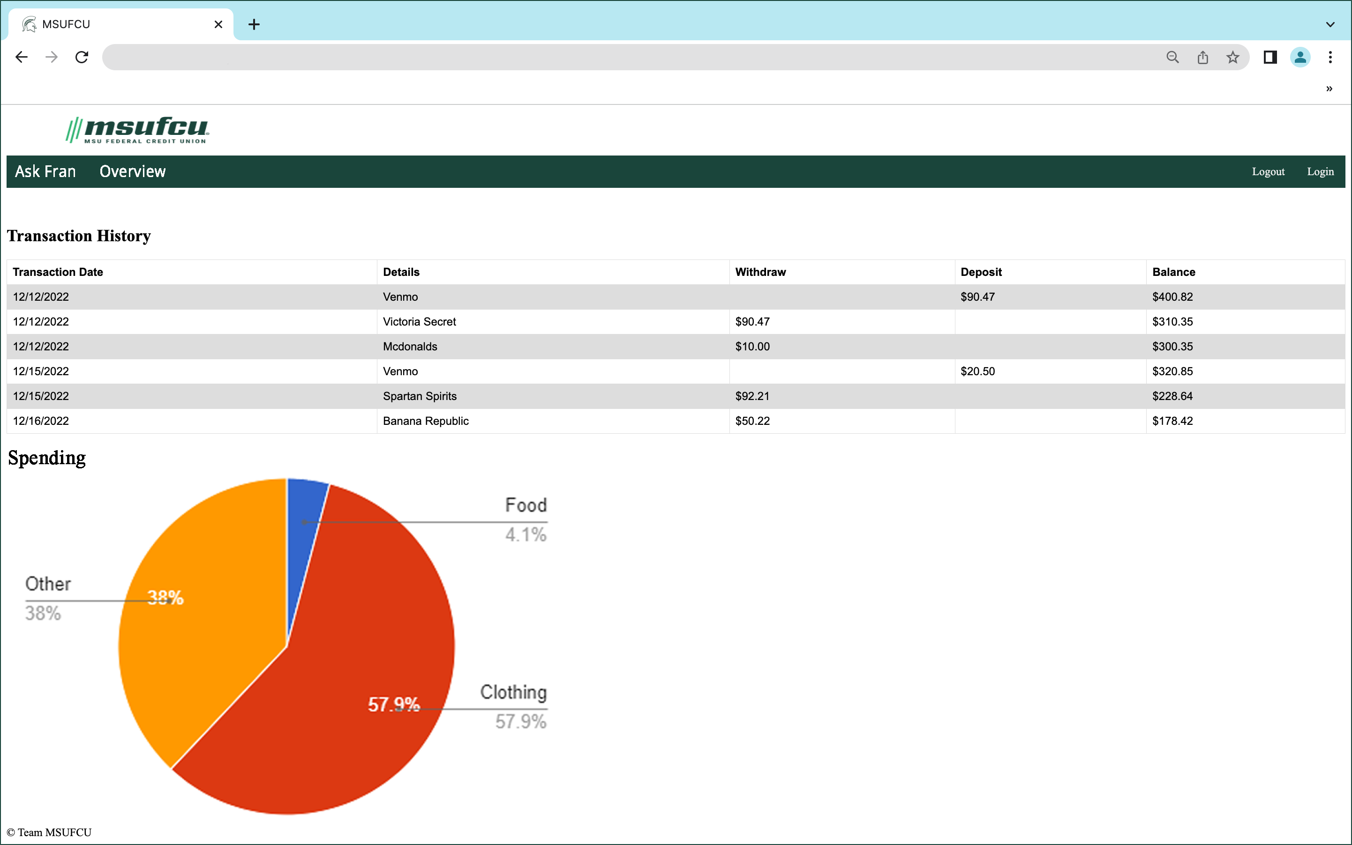

PAGE N + 18

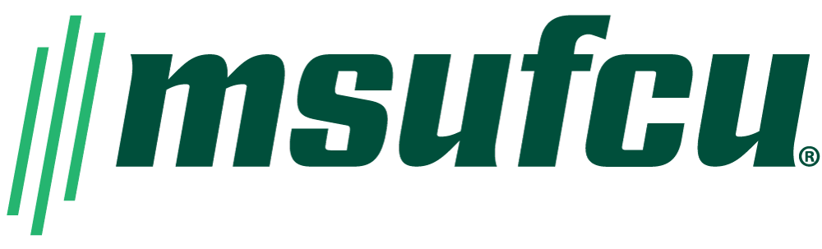

MSUFCU

Project Sponsors

April Clobes

East Lansing, Michigan

Filip Danielewicz

East Lansing, Michigan

Maria Hewitt

East Lansing, Michigan

Ben Maxim

East Lansing, Michigan

Meredith Nicholoff

East Lansing, Michigan

Michigan State University

Team Members (left to right)

Will Kelly III

Detroit, Michigan

Rikito Takai

Novi, Michigan

Nick Wallace

Grand Blanc, Michigan

Lexi Case

Lake Angelus, Michigan

Kaezar Leonard

Detroit, Michigan

Yu Chen

Fuzhou, Fujian, China

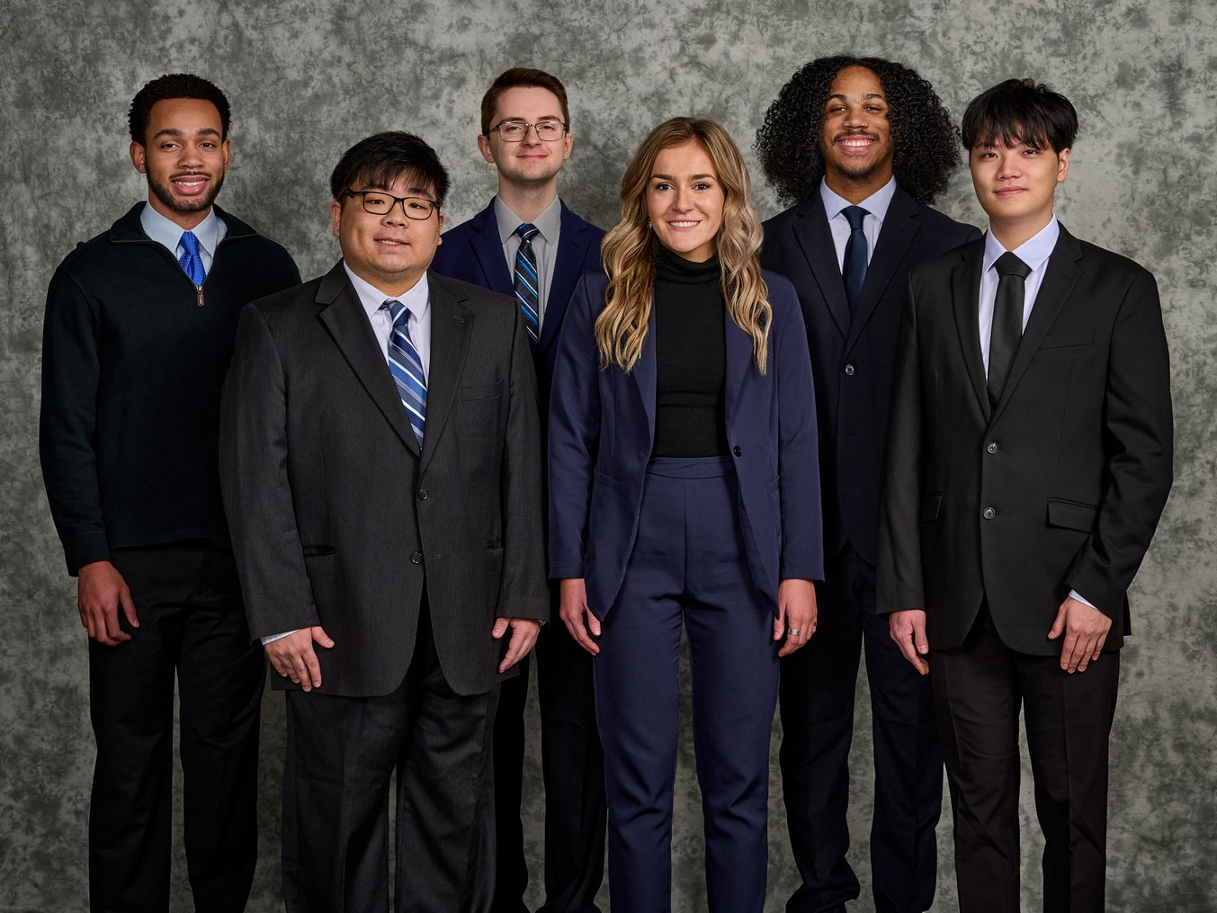

Established in 1937, MSU Federal Credit Union (MSUFCU) has been serving Michigan State University and the greater Lansing area for over 86 years. With over 20 branch locations statewide, 335,000 members worldwide, and managing nearly $7 billion in assets, MSUFCU strives to help its local communities thrive and achieve financial freedom.

MSUFCU offers a robust digital banking experience for members to check their balances, transfer funds, and manage all aspects of their account virtually. Providing exceptional banking tools is something MSUFCU already does, but they are now focusing on tools to assist members with their finances.

Our Predictive Chatbot Experience turns Fran, the MSUFCU chatbot, into a more informative and useful tool for members. Fran analyzes members’ history and provides supportive financial assistance. Looking at users’ accounts, our version of Fran can identify low points in their accounts, suggest when to pay bills to avoid overdraft fees, and schedule recurring bills.

For example, if a member regularly pays a bill on the 10th and Fran recognizes that the balance is low on that day, she instead suggests the member wait to pay the bill until after their payday on the 13th.

Members also can set spending goals and track them over the month, as well as request a breakdown by category of the spending in a month.

Our application is web-based and written in HTML with JavaScript and CSS. It connects to Boost.AI’s chat panel and a remotely hosted MySQL database. The chatbot’s logic is done in Boost.AI’s low code management platform used to train the artificial intelligence.

The Capstone Experience

MSU Federal Credit Union

Predictive Chatbot Experience