Design Day Booklet Team Page

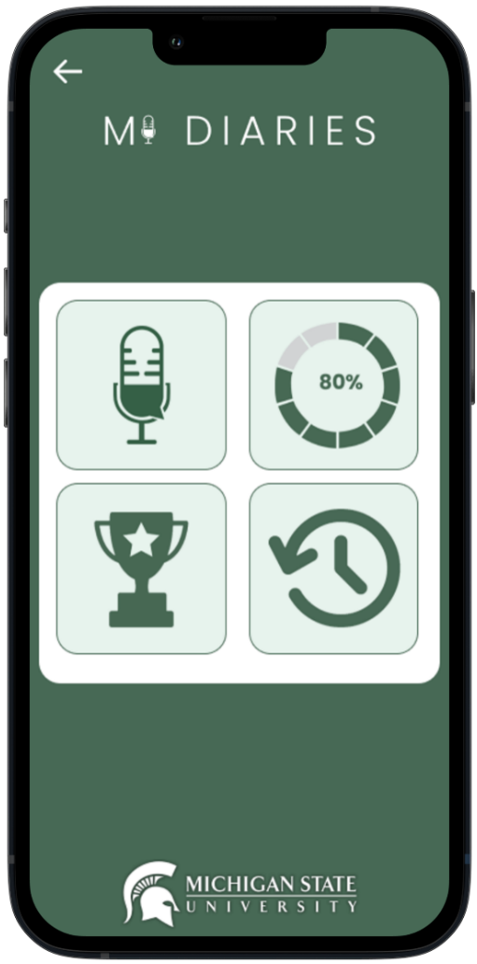

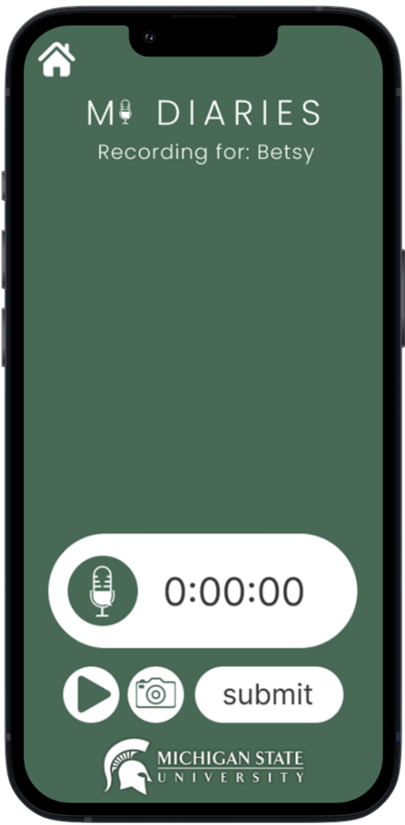

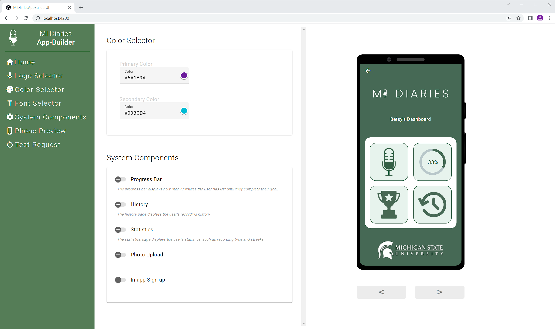

PAGE N + 16



Michigan State University Linguistics

Project Sponsors

Betsy Sneller

East Lansing, Michigan

Suzanne Evans Wagner

East Lansing, Michigan

Russ Werner

East Lansing, Michigan

Michigan State University

Team Members (left to right)

Daniel Magaway

Lansing, Michigan

Albert Crooks IV

Harrison Township, Michigan

Tess Coleman

Birmingham, Michigan

Hemkesh Agrawal

New Delhi, New Delhi, India

Shiyu Yan

Guangzhou, Guangdong, China

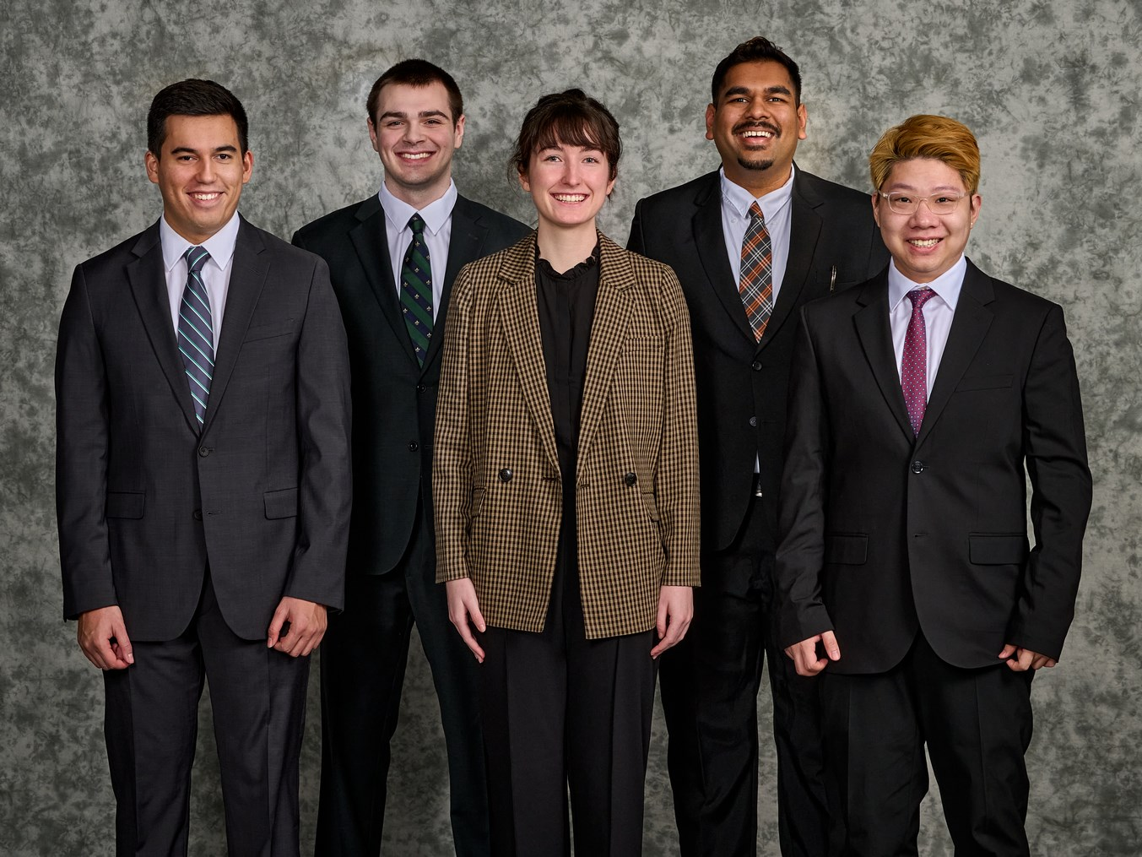

The Michigan State University Linguistics Department formed the MI Diaries team in 2020 in response to the COVID-19 pandemic. Using the MI Diaries app, the team collects and analyzes audio data to understand how people’s lives and language change over time.

The MI Diaries app is an audio recording app that collects audio remotely to use in research studies. This app provides a user-friendly interface that can be used by people of all ages and technical abilities. The app collects audio data, stores it in a database, and provides basic statistics for participants.

The MI Diaries team wishes to expand the reach of their app and allow researchers from across the world to utilize its audio recording capabilities. These researchers often do not have the tools necessary to collect audio data and want to focus on their study objectives, instead of the technical details of building an app.

Our MI Diaries App-Builder provides an easy way to customize the MI Diaries base app without having to touch a line of code. Researchers with minimal technical experience can produce a feature-complete and fully customized long-form audio recording app that is ready to use in their studies.

The App-Builder supports full customization of the colors, logos, and fonts, while also supporting gamification stat screens. The app can be configured to allow sign-up in-app or through an external form. While the main functionality of the app remains the same, users can create a uniquely styled app for their research.

Our solution provides an easy way for researchers to create applications tailor-made for their data collection, saving time and resources over building from scratch.

The main MI Diaries app is built using Flutter to provide a cross-platform app and can be connected to any back-end server.

The front end of our App-Builder is built using Angular 15, while the back end is implemented using Python Flask.

The Capstone Experience

Michigan State University

Build-an-App for Humanities Researchers