Design Day Booklet Team Page

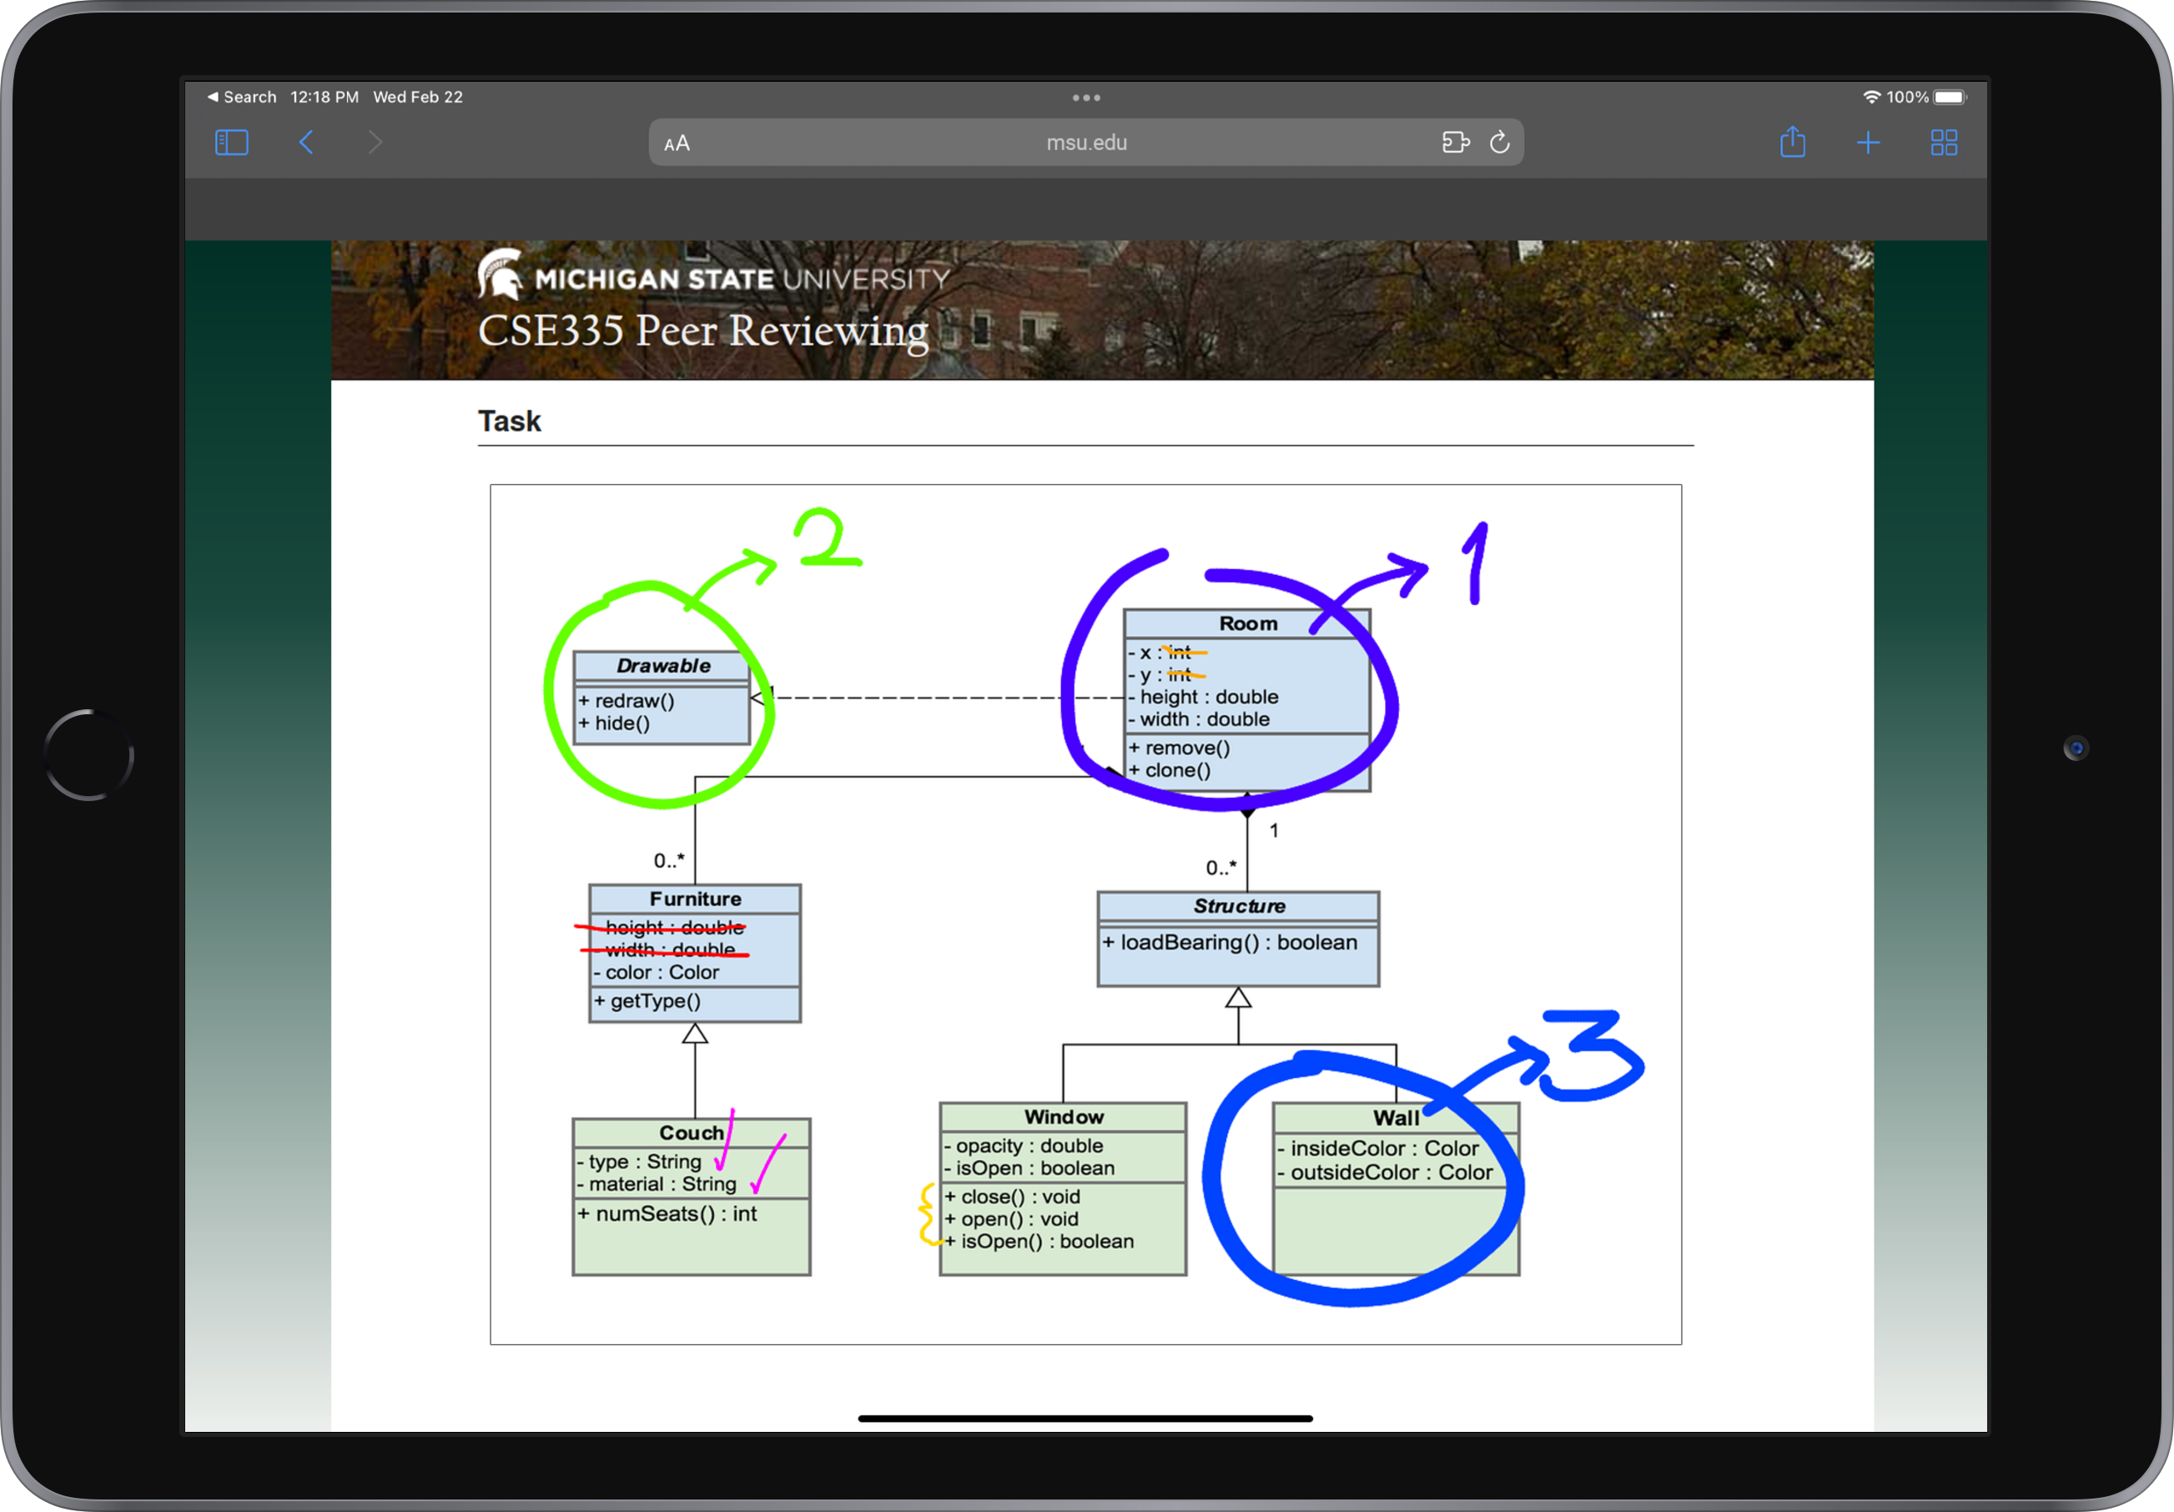

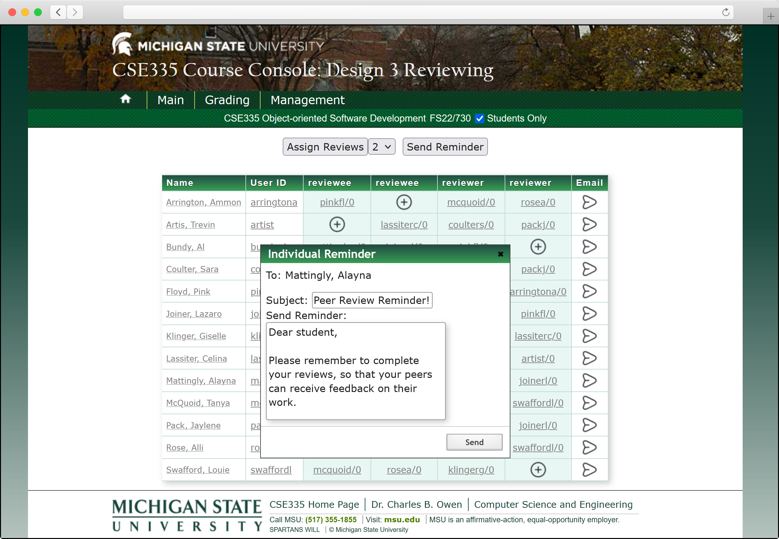

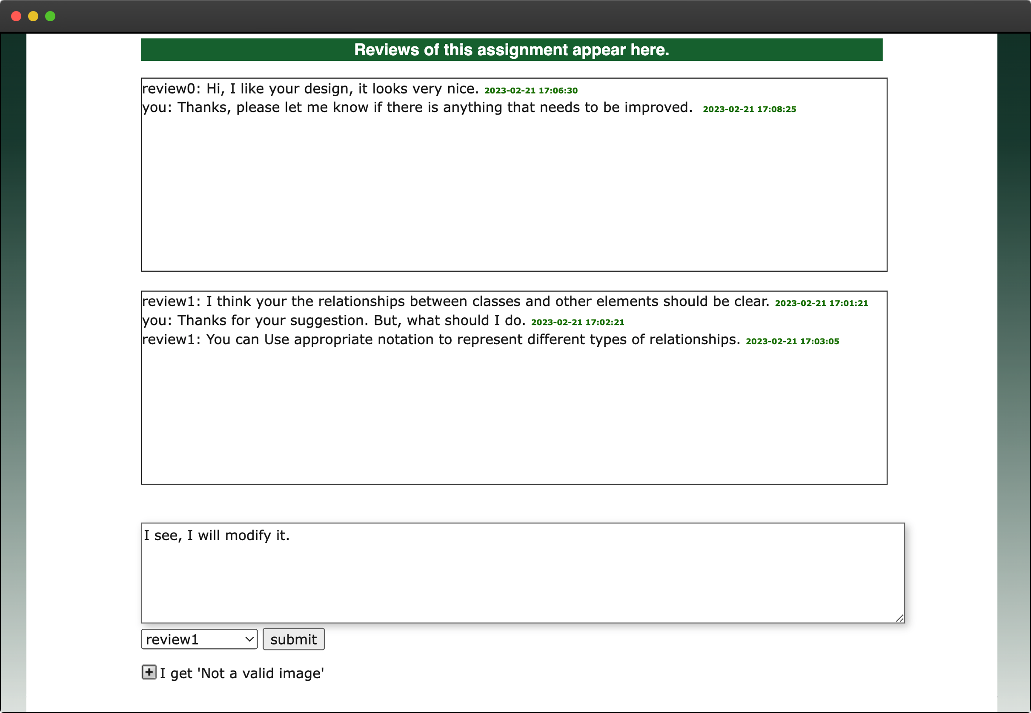

PAGE N + 15



Michigan State University CSE

Project Sponsor

Charles Owen

East Lansing, Michigan

Michigan State University

Team Members (left to right)

Dean Eggenberger

West Bloomfield, Michigan

Santiago Rodriguez-Papa

Montevideo, Montevideo, Uruguay

Justin Henkelman

Hudsonville, Michigan

Kishore Sirigiri

Novi, Michigan

Max Brombach

Almont, Michigan

Zhuofan Zeng

Changsha, Hunan Province, China



The Michigan State University Department of Computer Science and Engineering leads several state-of-the-art graduate and undergraduate programs for more than 1,700 students. The department is committed to providing a high-quality educational experience to all of its students.

The Department of Computer Science and Engineering keeps up with growing interest by maintaining a high level of adaptability. This is achieved via CourseLib, a system of components used to create course websites. CourseLib facilitates learning through detail-oriented instruction and hands-on activities.

CourseLib’s peer review system enables students to improve upon industry-valuable skills such as giving informative critiques of someone else’s work, accepting feedback from others, and turning feedback into impactful improvements. The peer review system within CourseLib, while effective, has areas for improvement.

Our improvements to the CourseLib peer review system make it easier than ever for students to receive feedback on their work. Reviewers and reviewees can now have a real-time dialog with one another, making crucial communication easier than ever before.

The feedback process is enhanced through the addition of submission image annotation, allowing users to know exactly where they can make improvements. The new submission association feature makes clear which submission is being discussed. The email notification system is redesigned to effectively provide notifications in all circumstances. Instructors can now reassign individual reviewer-reviewee pairings. Finally, instructors are now notified when students submit and have not been assigned a peer review assignment.

CourseLib uses a JavaScript front end using Vue for a responsive interface and webpack for bundling. CourseLib’s back end is built using PHP and SQL.

Computer Science and Engineering CSE 498

Michigan State University

Improved Peer Review in CourseLib