Design Day Booklet Team Page

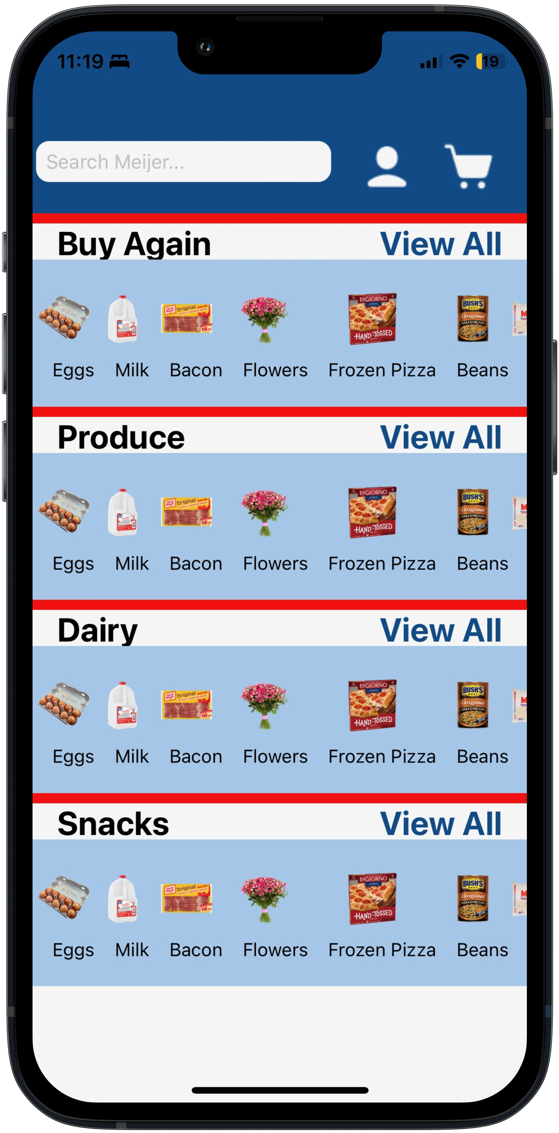

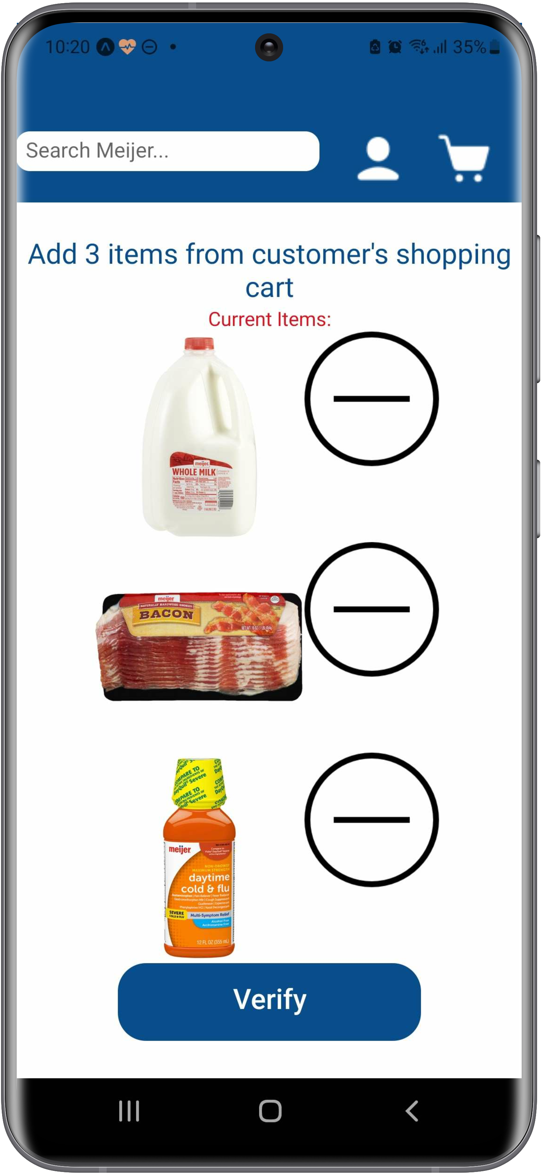

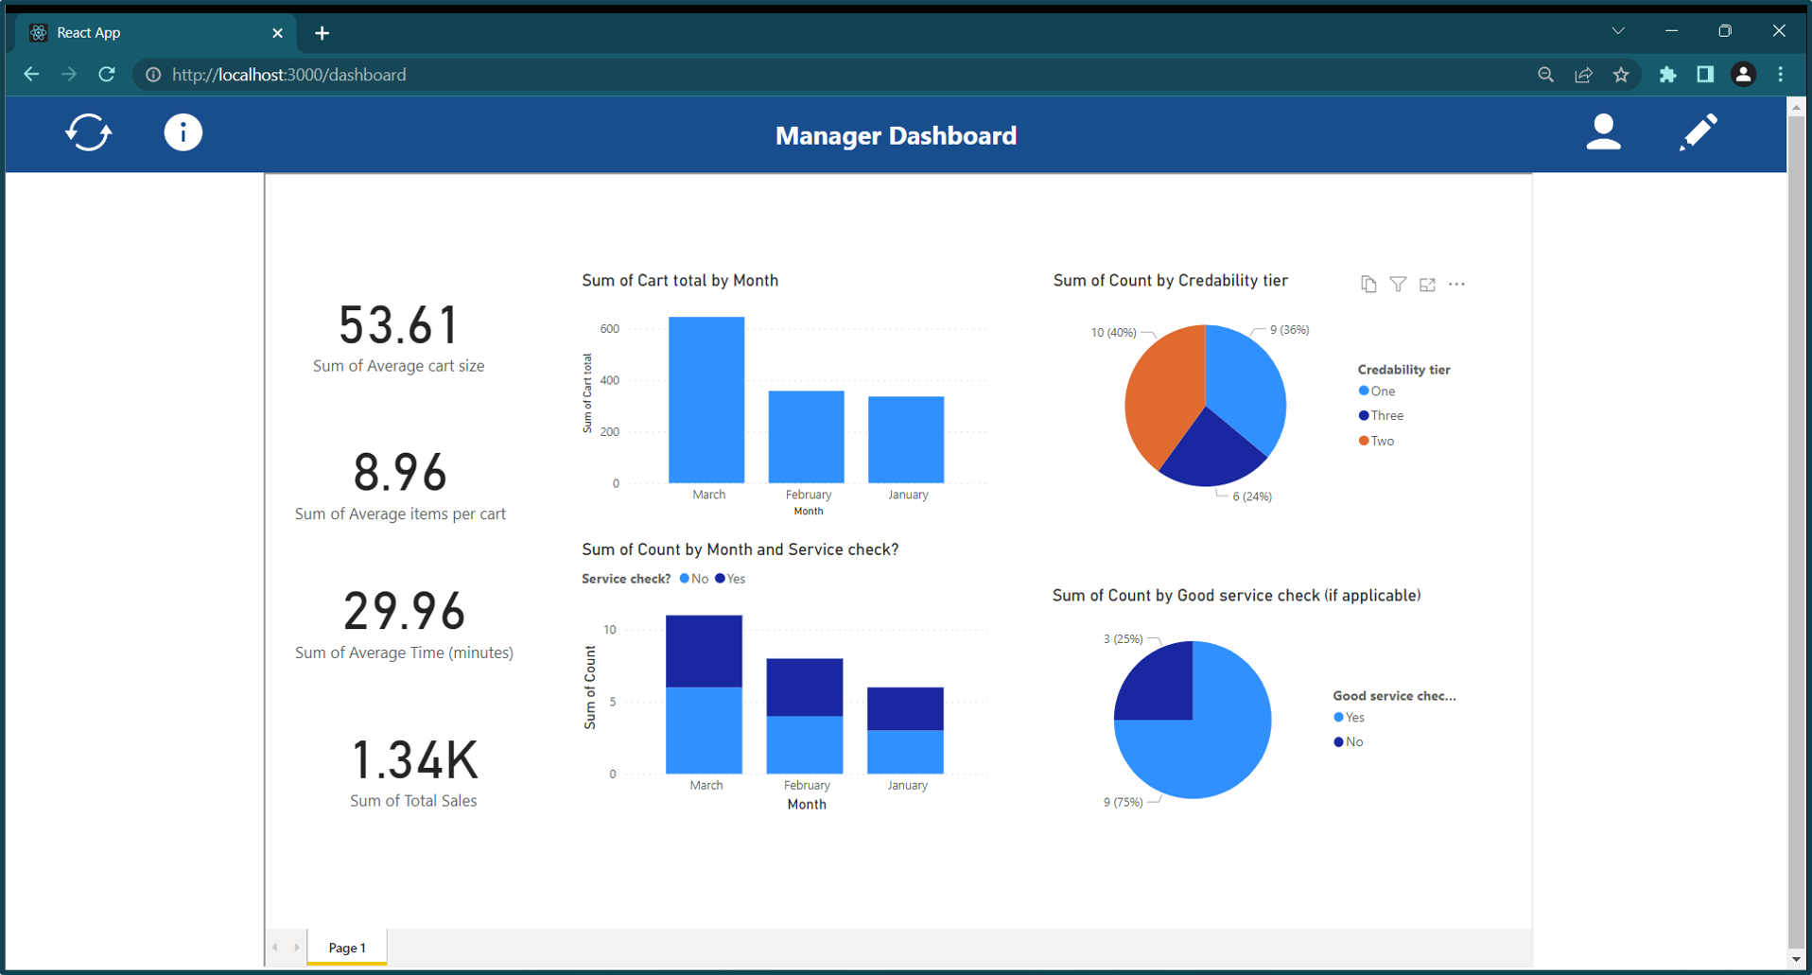

PAGE N + 14

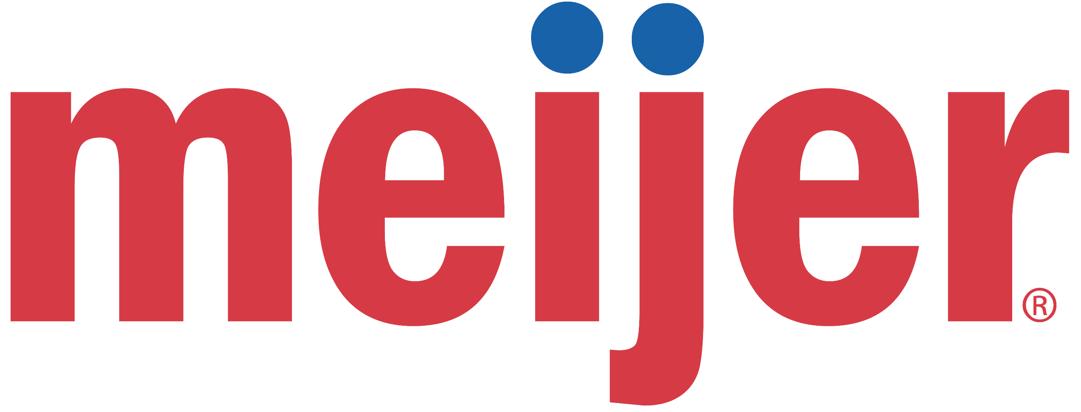

Meijer

Project Sponsors

Bill Baer

Grand Rapids, Michigan

Ariel Firon

Grand Rapids, Michigan

Phil Kane

Grand Rapids, Michigan

Terry Ledbetter

Grand Rapids, Michigan

John Morrison

Grand Rapids, Michigan

Samuel Ramos

Grand Rapids, Michigan

Mark Szymanski

Grand Rapids, Michigan

Michigan State University

Team Members (left to right)

Haichen Sun

Zhenjiang, Jiangsu, China

Josh Erno

Novi, Michigan

Marv Zurek III

Highland, Michigan

Naveen Kumanan

Chennai, Tamil Nadu, India

Matt Norris

Buchanan, Michigan

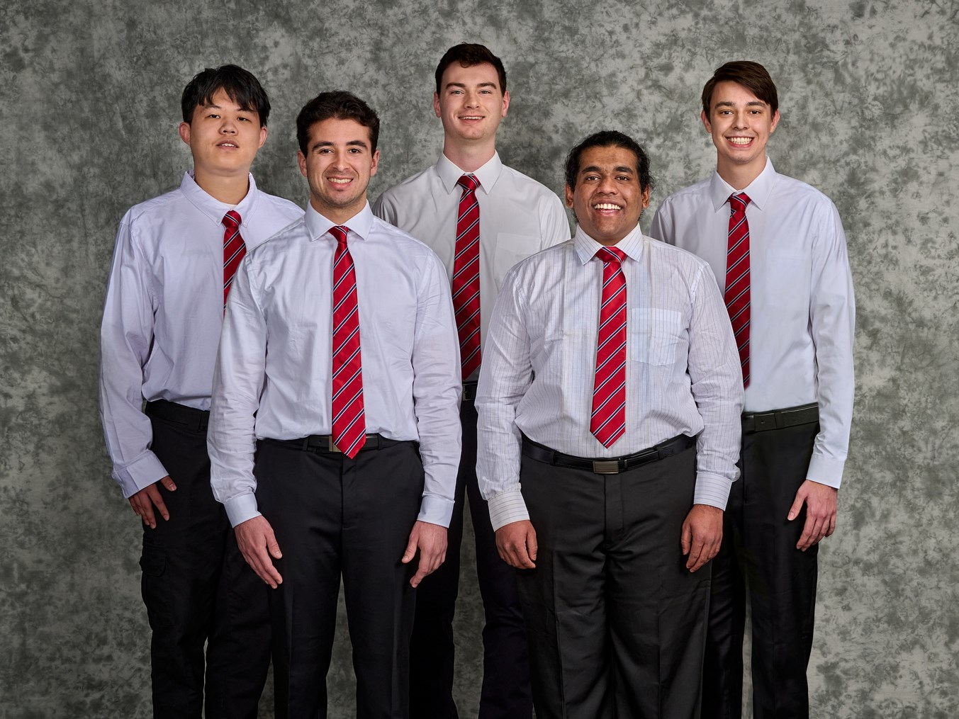

Meijer is an all-in-one retailer with over 265 locations throughout six midwestern states. Meijer is constantly increasing the efficiency and flow of their stores to improve their offerings and services, and in turn improve customer satisfaction.

One of these systems is Mobile Shop & Scan, available to all Meijer mPerks customers. Shop & Scan enables shopping in-store with the customer’s phone as they place products in the physical cart. Customers may scan items to add them to the mobile cart, clip coupons and promotions, and see the immediate offering value in the Meijer Mobile application.

Our Organization Efficiencies Utilizing WiFi Locationing tool expands the scope of the Shop & Scan process to decrease the checkout time for shoppers. Meijer Mobile shoppers have the option to pay entirely on their mobile device without checking out traditionally.

Our software provides a dashboard that shows the manager of a Meijer location a heat map of where customers in the store are physically located, along with different metrics that can be used to make informed decisions about each employee’s assignment.

Our system makes use of MIST wireless access points located throughout a store that connect to user smartphones to triangulate their location accurately. We pull live data from these access points to make predictions of customer location, as well as locations of customers who might need assistance.

If a customer requires assistance, a Meijer attendant uses our dashboard to locate the customer and performs a Service Check to help the customer quickly resolve any issues they are having.

The consumer mobile app and employee mobile app are built using React Native, while the web app is powered by ReactJS with a Microsoft Power BI dashboard. Each application uses data from an underlying Microsoft SQL database.

The Capstone Experience

Meijer

Organization Efficiencies Utilizing WiFi Locationing