Design Day Booklet Team Page
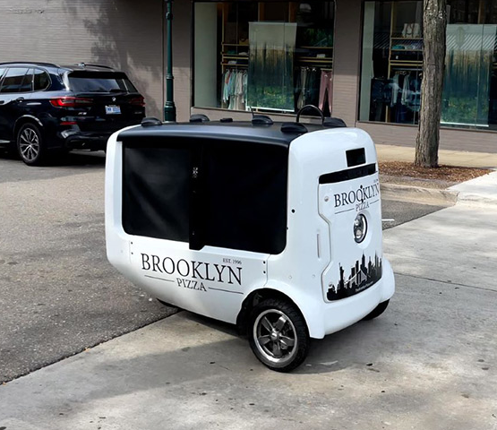
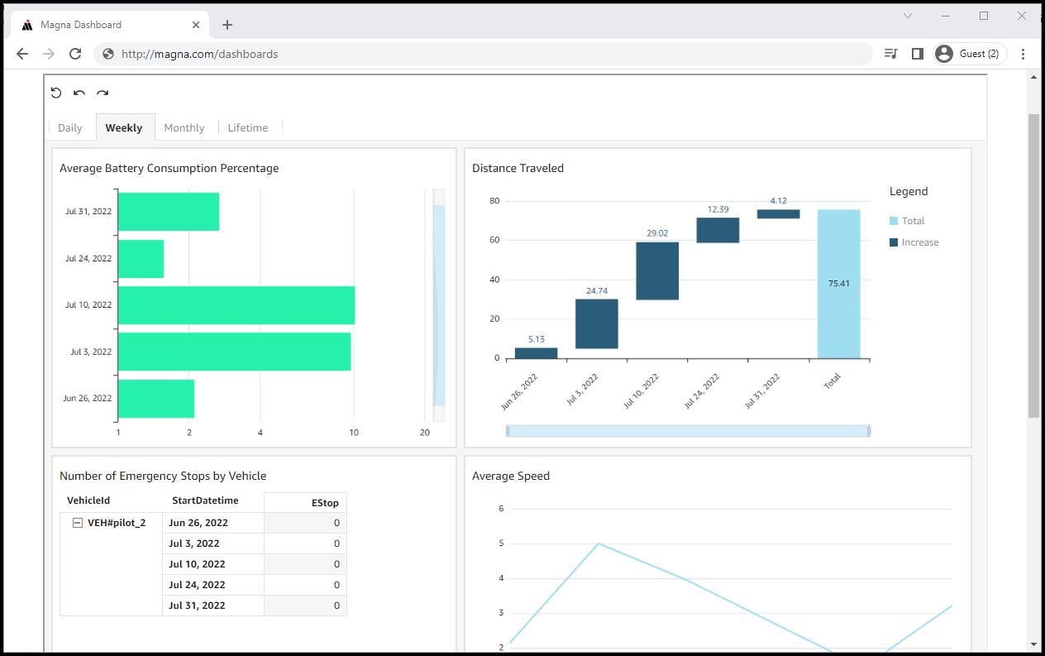
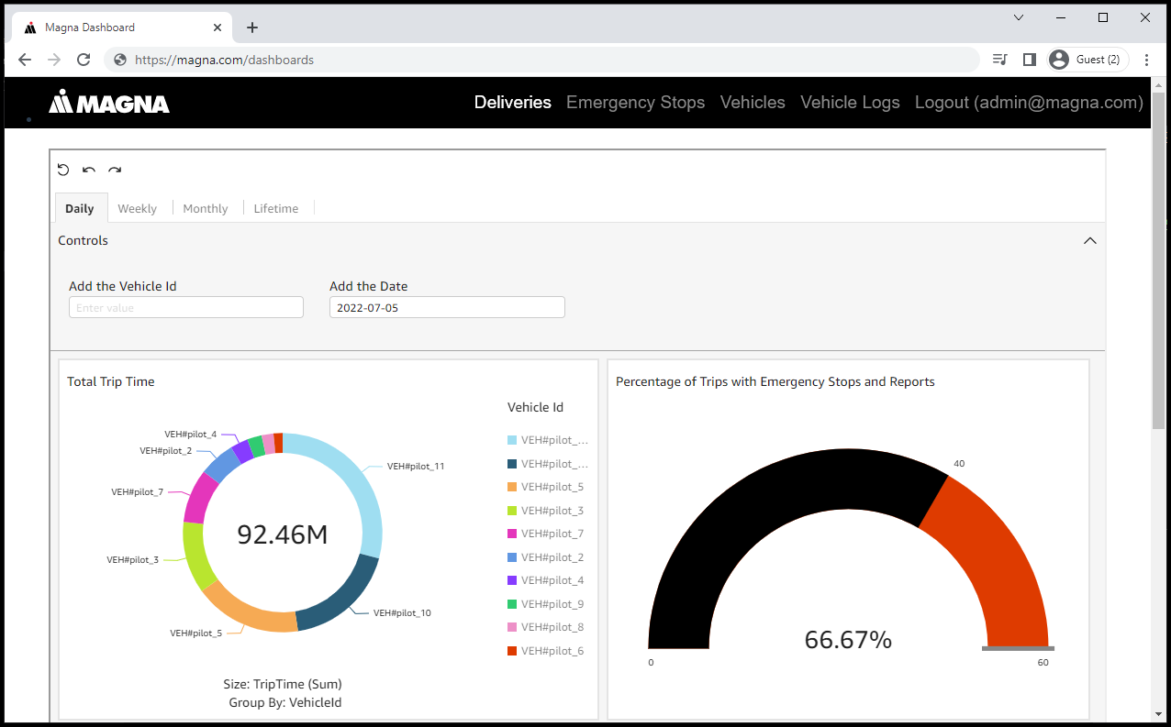
PAGE N + 13

Magna
Project Sponsors
Pranay Jain
Boston, Massachusetts
Adam Naish
Troy, Michigan
Jim Quesenberry
Troy, Michigan
Raidu Rayasam
Boston, Massachusetts
Michigan State University
Team Members (left to right)
Joey Meng
Troy, Michigan
Augie French
McLean, Virginia
Jannik Eisenlohr
Monheim Am Rhein, North Rhine-Westphalia, Germany
Ria Mokashi
Sterling Heights, Michigan
Suraj Karthikeyan
Singapore, Singapore, Singapore
Rondy Gonzalez
Macomb, Michigan

Magna International Inc. is a worldwide automotive supplier headquartered in Canada, with their U.S. headquarters in Troy, Michigan. They have been ranked in the Fortune Global 500 for 20 years straight. Magna is the largest automotive parts manufacturer in Canada, and 4th largest in the world.
One of Magna’s goals is reducing last-mile delivery-related emissions in large cities. To this end, they are piloting a program that operates an all-electric fleet of autonomous delivery robots.
Each bot generates countless data points that provide insight into delivery efficiency. Through trip data, Magna can efficiently track fleet performance and make any adjustments that will improve the efficiency of their autonomous delivery fleet.
Our Dashboard for Data Visualization provides a web app for Magna employees to track autonomous delivery data in real time.
Graphs and charts are a vital asset for being able to visualize the information from trips. Within these graphs, employees see various metrics such as battery consumption, distance traveled, trip time, average speed, emergency stop information and more.
All visualizations are updated dynamically as new data is added with respect to the database, providing Magna employees with up-to-date information for analysis of the fleet’s performance.
Using our tool, Magna ensures they are reducing emissions while still providing flawless service to their employees and customers.
Magna stores data in an Amazon Web Service (AWS) storage solution. The data is cleaned with custom AWS Lambdas and delivered to Amazon DynamoDB and then QuickSight. The visualizations created in QuickSight are rendered to Magna's internal LMDD website using the Vue.js framework.
Computer Science and Engineering CSE 498
Magna
Dashboard for Data Visualization

