Design Day Booklet Team Page

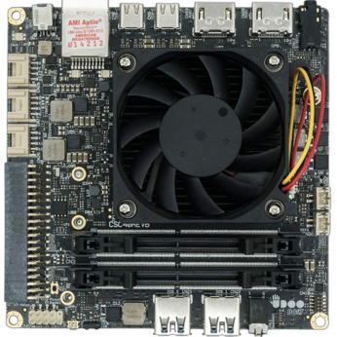

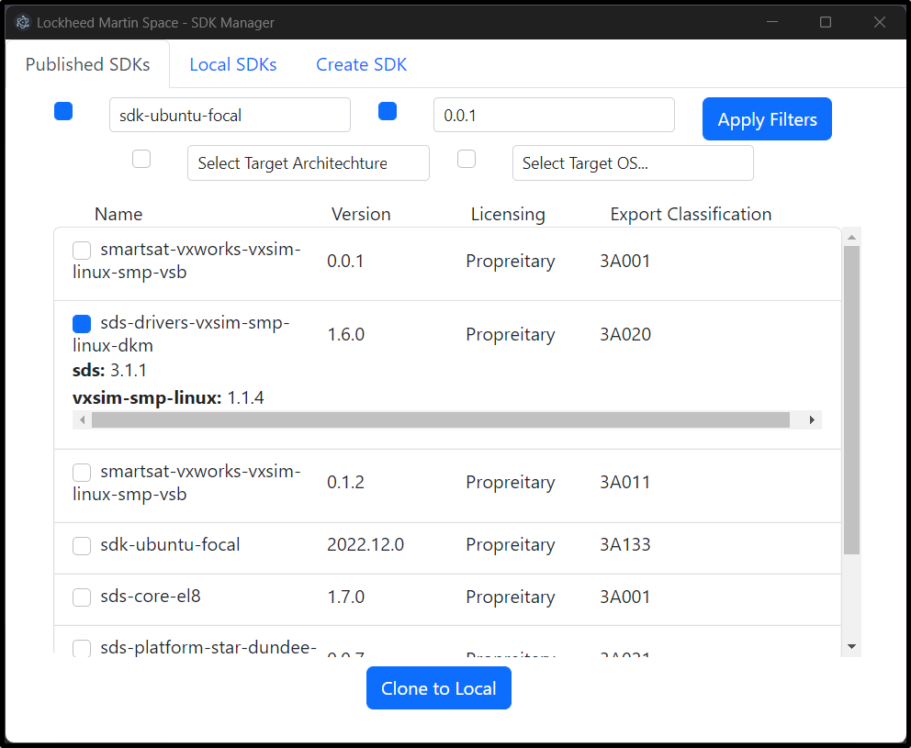

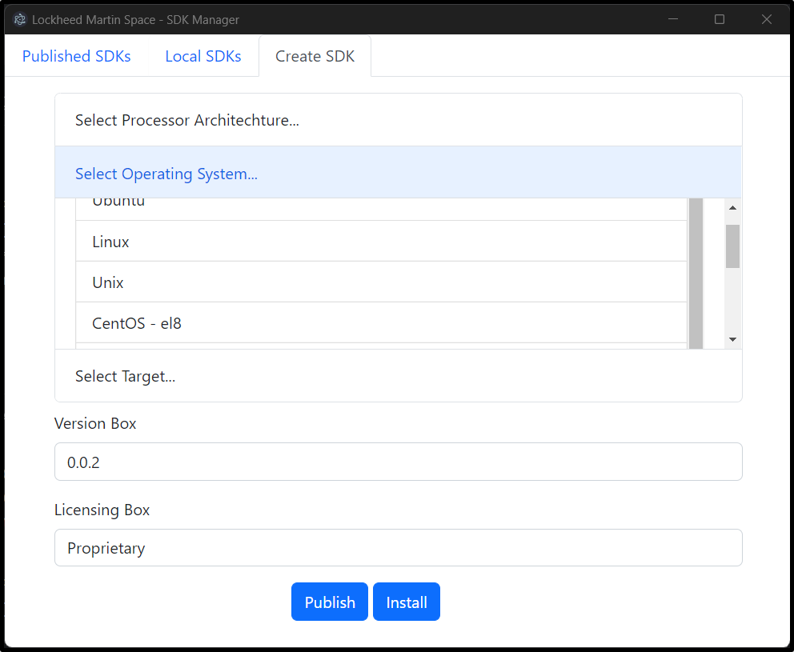

PAGE N + 12

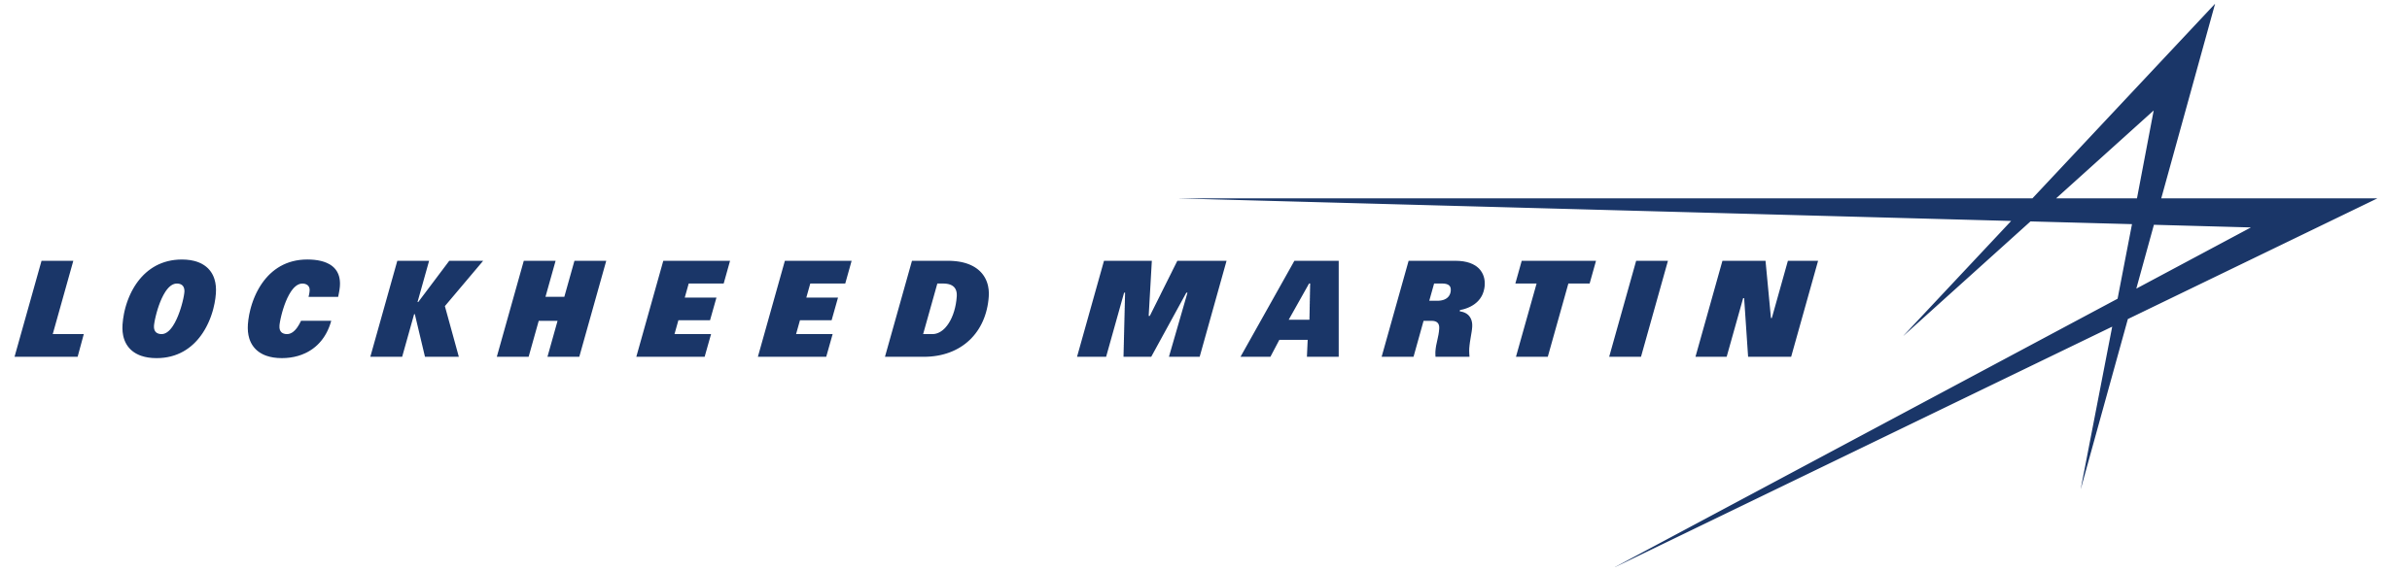

Lockheed Martin Space

Project Sponsors

Josh Davidson

Littleton, Colorado

Joe Epstein

Littleton, Colorado

Brandon Hearn

Littleton, Colorado

Elliott Hoefflin

Littleton, Colorado

Matt Jenkins

Littleton, Colorado

Nicole Saro

Littleton, Colorado

Mark Veyette

Littleton, Colorado

Michigan State University

Team Members (left to right)

Rob Francis IV

Grand Haven, Michigan

Kyle Soderlund

White Lake, Michigan

Maxwell Lu

Grand Rapids, Michigan

Tyler Holt

Concord, Michigan

Kurt LaBlanc

Grand Haven, Michigan

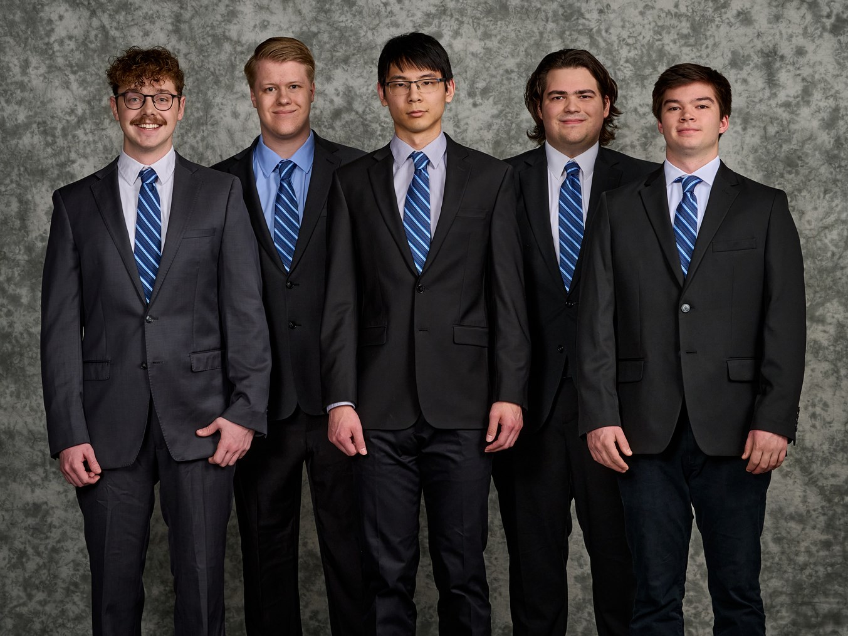

Lockheed Martin Space is a division of Lockheed Martin headquartered in Littleton, Colorado that employs over 16,000 people to build satellite systems and spacecraft.

Satellite operation is being fundamentally reshaped by SmartSat™, a software-defined satellite architecture developed by Lockheed Martin Space that enables the reprogramming of satellites while in orbit. SmartSat™ also facilitates the use of artificial intelligence onboard satellites to analyze and make decisions from collected data, such as overhead imagery and spacecraft telemetry.

Software development for SmartSat™ is done via software development kits (SDKs) provided by Lockheed Martin Space. Each SDK is a collection of several different development tools that interact with each other. As the variety of hardware supported by SmartSat™ grows, managing the rising number of SDKs becomes cumbersome.

Our SmartSat™ Software Development Kit Manager provides a straightforward way to view, install, modify and publish SDKs for SmartSat™.

The application displays relevant available SDKs based on the development system and target satellite, as well as currently installed SDKs, in a separate table. Users select an SDK listing to inspect the contents of an SDK or manage its installation status. System administrators publish new, either built from scratch or updated from an existing version, SDKs for download.

Our system’s main component is a command-line utility written in Python Flask that communicates with a MySQL server to store and retrieve SDKs. The front end is a desktop application powered by Electron and written in JavaScript. Onboard an AMD V1000 series APU, inferencing is powered by ONNX Runtime using AMD ROCm for hardware acceleration.

The Capstone Experience

Lockheed Martin Space

SmartSat™ Software Development Kit & AI Platform