Design Day Booklet Team Page

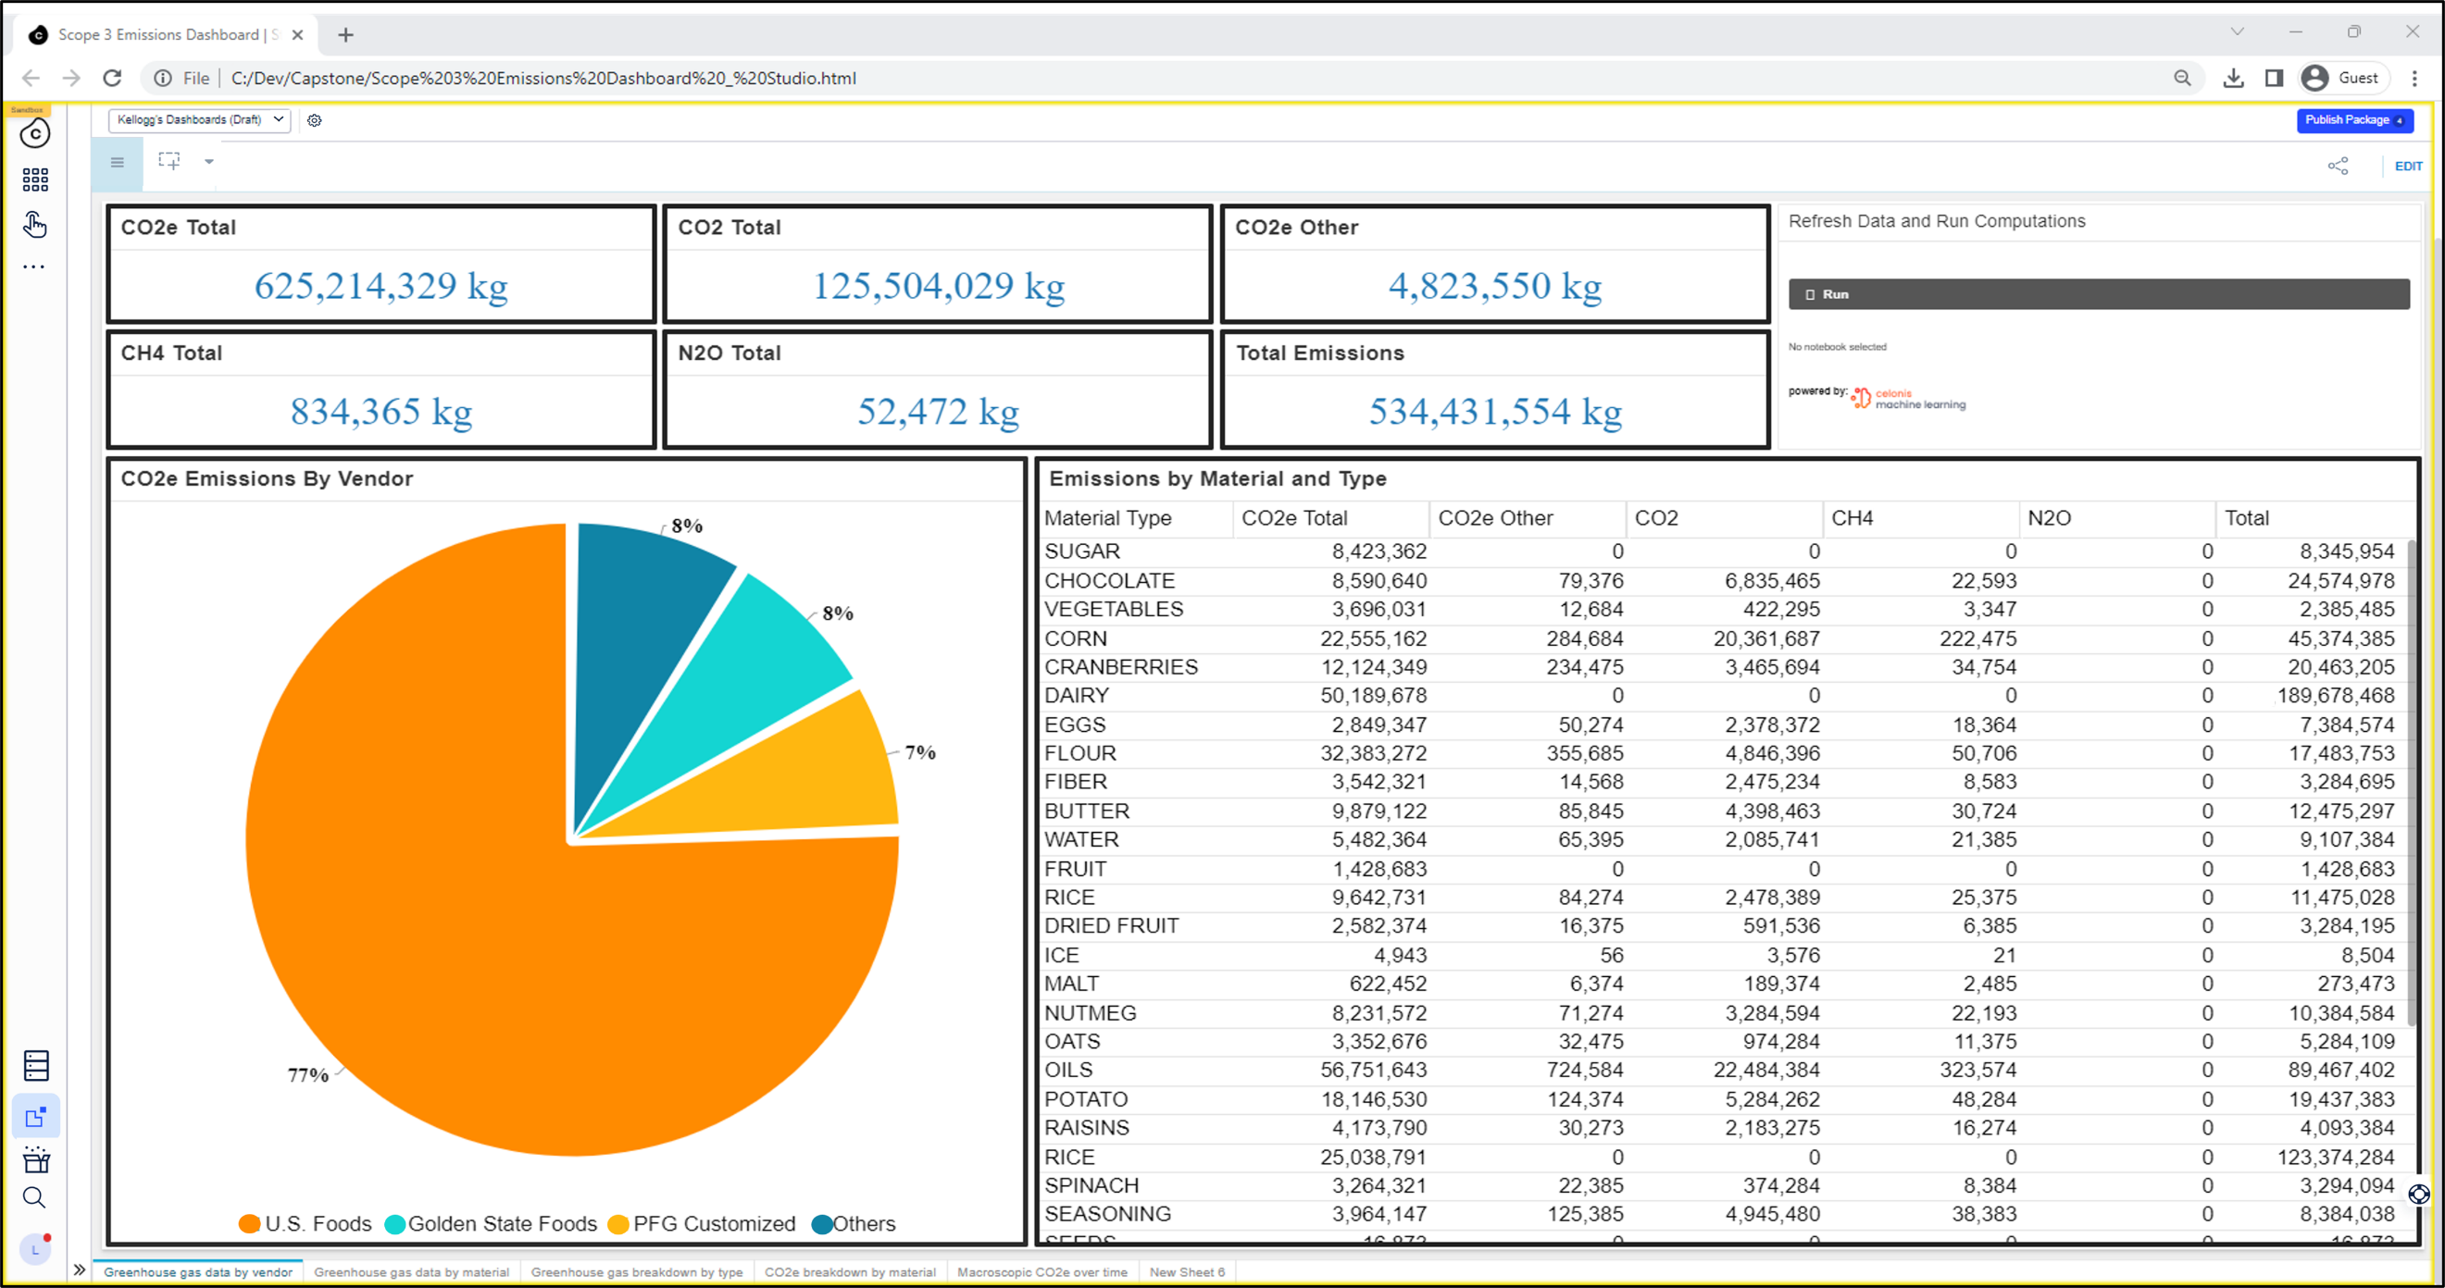

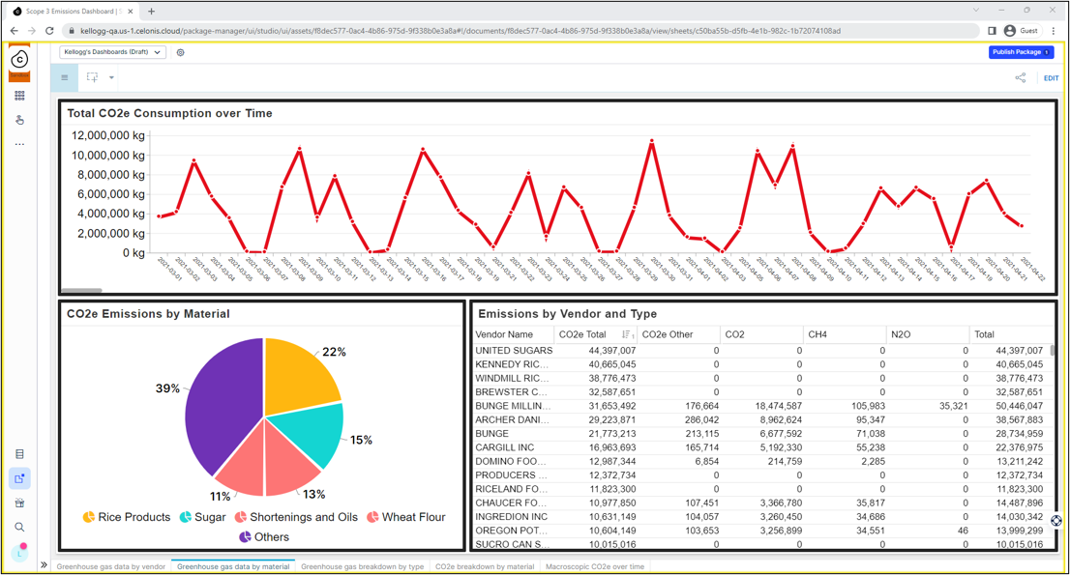

PAGE N + 11

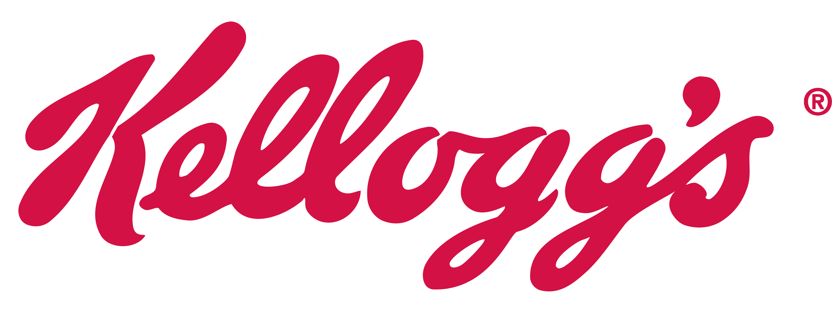

Kellogg’s

Project Sponsors

Deanna Adler

Battle Creek, Michigan

Federico Conde

Battle Creek, Michigan

Juan Pablo Cuellar

Querétaro, Mexico

Mackenzee Lamoreaux

Battle Creek, Michigan

Diana Morehouse

Battle Creek, Michigan

Debra Nave

Battle Creek, Michigan

Michigan State University

Team Members (left to right)

Randy Carnahan

New Baltimore, Michigan

Ayoung Du

Ji’An, Jiangxi, China

Michael Dittman

Casco, Michigan

Lily Albitar

St. Louis, Missouri

Jacob Zawacki

Oxford, Michigan

Shreesha Maddur

Novi, Michigan

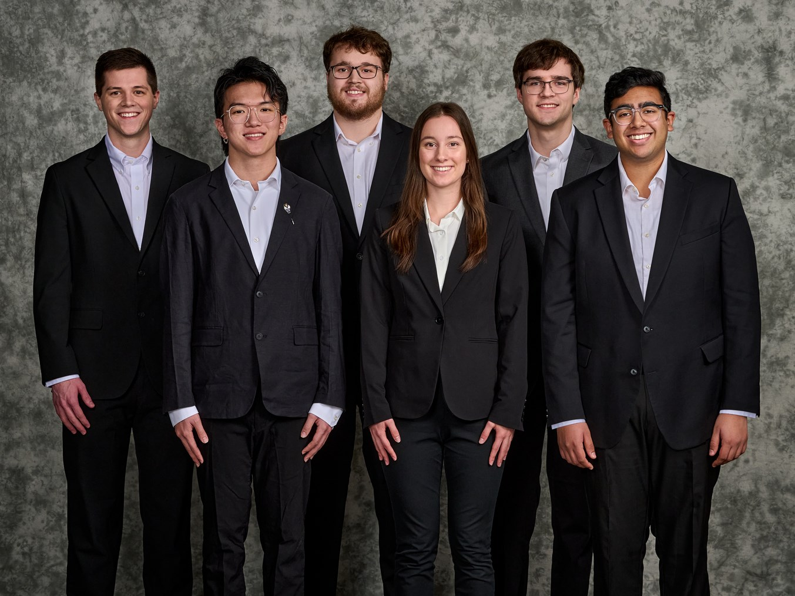

Kellogg’s is a Fortune 500 company that operates both domestically and in over 180 international markets. They are most famous for their cereal and snack brands, such as Cheez-It®, Pop-Tarts®, Froot Loops® and Frosted Flakes®.

Kellogg’s is committed to people and their well-being through their Better Days Promise initiative. Kellogg’s plans to reduce 45% of scope 1 and 2 greenhouse gas (GHG) emissions and 15% of scope 3 emissions by 2030. Scope 3 emissions are value chain emissions that include processing of sold products, business travel, waste generated in operations, end-of-life treatment of sold products, etc.

To accomplish their emissions reduction goals, Kellogg’s uses an external agency for which GHG scope 3 data must be collected and analyzed manually due to their complexity. Automating the calculation and creation of easily understood visuals reduces labor costs and reliance on external assessors.

Our GHG Scope 3 Automation tool presents relevant GHG emissions data in the form of charts and graphs in a visually intuitive dashboard accessible by Kellogg’s employees. Kellogg’s employees directly interact with the dashboard to view and analyze the effects of different food products, factories, and vendors. In addition to the dashboard, the GHG Scope 3 Automation website provides users insight on process metrics such as kilograms of greenhouse gas emissions, what ingredients are causing the emissions, and the gases that comprise the emissions.

Our tool helps Kellogg's automate a process, leading to significant savings in both time and money.

The GHG automation process takes place in the Celonis machine learning workbench. A Python script runs within the Jupyter notebook to perform calculations and store them. The Flask back end of our website connects to a SQL database with the calculated data. Our JavaScript front end visualizes all of the data.

Computer Science and Engineering CSE 498

Kellogg’s

GHG Scope 3 Automation