Design Day Booklet Team Page

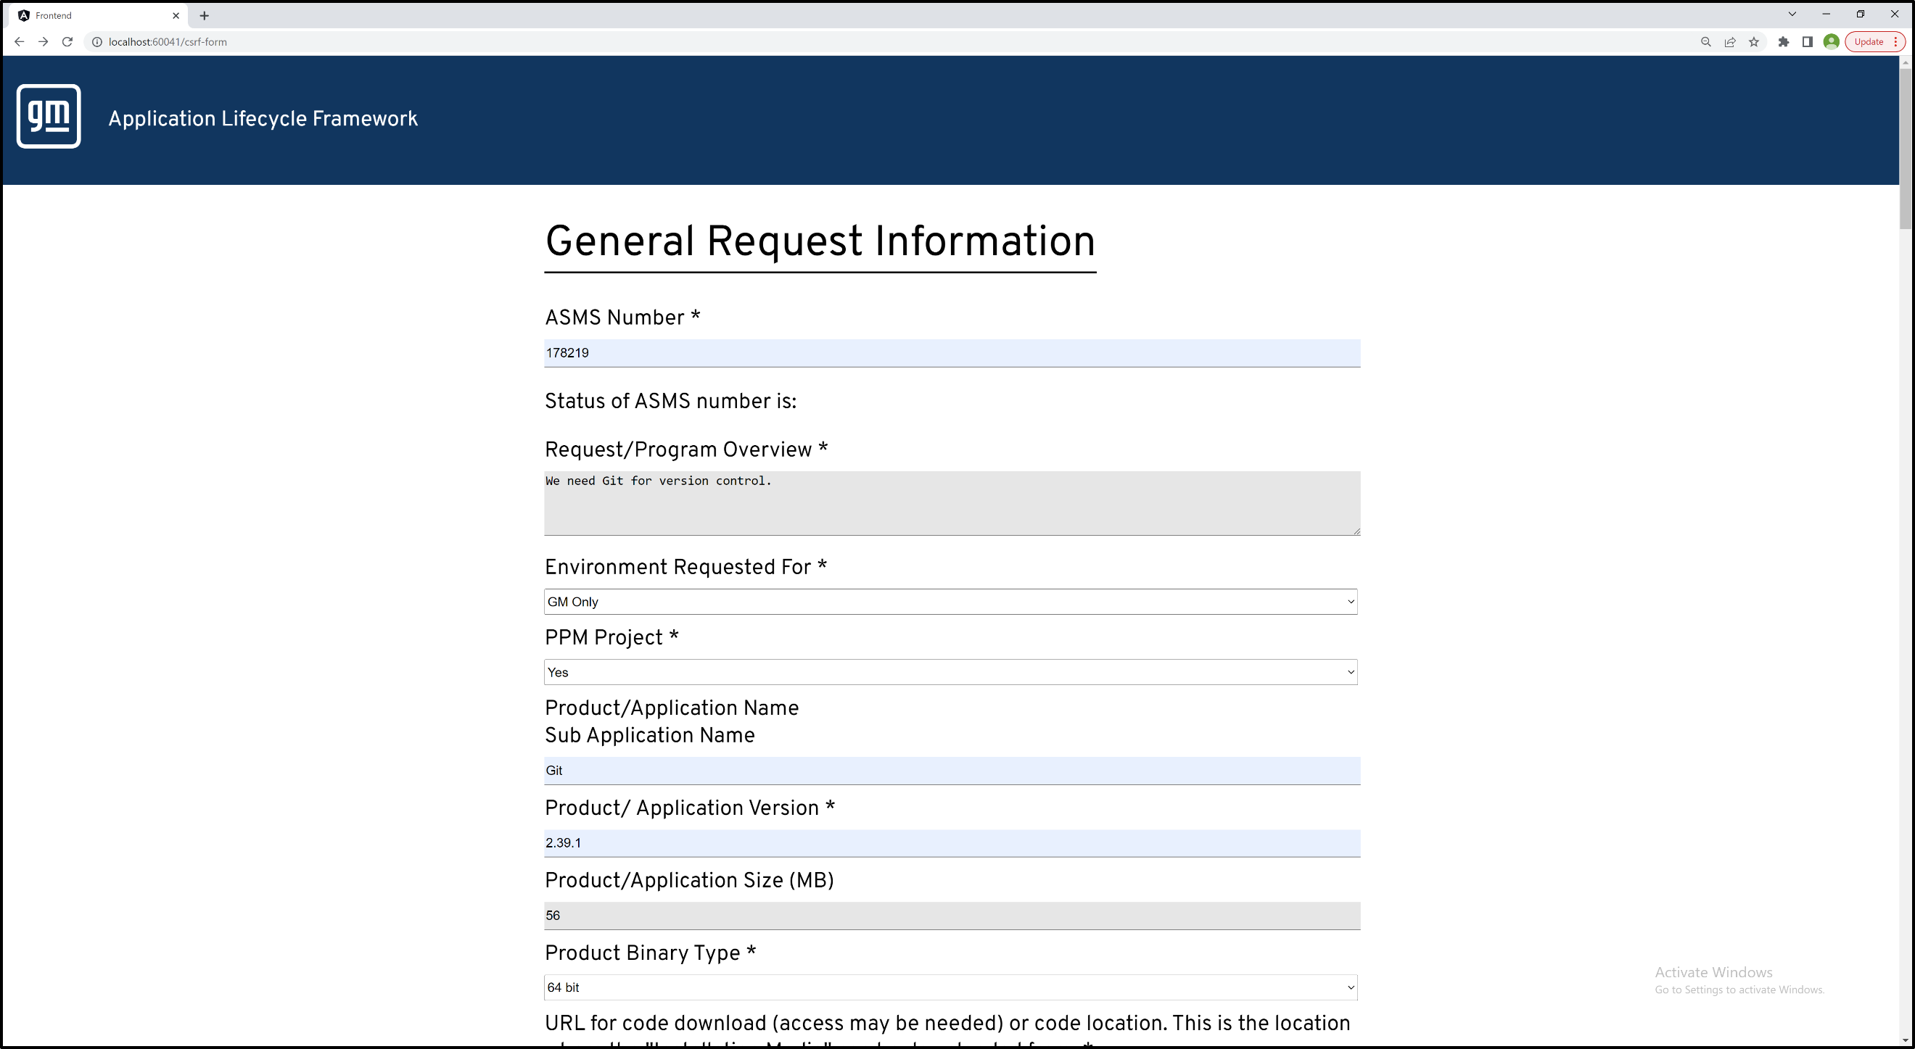

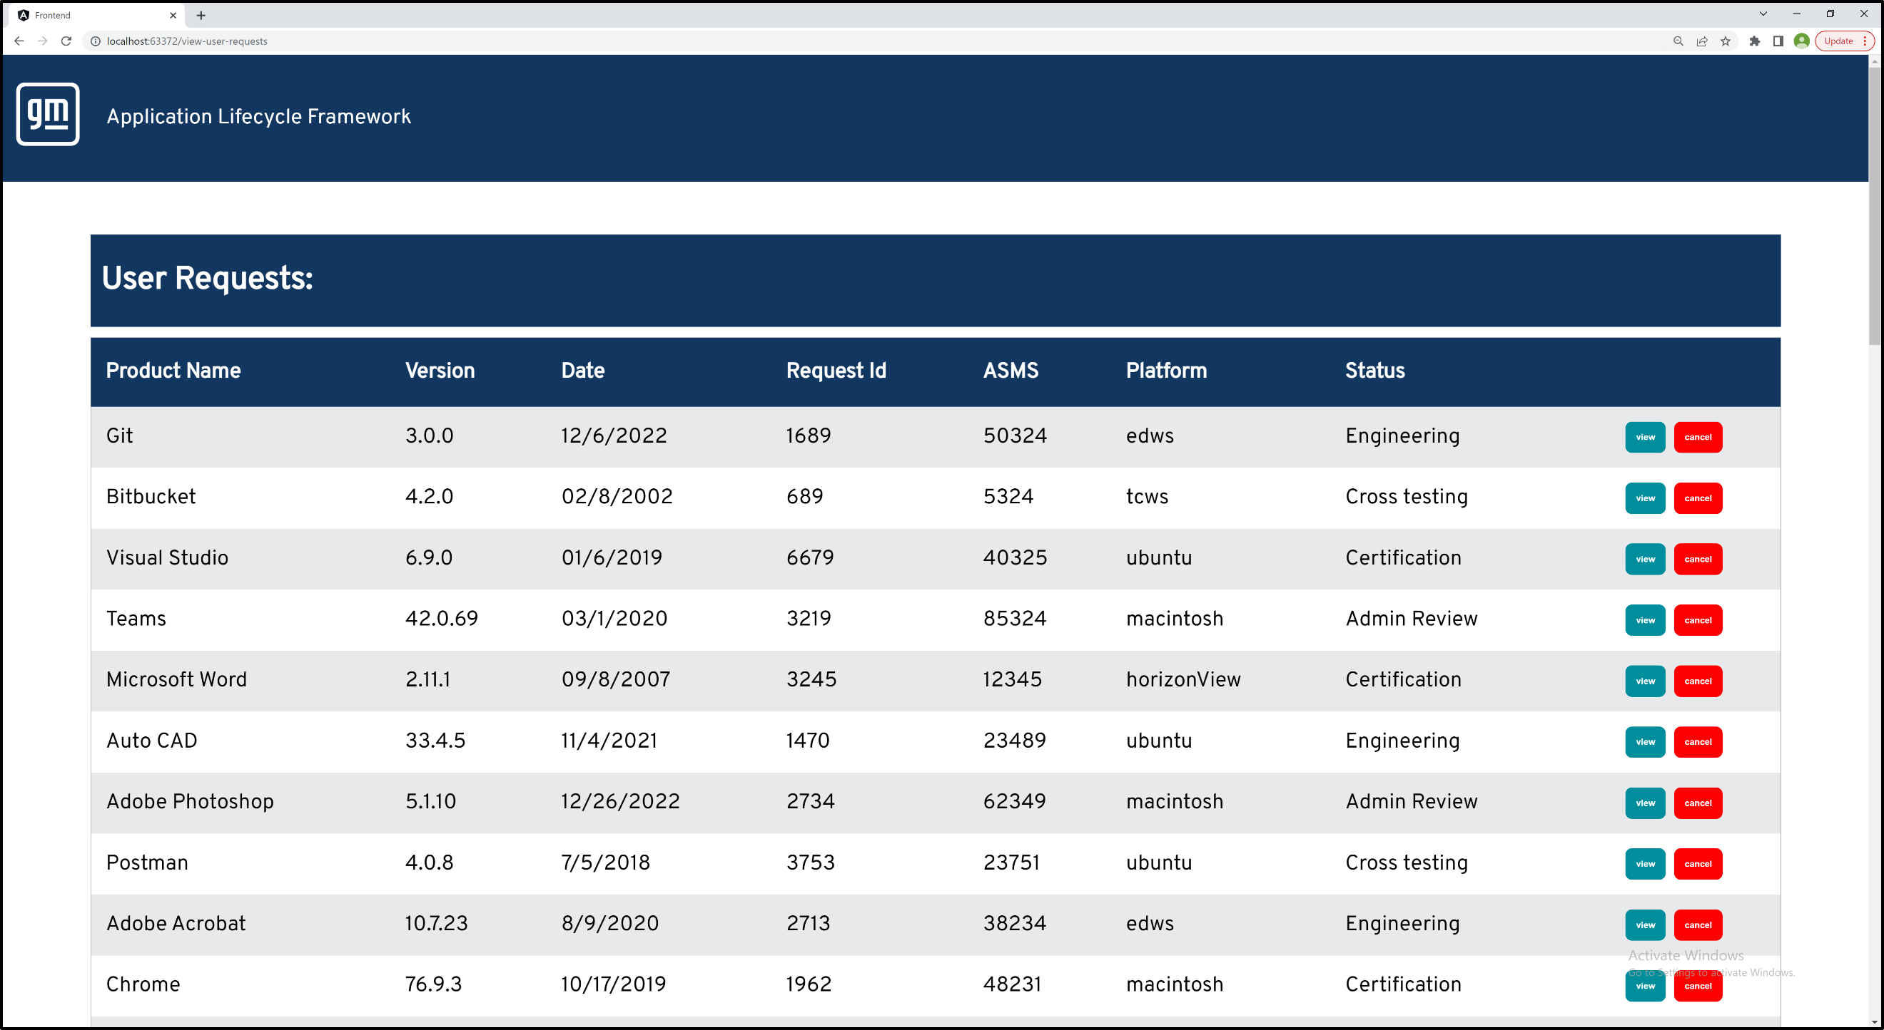

PAGE N + 10

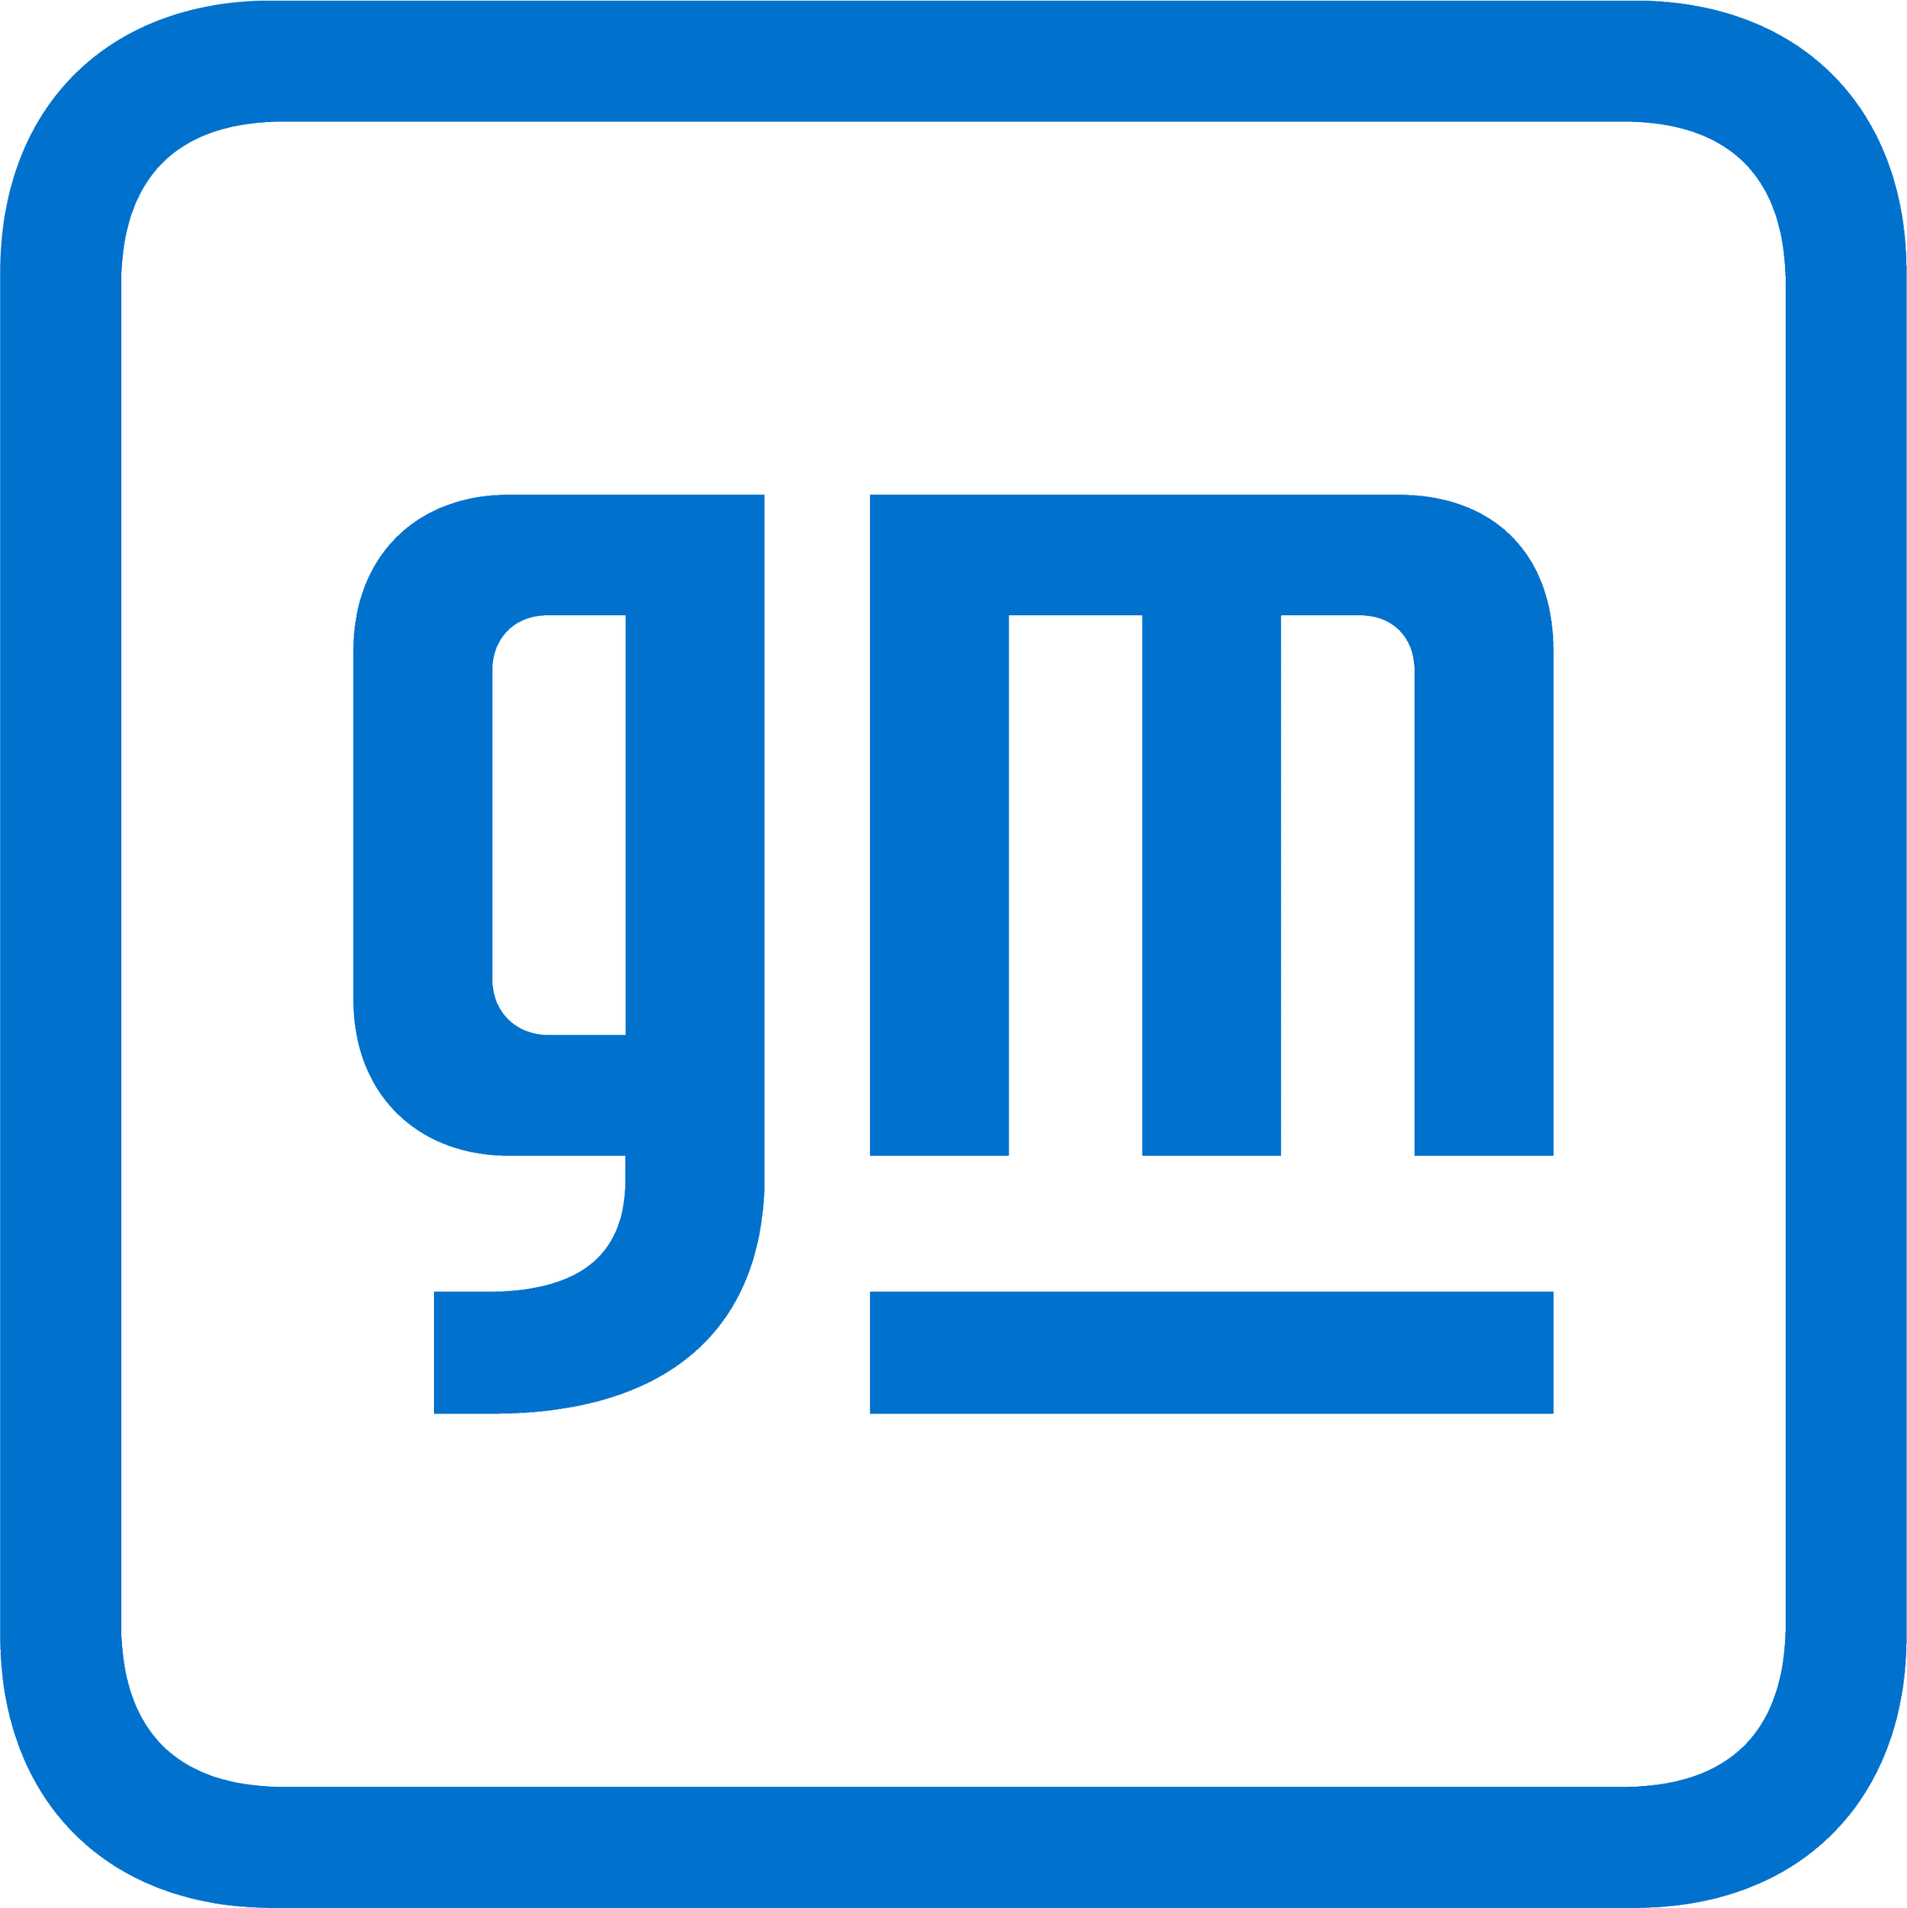

GM 2

Project Sponsors

Gordon Brown II

Detroit, Michigan

Fred Killeen

Detroit, Michigan

Tim Lumley

Detroit, Michigan

Spencer Searle

Detroit, Michigan

Michigan State University

Team Members (left to right)

Veeresh Rajendran

Kalamazoo, Michigan

Han Zuo

Lansing, Michigan

Muxing Dai

Hefei, Anhui, China

Sneha Sarkar

Al Khuwair, Muscat, Oman

Gram Boyle

Pleasant Ridge, Michigan

Muhammad Huwio

Ypsilanti, Michigan

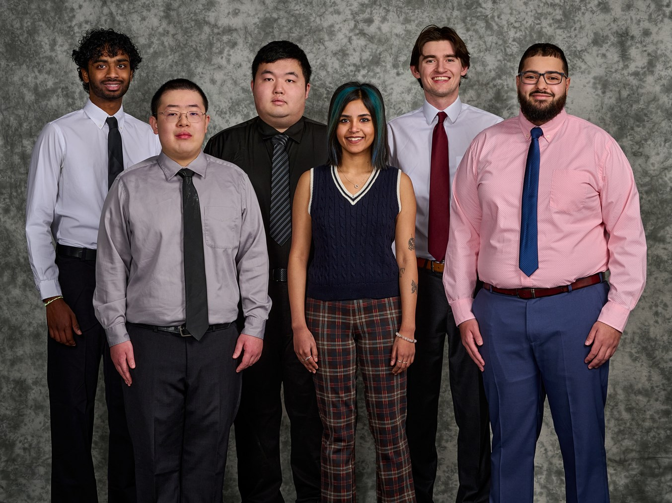

General Motors is an American automotive manufacturing company headquartered in Detroit, Michigan, and is the top automaker in the United States.

Application distribution is vital at General Motors given the diverse set of engineering and design applications needed during manufacturing. This distribution process is handled in a secure and efficient manner by an Application Lifecycle Framework.

Unfortunately, General Motors’ current application distribution solution is expiring, which necessitates the move to a new solution. The new solution replicates the functionality of the old application but also improves upon the existing process.

Our Application Lifecycle Framework facilitates easy request- submission for applications as well as providing a central hub for status information. It gives administrators, engineers, and testers fine-grained control during the distribution process.

When an employee needs an application on a company device for a work-related task, they submit a request to start the approval process. After submission, an administrator approves or denies the request before assigning a priority as well as an engineer for the next step. Finally, the engineer coordinates with cross-testers and distributors to complete the process. To keep all stakeholders updated, each stage of the process generates a notification.

Our web application features an easy-to-navigate user interface for non-technical personnel as well as an intuitive email notification system to keep users updated at every step of the process. This increases transparency and clarity, reducing internal errors.

For the front end, our application uses Angular, HTML, and CSS. Our system uses a MariaDB server running on Ubuntu for the back end. To communicate between the back end and front end, our application uses Tomcat with Spring Boot to serve HTTP endpoints.

The Capstone Experience

General Motors

Application Lifecycle Framework