Design Day Booklet Team Page

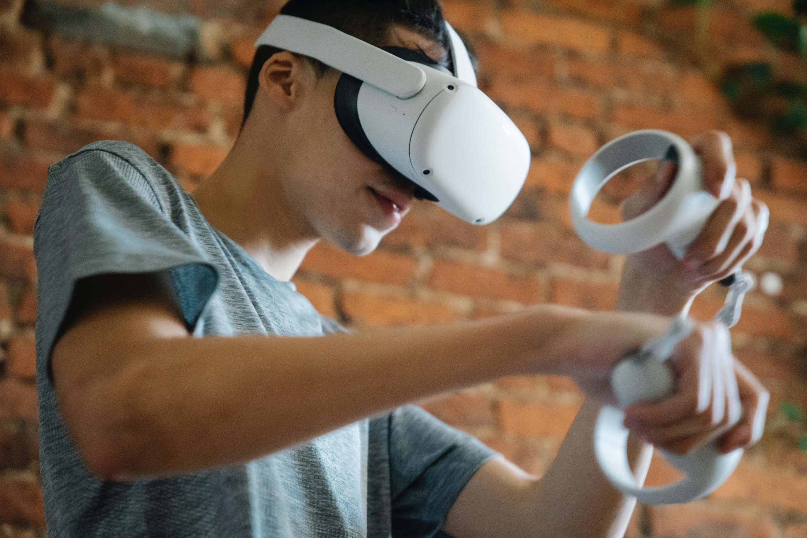

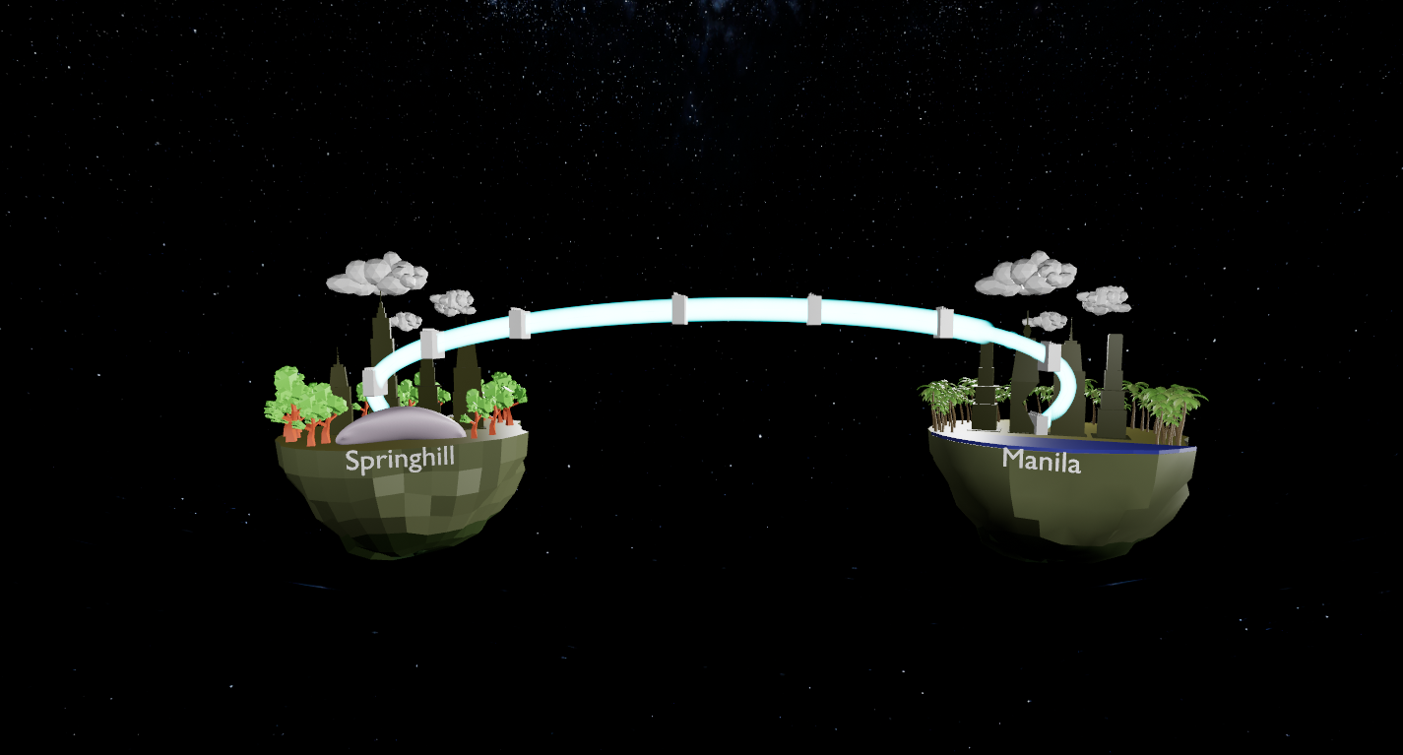

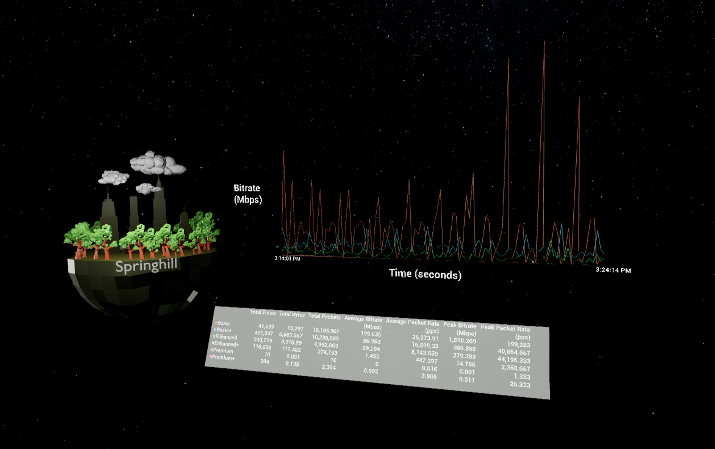

PAGE N + 9



GM 1

Project Sponsors

Paul Bester

Detroit, Michigan

Brian Chubick

Austin, Texas

Fred Killeen

Detroit, Michigan

Spencer Searle

Detroit, Michigan

Michigan State University

Team Members (left to right)

Adam Anderson

Oakland, Michigan

Yilong Xie

Chengdu, Sichuan, China

Nick Wang

Mount Pleasant, Michigan

Keerthi Gogineni

Guntur, Andhra Pradesh, India

Eric Gabbard

Westland, Michigan

Paul Schulte

Livonia, Michigan

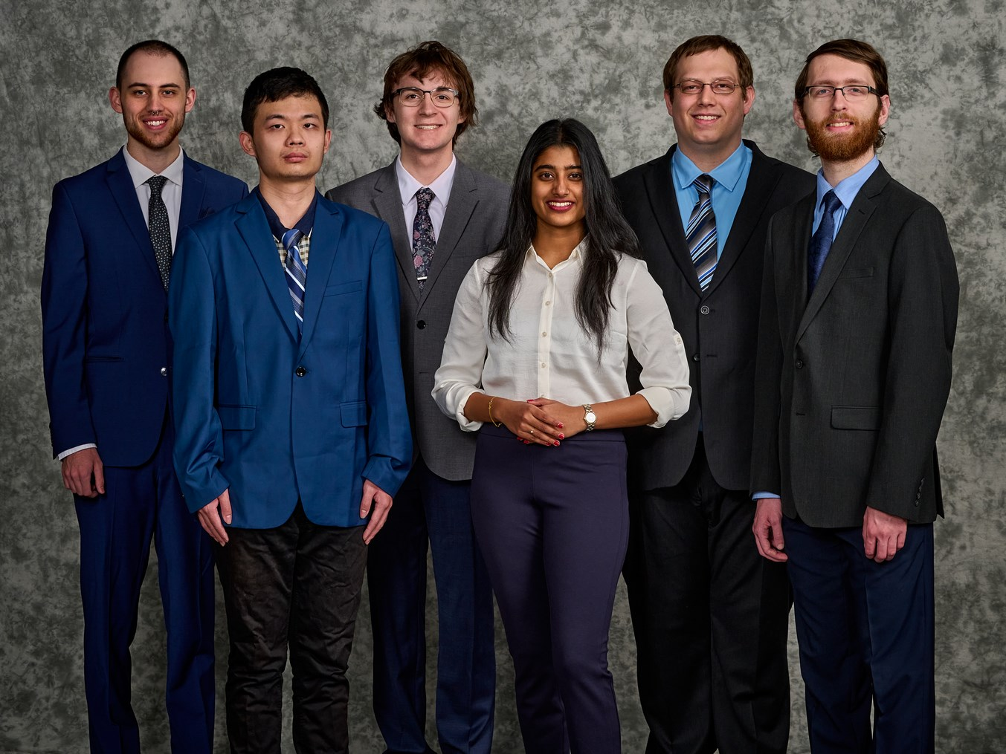

General Motors (GM) is a global automotive company with an extensive network infrastructure that facilitates communication between its various facilities worldwide. They are the top automaker in the United States.

Managing GM data centers effectively can be challenging due to the size and complexity of their computer network, requiring many systems and analysts to manage.

Our Virtual Reality Network Monitoring tool enables GM employees to monitor their global enterprise network's physical, logical, and digital traffic flows from anywhere in the world. Our tool provides a more interactive and holistic experience, giving users a better understanding of how data moves within the GM network. With our tool, users can quickly identify infrastructure errors and easily diagnose them.

Our application facilitates user interaction with any GM data center and monitoring of its traffic with three-dimensional virtual visualizations. The tool enables users to select data sites they want to monitor from a menu option, view detailed information about a connection, such as circuits, IP addresses, and packets moving between them, and diagnose issues more comprehensively.

Users can pause the scene, select each individual packet to get more information, and even modify the display brightness, text size, and background color. The experience of using our tool leads to quicker and better network management for GM.

Our application is built on Unreal Engine 5, which processes and displays the data and environment with which the user interacts. Our tool includes the use of both UE5 and C++ for data processing and rendering.

MySQL is used for packet information storage, and WireShark is used to read the packet capture data file, enabling easy exporting of data into various formats.

Computer Science and Engineering CSE 498

General Motors

Virtual Reality Network Monitoring