Design Day Booklet Team Page

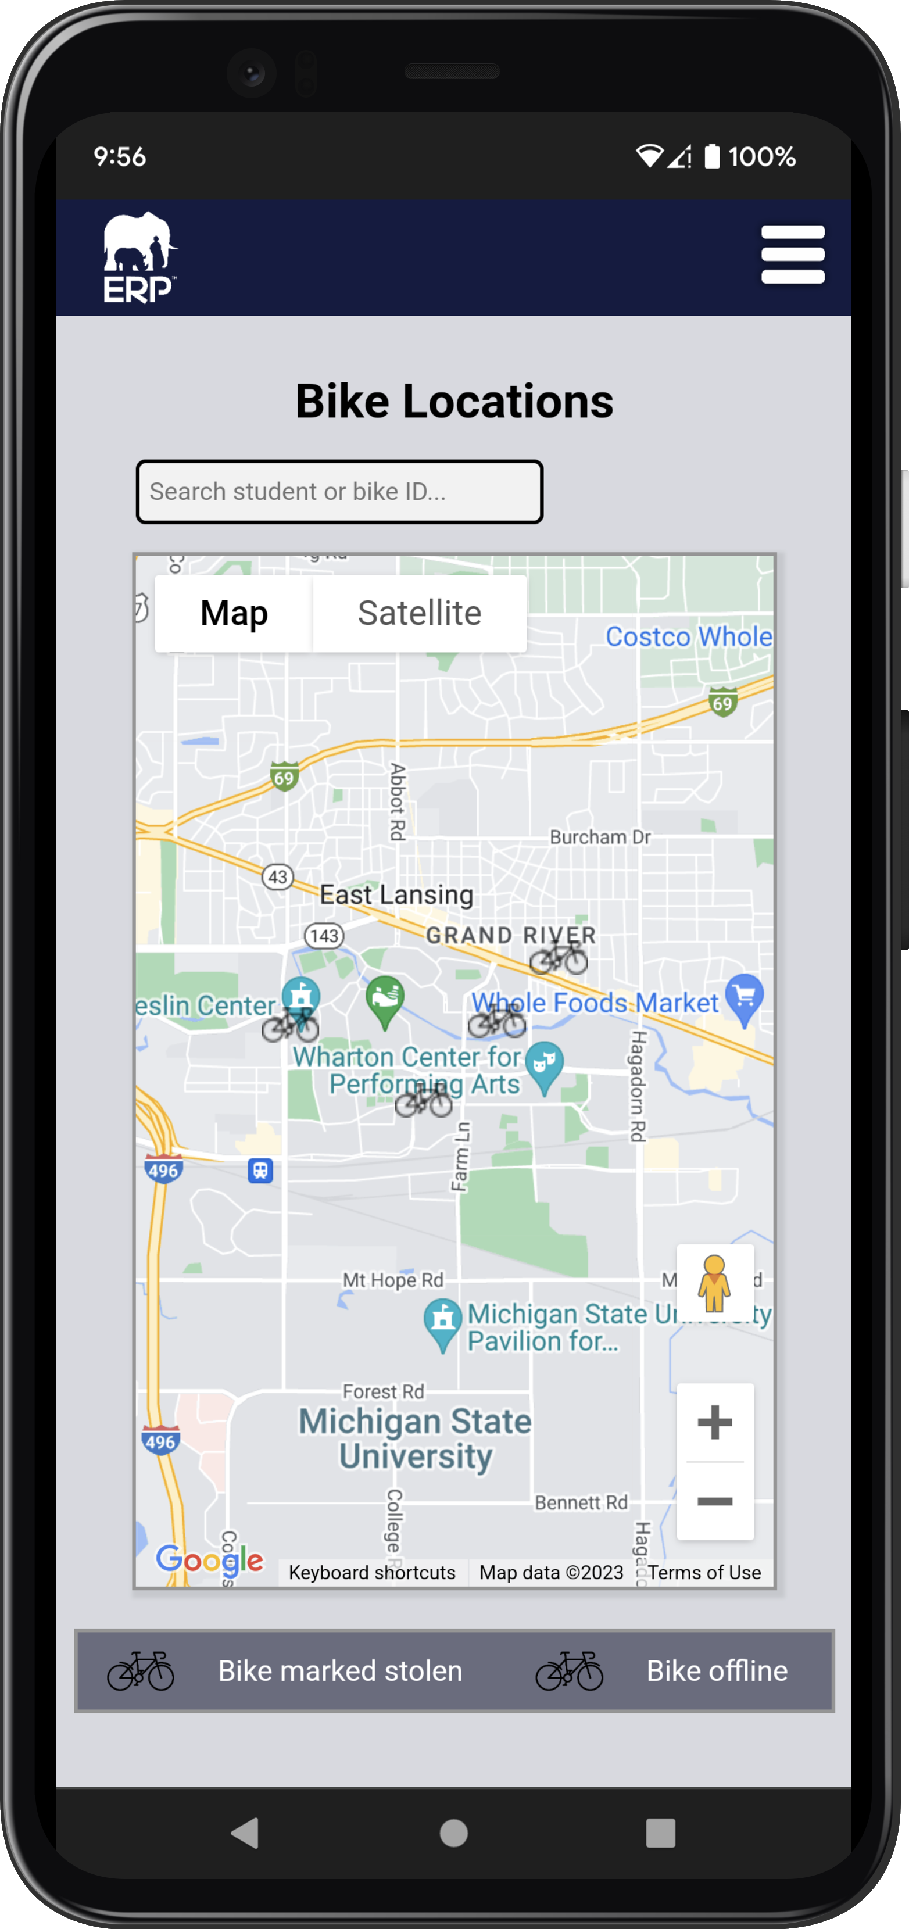

PAGE N + 8



Evolutio

Project Sponsors

Jordan Cobe

Lansing, Michigan

Jon Dressel

East Lansing, Michigan

Emmanuel Enzenwa

Houston, Texas

Daniella LaGuerre

Washington, D.C.

Jon Rigual

Eau Claire, Wisconsin

Michigan State University

Team Members (left to right)

Jason Mih

Kalamazoo, Michigan

Austin Stickney

Williamston, Michigan

Dorian Smalley

Detroit, Michigan

Samantha Kissel

Clarkston, Michigan

Zhilong Feng

Wuhan, Hubei, China

Nick Filerman

Buffalo Grove, Illinois

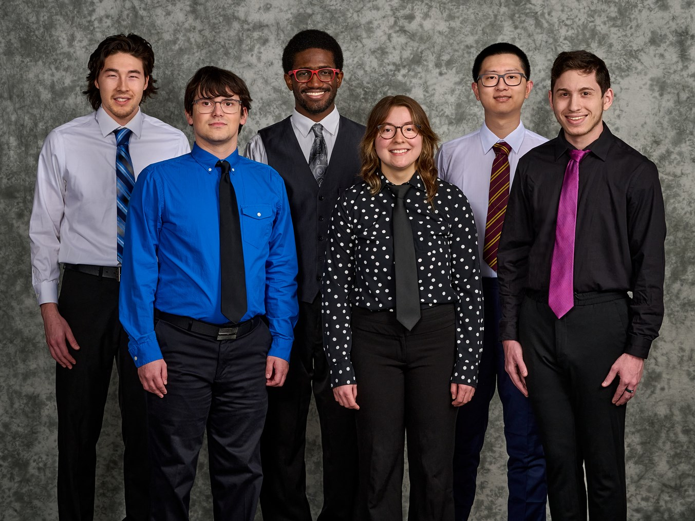

Evolutio, based in Chicago, brings visibility, simplicity, and usability to complex enterprise platforms. Evolutio and its parent company EPI-USE, are part of the groupelephant.com nonprofit. One part of this nonprofit, #BIKES4ERP, donates bicycles to rural children, mobilizing them to realize their dreams at school.

Unfortunately, there have been cases of these bikes being lost or stolen, with minimal chances of recovery.

Our #BIKES4ERP Tracking tool solves this issue by providing live tracking and alerts for the statuses of bikes through an intuitive web application.

In our tool, admins can add bikes and users of any lower-tiered role to the system. Once added to the system, a bike icon appears on the map on the home page with the color denoting its status.

Teachers with bikes assigned to them by an admin can add a student and pair them with their bike via the system page.

The status of a bike can be updated either automatically or manually. The system marks a bike as possibly stolen if it detects suspicious activity, such as traveling at a high speed or going offline for too long. The status remains as such until manually reverted. All users can make manual status updates to bikes determined by their role. Admins and mechanics can update the status of all bikes in the system, while students and teachers can only change the status of a bike assigned to them.

When a bike is marked as stolen, the assigned teacher and student receive a notification via e-mail and text. The teacher, student, mechanics, and admins are all informed through an alert on the alerts page.

Our system uses TypeScript-based ReactJS for the web page proper. Data communications are received and processed using Amazon web services (AWS). The Harness CI/CD software delivery service keeps our system updated.

The Capstone Experience

Evolutio

#BIKES4ERP Tracking