Design Day Booklet Team Page

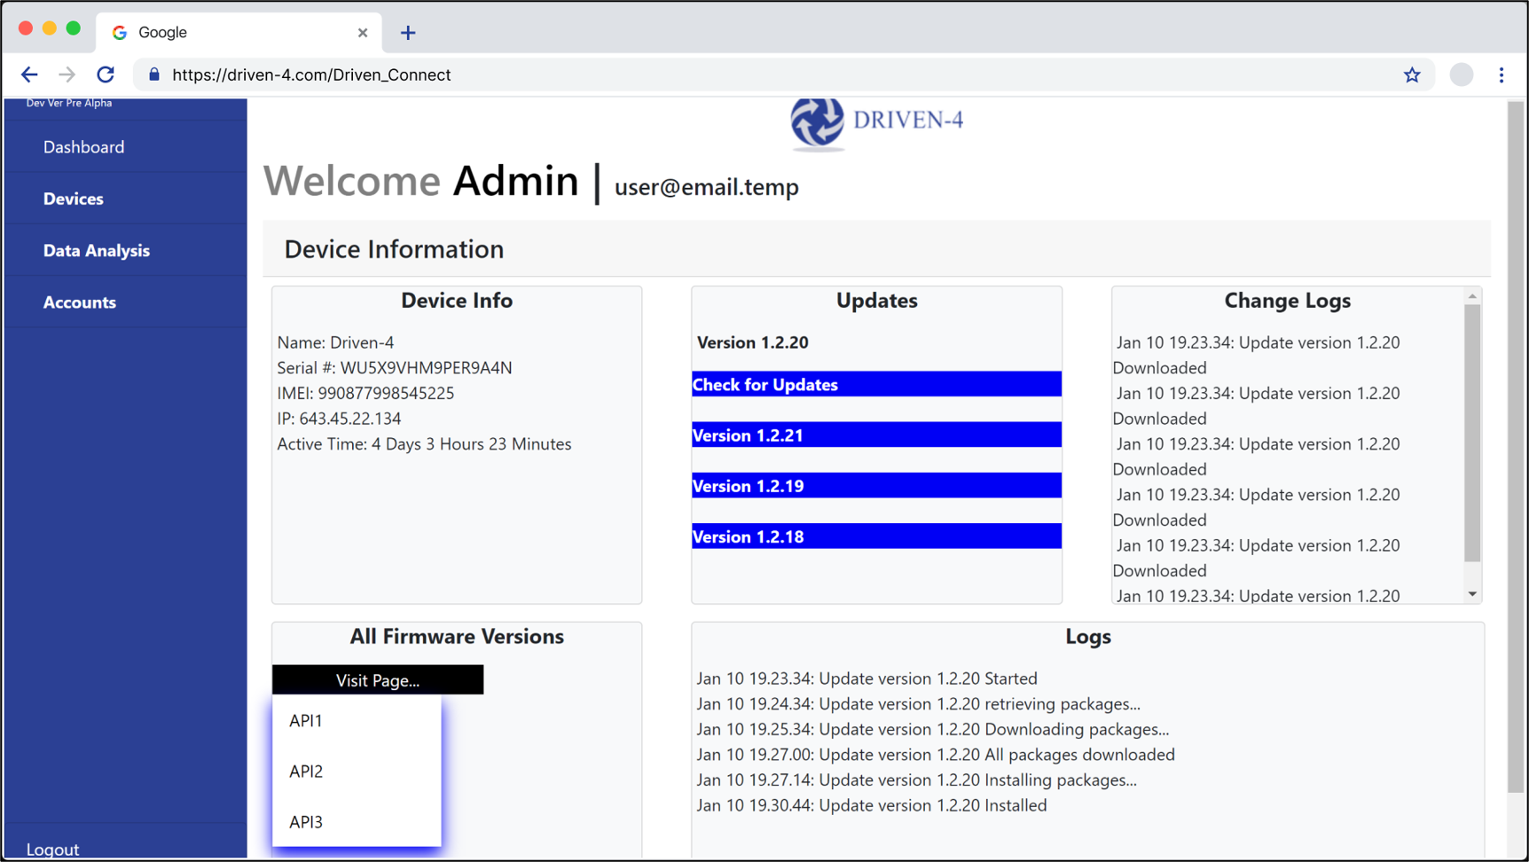

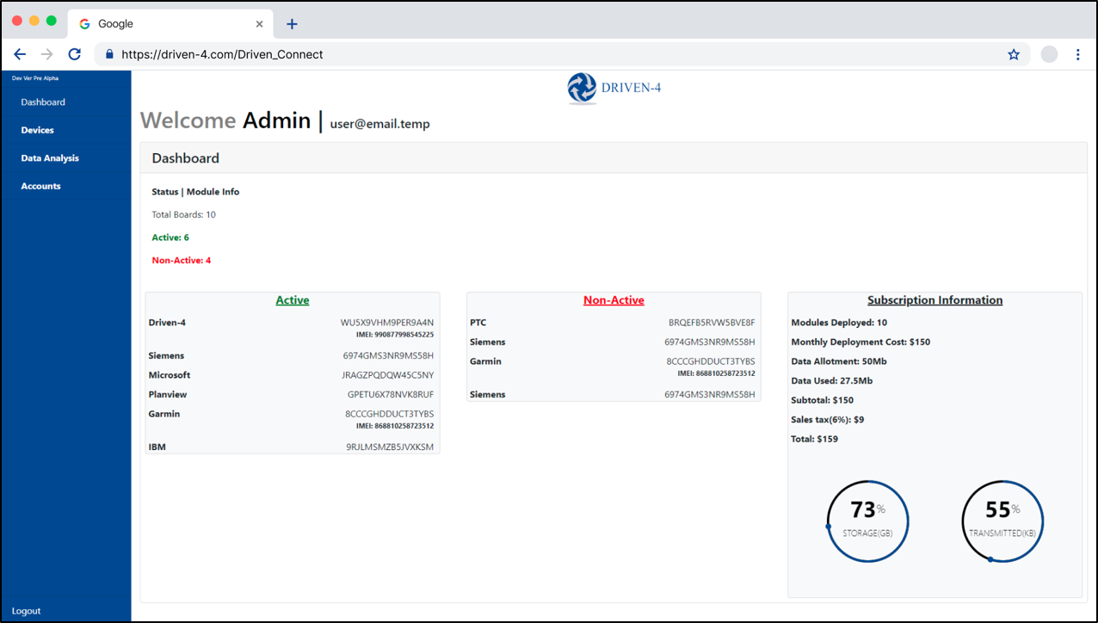

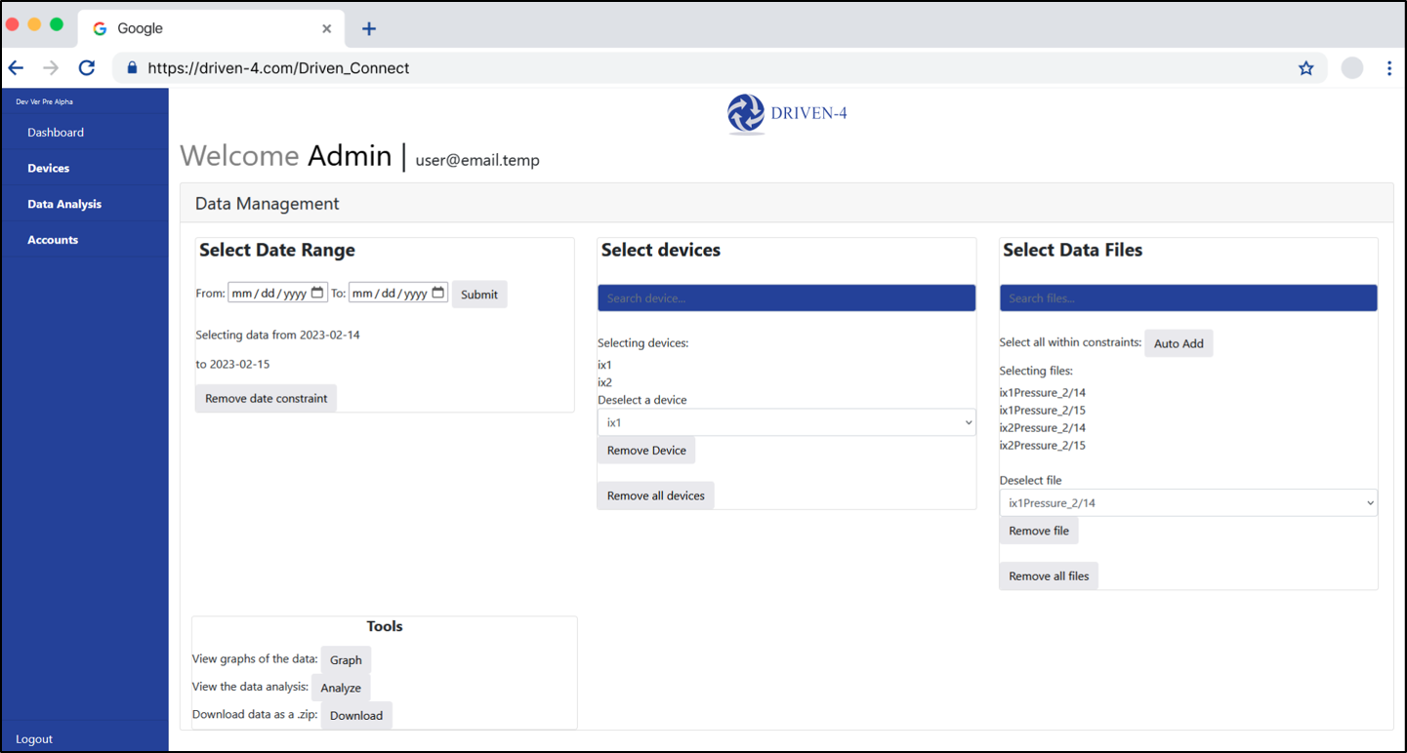

PAGE N + 7

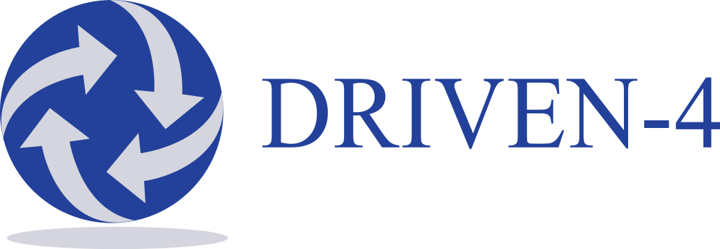

DRIVEN-4

Project Sponsors

Fred Bellio

Saint Joseph, Michigan

Ryan Slaugh

Saint Joseph, Michigan

Carl Wendtland

Saint Joseph, Michigan

Michigan State University

Team Members (left to right)

Dorian Florescu

Saline, Michigan

Anthony Eid

Troy, Michigan

Ryan Dukovich

Frankenmuth, Michigan

Dongyu Lyu

Shenzhen, Guangdong, China

Tim Nwanze

Ikoyi, Lagos, Nigeria

Jonathan Yamashita

Commerce Township, Michigan

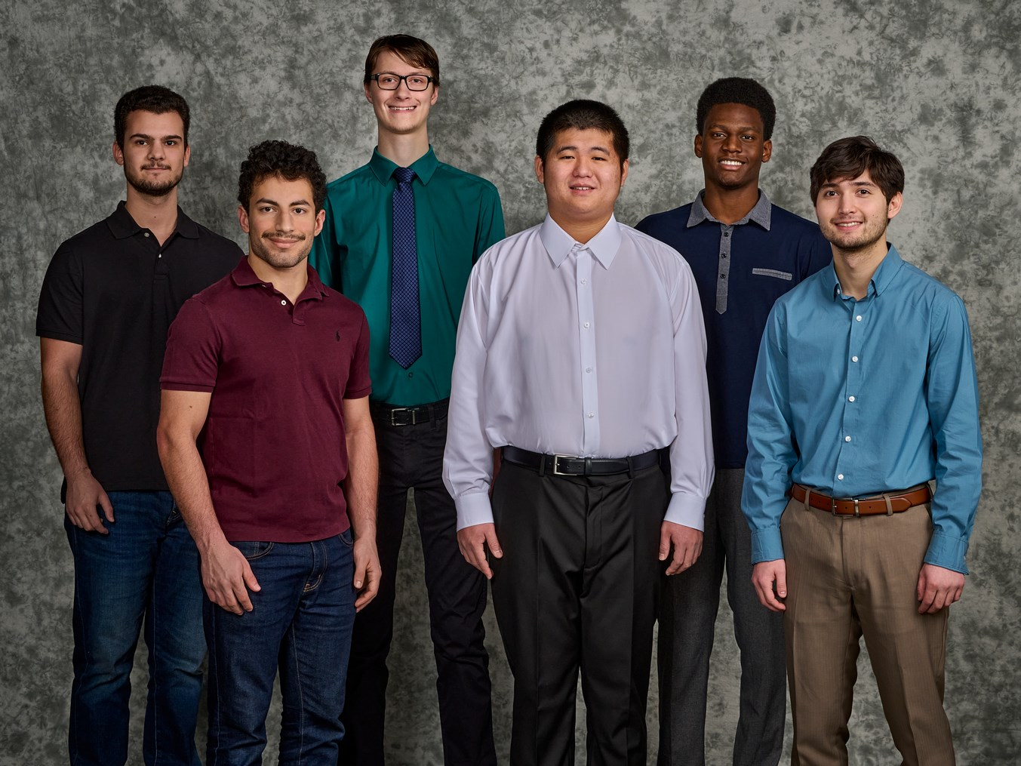

DRIVEN-4, recently founded in 2016 and headquartered in Saint Joseph, Michigan, provides industry-specific expertise and technological solutions to clients in the areas of Product Lifecycle Management (PLM), connected product development (IoT), connected operations (IIoT), cloud services, and cybersecurity.

Currently, DRIVEN-4 utilizes two core technologies for connected product development and operations: PTC’s ThingWorx and Digi’s Remote Manager. Together, they provide decentralized management and monitoring of remote devices. Users connect their devices to the Internet, monitor device health and storage, manage device firmware, download data from devices, and perform data analytics and visualizations.

As DRIVEN-4 scales up in size, they are developing their own IoT Driven Connect Board that collects data from the device’s sensors. Hosting, interacting with, and storing data from these new boards require a robust and cost-effective solution.

Our Driven Connect Application, Server, and Backend tool solves this issue with a single, streamlined web application. Registered users of an organization connect with their devices over the Internet where they can view and download device data. Users can perform custom data analytics and visualizations on collected data.

Within an organization, administrative accounts manage their users and boards. This includes adding new users, along with updating existing users’ settings, and pushing mass firmware upgrades or downgrades, to any selected boards.

Lastly, DRIVEN-4 server administrators manage all organizations’ users and admins, implement system level settings on devices, push firmware and enable/disable devices.

Our application is built using Python Flask, MySQL databases, and an FTP server for over-the-air firmware updates.

Computer Science and Engineering CSE 498

DRIVEN-4

Driven Connect Application, Server, and Backend