Design Day Booklet Team Page

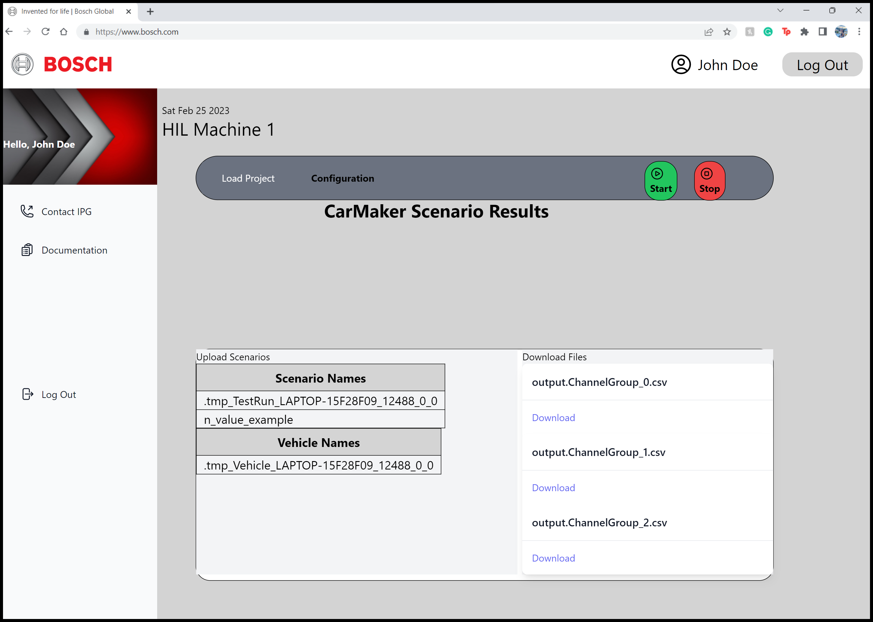

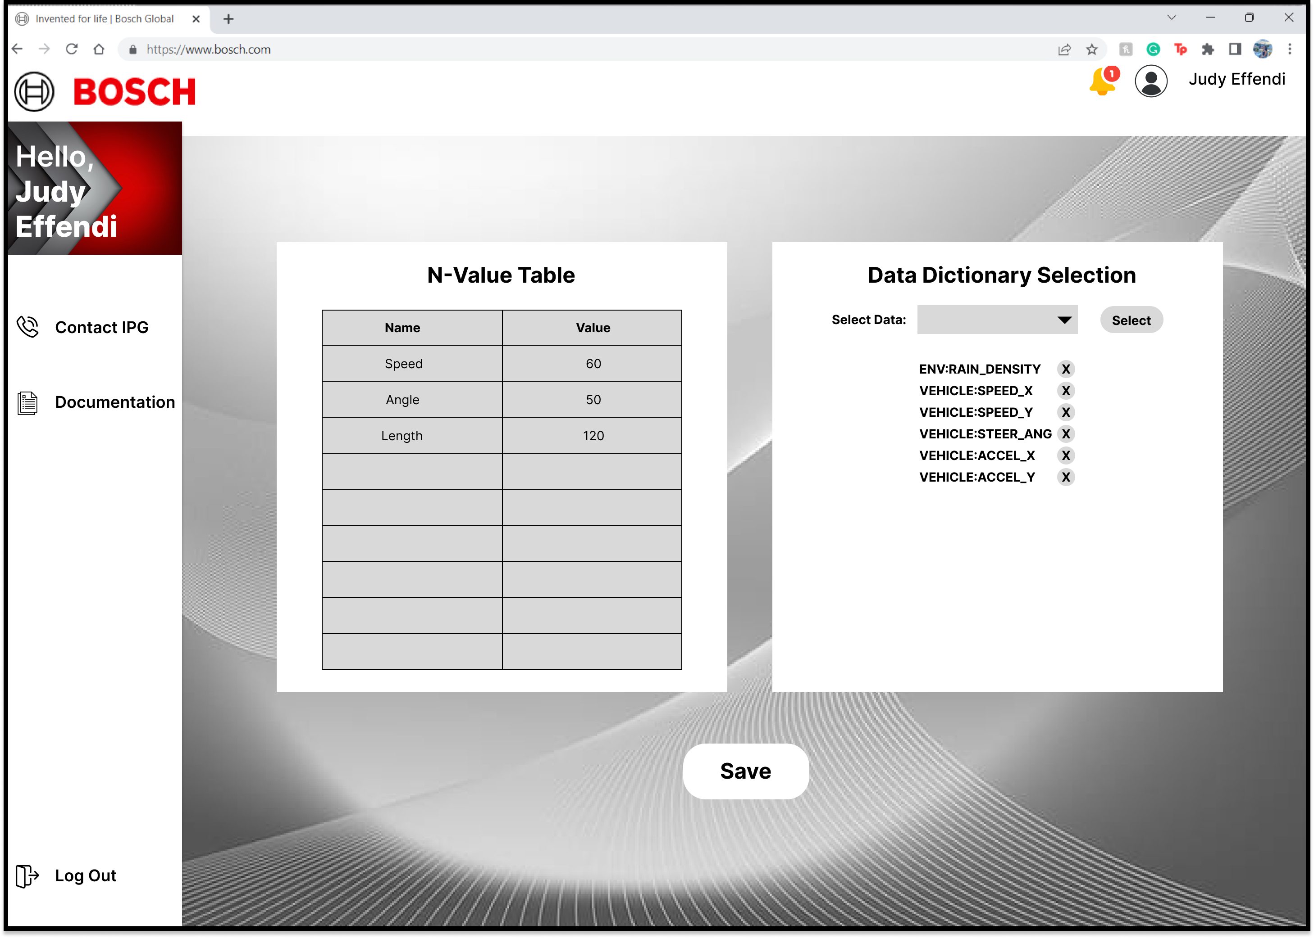

PAGE N + 6



Bosch

Project Sponsors

Troy McCormick

Plymouth, Michigan

Lucas Ringe

Plymouth, Michigan

Jian Tang

Plymouth, Michigan

Michigan State University

Team Members (left to right)

Nicholas Ly

Glendale Heights, Illinois

William Lu

Linyi, Shandong, China

Alhassan Diallo

Detroit, Michigan

Judy Effendi

Troy, Michigan

Tom Ladouceur

Farmington Hills, Michigan

Kevin Meehan

Waterford, Michigan

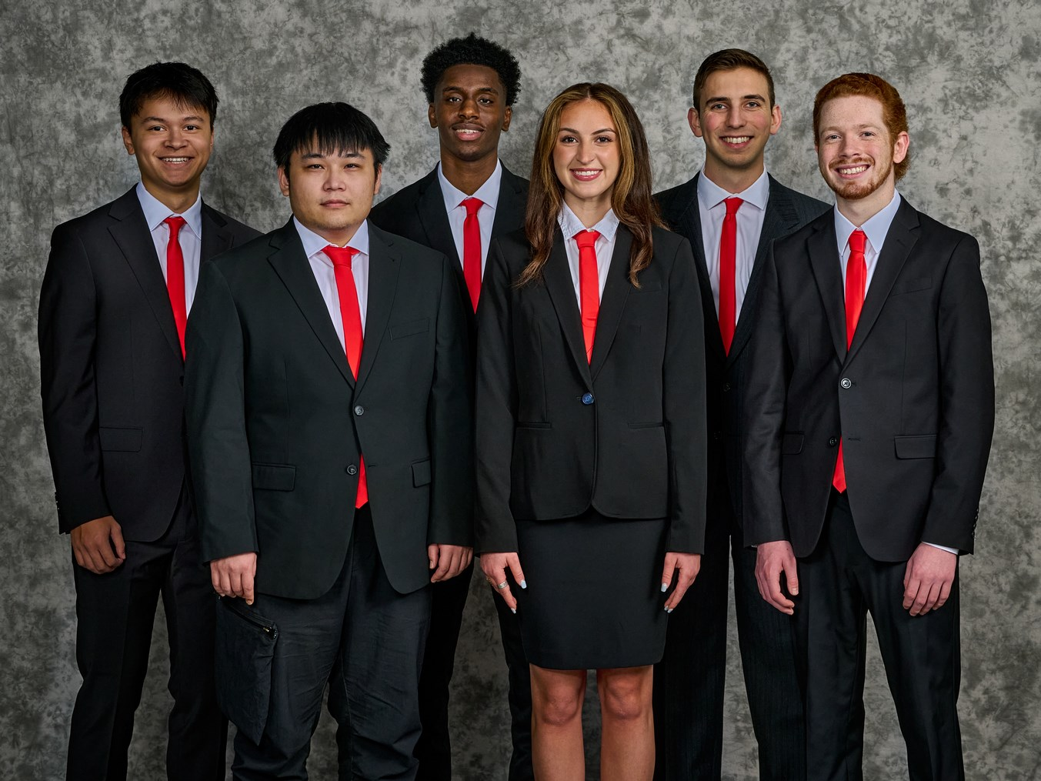

Bosch, founded by Robert Bosch, is a German multinational engineering and technology company headquartered in Gerlingen, Germany. Bosch is a leading global supplier of automotive technology and services, having more than 100 locations all over the world.

Bosch is a world leader in developing solutions for autonomous vehicles, and is on the forefront of creating, prototyping, and testing both hardware and software for these vehicles. Bosch utilizes the CarMaker simulation software to run complex simulations to test autonomous vehicles. However, CarMaker must be run on specialized workstations not present in every office, making it difficult for Bosch staff to use CarMaker on the fly.

Our Web Interface for CarMaker Simulation Tool provides an easier, more efficient way for Bosch engineers to communicate with CarMaker simulators to load, run, and view the results of their simulation without ever having to touch a physical computer or install any software.

Bosch engineers have the ability to load scenarios and vehicle models, change parameters in the scenarios, start and stop simulations, view the simulation status, and download simulation results remotely utilizing an easy-to-use web application.

Users can select the specific machine they want their simulations to run on, giving the maximum amount of control to engineers so they may further fine tune tests.

Through this application, Bosch engineers can utilize our web application to provide safer and more secure autonomous vehicles in the future.

The front end is built with SvelteKit and Tailwind CSS. The back end is built using Python and Flask. The back end sends HTTP requests to interact with the CarMaker API. A SQLite database is hosted on Bosch’s local network to store user log-in data.

The Capstone Experience

Bosch

Web Interface for CarMaker Simulation Tool