Design Day Booklet Team Page

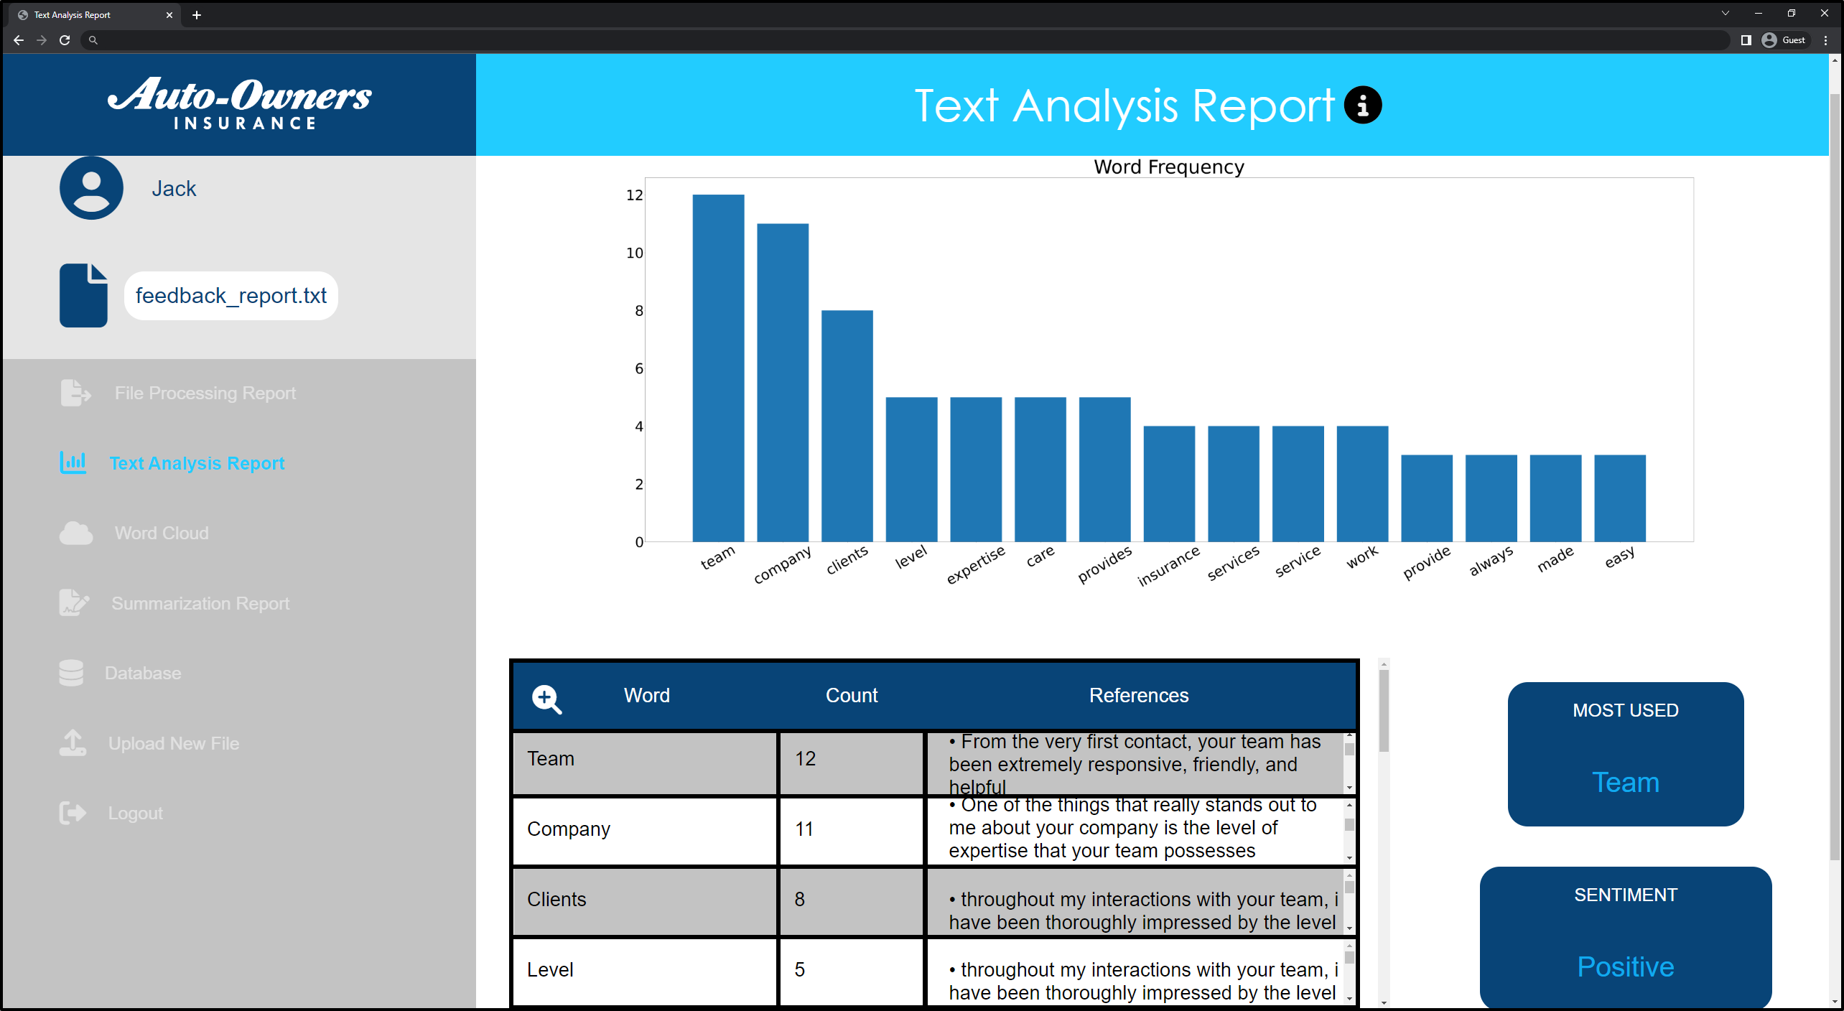

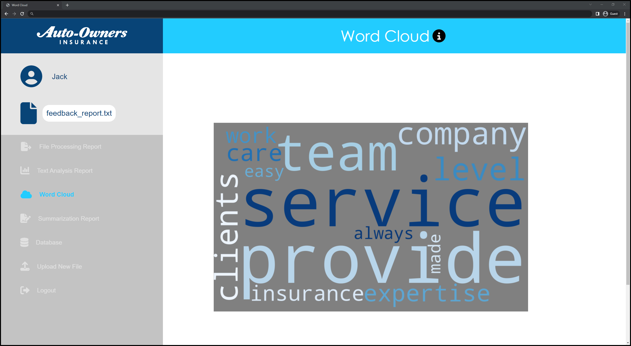

PAGE N + 5



Auto-Owners

Project Sponsors

Tony Dean

Lansing, Michigan

Ross Hacker

Lansing, Michigan

Scott Lake

Lansing, Michigan

Michigan State University

Team Members (left to right)

Jonathan Kippe

Goodrich, Michigan

Brylee Pavlik

Freeland, Michigan

Tyler White

New Boston, Michigan

Thinh Nguyen

Muskegon, Michigan

Ian Byram

Grand Blanc, Michigan

Jiahui Hu

Beijing, Beijing, China

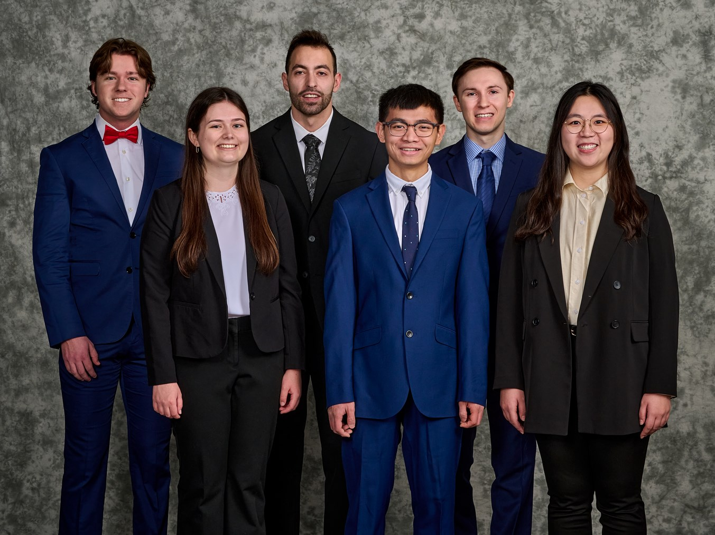

Auto-Owners Insurance is a Fortune 500 company headquartered in Lansing, Michigan. Auto-Owners is represented by 48,000 licensed insurance agents in 26 states and provides insurance to nearly 3 million policyholders.

As a major insurance agency, Auto-Owners receives thousands of feedback reports, employee surveys and branch audits. These documents provide Auto-Owners general information on how customers and employees view the company.

Currently, Auto-Owners employees manually review and extract key takeaways from these documents, a labor-intensive and time-consuming process.

The Summarizer is a web application that reduces the time needed to review documents by quickly processing them and distilling them down to key components for the user to view.

Users start by uploading a document they want summarized to the web application. Our software then processes the document and displays key metrics such as word frequencies, the overall sentiment of the document, as well as a document summary.

The metrics are displayed in a visually intuitive interface which includes tables, graphs and a word cloud. Users can click between tabs to view the different aspects of the summary report. Administrators can also view summary reports from previously uploaded documents.

Our software cuts down on the time Auto-Owners’ employees spend to understand the feedback they receive and gives them more time to act on it. This gives Auto-Owners the ability to make quick and effective changes so they can continue to deliver excellent service and quality products to their customers.

Our front end of the application is built with HTML, CSS and JavaScript, while the back end is implemented with Python Flask. The data for the application is stored in an SQLite database.

Computer Science and Engineering CSE 498

Auto-Owners Insurance

The Summarizer