Design Day Booklet Team Page

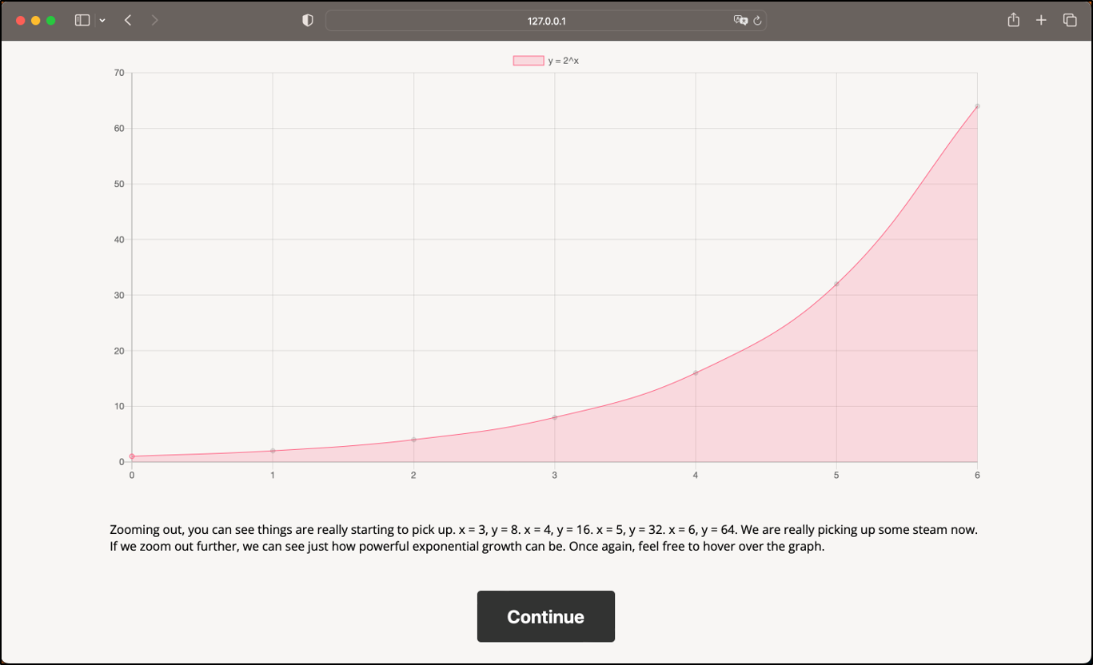

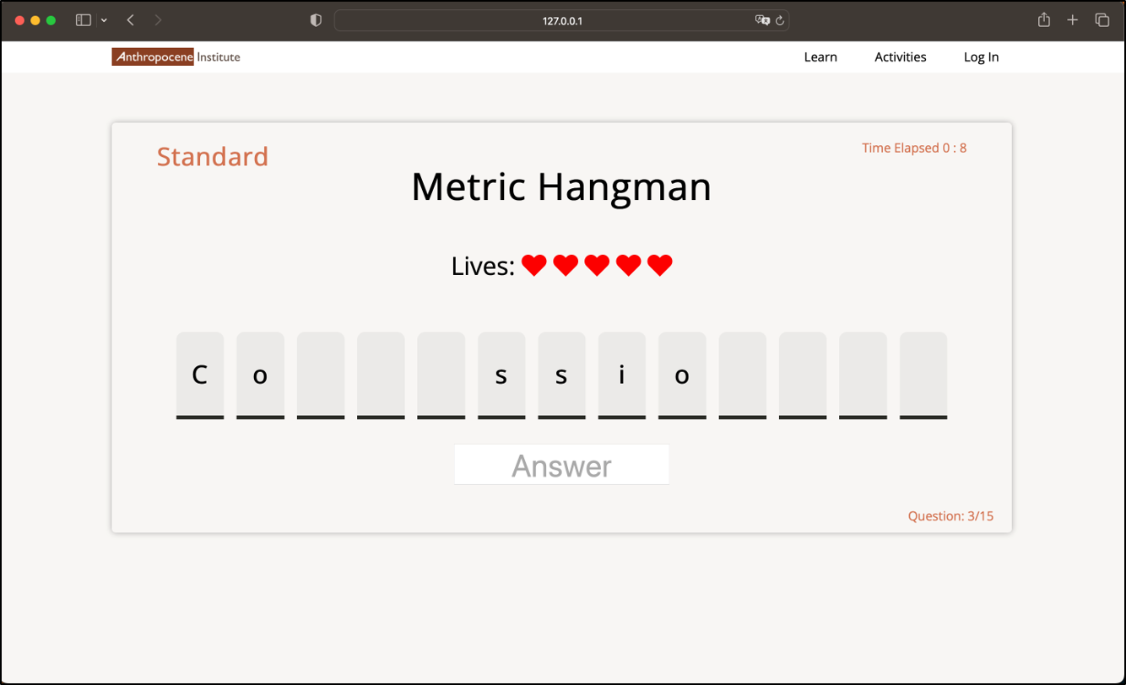

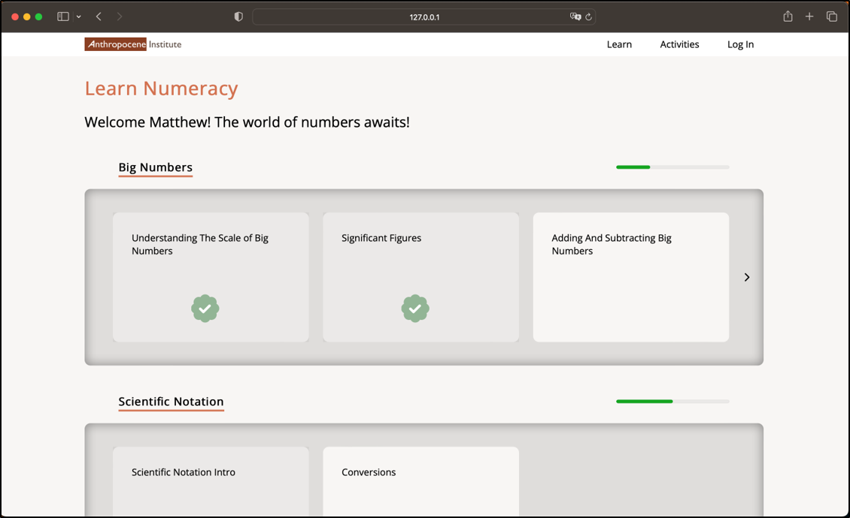

PAGE N + 4



Anthropocene Institute

Project Sponsors

Melinda Alankar

Palo Alto, California

Frank Ling

Tokyo, Japan

Carl Page

Palo Alto, California

Michigan State University

Team Members (left to right)

Xukai Fang

Hangzhou, Zhejiang, China

Matthew McDerment

Commerce Township, Michigan

Ricky Horan

Chicago, Illinois

Christian Vaughan

Dexter, Michigan

Daniel Passos

Ann Arbor, Michigan

Phumapiwat Chanyutthagorn

Buengkum, Bangkok, Thailand



The Anthropocene Institute is an organization that supports researchers, universities, and start-ups in a quest to advance necessary technologies for a better future. Their focus is currently on alleviating the current climate crisis.

In the modern day, critical thinking about numbers is a required skill for success. Being able to make quick, informed judgments with numbers is vital. Topics like government spending, bills, investing, and many more require this skill. However, many people today are currently lacking these abilities.

Our Machine Learning for Numeracy Training software alleviates this issue by educating the public about numeracy with an easy-to-use website that both teaches and challenges users.

The first component of our software is the instructional content, composed of three modules: big numbers, scientific notation, and units of measurement.

Each module holds a set of lessons. These lessons contain text, graphics, and questions that users interact with to master the topics. The user’s progress is saved and viewable from the learn page indicated by progress bars. The user can interact with an AI chatbot for assistance at any time during their learning process.

The second component of our software is the activities. There are two main games offered: metric hangman, and estimates. Metric hangman is a classic game of hangman; however, users input metric prefixes as their guesses, either the literal prefixes or their numerical value. Estimates is a guessing game in which users are prompted with quick questions to answer about a range of topics. Their answers are graded on both speed and accuracy.

The front end of our software is written in HTML and JavaScript. The back end is composed of a mySQL database and Flask for storing and rendering content for games and user information. The software utilizes OpenAI’s GPT-3 API to support the chatbot.

The Capstone Experience

Anthropocene Institute

Machine Learning for Numeracy Training