Design Day Booklet Team Page

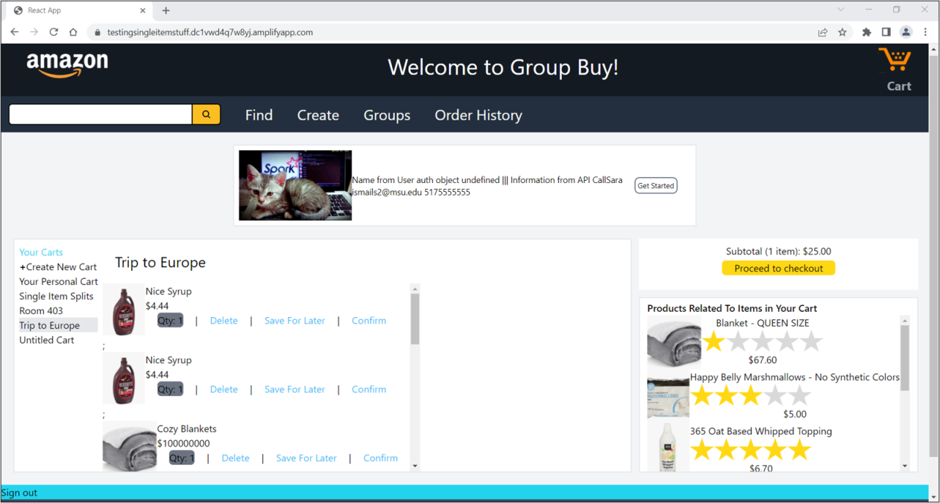

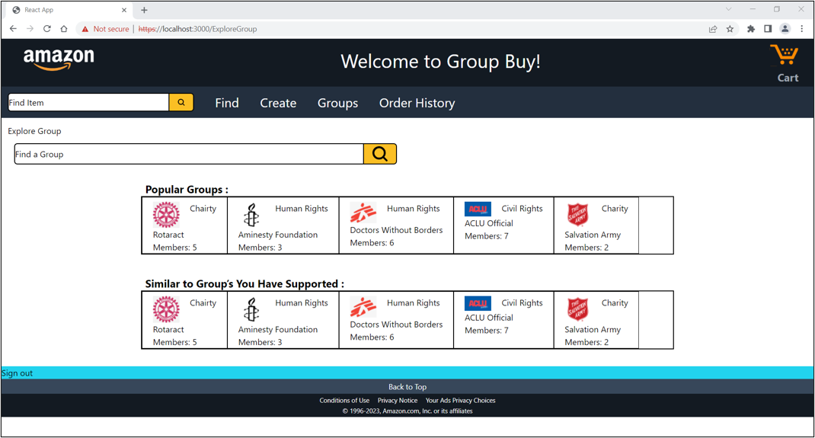

PAGE N + 3



Amazon

Project Sponsors

Jacob Ackley-Smith

Detroit, Michigan

Zach Arnold

Detroit, Michigan

Tejas Bharath

Detroit, Michigan

Garret Gaw

Detroit, Michigan

Derek Gebhard

Detroit, Michigan

Varun Mantri

Detroit, Michigan

Mitchell Morrell

Detroit, Michigan

Michigan State University

Team Members (left to right)

Ryan Conley

Grayslake, Illinois

Sungyu Kwon

West Hartford, Connecticut

Ashrey Gupta

Ludhiana, Punjab, India

Sara Ismail

Novi, Michigan

Rashad Abada

Grand Rapids, Michigan

Zane Aridi

Dexter, Michigan



Amazon is a multinational technology company that has grown to become the world’s largest online retailer. Founded in 1994 by Jeff Bezos, Amazon has since expanded into various industries, including cloud computing, digital streaming, and artificial intelligence.

By practicing customer obsession, Amazon delivers products that bring joy and utility to their customers. The company provides shoppers with an intuitive purchasing experience, enabling items to be added to a customer’s cart quickly and seamlessly. Amazon is consistently thinking about different features to enhance their product purchasing process. Currently, customers must utilize third-party services to share expenses, without a way to do so on the Amazon retail website.

Our Amazon Group Buying Tool enhances the shopping experience by enabling users to form groups, initiate purchases with other customers, and share costs among group members. The tool also helps users to search for products and receive product recommendations based on group information and products in their cart.

Our software significantly reduces the time needed to buy items in collaboration with other customers. It also simplifies the process of purchasing items that may be challenging to afford individually, leading to an increase in sales.

The tool also makes donating to organizations easier than ever by giving users a simple method to find and contribute to group wallets. Overall, our tool provides value to a wide variety of people.

The web application is responsive and scalable due to a robust set of Amazon Web Services. The front end is hosted on AWS Amplify and back-end requests are swiftly handled by API Gateway, Lambda, and DynamoDB. Product recommendations are managed by AWS Comprehend.

Computer Science and Engineering CSE 498

Amazon

Amazon Group Buying Tool