Design Day Booklet Team Page
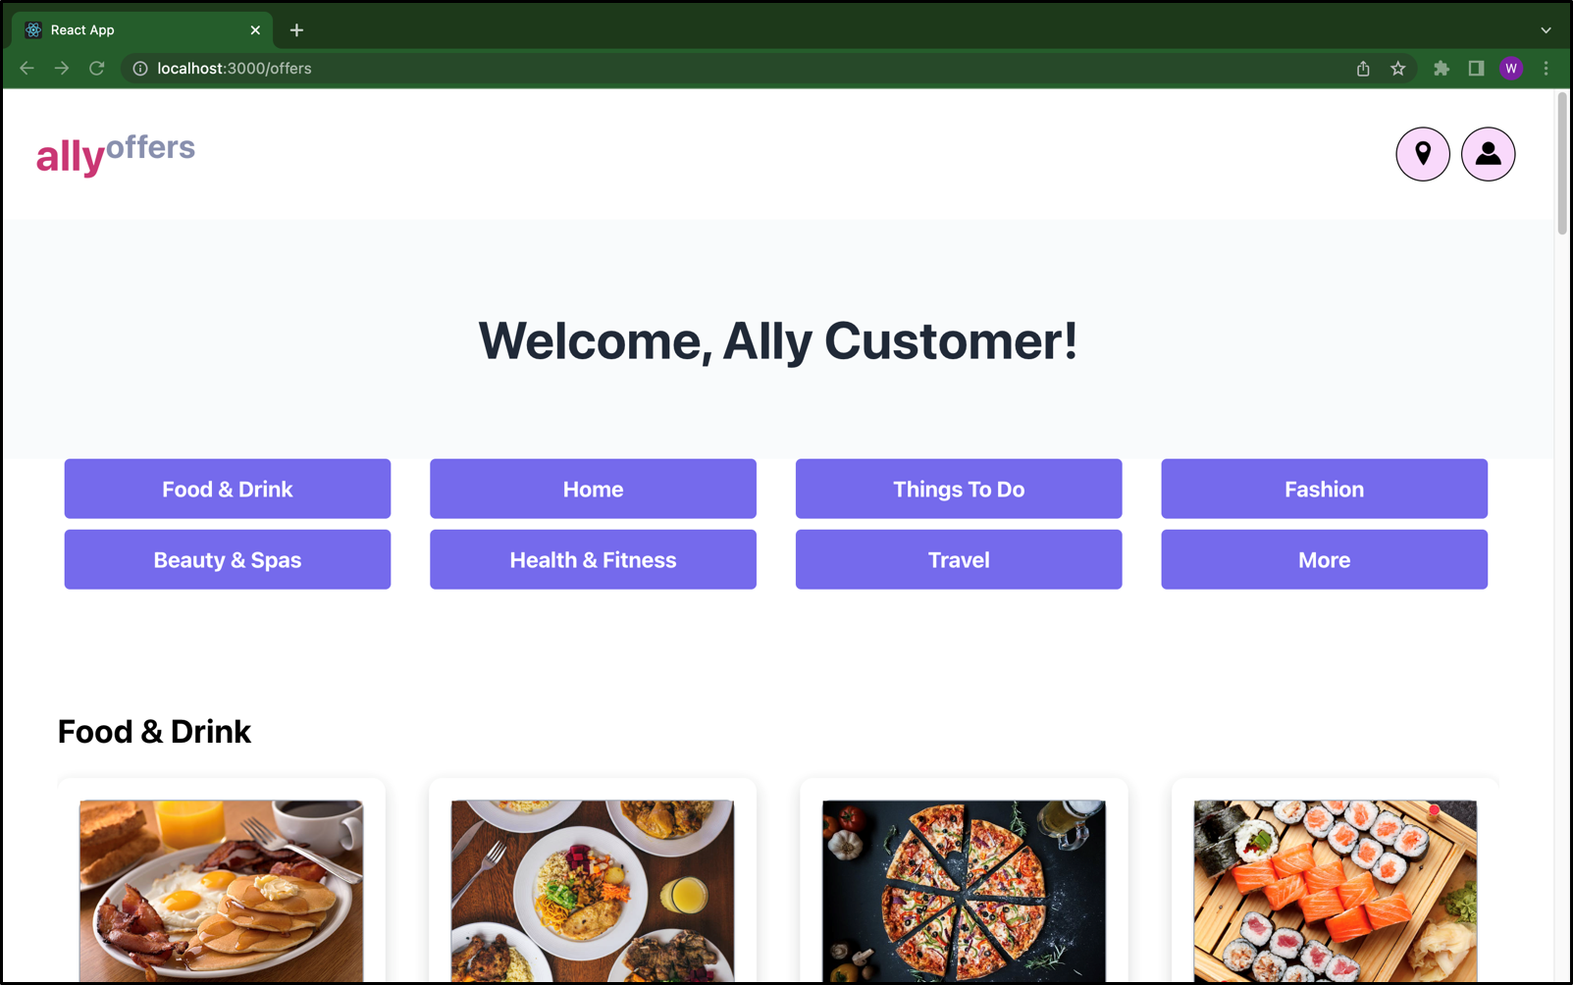
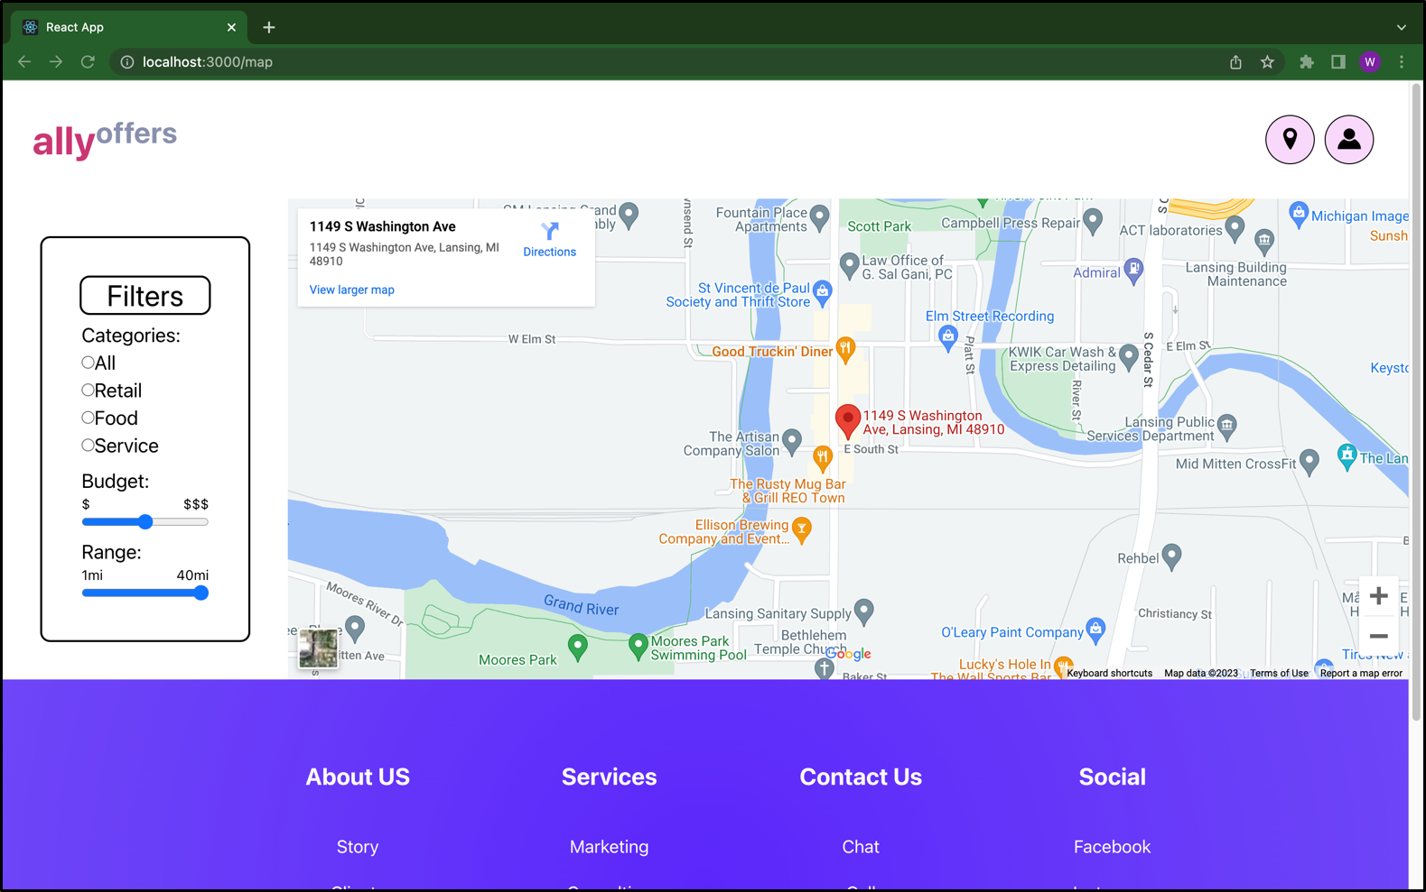
PAGE N + 2

Ally
Project Sponsors
Jared Allmond
Detroit, Michigan
Dzmitry Dubaru
Charlotte, North Carolina
Dallas Gale
Phoenix, Arizona
Dan Lemont
Detroit, Michigan
Harish Naik
Phoenix, Arizona
Susan Nord
Detroit, Michigan
Arvy Rajasekaran
Charlotte, North Carolina
Kevin Werner
Charlotte, North Carolina
Michigan State University
Team Members (left to right)
Jered Brophy
Rockford, Michigan
Aesha Ray
Rochester Hills, Michigan
Kainan Chen
Xiamen, Fujian, China
Charles Kellogg
Traverse City, Michigan
Jack Cruz Jr
Zion, Illinois
Winnie Yang
Chicago, Illinois

Headquartered in Detroit, Michigan, Ally is a top 25 financial holding company in the United States and a leader in digital financial services. Ally provides financial products for consumers, businesses, automotive dealers, and corporate clients in their commitment to digitalizing and innovating a seamless customer experience. As their name implies, Ally is committed to being an ally to their small business customers.
Ally customers and small businesses use our web application, Ally Offers Ecosystem, to help communities thrive and stay vibrant. Small businesses are often unable to gain traffic in their stores, as well as advertise themselves to a larger audience due to inexperience with technology or lack of a digital platform. Our Ally Offers Ecosystem helps small businesses reach a much broader audience, which in turn, benefits Ally customers too.
The platform gives access to businesses to register and upload their offers on a personalized dashboard. These offers are available to and accessible by all of Ally’s customers. A business can access a personalized dashboard with analytics displaying their performance. Depending on the success of their deals, they can upload, edit, or delete any ongoing offers they would like to advertise to their customers.
Ally customers access a separate dashboard with a multitude of categories of offers to choose from, as well as save their coupons on their profile. Customers can set filters to personalize their interests, which are reflected in a map view of nearby offers. This shows Ally customers appropriate deals and ways to save when visiting businesses partnered with Ally.
Our application is written in HTML, CSS and JavaScript and is powered by the React framework. Our web app interacts with MongoDB and Express to connect to AWS and offers machine learning capabilities.
The Capstone Experience
Ally Financial
Ally Offers Ecosystem

