Overview
One aspect of Design Day is the Design Day booklet, which is a professional, full-color, glossy publication. Each team will have one full page in the booklet to describe their project.
As with all such publications, in order for the booklet to be designed, laid out, edited, proofed and printed well before Design Day (which is on Friday, December 11, 2020), you will need to submit your team’s copy and artwork to Dr. D. much earlier, in particular, by 11:59 p.m. Saturday, October 10, 2020.
So, here’s what you need to do…
There is a Microsoft Word template in a zipped folder for each team on the course web site on the Downloads page. Click on your team name to download your zipped folder. Unzip it.
Also on the Downloads page are the Design Day Booklet Page Instructions (Slide Deck), the Design Day Booklet Production Schedule and the Design Day Booklet Production Calendar. Download and study all three of these.
Then, read these instructions carefully and repeatedly…
The Word Template
The Word template is intended solely to help you visualize how your page will appear. It is not camera-ready copy. A graphic designer will transfer the content that we provide to him into his system. Your task is to fill in the missing content and email the required things (see below) in your team’s zipped folder to me.
The Project Sponsor Name and Project Title
The project sponsor name and the project title must fit in the space provided using the given point size. You’ll see that the company name and project title have already been entered.
Note that the sponsor name may be different than your team name, depending on what your sponsor requested. So, for example, Team Ford’s sponsor name is “Ford Motor Company.”
Do not change either the project sponsor name or the project title, but do check the spelling of your project sponsor name and your project title.
The official project title is on the web site and should not be changed. Do not change your project title unless you get approval from Dr. D. first.
If, after obtaining permission from Dr. D., you do make any changes to the project sponsor name or project title, highlight all changes in yellow.
The Project Description
Your project description should, as expected, describe your project. The target audience should be on the level of a high school student. You will face at least two challenges. One challenge will be to describe something that is very complicated and technical using terms that are relatively simple and non-technical. The second challenge will be to make it fit in the very limited space provided, which allows for about 250 words.
The project description must begin with sentence or two about your project sponsor. If your sponsor has sponsored projects in the past, look at previous Design Day booklets.
Feel free to borrow introductory sentences about your project sponsor from previous booklets, making sure to update any statistics such as, number of employees, number of stores, annual sales, etc.
Next, your project description should explain the motivation for the project. What’s the problem?
Avoid writing anything that might be construed as negative about your client. For example, projects often involve designing and building a software system to improve a client’s particular business process. So, do not write things like “Currently the way that our client does this-and-that is dumb, backwards and stupid. Our great system will replace their crappy system with something much better.”
After describing the problem, explain your solution.
Do not use phrases like “Our project was to make…” or “For our project, we…” or “Our client asked us to make…”.
When first introducing your project software, use your project title as in “Our Training Scheduling and Optimization System II provides a web app to facilitate United’s maintenance training schedulers to schedule instructors, students, and courses across the country.” Subsequently, refer to your project as “Our system…” or “Our software…”
When explaining your software, if possible, use words or phrases that appear in the project title to connect your project title to your project description.
Do not write things like “…our software system aims to …” or “…our software system strives to ….” What, your software aims to do something, but doesn’t? It strives to do something, but it doesn’t? Instead, simply write things like “…our software system does this or that…”
And finally, your project description should end with two to three lines of technical information.
Use a “newspaper” style of writing. Sentences and paragraphs should tend to be short and snappy. It’s even okay to have a paragraph with only one sentence as long as you don’t have too many of them.
Write in the present tense throughout. So, even though your project is not complete do not write things like “The basketball timer software will keep track of…” but rather do write things like “The basketball timer software keeps track of…” Do not write things like “When a user presses the button, the results will appear.” Will appear? The results will appear? When? Do write things like “When a user presses the button, the results appear.” Get it?
Note that subjects and topics are not capitalized. So, words and phrases like computer science, mathematics, machine learning, natural language processing, data science, etc. are not capitalized. Of course, acronyms are capitalized. In general, do not use acronyms.
Note the difference between “front end” and “back end” versus “front-end” and “back-end,” the former being two separator words while the latter being two words joined with hyphens. Use “back end” and “front end” when the pair being used as a noun. For example, “Our front end is written in JavaScript, while our back end is written in Python.” Use “front-end” and “back-end” when the pair is being used as an adjective. For example, “Our front-end software is written in JavaScript, while our back-end software is written in Python.”
If you have a list of items separated by commas, in general do not use a comma before the “and” if the list is a list of simple items and there would be no confusion without the comma. Consider the following example: “The letters in the acronym RGB stand for red, green and blue.” Do not use a comma in such a case. However, consider the following example: “Before you can play video games, you must do your homework, wash your clothes, and clean your room.” In that case, use a comma.
At the end of this document is an Appendix of Spelling and Capitalization of Technical Terms. Consult it for the correct spelling and capitalization of technical terms.
Use the Word template AND the Windows Office 365 version of Word to create and edit your project description. DO NOT create the text for the project description using some other word processor (like Google Docs or an ASCII text editor) or even another instance of a Word document. If you do, you will most likely cause problems when you copy-and-paste the text from one document to the template that was distributed. The paragraph style of all of the project description paragraphs must be style “3-project-description.” If you copy-and-paste from another document, you run the risk of destroying the paragraph style. In addition, if you copy-and-paste from another document, you run the risk of introducing incorrect special characters like curly double quotes (“”) or curly single quotes (‘).
If some team members are working on the project description while others are working on the artwork, create two copies of the original template. In order to merge the two versions into a single document, simply copy-and-paste the project description to the copy of your template that contains the artwork. That way, the artwork will all be in place, and, since you’re copying the text from one copy of the template to another, the paragraph style will be preserved.
While using word, show all of the paragraph marks and other hidden formatting symbols by pressing the paragraph symbol in the Paragraph section in the Home ribbon.The Word template includes a paragraph style (3-project-description) for your project description. It uses 10-point, Californian FB font with single-spaced lines. Both margins are justified. Do not double space between paragraphs. Use one blank between sentences within a paragraph. Do not change this paragraph style. Make sure that the project description that you submit uses this paragraph style.
The size of the project description textbox is 3.5” (wide) by 4.8” (high). Do not change the size of this textbox. Your text must fit exactly within this textbox within these dimensions. This means you should have enough text to fill the entire textbox but no more.
After you have a draft, send the project description to your client for feedback and approval.
Look at The Capstone Experience booklets scattered around the Capstone Lab for ideas on how to write project descriptions. The same content can be found online in the project page for past teams. Just start at our Archives Projects by Semester page and click on links to previous semesters’ projects.
Also, look at the previous Design Day booklets. Design Day booklets from previous semesters are available on-line by following links from the Design Day booklet page.
As one more example, read the project description that Dr. D. wrote for the Spartan Basketball Player Timer. A link to it appears on the Downloads page under MSU Men’s Basketball.
Artwork
Your team should provide appropriate artwork that best represents your project for the space in the upper right. Artwork should include at least one or more screenshots. In general, the artwork should be actual screenshots of your software. The artwork should be something that is eye-catching.
Do not using boring or trivial screenshots such as login screenshots.
If your project involves devices with voice input, look at the web page of a former Team MSUFCU or their Design Day booklet (page 36) to see how they illustrated their apps.
Naturally, your projects are still in the alpha or beta stages. Pick the best screenshot or screenshots that you can as of now. It’s possible that your final product will look different and possibly better.
The template includes four textboxes reserved for artwork. You should change the size and locations of these textboxes to accommodate and lay out your artwork. You will most likely not need four textboxes. Delete the ones that you do not need.
Each piece of artwork must be in its own separate textbox.
The textboxes have red outlines. For our drafts, leave the red outlines. They make it easier to manipulate the textboxes. The final booklet layout will not have the outlines. The outlines of the textboxes are merely handles for moving the textboxes. Do not use these outlines to outline your artwork.
Look at the most recent edition of The Capstone Experience to see examples of artwork and layouts.
After selecting some possible candidate images, insert them into the textbox templates, resize them to fit, and arrange them. Do not change the size of your client’s logo.
The textboxes can overlap. Right click on a textbox and select Order to bring a textbox to the front or send it to the back.
You may use as many images as you like (but probably not more than three) as long as they fit within the existing textbox and they are viewable once scaled to fit and printed.
Some things to consider as you create your artwork.
- Size your artwork to be as large as possible to fill the entire artwork space.
- Add enough data to your software system to make your artwork interesting. Do not use “cute” usernames like “Superman” or obviously fake data like “123 Main Street.” Eliminate all alpha or debug labels.
- Check the spelling of all of your screenshots.
- Use very high resolution screen captures and scale.
- When you resize an image, make sure that you preserve its aspect ratio.
- Make artwork pieces of similar things, the EXACT same size. For example, if your project is a web app, and your artwork consists of two window grabs of your web app, in general, those two pieces of artwork should be the EXACT same size.
- Ensure that your artwork is readable (as possible). After inserting your artwork, print it to test how readable it is.
- Web apps should be displayed in a web browser (of your choice). Eliminate extra buttons from the web browser. Change the desktop background to a solid color so that the desktop does not bleed through in the window title bar (because of glass). If your app is not responsive, resize the browser window to match the size of your app. Eliminate “black bars” of empty space from the sides and bottom of the browser window before you capture it.
For web app artwork, do not embed your web browser over an image of a PC or iMac.
- When doing a screen capture, enlarge the text if you can. On an iPhone go to Settings > General > Accessibility > Larger Text. On Android devices, this varies by manufacturer, but you can do it on most Android phones.
- Mobile device software screen captures should be superimposed over the appropriate device. See MockuPhone for device images. Make sure that the device frame does not include a shadow.
- Ensure that your artwork has a transparent background.
- The transparent background surrounding your artwork should be as small as possible. Crop your artwork’s transparent background as closely as possible to the artwork itself. Eliminate all unnecessary whitespace.
To test for unnecessary whitespace, download the design-day-artwork-whitespace-tester.pptx slide deck from the Design Day booklet downloads page and read the instructions.
As an illustration, a 6pt red border was added to the artwork below in Figure 1. You can see that there is no surrounding whitespace. The artwork was scaled to be 2” high.
Figure 1
As with the artwork in Figure 1, a 6pt red border was added to the artwork below in Figure 2. By contrast, the artwork below has a considerable amount of surrounding white colored whitespace. When it was rescaled to a height of 2”, the iPad image become much smaller than 2” because of the surrounding whitespace.
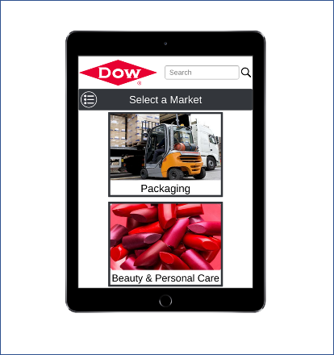
Figure 2
Finally, the artwork below in Figure 3 has a considerable amount of transparent whitespace (so the space is not really white, it’s transparent). The space looks white because the background is white.
Click on the Design Tab in Word above. Then click Page Color and select a color other than white or red. You will see that there is no space around Figure 1 (above), there is white whitespace around Figure 2 (above) and there is transparent whitespace (so the colored page background shows through) in Figure 3 (below).
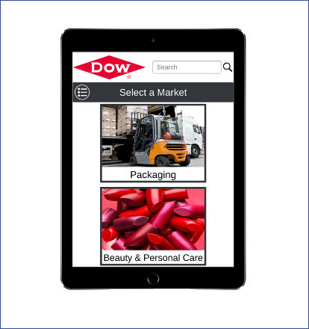
Figure 3
To test for unnecessary whitespace, download the design-day-artwork-whitespace-tester.pptx slide deck from our Downloads page and read the instructions.
- Your artwork png file will contain a rectangular image. If your artwork has curved corners (i.e., an iPhone or iPad), make sure that the corners of the image are transparent.
- As expected, multiple textboxes can be layered from “front to back.” Right-click on a textbox and select “Bring to Front” or “Send to Back.”
- If you need to edit your artwork, you can use the freeware paint.net, which is excellent free software that was a computer science capstone project at the University of Washington.
- If the borders of your artwork are white or light gray, they will “disappear” into the white background of the page. For example, the following artwork needs a border.
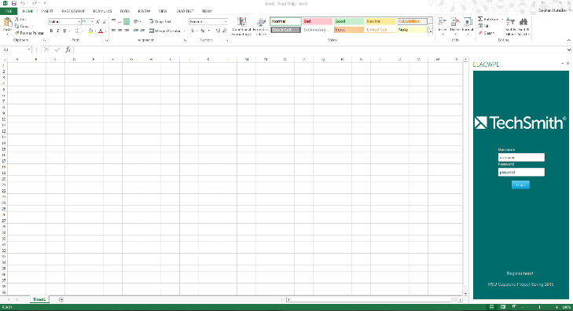
Figure 4
In such a case, use PowerPoint to add a suitably colored border to the artwork. Launch PowerPoint. Create a new presentation with a blank slide. Click the Design tab in the ribbon and select Slide Size in the Customize section. Change the size of the slide to something very large like 36 by 36. Copy and paste the artwork into PowerPoint. Don’t resize it, even if it’s huge and doesn’t fit on a slide. Use Picture Border to add a thin border of the appropriate color (i.e., black or gray or light gray) and of the appropriate weight (i.e. ¾ point). Right mouse-click on the artwork and select Save as Picture. With a border, the artwork will look something like the following.
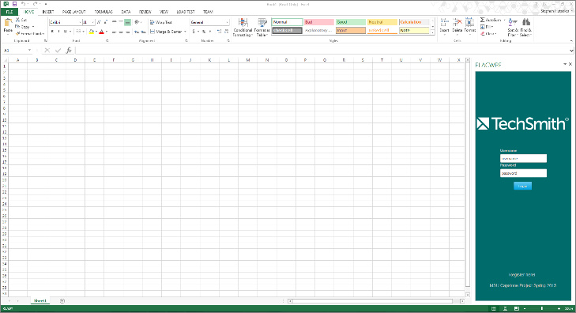
Figure 5
- If your artwork includes textboxes or check boxes or slider bars or anything similar, make sure that the textboxes include meaningful text and some of the check boxes are checked and some of the slider bars are slid.
So, do not submit artwork like the one on the left. Do submit artwork like the one on the right.
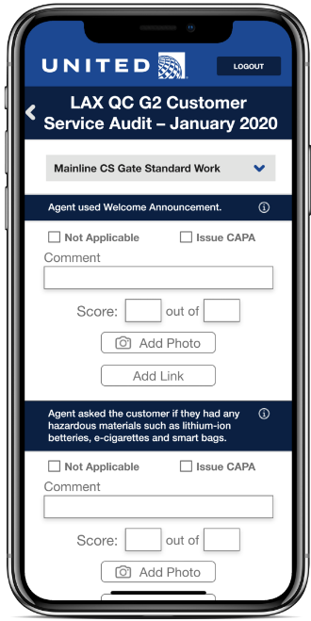
- The top of your artwork pieces should not extend above the top of the project description textbox.
In addition to inserting your artwork into your template, you must provide the original high resolution versions of the source file. You must provide very high resolution png images with transparent background, eliminating any surrounding whitespace.
Name your artwork files using the same naming convention as the template placeholder artwork in your team folder; that is, using the convention “team-[team-name]-artwork-1.png” and “team-[team-name]-artwork-2.png” etc. As always with filenames, use all lower case and replace blanks with dashes.
The team folder that you downloaded contains four template placeholder artwork png files. Delete the placeholder files that you are not using.
As with the project description, look at previous Design Day booklets to see what kind of artwork previous capstone teams have used.
For examples of issues with artwork along with examples of Dr. D.’s feedback, see my Dr. D.'s artwork feedback from Fall 2019.
Your Project Sponsors’ Names and Locations
At the lower right is the name of your project sponsors (aka clients).
The format of the project sponsor company or organization name at the bottom of the page is the same as your team name and not the same as the formal corporate name in the title at the top of the page. So, for example, for Team Auto-Owners, the title at the top reads “Auto-Owners Insurance” whereas the Corporate Sponsor below is simply “Auto-Owners.”
This list of names should include not only your sponsor contacts but also any other names from your client company that your contacts feel would be appropriate even if somewhat “honorific.” For example, with Auto-Owners Insurance, we normally list the name of Jim Schumacher who is the CIO. Even though Mr. Schumacher does not interact directly with the capstone team, it’s very appropriate to list him in the Design Day booklet.
You’ll see that the list of project sponsors has already been entered. You’ll see that these names are listed in alphabetical order. If you add sponsor, make sure that you add them in alphabetical order. Along with each person’s name, we include the location where they work. In some cases, it may be all the same city and state. That’s okay. We do have some cases where we have people in different cities and even in different countries.
Ask your corporate sponsors to approve their list of project sponsor names.
Do not delete any names without my permission. You may add names. Check and correct the locations.
If you make any changes to the list of Project Sponsors, highlight the changes in yellow.
Team Photos
To the right of the team picture is a list of team names and hometowns. The names and hometowns are as you requested. Check everything for typos.
Edit the list so that your team members’ names appear exactly as they wish.
If you make any changes to the list of team members, highlight the changes in yellow.
Getting Approval from Your Corporate Client
It’s your responsibility to get approval from your client on the final version of your template. You’ll have to send them your final version in advance of when it’s due to me to give them sufficient time to review it.
In the past, there have been two non-CSE situations where student teams included confidential information in their Design Day page, which made it into print. Every one of the thousands of booklets had to be recalled with an edited page pasted over the original. We do not want this to happen to us.
File Extensions and Hidden Files
For the file browser you are using, turn on the ability to see file extensions and turn on the ability to see hidden files.
Sometime teams submit artwork named artwork-1.PNG (with PNG in uppercase) or artwork-1.png.png (with png duplicated). If you turn on file name extensions, you will catch these errors. Note that in Windows you cannot change the case of letters in a filename. So, if you inadvertently named your artwork artwork-1.PNG, you’ll have to first rename it to something like artwork-1.abc, which will result in a warning, and then change from artwork-1.abc to artwork-1.png. (I know this is hard to believe, but it’s true.)
Word (and other applications) sometimes create temporary files, which are hidden files and may start with a tilde (~). If you turn on the ability to see hidden files, you will see these files and can delete them from your assets folder.
Our Design Day Booklet Production Schedule
Go to our Downloads page and download our Design Day Booklet Production Schedule and our Design Day Booklet Calendar. Study both documents and begin planning to meet the submission deadlines.
What do you need to send to Dr. D. and when?
When you have completed everything, put everything in the team folder that you downloaded with the same naming convention that you downloaded, namely your team folder should be names as “team-[team-name]-design-day-booklet-page.”
For file names use all lower case and replace any blanks by dashes.
Your contribution to the project page template should be your project description and your artwork. However, you should carefully proofread the rest and obtain approval for everything from your project sponsor. If you make any other changes to anything in the project template other than the project description or artwork, highlight the changes in yellow.
In your team folder, place a copy of your team’s Word template; keep the name of your template exactly as downloaded in the form “team-[team-name]-design-day-booklet-page.docx.”
Also place in the folder the original, very high resolution originals for your all of your artwork. Each piece of artwork should be in a separate file in png format with a transparent background. Name your artwork files “team-[team-name]-artwork-1.png” and “team-[team-name]-artwork-2.png” etc. When you name your artwork files, number your artwork from top to bottom or left to right. Delete the placeholder artwork files that you are not using. So, if you are submitting two pieces of artwork, delete the files team-[team-name]-artwork-3.png and team-[team-name]-artwork-4.png.
Zip up your team folder and email it to Dr. D. by 11:59 p.m. Saturday, October 10, 2020.
For email subject, use “Team [Team Name]: Design Day Booklet Project Page’”
This is a very short deadline since you need to get feedback from your client. You should send a draft to your client as soon as possible to give them enough time to provide meaningful feedback that you can incorporate into your draft.

Appendix of Spelling and Capitalization of Technical Terms
Below is a list of the correct spelling and capitalization of technical terms. You should Google every technical term that you use to ensure that you are spelling it and capitalizing it correctly.
Terms like natural language processing and machine language are not capitalized.
“Back end” and “front end” (without a hyphen) are nouns. (Actually “end” is the noun with “back” and “front” being adjectives.) They would be used as in “The front end of our system is written in JavaScript while the back end uses a MySQL database.” “Back-end” and “front-end” (with hyphens) are adjectives. They would be used as in “Our front-end software is written in JavaScript while the back-end database is implement with MySQL.”

- .NET Core
- ASP.NET
- back end
- backend
- back-end
- Bluetooth
- Bluetooth Low Energy
- Bootstrap
- CloudFront
- CSS
- D3.js
- Dialogflow
- DynamoDB
- Elastic MapReduce
- Elasticsearch
- front end
- frontend
- front-end
- HTML
- JavaScript
- machine learning
- MapReduce
- MongoDB
- MySQL
- natural language processing
- Node.js
- PHP
- Python
- Python Flask
- ReactJS
- RESTful
- scikit-learn
- TensorFlow
- Wi-Fi
- YARA
- YOLOv3

