Yello

Project Sponsors

Jason Allen

Chicago, Illinois

Lukasz Czechura

Chicago, Illinois

Phil Prescher

Chicago, Illinois

Rob Timpone

Chicago, Illinois

Jason Weingarten

Chicago, Illinois

Founded in 2008, Yello provides talent acquisition that helps companies fill their most challenging job openings by hiring the right talent at the right time. Currently, Yello supports 20% of the Fortune 500 companies.

According to the Harvard Business Review, 80% of employee turnover is due to bad hiring decisions. In addition, it costs companies, on average, one-third of a new hire’s annual salary to replace them.

Our Automatic Resume Verification software helps Yello’s client-partners identify and recruit the best candidates by automatically verifying a candidate’s resume credentials.

Institutions such as universities or companies use one of our web apps to upload a prospective candidate’s credentials including things like academic degrees and employment dates. Each credential uploaded is assigned a unique transaction ID which is then given to the candidate.

A candidates uses our second web app to upload their resume along with their transaction ID. By providing the transaction ID along with the resume, our system is able to verify the candidate’s credentials automatically.

Candidate credentials are stored using a custom blockchain, which ensures scalability and security.

Our Automatic Resume Verification web apps are built with Ruby on Rails and hosted on an Amazon AWS EC2 instance. The blockchain is implemented in Python 3.6 and stored in a MySQL server.

Michigan State University

Team Members (left to right)

Wan Kim

Troy, Michigan

Nathaniel Hagan

Lansing, Michigan

Giorgio Maroki

Sterling Heights, Michigan

Brandon Burt

Grand Blanc, Michigan

Ryan Nagy

Saline, Michigan

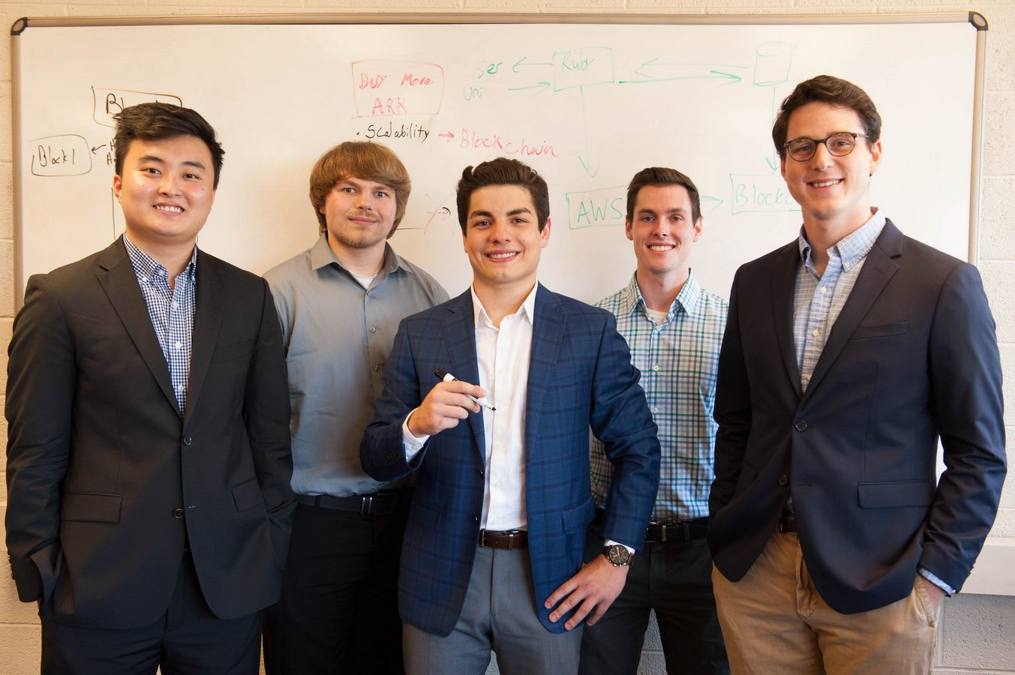

Yello

Automatic Resume Verification

