Urban Science

Project Sponsors

Linda Conley

Detroit, Michigan

Mike DeRiso

Detroit, Michigan

Elizabeth Klee

Detroit, Michigan

Luke Mercier

Detroit, Michigan

Michael Nelson

Detroit, Michigan

Urban Science is an internationally renowned solutions company with a passion for solving data-driven problems. Headquartered in Detroit, Urban Science specializes in providing science-based solutions for the automotive, health and retail industries.

Within the automotive industry, Urban Science provides deep-data insights that dealerships use to improve their business. These dealerships frequently encounter the challenge of facing numerous metrics to analyze, making it difficult to determine which areas of their business need the greatest improvement.

Our Virtual Dealership Adviser targets these areas by allowing dealership employees to ask specific or general questions on how to improve segments of their business. For example, a user may ask: “How can I improve my SUV sales?”

Users choose between areas of improvement relevant to their question or those that offer the most room for improvement overall. Actionable solutions related to their area of improvement are then presented to the user, such as “optimize inventory mix to meet consumer demand” or “leverage sales leads to find additional interest in your area.”

Using our intuitive interface, dealership employees can find quick, data-driven solutions, allowing them to respond effectively to their market.

Our Virtual Dealership Adviser is accessible through Android, iOS and web browsers. Our databases are hosted in Amazon Web Services. Microsoft Azure is used for hosting and language processing services.

Michigan State University

Team Members (left to right)

Will Renius

Goodrich, Michigan

James Grenfell

Dearborn, Michigan

Daniel Oforidankwa

Saginaw, Michigan

Eric Zhou

Troy, Michigan

Harry Singh

Saginaw, Michigan

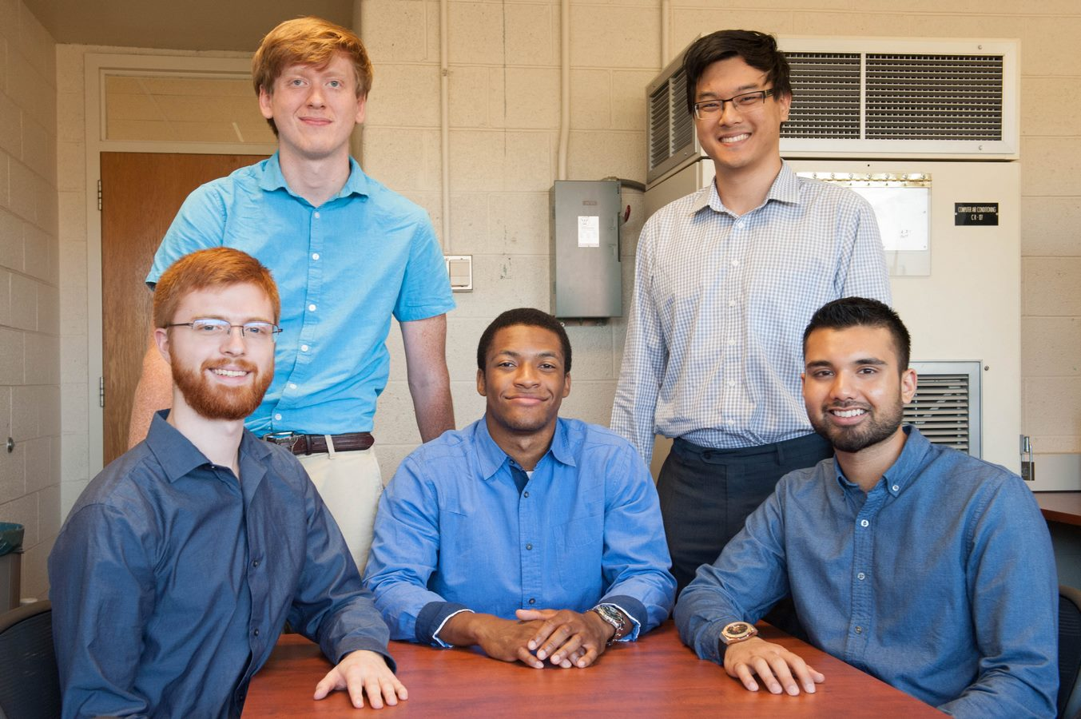

Urban Science

VDA: Virtual Dealership Adviser



