TWO MEN AND A TRUCK

Project Sponsors

Jake Gaitan

Lansing, Michigan

Corey Lasley

Lansing, Michigan

Jon Nobis

Lansing, Michigan

Mark Roberts

Lansing, Michigan

Ashley Skaggs

Lansing, Michigan

Caleb Williams

Lansing, Michigan

TWO MEN AND A TRUCK is the fastest-growing franchised moving company in the country with more than 400 locations in 42 states and 4 countries.

While TWO MEN AND A TRUCK customers can request to receive a moving estimate online, if the customer’s home is over 2,000 square feet, an in-home consultation may be required, which takes time both for TWO MEN AND A TRUCK and its customers.

Our three new features for TWO MEN AND A TRUCK’s Online Moving Estimator make the estimation process faster and more convenient for both parties.

First, our online video chat service enables a customer to connect with a TWO MEN AND A TRUCK agent who completes the estimate remotely through video conferencing.

Secondly, our web app allows TWO MEN AND A TRUCK to select from a queue of waiting customers or schedule a video conference consultation at a later time.

Finally, our mobile apps remove the need for an agent to be involved and allow a customer to complete an estimate on their own time by using image recognition. Customers take pictures throughout their house or apartment, confirm objects in each image, and then submit a final list to obtain their estimate.

Our web app for Online Moving Estimator is written in CSS, HTML and JavaScript. The video conferencing uses WebRTC. YOLO provides the object recognition library. The backend uses ASP.NET/C# with a MySQL database. Our mobile apps are written in Swift 4 for iOS devices and Java for Android devices.

Michigan State University

Team Members (left to right)

Liyang Ye

Hangzhou, Zhejiang, China

Clayton Wilson

Canton, Michigan

Daria Tarasova

Holt, Michigan

Bradley Williams

Midland, Michigan

Kevin Dittman

South Lyon, Michigan

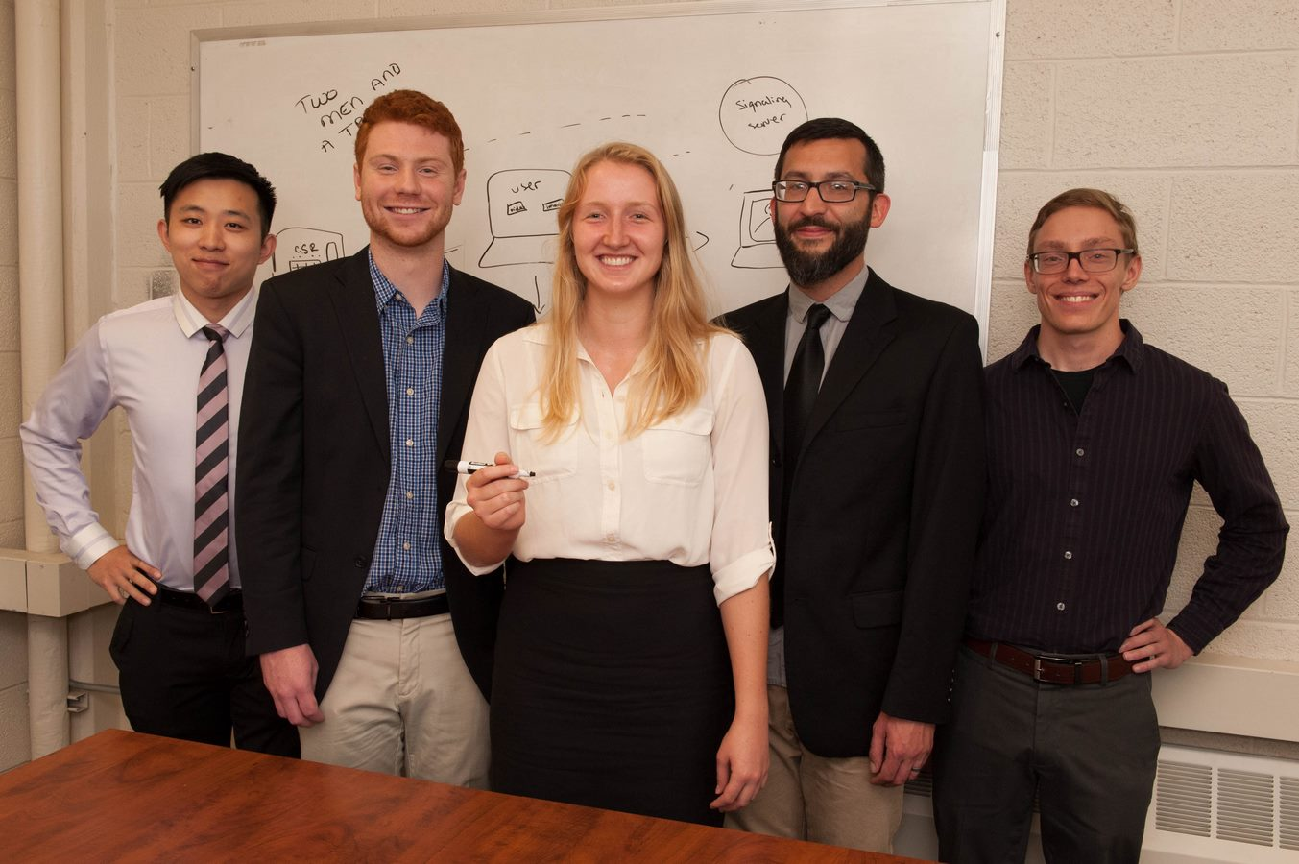

TWO MEN AND A TRUCK®

Online Moving Estimator

