

TechSmith helps people easily create visual content such as images and video, to communicate more effectively. Our products, including Snagit and Camtasia, are used by more than 30 million users worldwide, and growing.

Due to the complexity of many video editing platforms, video creation is difficult for the average person. There are often countless menus, buttons and settings that require time and experience to learn and understand.

Our TechSmith Director strips the need for a complicated interface by interpreting the user’s spoken commands to create a video. Users dictate commands to Director and let the software handle the tedious work. The user further edits their video project using simple drag and drop functionality.

For example, a user may create a video by saying things like “I’d like a beach background for my video” followed by “Let’s place a dog with a frisbee on the beach.” Animations may be added simply by saying “I’d like the dog to walk across the beach.” Users also search for audio clips in the same way.

Video projects are saved so users may view and edit them later. Multiple projects are stored and managed through a single user interface.

TechSmith Director is written in C# using ASP.NET Core, HTML and JavaScript. The site is hosted on Microsoft Azure and data is stored on a SQL server. Voice commands are processed using Microsoft Cognitive Services.

Michigan State University

Team Members (left to right)

Jared Ballance

Grand Blanc, Michigan

Joe Freedman

Commerce Township, Michigan

Kevin Ahn

Bloomfield Hills, Michigan

Jacob Heisey

Holt, Michigan

Pranay Kandru

Novi, Michigan

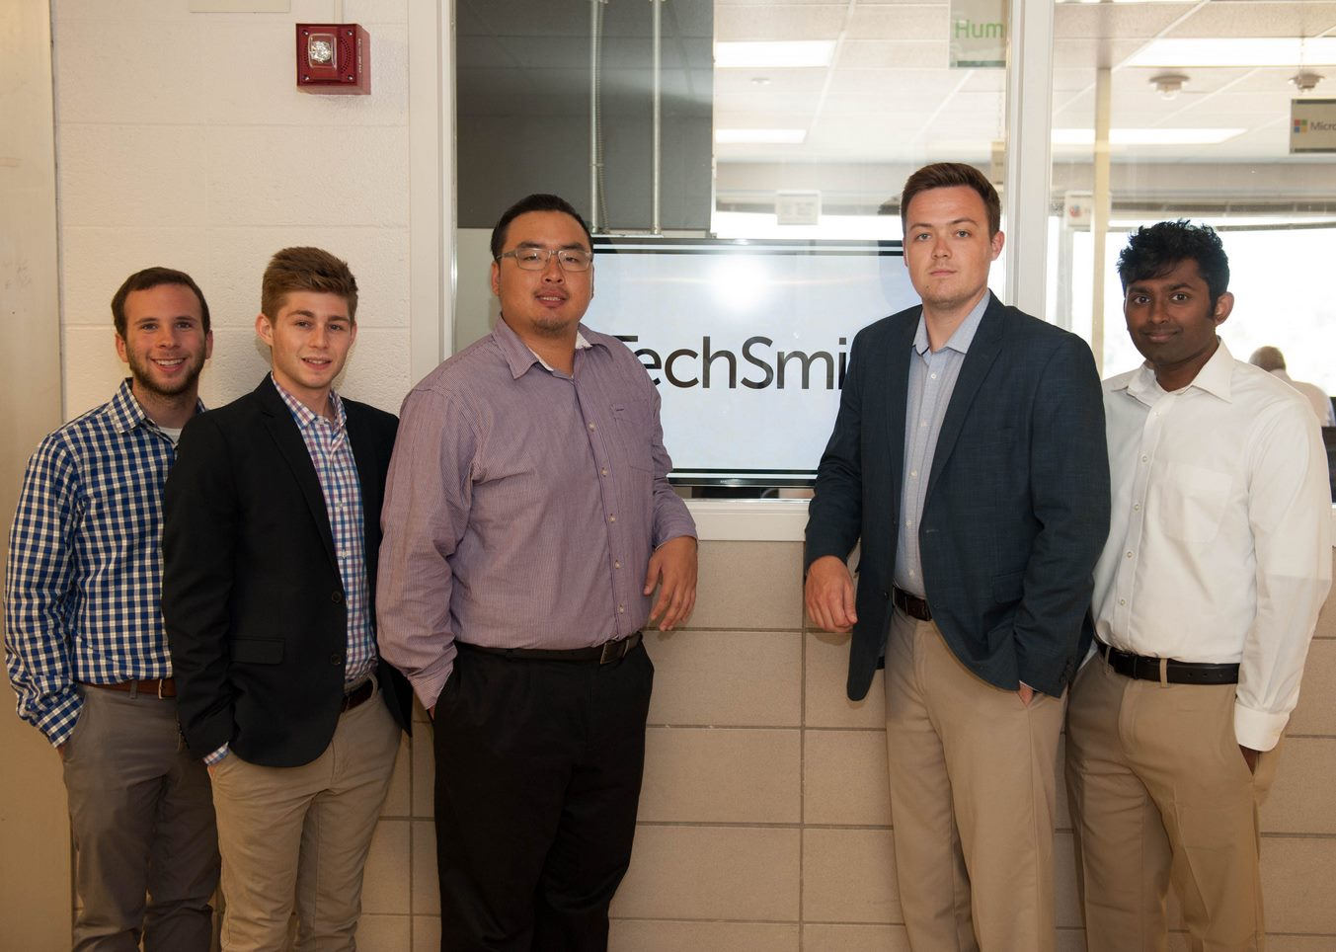

TechSmith

TechSmith Director

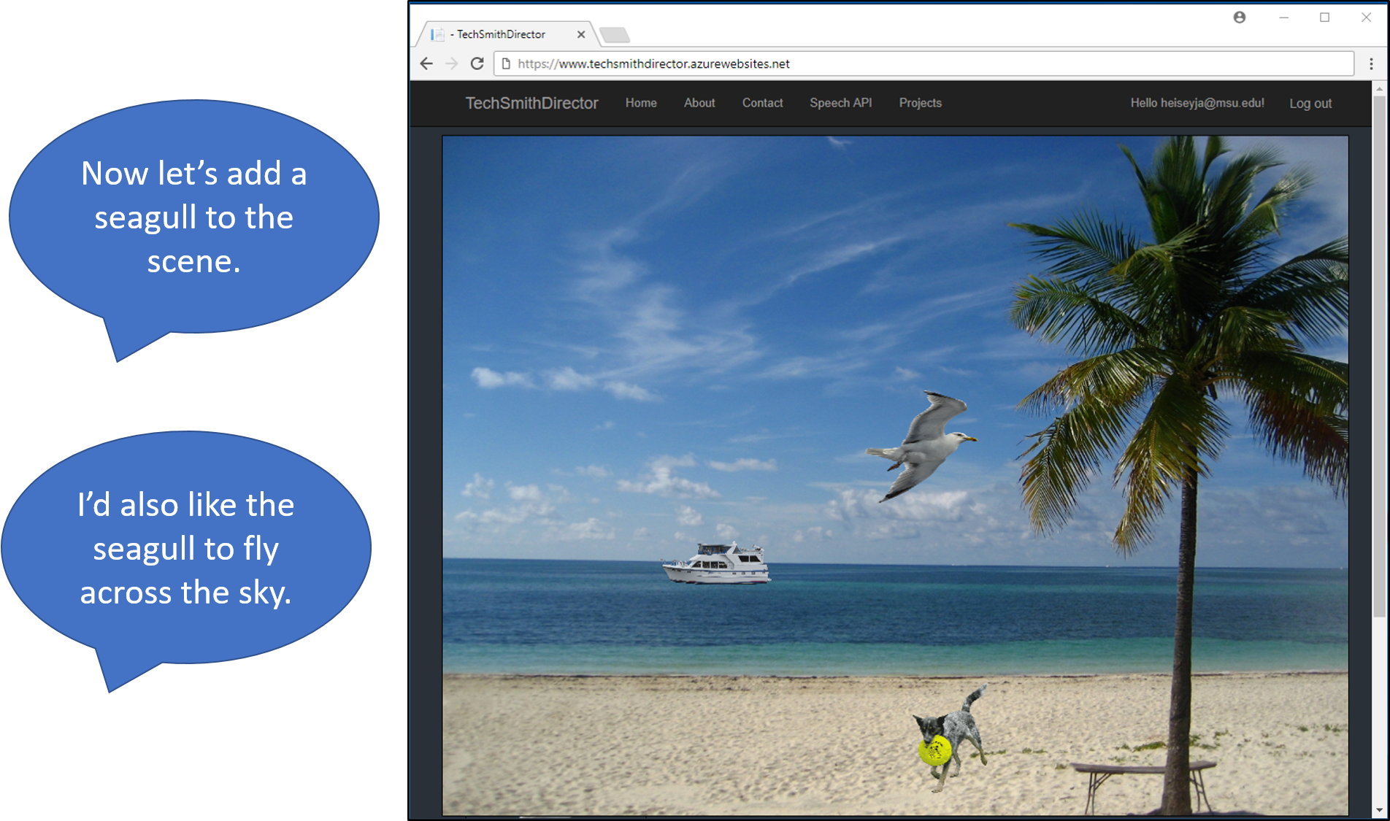

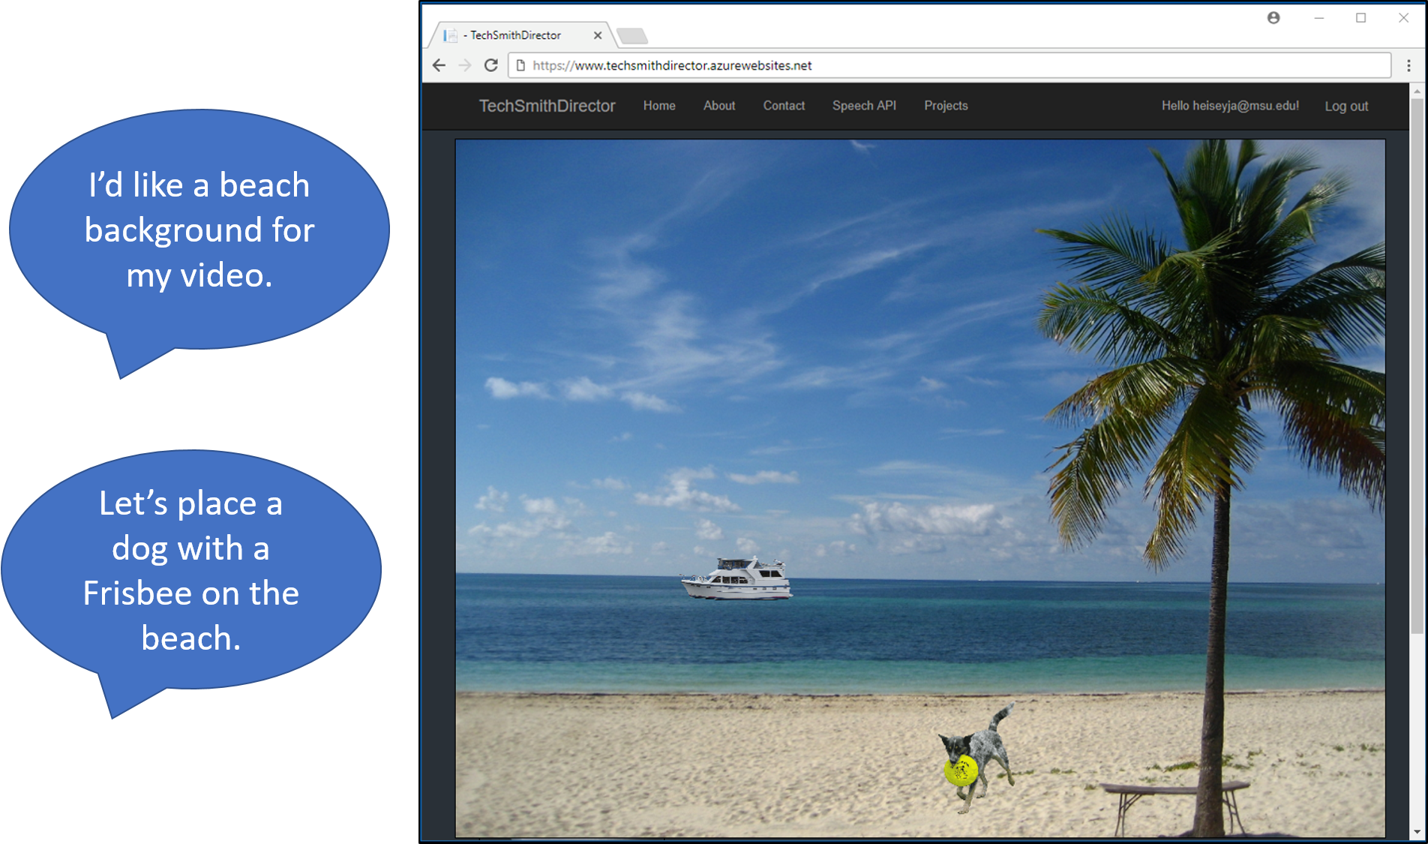

TechSmith

Project Sponsors

Ryan Eash

Okemos, Michigan

Wendy Hamilton

Okemos, Michigan

Tony Lambert

Okemos, Michigan

Dan Latterner

Okemos, Michigan

Dave Noris

Okemos, Michigan

Ben Rhodes

Okemos, Michigan

Paul Stanos

Okemos, Michigan