MSUFCU

Project Sponsors

Samantha Amburgey

East Lansing, Michigan

April Clobes

East Lansing, Michigan

Ben Maxim

East Lansing, Michigan

Founded in 1937, Michigan State University Federal Credit Union offers financial services to members of the Michigan State University and Oakland University communities. With 250,000 members and over $3.7 billion in assets, MSUFCU is the largest university-based credit union in the world.

Currently, Credit Union members can speak to a customer service representative over the phone or through live chat on the MSUFCU website. Members can also log on to the Credit Union’s website or mobile phone apps to view their accounts.

Our Digital Banking with Chatbots system enhances this customer support by allowing members to complete common tasks 24 hours a day with no wait time. The system also increases accessibility by expanding to three new platforms: Facebook Messenger, Google Assistant and Amazon Alexa.

The chatbot system allows for natural conversation. Members can check account balances, transfer funds, reset passwords and perform other tasks just as easily as they would speak to a teller at an MSUFCU branch.

These chatbot conversations can be initiated through the existing web chat, on Facebook, and even through voice controls with Google Assistant and Amazon Alexa. If a member needs more help, the chatbot connects them to a live representative.

The natural language processing (NLP) services are Google Dialogflow and Amazon Lex. Each communication platform connects to the NLP service and to a SQLite database through a custom API. The API, fulfillment application and web application are written in Node.js.

Michigan State University

Team Members (left to right)

Chuanyun Xiao

Chongqing, China

Josh Benner

Grand Rapids, Michigan

Gustavo Fernandes

Sao Paulo, Brazil

Cori Tymoszek

Cheboygan, Michigan

Syed Naqvi

Muscat, Oman

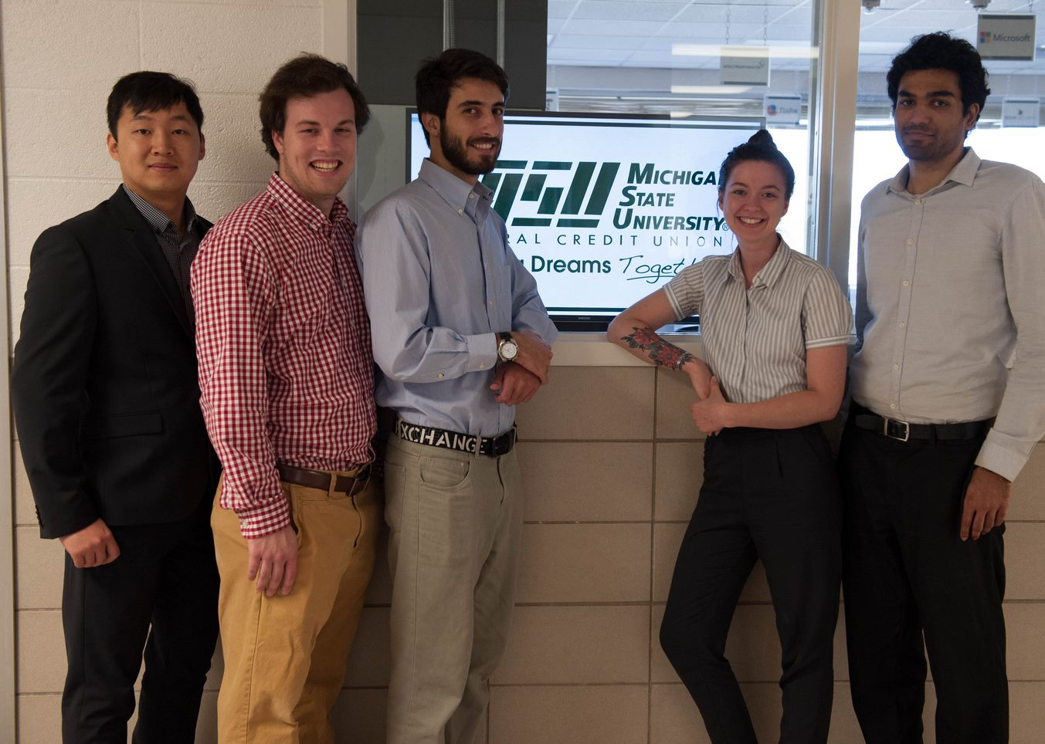

MSU Federal Credit Union

Digital Banking with Chatbots

