Mozilla

Project Sponsors

Mike Conley

Toronto, Ontario, Canada

Jared Wein

Burton, Michigan

Mozilla is a global, nonprofit organization dedicated to improving the World Wide Web. Mozilla’s international community of developers creates open source software such as Firefox, which is one of the most widely used browsers today.

Firefox requires automated quality assurance during development to provide an excellent and consistent user experience. Occasionally, developers may inadvertently change the user interface.

Mozilla’s Firefox Screenshots Testing Suite detects inadvertent changes and alerts developers by taking a screenshot of a development version of Firefox, comparing it to a known “good” screenshot, and highlighting any differences.

Our improvements to the Firefox Screenshots Testing Suite make it more reliable and efficient. The tool now automatically crops screenshots to relevant areas, reducing false positives. Additionally, the tool takes a more varied sample of the Firefox user interface. Finally, better communication now exists between the screenshot testing suite and other quality assurance tools.

Our combined improvements make the Firefox Screenshots Testing Suite a more important piece of Firefox’s overall quality assurance process.

Our improvements to the Firefox Screenshots Testing Suite are written in JavaScript and use Mozilla’s Mochitest and XPCShell frameworks to run tests. The tool includes a legacy Firefox extension which manipulates the user interface and takes screenshots.

Michigan State University

Team Members (left to right)

Michael Williams

Pittsburgh, Pennsylvania

Robin Miller

Laingsburg, Michigan

Christopher Cho

Troy, Michigan

Rand Mustafa

Grand Rapids, Michigan

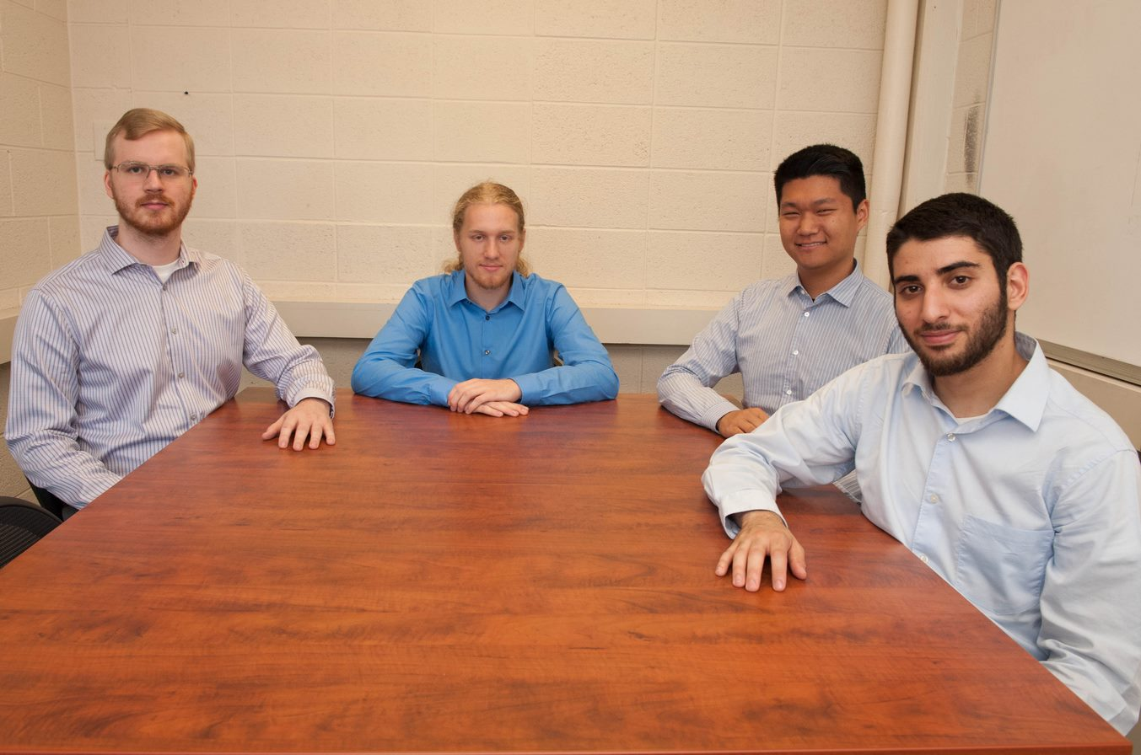

Mozilla Corporation

Taking Firefox Screenshots Testing Suite to 11



