Michigan State University

Project Sponsors

E.J. Dyksen

East Lansing, Michigan

Rob McCurdy

East Lansing, Michigan

Tyler Olsen

East Lansing, Michigan

Spencer Ottarson

East Lansing, Michigan



The nation’s pioneer land-grant university, Michigan State University (MSU) is one of the top research universities in the world. With over 50,000 students, MSU is home to nationally ranked and recognized academic, residential college and service-learning programs.

Our Spartan Experience App (SEA) is a mobile app that provides useful information for both students and visitors to enhance their MSU experience.

Looking for a bite to eat? SEA shows categorized menus within each dining hall, including dietary restrictions.

Not sure where your first class is? Use our app to search for building locations and get directions.

Visiting and not sure where to park? SEA gives parking locations as well as navigation to get to them.

Wondering when the next football game is? Our app notifies users of current and upcoming events and keeps them connected with a live Twitter feed.

SEA’s personalized home view provides relevant and contextual information based on the user’s location and time of day. Users see nearby dining halls and are alerted to upcoming events. A countdown timer helps students avoid being late to their next class.

Our SEA: Spartan Experience App is developed with Swift for iOS platforms and Java for Android platforms. The AWS Lambda API is written in Python and uses PostgreSQL as the underlying database.

Michigan State University

Team Members (left to right)

Scott Swarthout

Farmington Hills, Michigan

Ryan Johnson

Brighton, Michigan

Nayana Kodur

Okemos, Michigan

Patrick Pale

Troy, Michigan

Roy Perryman

Roscommon, Michigan

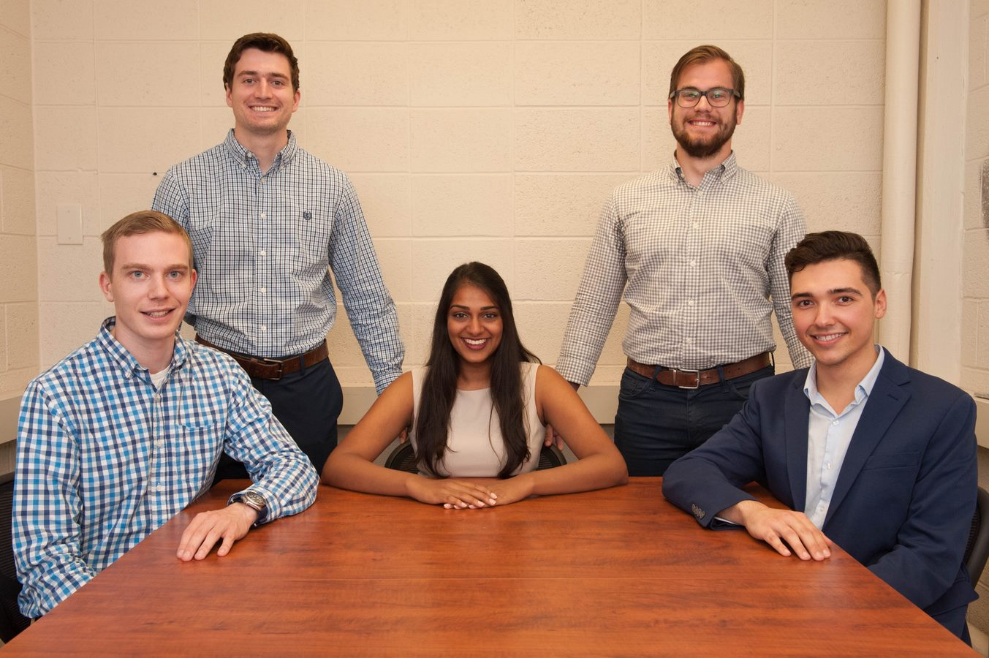

Michigan State University

SEA: Spartan Experience App

.

