Committed to providing customers with new and innovative shopping experiences, Meijer is one of the largest supercenter chains with 237 stores located throughout the Midwest.

Our Meijer Fresh-ipes app streamlines meal planning, shopping and meal preparation for Meijer customers.

As items are purchased, Fresh-ipes adds them to a customer’s virtual pantry that tracks their availability as ingredients for recipes. Stock of pantry items is adjusted automatically when used in recipes or manually by the customer.

Fresh-ipes offers intelligent recipe recommendations based on ingredients that are available in a customer’s virtual pantry. Customers add recipes to their planned meals or favorite recipes. When preparing meals, customers view recipe directions on their mobile device or Amazon Echo Show.

Fresh-ipes provides customers with purchase recommendations based on planned meals and low ingredient stock in their virtual pantry. Customers add items to their shopping list manually and from items recommended by our app. Additionally, Fresh-ipes offers the options for curbside pickup or delivery.

Our Fresh-ipes app encourages customers to shop at Meijer by making meal planning and shopping easier and simpler.

Android, iOS and Amazon Echo Show apps make requests to the .NET Core Web API and SQL Server database hosted in a Microsoft Azure Cloud environment. These requests integrate with the Yummly API to provide recipe recommendations.

Michigan State University

Team Members (left to right)

Charles Heil

Novi, Michigan

Daniel Radler

Midland, Michigan

Olivia Miller

Birmingham, Michigan

Justin Pearson

Eaton Rapids, Michigan

James Murray

Dearborn Heights, Michigan



Meijer

Meijer Fresh-ipes

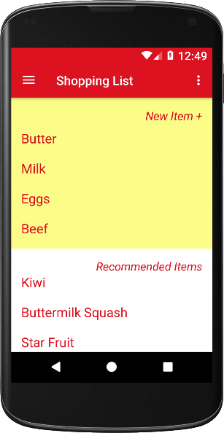

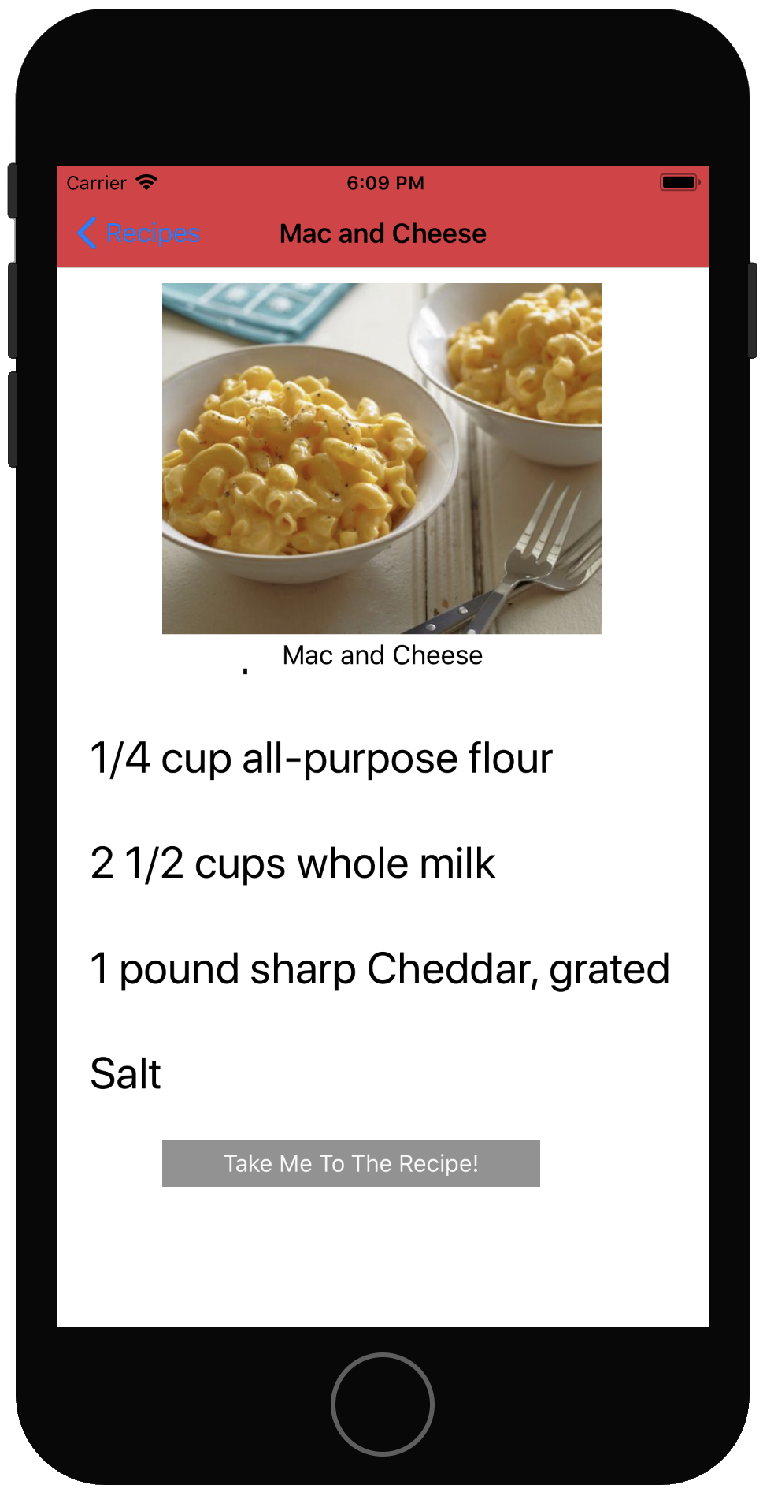



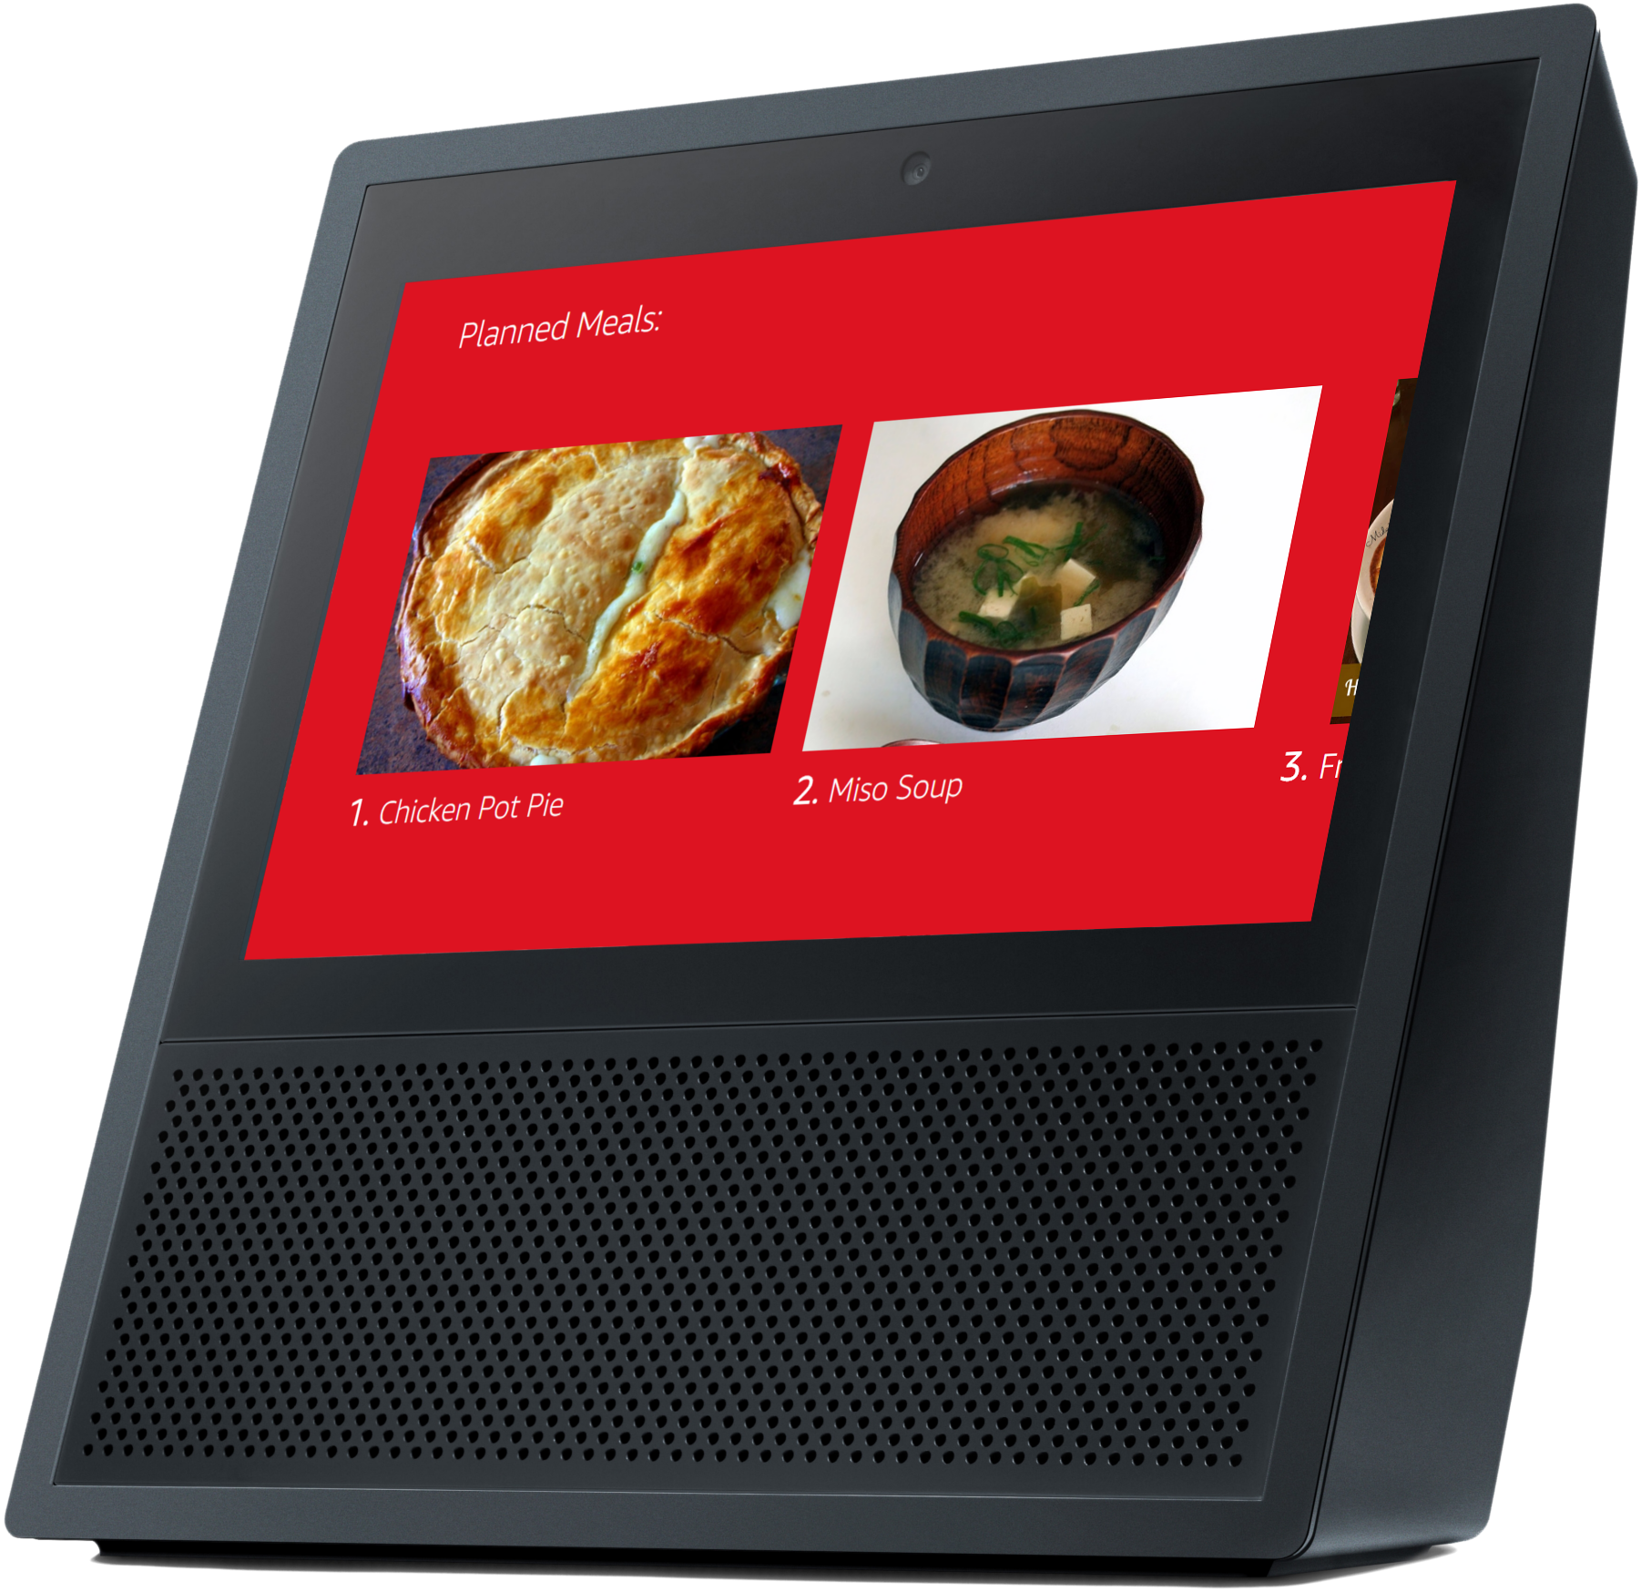

Meijer

Project Sponsors

Bill Baer

Grand Rapids, Michigan

Jim Becher

Grand Rapids, Michigan

Von Franklin

Grand Rapids, Michigan

Chris Laske

Grand Rapids, Michigan

Terry Ledbetter

Grand Rapids, Michigan

Murali Rajagopalan

Grand Rapids, Michigan