Humana

Project Sponsors

Ashlee DeLine

Louisville, Kentucky

Mick Horton II

Louisville, Kentucky

Erin Wycoff

Louisville, Kentucky

Humana promotes health and wellness by offering many innovative products and services to a diverse customer base. Humana takes pride in providing personalized plans for each of its members.

To ensure that current and prospective members understand their options, Humana communicates the value of their plans through intuitive, easy-to-use customer service tools.

One of these tools is our MyHumanaBot, which provides a natural, in-person conversational experience. Users ask MyHumanaBot questions just as they might ask a Humana customer service agent. MyHumanaBot responds with accurate answers, quickly and efficiently.

For example, after logging into the Humana web portal, members can ask specific questions about their account such as “What are my current health insurance plans?” or “What’s the status of my most recent claim?”

Users can ask more general questions such as “Can you help me find a doctor?” to which MyHumanaBot may respond “Sure, what kind of doctor are you looking for?”

Conversations are saved and viewed using our the companion administrative web portal, which is used by Humana associates for continuous improvement of MyHumanaBot.

Our MyHumanaBot uses Microsoft’s Bot Framework written in C# along with Dialogflow for natural language processing. All components are hosted on Microsoft Azure.

Michigan State University

Team Members (left to right)

Anthony Dionise

Lansing, Michigan

Madeline Levinson

Midland, Michigan

Jason Thompson

Dayton, Ohio

Yi Shi

Beijing, China

Tynan Ford

Williamston, Michigan

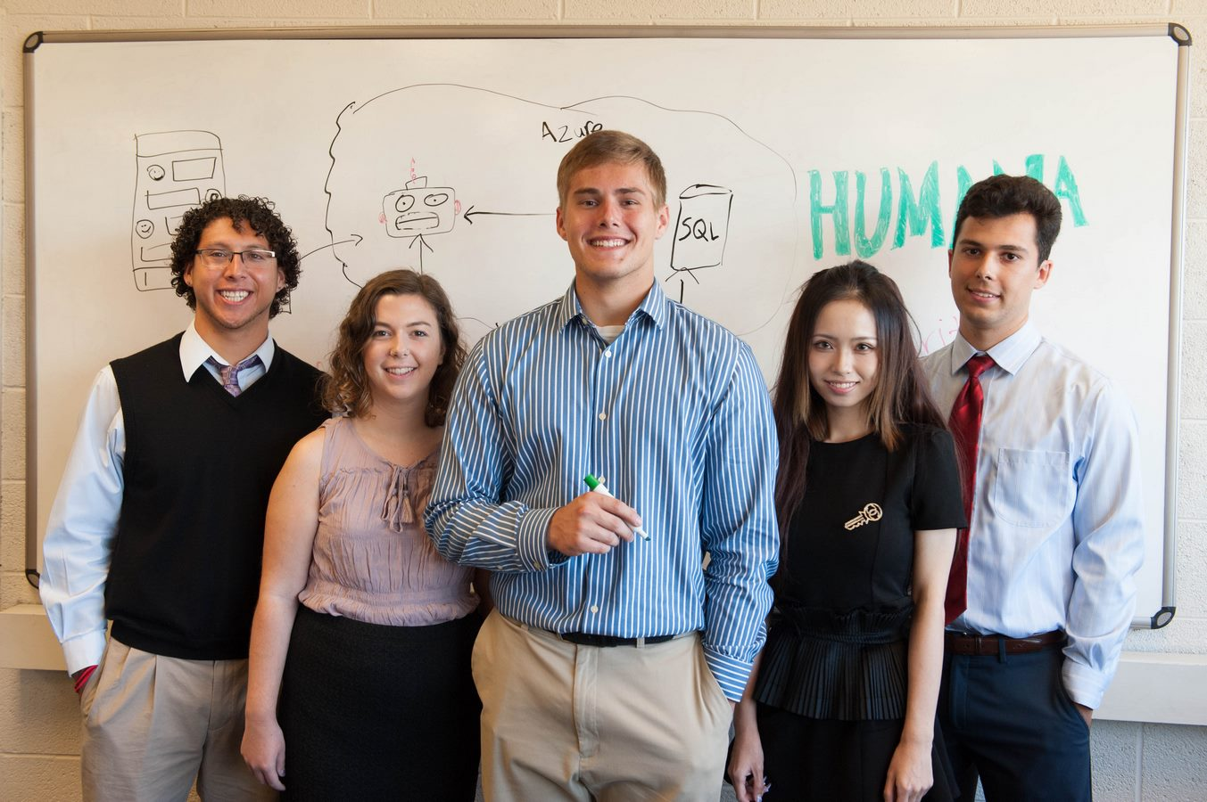

Humana

MyHumanaBot

