GM

Project Sponsors

Mike Adelson

Warren, Michigan

Chelsea Jacobs

Warren, Michigan

Fred Killeen

Warren, Michigan

Dan Rudman

Warren, Michigan

Christian Stier

Warren, Michigan



General Motors is one of the world’s foremost designers and manufacturers of cars and trucks sold in more than 125 countries. Headquartered in Detroit, GM operates almost 400 facilities on six continents around the world.

Among GM’s facilities are its many factories that build and assemble cars and trucks. In order to ensure the safety and well-being of those who work in these factories, GM provides a variety of personal protective equipment (PPE) including helmets, goggles and vests.

Our Automated Workplace Safety System determines if workers are missing any of their PPE by analyzing the video from cameras stationed at factory entrances. Our system uses object detection models to identify the workers and their PPE as they pass by.

If a worker is determined to be missing any of their PPE, a text message is sent to their safety manager, and a violation incident is recorded in a database.

Safety managers use our companion web app to display statistics and graphs of the PPE violation incidents, which can be sorted by camera, time or PPE. In addition, managers use our web app to indicate shift changes, and to add and remove cameras.

Our Workplace Safety System utilizes an NVIDIA Jetson to run the object detection models. Camera configuration with NVIDIA’s Jetson is written in Python. Our web app, written in HTML, CSS, PHP and JavaScript, is connected to a MYSQL database. Twilio is used to send SMS text messages.

Michigan State University

Team Members (left to right)

Michael Peng

Troy, Michigan

Marc Bellemare

Plymouth, Michigan

Steven Levesque

Holland, Michigan

Ike Uchendu

Southfield, Michigan

Guannan Hong

Dalian, Liaoning, China

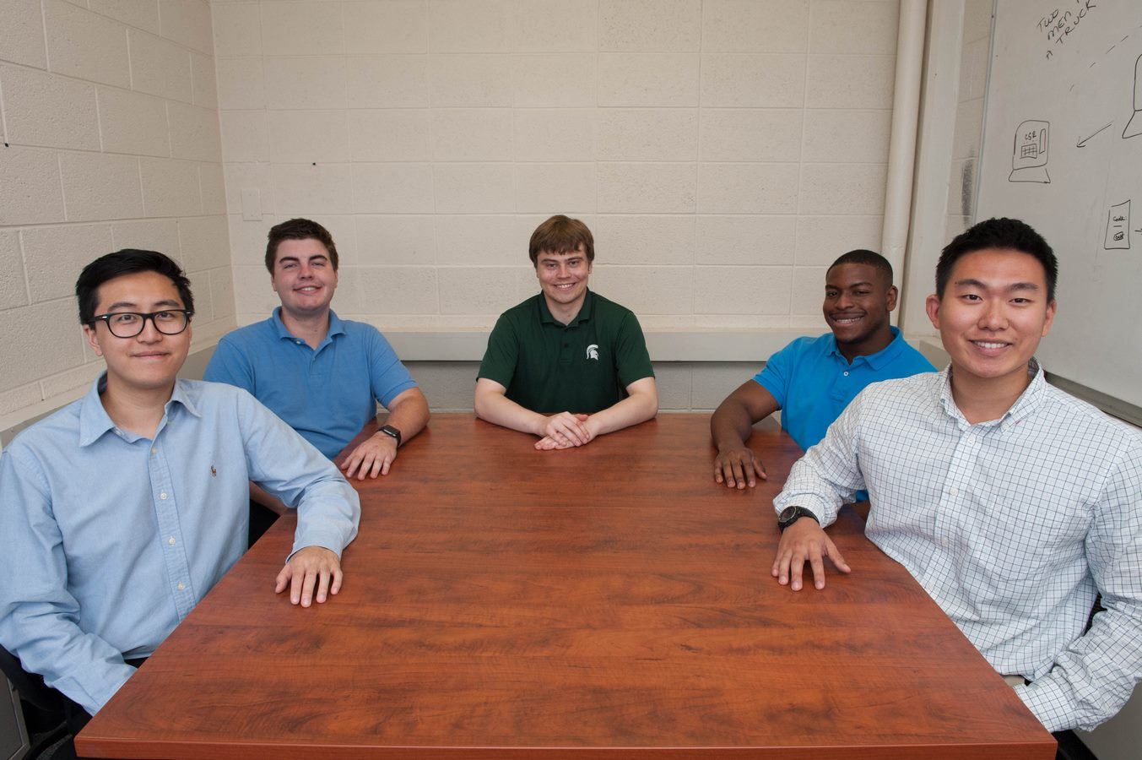

General Motors

Automated Workplace Safety System

