Ford

Project Sponsors

Adam Haas

Dearborn, Michigan

Clifford Harding

Dearborn, Michigan

Dave Sexton

Dearborn, Michigan

Michael Volk

Dearborn, Michigan

Ford Motor Company is a Fortune 500 automotive company headquartered in Dearborn, Michigan, employing 201,000 employees worldwide and selling 6.65 million vehicles in 2016.

Often times while driving around crowded places you do not know where there is open parking. You waste time and gas looking for parking spaces, which leads to late meetings and unpleasant moods.

Our Ford Smart Parking allows pedestrians to report open spots and it then enables drivers to find those spots. This helps drivers save time and gas when parking in crowded places whether on college campuses or at work.

When a pedestrian sees an open spot, they open the app to login and fill out a short survey to report the spot. Drivers can login and press a button which shows them the nearest parking space available.

Our Ford Smart Parking app is mirrored on Ford’s SYNC onboard vehicle system so that a driver of a Ford vehicle can find a parking space using their car’s touch screen.

In addition to finding a place to park, users can place virtual Ford vehicles into their home garage to see if they will fit.

Our Ford Smart Parking is a mobile app for Android devices written in Java. Parking spots are stored in a Firebase database. Virtual vehicles are displayed using the Google Tango and Android APIs.

Michigan State University

Team Members (left to right)

Rahul Patel

Livonia, Michigan

Douglas Kantor

Suffern, New York

Helena Narowski

Ann Arbor, Michigan

Eric Wu

Farmington Hills, Michigan

Chengzhu Jin

Qingdao, Shandong, China

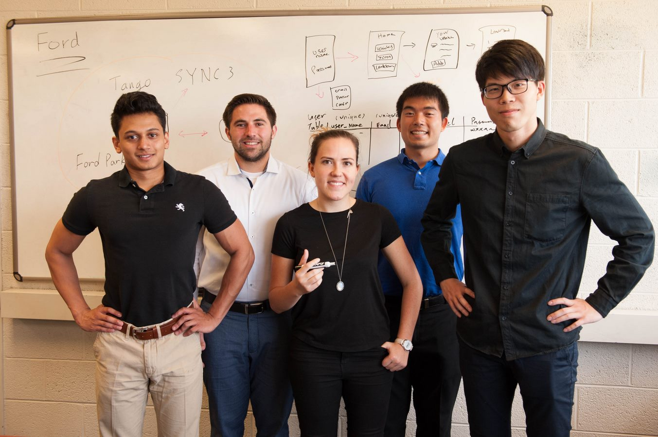

Ford Motor Company

Ford Smart Parking

