Auto-Owners

Project Sponsors

Ross Hacker

Lansing, Michigan

Scott Lake

Lansing, Michigan

Jim Schumacher

Lansing, Michigan

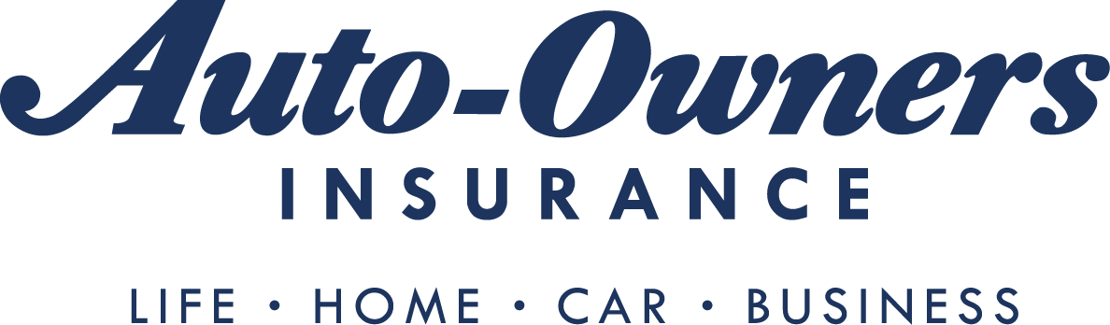

With over 100 years of experience, Auto-Owners Insurance is a Fortune 500 company with more than 6,200 independent insurance agencies in 26 states and a written premium of almost $6 billion.

Auto-Owners insures homes throughout the Midwest. So, understanding and teaching home safety is an important aspect of their mission.

Our House of Hazards is a competitive virtual reality game that is designed to teach Auto-Owners’ associates about just that, home safety. Associates learn in an enjoyable, immersive and interactive way while getting a realistic experience.

Using an Oculus Rift Headset, Touch controllers and sensors, a player explores a virtual furnished home. A player is tasked with identifying potential hazards to the occupants and to the property itself. Players are educated about home safety with a simulation of a realistic everyday home.

Our game features three difficultly levels. In the easiest level, hazards are easy to find and numerous. In harder levels, hazards are harder to find, and identifying harmless items as hazardous results in the loss of points.

To give our game a competitive feel, the scores are recorded and displayed on a leaderboard.

Our House of Hazards game is played on a Microsoft Windows PC with the Oculus Rift Headset, Touch controllers and sensors. The Oculus Rift hardware communicates the input to our game, which is implemented using the Unity game engine.

Michigan State University

Team Members (left to right)

Frederick Lee

Rochester, Michigan

Matthew Drazin

West Bloomfield, Michigan

Kenneth Stewart

Ann Arbor, Michigan

Kevin Nickolai

Waterford, Michigan

Brian Wong

South Lyon, Michigan

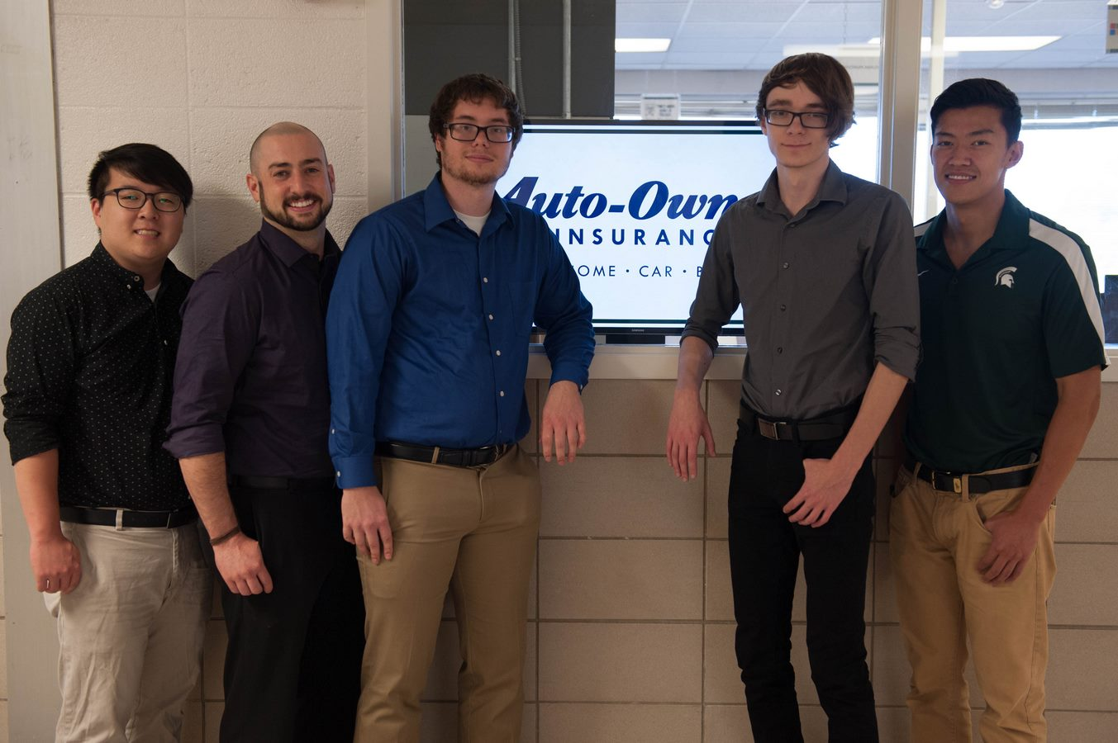

Auto-Owners Insurance

House of Hazards

