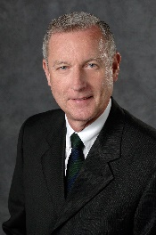

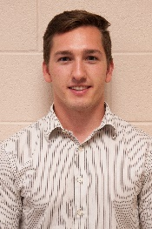 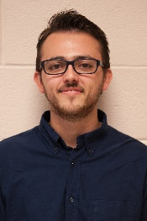

**Jonny Dowdall James Mariani**

**Teaching Assistants**

**Presentation Schedule – Engineering Building, Room 3405**

**The Capstone Projects**

**Dr. Wayne Dyksen**

**Professor of Computer Science and Engineering**

**CSE498 Collaborative Design**

CSE498, Collaborative Design, provides the educational capstone for all students majoring in computer science. Teams of students build software systems for corporate clients.

During the capstone experience, students

* design, develop, debug, document, and deliver a comprehensive software system,
* work in a team environment,
* develop written and oral communication skills,
* become proficient with software development tools and environments,
* build and administer computer systems, and
* consider issues of professionalism and ethics.

Our clients are local, regional, and national including Amazon, Auto-Owners Insurance, Avata Intelligence, Boeing, Bosch, Chrysler, Electronic Arts, Ford, GE, General Motors, Google, Humana, Meijer, Michigan State University, Microsoft, Mozilla, MSU Federal Credit Union, the Phoenix Group, Quicken Loans, Spectrum Health, Rook Security, Symantec, TechSmith, **TWO MEN AND A TRUCK**®, Union Pacific, Urban Science, Whirlpool and Yello.

|  |  |  |
| --- | --- | --- |
| **Time** | **Team** | **Project Title** |
| 7:30 a.m. | Amazon | Faia: Fashion Artificial Intelligence Assistant |
| 7:44 a.m. | Auto-Owners | House of Hazards |
| 7:58 a.m. | Avata | Security Analytics Suite: Configuration Setup Tool |
| 8:12 a.m. | Ford | Ford Smart Parking |
| 8:26 a.m. | GM | Audio Video Workplace Safety System |
| 8:40 a.m. | Humana | MyHumanaBot |
| 8:54 a.m. | Meijer | Meijer Fresh-ipes |
| 9:08 a.m. | Michigan State University | SEA: Spartan Experience App |
| 9:22 a.m. | Microsoft | Enhanced Company Portal with Graph |
| 9:36 a.m. | Mozilla | Taking Firefox Screenshots Testing Suite to 11 |
| 9:50 a.m. | MSUFCU | Digital Banking with Chatbots |
| 10:04 a.m. | Phoenix Group | OPEN v2.0: Smart Order Picking |
| 10:18 a.m. | Rook | Cloud Security Event Processing and Alerting Platform |
| 10:32 a.m. | Spectrum Health | Spectrum Health Symptom Checker |
| 10:46 a.m. | Symantec | Secure Application Layer API Proxy |
| 11:00 a.m. | TechSmith | TechSmith Director |
| 11:14 a.m. | TWO MEN AND A TRUCK | Online Moving Estimator |
| 11:28 a.m. | Union Pacific | RailBuilder: The Great Race to Promontory |
| 11:42 a.m. | Urban Science | VDA: Virtual Dealership Adviser |
| 11:56 a.m. | Yello | Automatic Resume Verification |