Symantec

Project Sponsors

Kunal Agarwal

Mountain View, California

Renault Ross

Atlanta, Georgia

Michigan State University

Team Members (left to right)

Chris Perry

Okemos, Michigan

James Mariani

Sterling Heights, Michigan

Tyler Erskine

Saginaw, Michigan

Scott Binter

Downers Grove, Illinois

Dan Parlin

Traverse City, Michigan

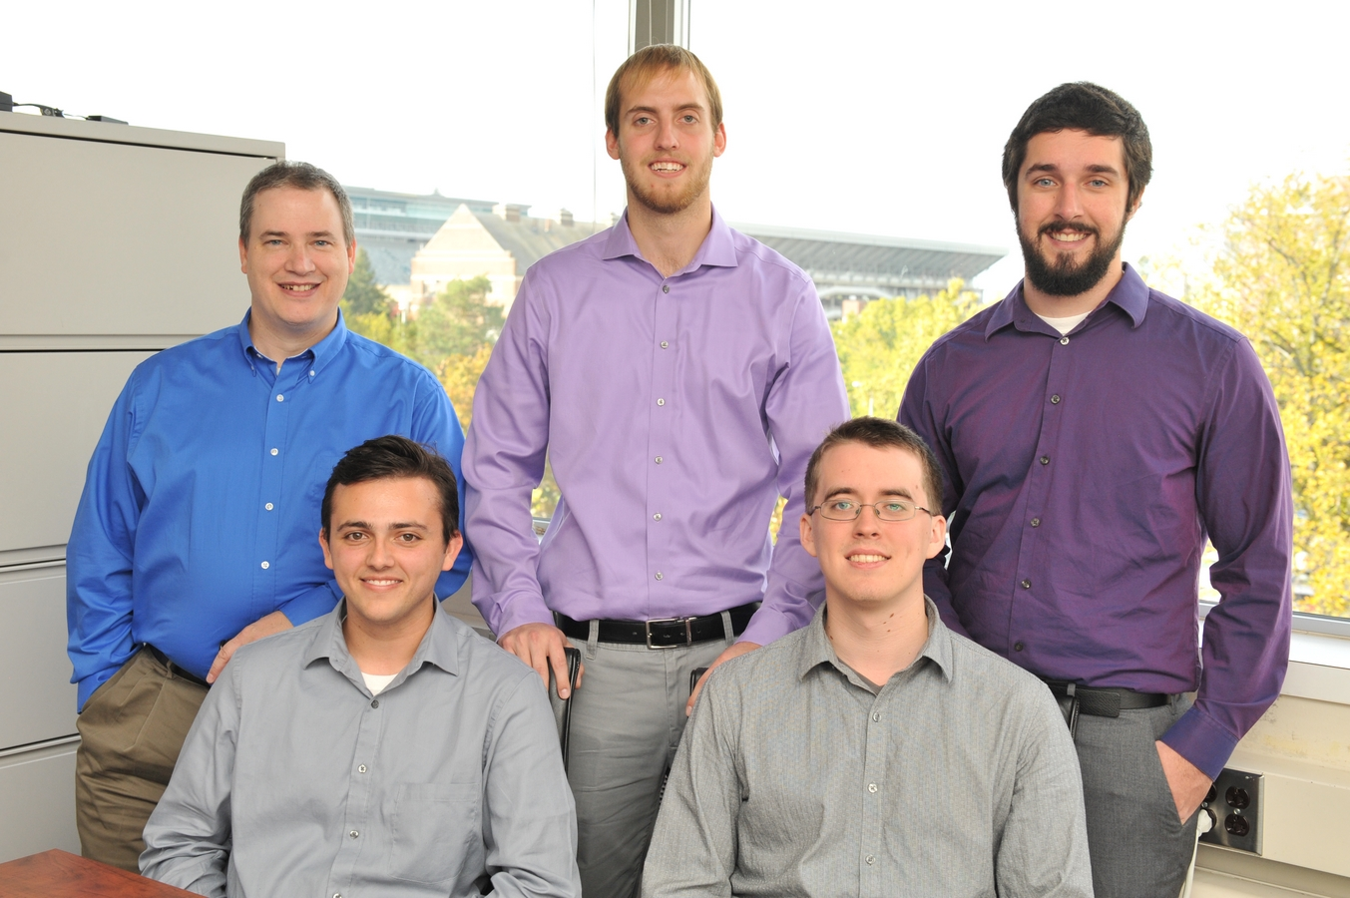

Symantec

Integrated Silent Authentication via Symantec VIP

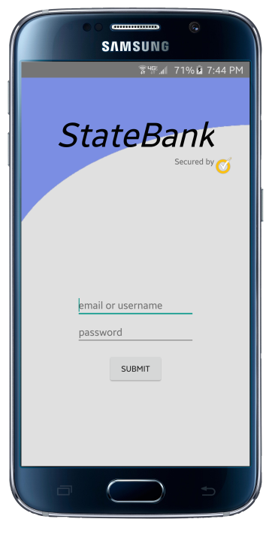

Based in Silicon Valley, Symantec Corporation is a security technology company that offers software products and services related to computer and information protection.

While passwords are the most common method to authenticate users, using passwords alone is not secure. Security is increased by adding a second factor such as a unique secret PIN generated dynamically on a user’s mobile phone.

Symantec provides a two-factor authentication (2FA) product with their “Validation and ID Protection” or VIP service.

Typical 2FA on a mobile device is cumbersome. A user must enter a userid and password in one app, generate a secret PIN with a second app, copy the PIN from the second app, and finally paste the PIN into the original first app.

Our *Integrated Silent Authentication via Symantec VIP* architecture integrates the second authentication factor into an app so that it’s done silently and automatically for the user.

Our system consists of multiple sample apps including “Clock It Pro” and “StateBank.” Users need only enter their userid and password, which demonstrates the user friendliness of the VIP service by making 2FA transparent to the user.

Our sample apps with corresponding documentation are used by Symantec customers to design and develop their own apps.

Our Android and iPhone apps are written in Java and Swift, respectively. Communication with Symantec servers is accomplished through the Symantec VIP SDK as well as our own Java Enterprise Edition server. Our data is stored in a MySQL database.

