Spectrum Health

Project Sponsors

Adam Bakker

Grand Rapids, Michigan

Mary Delrue

Grand Rapids, Michigan

Jane Gietzen

Grand Rapids, Michigan

Matt Hahnfeld

Grand Rapids, Michigan

Markus Neuhoff

Grand Rapids, Michigan

Patrick O'Hare

Grand Rapids, Michigan

Mike Ply

Grand Rapids, Michigan

Mark Welscott

Grand Rapids, Michigan

Michigan State University

Team Members (left to right)

Jim Torres

Clawson, Michigan

Justin Oh

Seoul, South Korea

Josh Curl

Chesterfield, Michigan

Charles Bean

Milford, Michigan

Luke Stanton

Livonia, Michigan

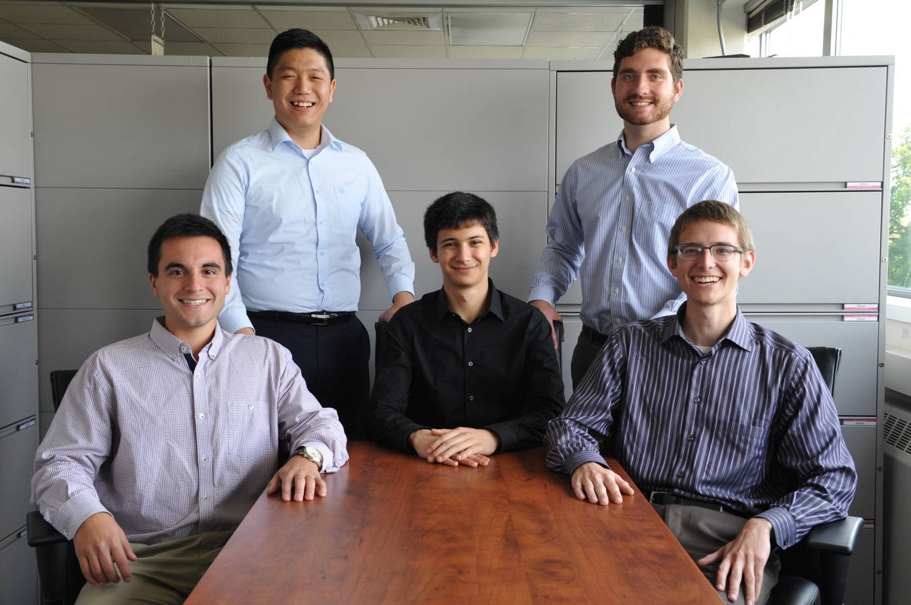

Spectrum Health System

Patient Service Delivery Planning

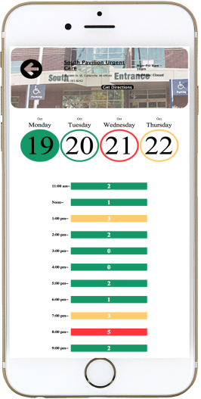

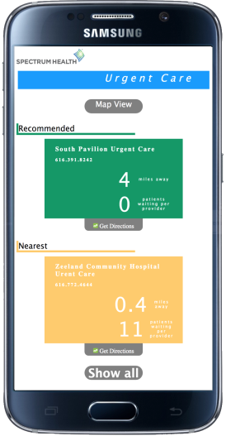

Spectrum Health, located in Grand Rapids, Michigan, provides high quality, high value healthcare through its seven hospitals, more than 140 service sites, and Priority Health, a health plan with nearly 500,000 members.

Our *Patient Service Delivery Planning* system increases customer satisfaction for patients while at the same time improves efficiency for Spectrum Health. It consists of two distinct parts, a mobile app and a web app, which share a common backend.

Our mobile app enhances the experience for patients by finding the nearest Spectrum Health urgent care center with the shortest wait time.

In addition, patients can see predicted future wait times so that they can plan for future visits on days and at times when wait times are normally shorter.

Our companion web app provides Spectrum Health with graphs and analytics of both past and predicted patient arrivals. Spectrum Health leverages this data to staff their facilities, optimize business hours, and predict average treatment time.

Both the mobile app and the web app use complex statistical software that predicts patient wait and treatment times. The design of this predictive model is completely modular so that it can be easily updated, enhanced, or even completely replaced.

Our *Patient Service Delivery Planning* system is written in C#, JavaScript, and R using AngularJS, D3.js, and MongoDB.



