MSUFCU

Project Sponsors

Samantha Amburgey

East Lansing, Michigan

Sarah Barber

East Lansing, Michigan

April Clobes

East Lansing, Michigan

Deidre Davis

East Lansing, Michigan

Collin Lochinski

East Lansing, Michigan

Ben Maxim

East Lansing, Michigan

Michigan State University

Team Members (left to right)

Zac Walters

Midland, Michigan

Ryan McIntyre

Midland, Michigan

Andrew MacAfee

Clarksville, Michigan

Aaron Ta

Northville, Michigan

Neha Gupta

Midland, Michigan



MSU Federal Credit Union

Online Dollar Dog Store



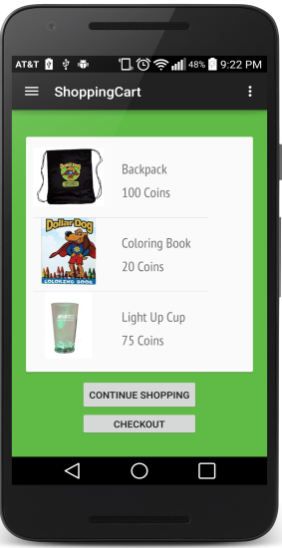

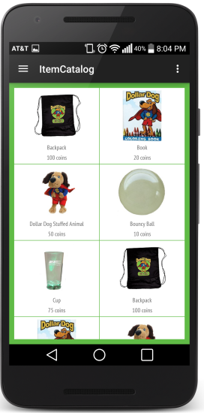

Michigan State University Federal Credit Union (MSUFCU) is the largest university-based credit union in the world, serving Michigan State University, Oakland University and their surrounding communities.

The MSUFCU Dollar Dog program encourages good banking habits in young MSUFCU members. When children ages 5-12 make deposits, they earn Dollar Dog coins, which they can exchange at a Dollar Dog Store for prizes such as backpacks, coloring books, bouncy balls, and stuffed animals.

Currently, there are Dollar Dog Stores in only four MSUFCU branches so it’s difficult for kids who do not live near one of these branches to use Dollar Dog coins to buy prizes.

With our *Online Dollar Dog Store*, MSUFCU kids can shop online using Dollar Dog coins to buy prizes, which are shipped directly to their homes.

After logging in with their MSUFCU user ID and password, kids can add prizes to a cart for purchase with Dollar Dog coins or they can add them to a wish list for a future purchase.

Our *Online Dollar Dog Store* works on desktop web browsers, iPhones, iPads and Android devices.

MSUFCU administrators use our companion web app to edit the store catalog and adjust user coin balances.

Our *Online Dollar Dog Store* native mobile apps are written in Java and Swift. The responsive web app uses CSS, HTML, JavaScript, and Bootstrap. All three platforms connect to a MySQL database through a RESTful API running PHP.

