Ford

Project Sponsors

Chad Esselink

Dearborn, Michigan

Adam Haas

Gurgaon, Haryana, India

Jeff Hentschel

Dearborn, Michigan

Michael Platt

Dearborn, Michigan

Michael Volk

Dearborn, Michigan

Matthew Whitaker

Dearborn, Michigan

Michigan State University

Team Members (left to right)

Weilong Li

Dalian, Liaoning, China

Eric Coldwell

Midland, Michigan

Ryan Bruns

Birch Run, Michigan

Alex Bergman

Troy, Michigan

Usman Majeed

Saginaw, Michigan

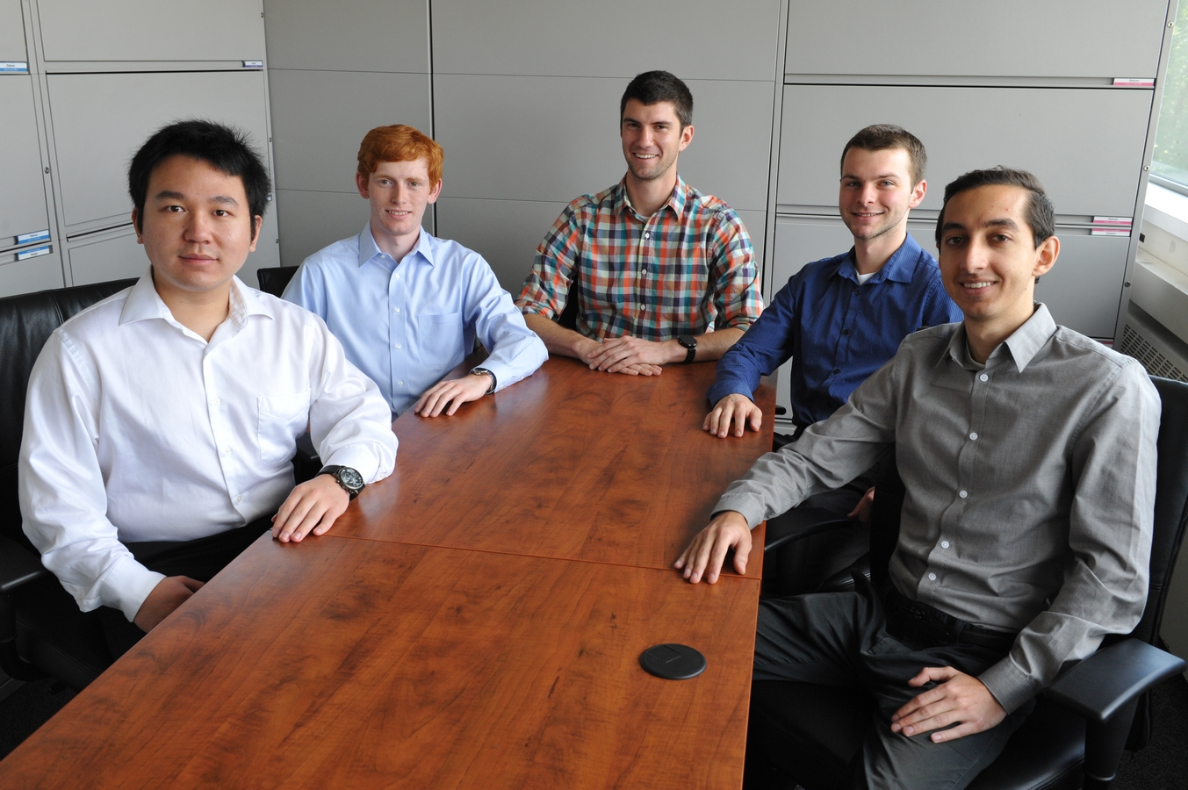

Ford Motor Company

Connected Vehicle Protocol Test Harness

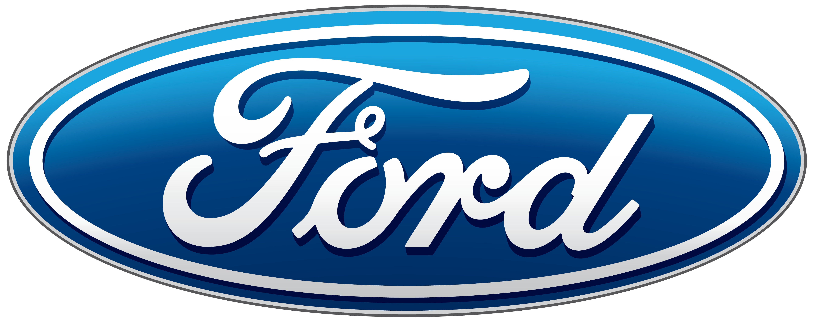

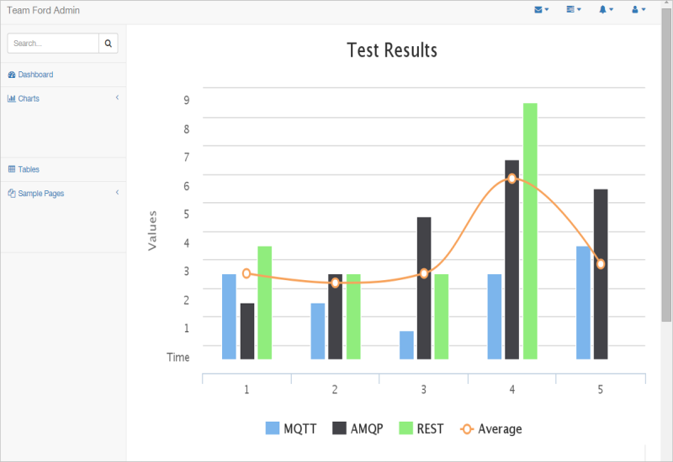

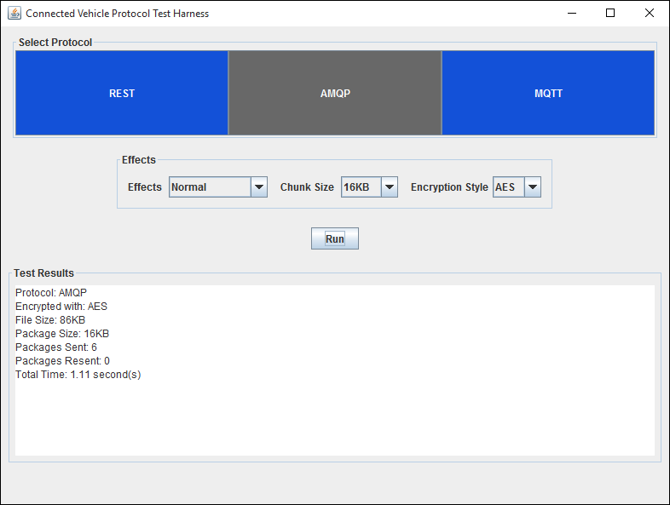

Ford Motor Company designs and manufactures Ford and Lincoln vehicles across six continents and employs more than 220,000 employees in 90 plants worldwide.

Many Ford vehicles that roll off the assembly lines have complex infotainment systems. The performance demands on these systems varies with the customers’ desires such as streaming audio and video directly to their car or truck.

Infotainment systems send and receive a wide array of messages around the vehicle which include things like media files and system updates. As these messages are transmitted, they must arrive at their destination quickly and accurately.

Ford engineers use our *Connected Vehicle Protocol Test Harness* to evaluate the performance of a variety of messaging protocols. Engineers use the results of these evaluations to choose the best protocols for their designs.

Our test harness transmits various encrypted file types from the Ford Discovery Box, which simulates a vehicle, to a server. The test harness monitors and measures these transmissions, and collects data about a protocol’s performance.

Ford engineers visualize the test results with graphs and tables using our companion web application, which enables them to compare and analyze various messaging protocols to determine the optimal performance.

Our *Connected Vehicle Protocol Test Harness* is written in Java and uses RabbitMQ as a message broker. The web app uses HTML/CSS and JavaScript with PHP and SQL to store data.