Auto-Owners Insurance is a Fortune 500 company working with more than 6,200 independent agencies in 26 states. Founded in 1916, Auto-Owners continuously improves their products and services for their policyholders.

Auto-Owners is committed to recruiting and hiring the very best candidates to be associates at Auto-Owners. Our *HR Recruiting System* streamlines the entire process from recruiting to applying to hiring.

Applicants create accounts and complete job applications easily. They can upload their resumes and pull data from their LinkedIn profiles.

To measure the user-friendliness of the system, Google Analytics tracks the number of applicants who complete the entire application process.

Recruiters assign themselves to specific applicants, rank applicants based on interviews, and update the status of each application.

Recruiters can request video, phone, and in-person interviews. They can send acceptance, rejection, and hold letters.

Recruiters use our system to log recruiting events and record relevant information such as expenses, number of recruits in attendance, and contact information. Paper copies of resumes collected at events are scanned and stored in the system.

Our *HR Recruiting System* is written in HTML, CSS, AngularJS, and NodeJS. Our system is supported on the backend by a SQL database.

Auto-Owners

Project Sponsors

Scott Lake

Lansing, Michigan

Rebecca Mengerink

Lansing, Michigan

Jim Schumacher

Lansing, Michigan

Michigan State University

Team Members (left to right)

Abigael Onchiri

East Lansing, Michigan

Gauthier Devolder

Midland, Michigan

Jun Gao

Suhou, Jiangsu, China

Ashwin Jayakumar

Novi, Michigan

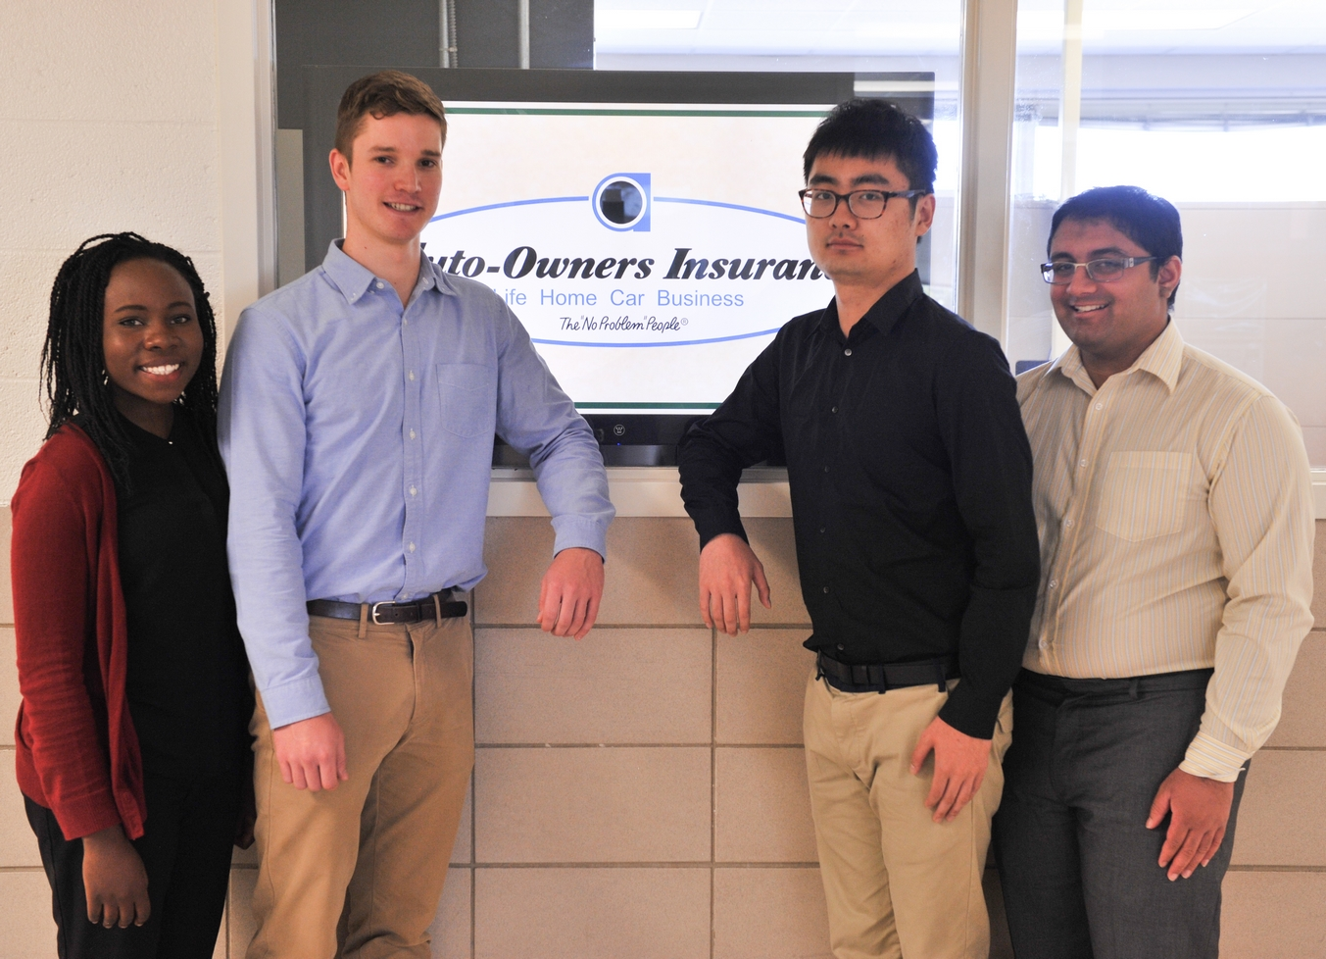

Auto-Owners Insurance

HR Recruiting System

