**TechSmith**

***Corporate Sponsors***

Randall Brown

Okemos, Michigan

Dean Craven

Okemos, Michigan

William Hamilton

Okemos, Michigan

Larry LaHaie

Okemos, Michigan

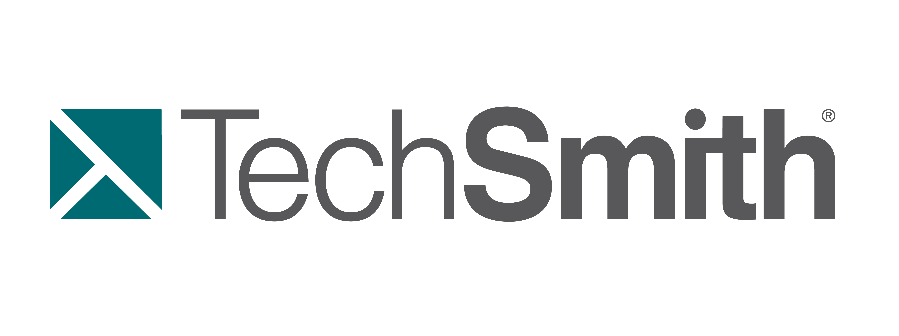

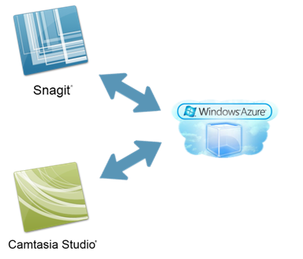

TechSmith is harnessing the power of the cloud to create a new resource for sharing and acquiring assets for two of their most popular programs, Snagit and Camtasia Studio.

Using Microsoft’s Windows Azure cloud platform, this program enables users to easily browse and download shared assets or to upload and share assets with friends, groups, or the whole world.

Sharable assets include things like images and video clips created by users, as well as other graphical elements such as callouts and title screens.

Once a user has downloaded a new asset, it is automatically installed into the correct location for each program for immediate access. Additionally, a special plug-in for Snagit allows users to instantly save their images to the cloud.

Users will enjoy a more efficient and richer experience as we make it easier for them to share and find these assets.

Snagit is a screenshot program that replaces the native Print Screen function with additional features, such as the ability to take shots of entire web pages or shots of the contents of a program window. It also contains a built in editor that automatically opens after taking a shot.

Camtasia is a screen video capture program that allows users to capture what is happening on their screen in video. The user may define the area of the screen or the window that is to be captured or the whole screen can be recorded instead.

**Michigan State University**

***Team Members*** (left to right)

Seungmin Kim

Jeju, South Korea

Timothy Miller

Owosso, Michigan

Alex Nolley

Fenton, Michigan

Chris Dasbach

Lake Orion, Michigan

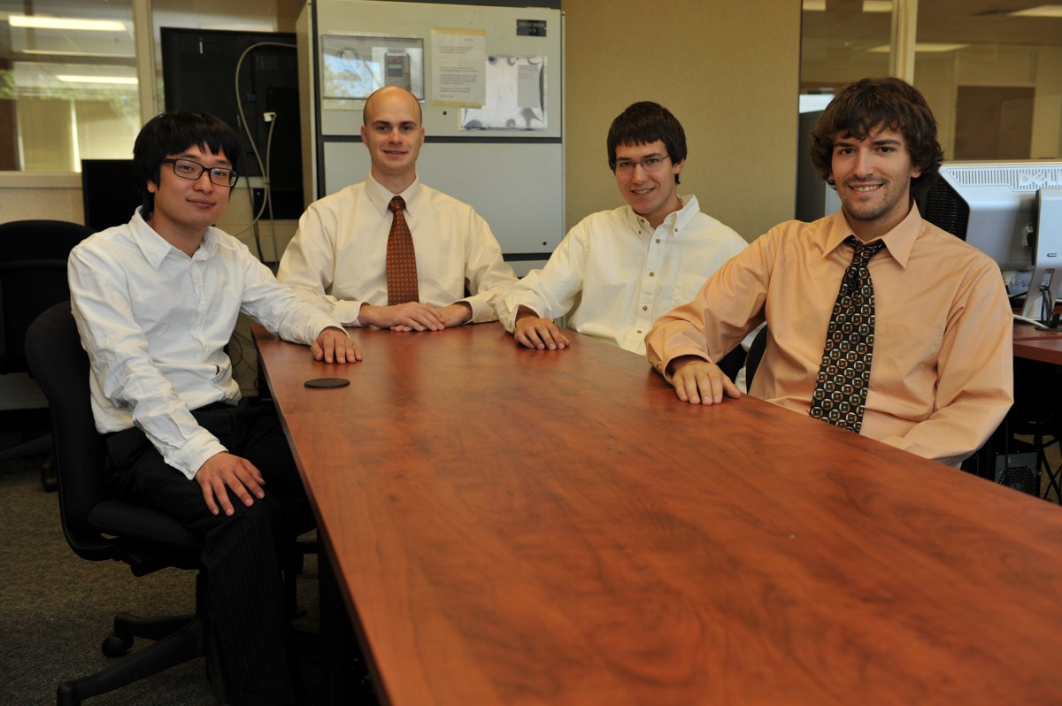

**TechSmith**

**Extending Apps with Cloud Asset Sharing**