**Motorola**

***Corporate Sponsors***

Kabe Vanderbaan

Schaumburg, Illinois

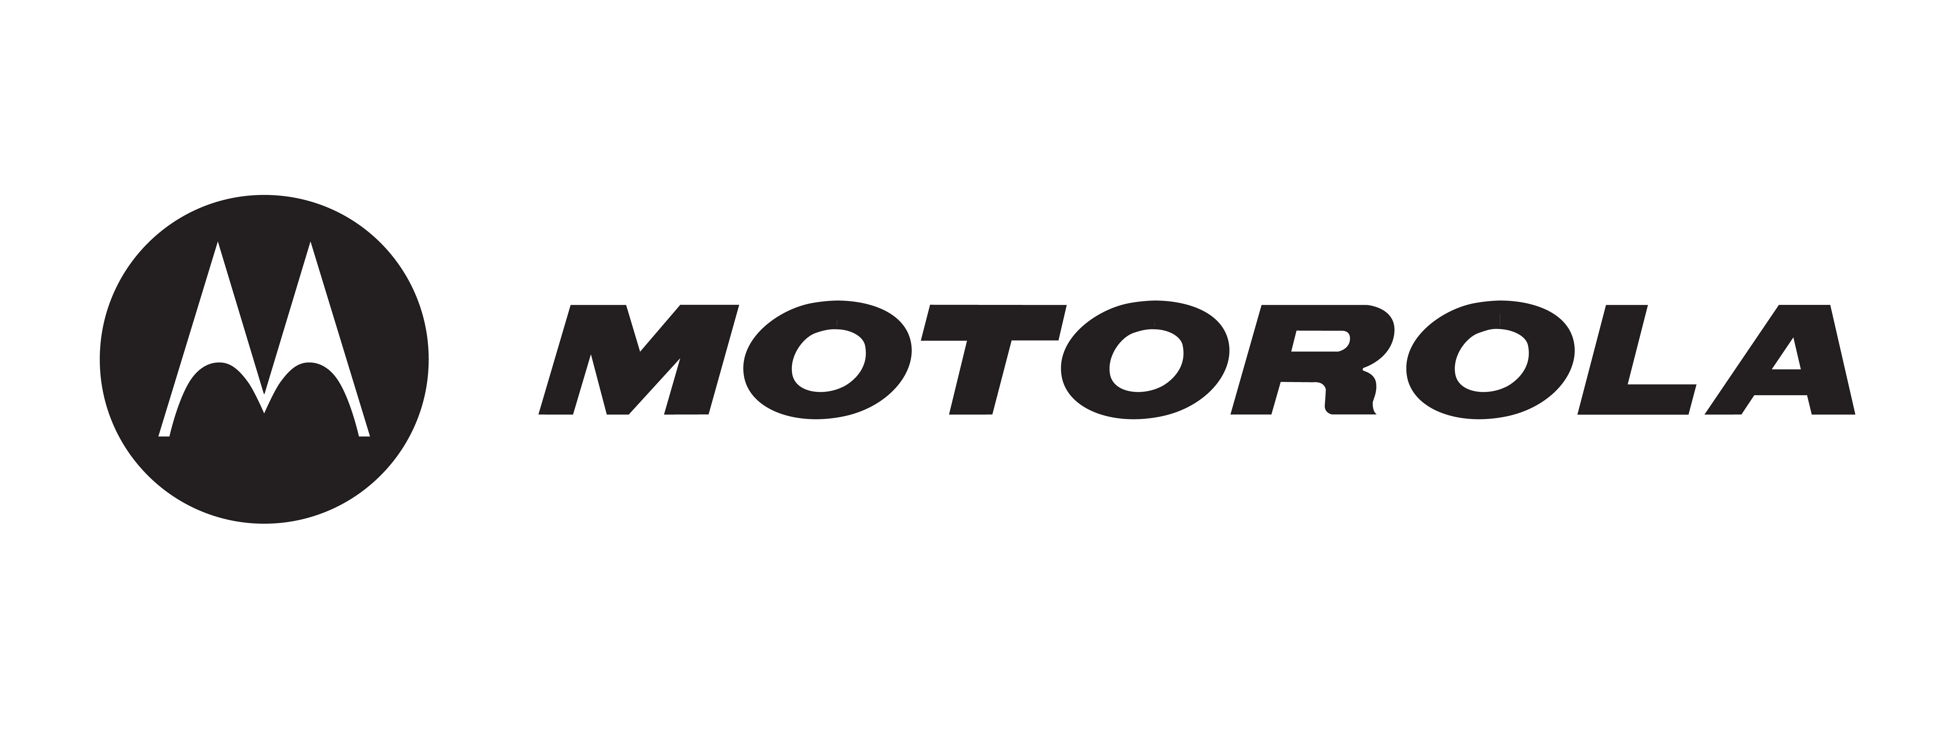

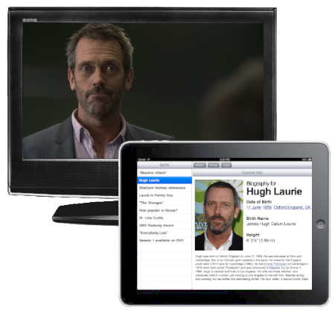

Television has become more intertwined with the World Wide Web than ever before. With the emergence of smart devices, consumers are connected wherever they go. Motorola aims to leverage these platforms and give consumers the ability to follow their favorite programs wherever they may be, while providing a television viewing experience unlike any other.

Our Enhanced Electronic Program Guide (EEPG) allows a content provider to create and manage supplementary content through an easy to use web interface. The provider can associate this content with a TV program and choose a specified time when it should appear on a synced mobile device during the viewing of a show. This content can be used to enhance the television experience by providing new and exciting information to the viewer as a show airs.

The EEPG allows consumers to receive this supplementary content on their mobile device as they watch their favorite shows. The EEPG is presented in an intuitive interface that alerts the user when new content is available. It displays the content in a non-intrusive manner and in user selectable layers.

The EEPG service is written in Java with a RESTful architecture and deployed on a Glassfish server. Our persisting data is stored on a MySQL database and accessed through an iBatis persistence layer. The Secondary Content Creation Tool is written in Java using Google Web Toolkit and the iPad mobile application is written in Objective C.

**Michigan State University**

***Team Members*** (left to right)

Tim Aubel

Essex, Vermont

Andrew Rossow

Canton, Michigan

Brian Cripe

Medfield, Massachusetts

Drew Hanlon

Grosse Point Shores, Michigan

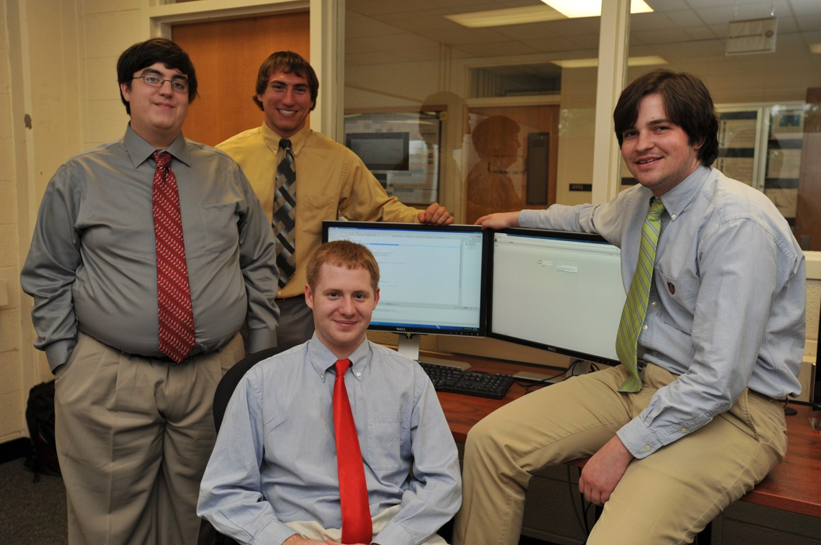

**Motorola**

**Enhanced Program Guides for Mobile Devices**