**Meijer**

***Corporate Sponsors***

Randy Brower

Grand Rapids, Michigan

David Rodgers

Grand Rapids, Michigan

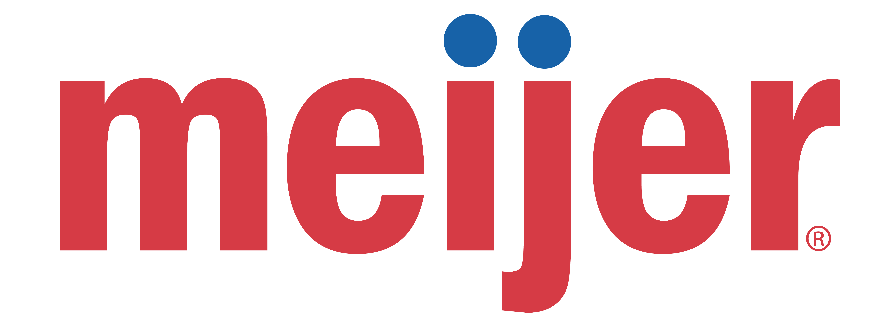

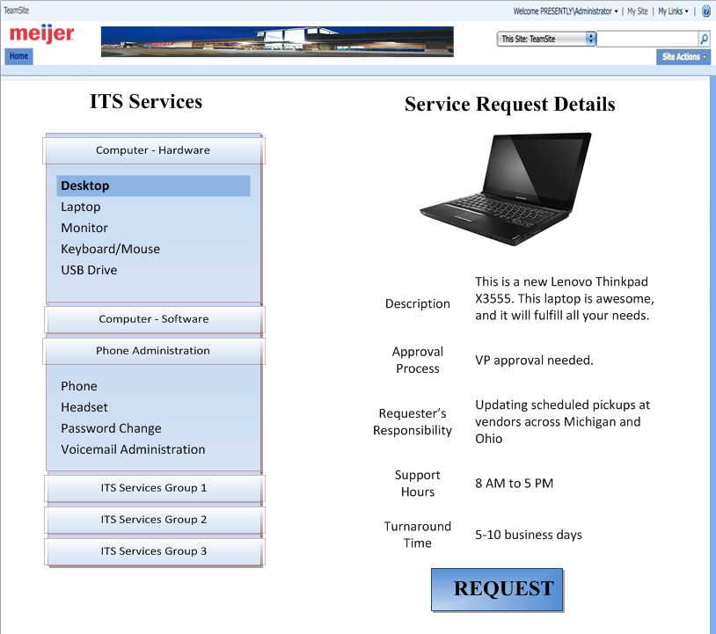

Meijer ITS—Information Technology Services—provides products and services to all divisions within the company. Currently, there is no single web site where ITS products and services can be found and requested by Meijer employees.

We have developed a web portal built upon SharePoint, which consolidates all ITS products and services. In addition, our portal includes a standardized form for all requests.

The portal directs customers to the ITS Service Request Catalog. Customers are then able to view the available products and services via an expandable menu. When a service is selected from the menu, a detailed description of the service is displayed. Once the desired service is found, the user is directed to the corresponding for to request it.

After a form is filled out and submitted, a copy of the form is stored within SharePoint and an email is sent to the existing ticketing system, which handles such requests.

The goal of our web portal is to make it easier for Meijer employees to find and request the desired ITS products and services and to provide the ability to view the status of their request, thereby allowing ITS to provide quicker request turnover rates. By using our web portal, the user and ITS will save valuable time, thus increasing productivity.

The site is developed in ASP.NET and C#. The forms are created with Microsoft InfoPath. The Database is created with Microsoft SQL Server 2008.

**Michigan State University**

***Team Members*** (left to right)

Andrew Thielking

Kalamazoo, Michigan

Austin McCarty

Clinton Township, Michigan

Matt Packowski

Charlotte, Michigan

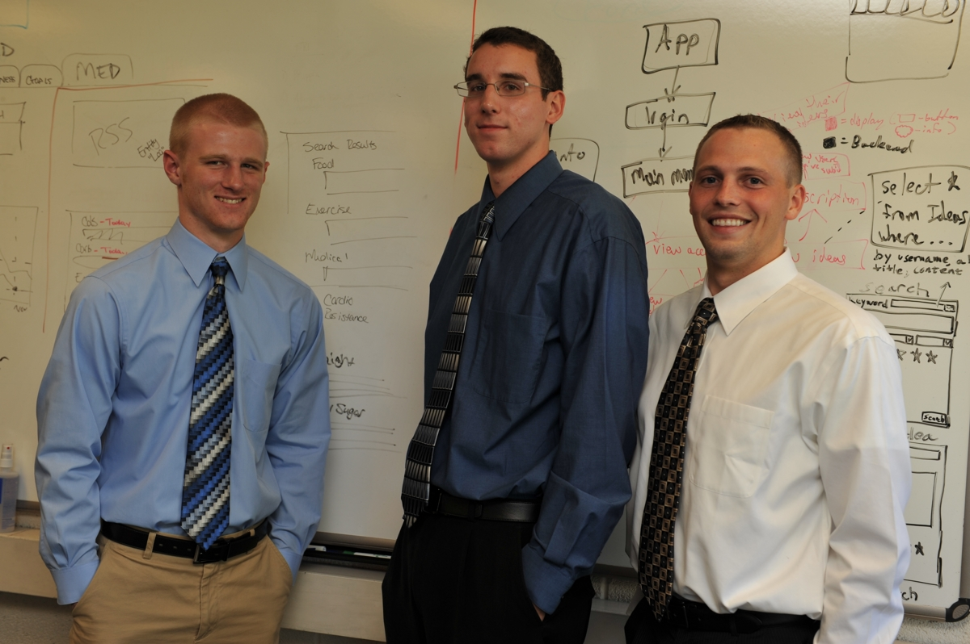

**Meijer**

**ITS Products and Services Request System**