

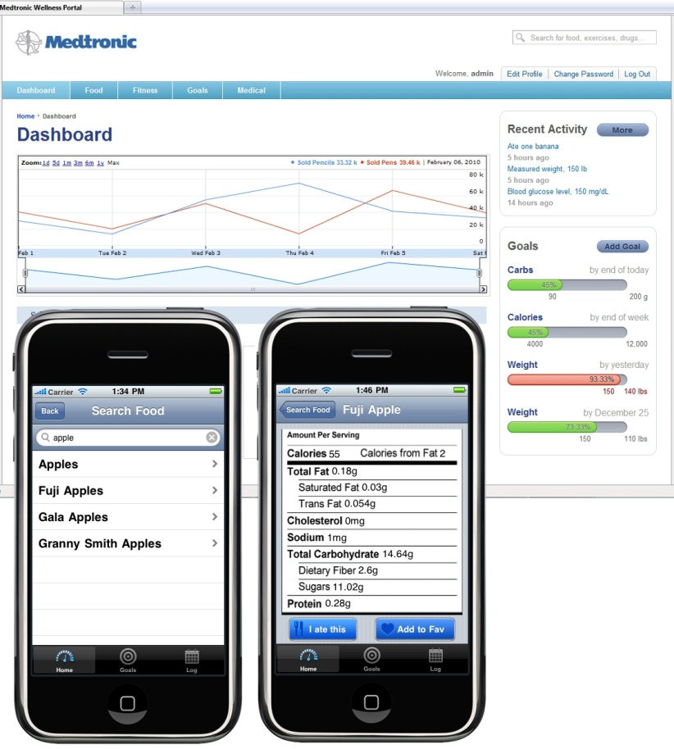

**Medtronic, Inc.**

***Corporate Sponsors***

Patrick Agrawal

Mounds View, Minnesota

Peter Erickson

Mounds View, Minnesota

Vandy Johnson

Mounds View, Minnesota

Scott Mark

Mounds View, Minnesota

Javid Masoud

Mounds View, Minnesota

Karin Petty

Mounds View, Minnesota

Michael Studemann

Mounds View, Minnesota

For over 50 years, Medtronic’s mission has been to alleviate pain, restore health, and transform the way the world treats chronic diseases so patients can live a fuller life. To this end, the Medtronic Wellness Portal enables patients to manage their diet, health and activity levels in a streamlined, more convenient way.

The heart of the Wellness Portal is to help a patient understand the impact of their food and exercise choices on their overall wellness. Patients can track a wide range of goals such as weight, activity levels, blood sugar or daily calorie intake, with a goal to reinforce healthy choices.

The Wellness Portal is comprised of web and iPhone applications that allow users to quickly input data. If, for example, the user wishes to track a daily caloric input, the application has a fast and easy way to input food eaten at any time of the day. The user can see at a glance the total calories consumed compared to the daily goal.

Along with user input, the portal also automatically inputs and tracks data from the patient’s Medtronic devices, such as insulin pumps or a continuous glucose monitor, as well as from the user’s Google Health account. Graphs are used to show data correlation and, by using analytics, appropriate observations and recommendations are made.

The web application is written in Groovy and JavaScript in a Grails framework. The iPhone app is written in Objective-C.

**Michigan State University**

***Team Members*** (left to right)

Vu Bui

Lansing, Michigan

Joe Heldt

Lansing, Michigan

Zach Riggle

Stevensville, Michigan

Chris Van Wiermeersch

Novi, Michigan



**Medtronic, Inc.**

**Medtronic Wellness Portal**